NAME: …………………………………………………..……………………………………….
ADM ……………….CLASS…....CANDIDATE’S SIGNATURE: ………………………....... DATE: ...............

231/2 (THEORY)
SEPTEMBER EXAM
BIOLOGY PAPER 2
TIME: 2 HOURS

KASSU – JET EXAMINATIONS
BIOLOGY PAPER 2
2021

Instructions to candidates
- Write your name and index number in the spaces provided above
- Sign and write the date of examination in the spaces provided above
- This paper consists of two sections: A and B
- Answer all the questions in section A in the spaces provided
- In section B answer question 6 (compulsory) and either question 7 or 8 in the spaces provided after question 8
- This paper contains 8 printed pages
- Candidates should check the question paper to ascertain that all pages are printed as indicated and that no questions are missing
- Candidates should answer the questions in English

FOR EXAMINER’S USE ONLY
Section | Question | Max. score | Candidate’s score
A | 1 | 8
A | 2 | 8
A | 3 | 8
A | 4 | 8
A | 5 | 8
 | 6 | 20
 | 7 | 20
 | 8 | 20
Total score |  | 80

SECTION A (40 MARKS)
Answer all the questions in the spaces provided
- a) The inheritance of Duchene muscular dystrophy is sex-linked caused by a recessive gene located in the X chromosome. A marriage between normal parents Avital and Jorum resulted into a Dystrophic son Abednego and two normal daughters Rachael and Ariel. Their son Abednego had a normal daughter called Naomi while Ariel’s two sons, Aaron were dystrophy and Heron normal. Using letter D to denote the gene for normal ,draw a pedigree chart to represent the family indicating the probable genotypes of the parents and grandchildren ( 5marks)

b) Suggest a reason why a pedigree chart is important in genetics (1 mark)
………………………………………………………………………………………………………………………………………………………………………………………………
c) Drosophila melanogaster (fruit fly) is suitable for genetic study. Explain?
(2 marks)
………………………………………………………………………………………………………………………………………………………………………………………………………………………………………………………………………………………………………………………………………………………………………………………………………………………………………………………………………………………………

- The diagram below illustrates an experiment to determine the rate of respiration in a small insect
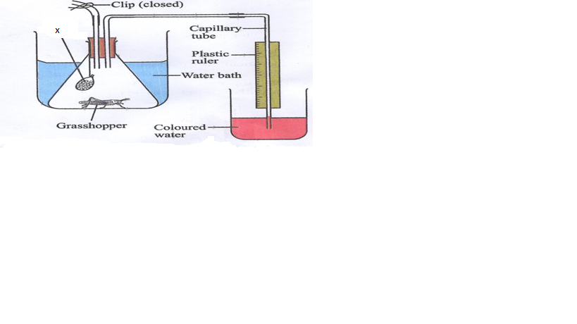
- Name the chemical compound labelled X and state its function (2marks)
................................................................................................................................................
- Why is it necessary to place the flask in a water bath? (2marks)
................................................................................................................................................................................................................................................................................................
- What changes would you expect to observe in the level of coloured water in the capillary tube after the experiment has run for 5 minutes? (1mark)
................................................................................................................................................ Explain the changes you have stated in (c) above (2marks)
................................................................................................................................................................................................................................................................................................................................................................................................................................................
- Explain how you can set up a control for the experiment? (1mark)
................................................................................................................................................................................................................................................................................................

3. The figure below illustrates a process that takes place in the alimentary canal.
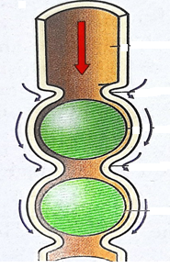
(a) Name the process. (1 mark)
…………………………………………………………..……………………………
(b) Name two muscles that enhance the above process. (1 mark)
……………………………………………………………………………………………………………………………………………………………………………………………………
(c) Explain the importance of roughage to the above process. (1 mark)
………………………………………………………………………………………………… (d) State how the stomach protects its walls against digestion by enzyme pepsin. (2 marks) ……………………………………………………………………………………………………………………………………………………………………………………………………
(e) State any one function of HCl produced in the stomach during the digestion process. (1 mark) …………………………………………………………………………………………………
(f) Explain the reason why the digestion of starch stops shortly after food enters the stomach. (2 marks)
……………………………………………………………………………………………………………………………………………………………………………………………………
- The table below shows the concentration of sodium and Iodine ions in pond water and in the cell sap of water lettuce plant

 | Sodium ion concentration | Iodine ion concentration
Pond water | 160 | 0.4
Cell sap | 70 | 500
- Giving reasons, name the process through which each of the ions is taken up by the plant
Sodium (2marks)
…………………………………………………………………………………………………………………………………………………………………………………………………………………………………………………………………………………………………………………………………………
Iodine (2marks)
…………………………………………………………………………………………………………………………………………………………………………………………………………………………………………………….………………………………………………………………………………………………………………………………………………………………………
- The lettuce plant was then treated with a chemical substance that inhibits the synthesis of ATP. Giving a reason, state which ion uptake was affected by the treatment (2marks)
……………………………………………………………………………………………………………………………………………………………………………………………………………………………………………………………………………………………………………………….……………….
- Explain why fresh water fish cannot survive in marine habitat (2marks)
……………………………………………………………………………………………………………………………………………………………………………………………………………………………………………………………………………………………………………………………………………………………………………………………………………………………………………………………………………………………………………..

- Study the diagram below and answer the questions that follow
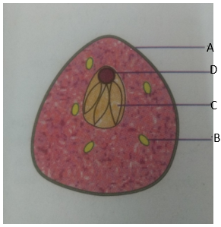

- Name the type of reproduction exhibited by the organism illustrated above?
(1mark)
…………………………………………………………………………………
- State the advantages of this type of reproduction named in (a) above?
(3marks)
…………………………………………………………………………………………………………………………………………………………………………………………………………………………………………………………………………………………………………………………………………..
- Name the parts labeled A, B and C (3marks)
…………………………………………………………………………………………………………………………………………………………………………………………………………………………………………………………………………………………………………….……………………………
- State one function of the part labeled D (1mark)
…………………………………………………………………………………………………………………………………………………………………………………………………………………………………………………………………………………………………………………………………………

SECTION B (40 MARKS)
Answer question 6 and either question 7 or 8 in the space after question 8
6. There are slightly more than seven thousand leucocytes per cubic millimeter of blood of an average healthy human being. However, the number changes sharply following an infection. The table below shows the concentration of leucocytes in man after a bacterial infection
Time in hours | 0 | 6 | 12 | 18 | 24 | 30 | 36 | 42 | 48
Number of bacteria per mm³ of blood (x10³) | 0 | 0.5 | 1.5 | 3.0 | 4.0 | 4.5 | 4.0 | 2.0 | 0
Number of leucocytes per mm³ of blood (x10³) | 7.0 | 7.0 | 10.0 | 13.0 | 14.0 | 14.0 | 13.0 | 12.0 | 10.0

- Using the values provided on the table, plot curves of number of bacteria and leucocytes in blood against time (8marks)



- What is the role of leucocytes in the human body (1mark)
................................................................................................................................................................................................................................................................................................

- Account for the relationship between the concentration of bacteria and that of leucocytes in human blood. (3marks)
...............................................................................................................................................................................................................................................................................................................................................................................................................................................................................................................................................................................................................................................................................................................................................

- What is the concentration of bacteria and leucocytes in blood 21 hours after infection
(2marks)
Bacteria
......................................................................................................................................................
Leucocytes
......................................................................................................................................................
- Name any two types of antibodies produced by lymphocytes and for each, give their mode of action. (4marks)
...............................................................................................................................................................................................................................................................................................................................................................................................................................................................................................................................................................................................................................................................................................................................................

- Give two sites where leucocytes are formed in the human body. (2marks)

................................................................................................................................................................................................................................................................................................
7.(a) Name two blood vessels found in umbilical cord and state the differences in the composition of blood in the vessels you each named. (4marks)
(b)Explain how the placenta is adapted to its function. (4 marks)
c) Discuss the effects of the following hormones in plant growth. (12 marks)
(i) Auxins
(ii) Abscisic acid
(iii) Gibberellins
8. a)Describe four causes of water pollution? (12marks)
b) Explain how the Human skin is a thermoregulatory organ (8marks)

…………………………………………………………………………………………………………………………………………………………………………………………………………………………………………………………………………………………………………………………………………………………………………………………………………………………………………………………………………………………………………………………………………………………………………………………………………………………………………………………………………………………………………………………………………………………………………………………………………………………………………………………………………………………………………………………………………………………………………………………………………………………………………………………………………………………………………………………………………………………………………………………………………………………………………………………………………………………………………………………………………………………………………………………………………………………………………………………………………………………………………………………………………………………………………………………………………………………………………………………………………………………………………………………………………………………………………………………………………………………………………………………………………………………………………………………………………………………………………………………………………………………………………………………………………………………………………………………………………………………………………………………………………………………………………………………………………………………………………………………………………………………………………………………………………………………………………………………………………………………………………………………………………………………………………………………………………………………………………………………………………………………………………………………………………………………………………………………………………………………………………………………………………………………………………………………………………………………………………………………………………………………………………………………………………………………………………………………………………………………………………………………………………….……..
…………………………………………………………………………………………………………………………………………………………………………………………………………………………………………………………………………………………………………………………………………………………………………………………………………………………………………………………………………………………………………………………………………………………………………………………………………………………………………………………………………………………………………………………………………………………………………………………………………………………………………………………………………………………………………………………………………………………………………………………………………………………………………………………………………………………………………………………………………………………………………………………………………………………………………………………………………………………………………………………………………………………………………………………………………………………………………………………………………………………………………………………………………………………………………………………………………………………………………………………………………………………………………………………………………………………………………………………………………………………………………………………………………………………………………………………………………………………………………………………………………………………………………………………………………………………………………………………………………………………………………………………………………………………………………………………………………………………………………………………………………………………………………………………………………………………………………………………………………………………………………………………………………………………………………………………………………………………………………………………………………………………………………………………………………………………………………………………………………………………………………………………………………………………………………………………………………………………………………………………………………………………………………………………………………………………………………………………………………………………………………………………………………………….
………………………………………………………………………………………………………………………………………………………………………………………………………………………………………………………………………………………………………………………………………………………………………………………………………………………………………………………………………………………………………………………………………………………………………………………………………………………………………………………………………………………………………………………………………………………………………………………………………………………………………………………………………………………………………………………………………………………………………………………………………………………………………………………………………………………………………………………………………………………………………………………………………………………………………………………………………………………………………………………………………………………………………………………………………………………………………………………………………………………………………………………………………………………………………………………………………………………………………………………………………………………………………………………………………………………………………………………………………………………………………………………………………………………………………………………………………………………………………………………………………………………………………………………………………………………………………………………………………………………………………………………………………………………………………………………………………………………………………………………………………………………………………………………………………………………………………………………………………………………………………………………………………………………………………………………………………………………………………………………………………………………………………………………………………………………………………………………………………………………………………………………………………………………………………………………………………………………………………………………………………………………………………………………………………………………………………………………………………………………………………………………………………………….
.

