565/1
BUSINESS
MARKING SCHEMES
PAPER 1
1. a) Utility-ability of a good or service to satisfy human wants,
b) Producer goods-Goods used in producing other goods e.g machinery
c) Scarcity and choice-resources are few but wants are many so or consumers must choose the most important
d) Scale of preferences-a list of wants in order of their importance.
2. Factors that account for predominant direct production.
• Reliance on poor technology
• Low income due to poverty which limits production activities Negative attitude towards commercialization of most productive activities
• Poor resource endorsement
• Lack of market for some goods.
• Lack of skills.
3. Shares Debentures

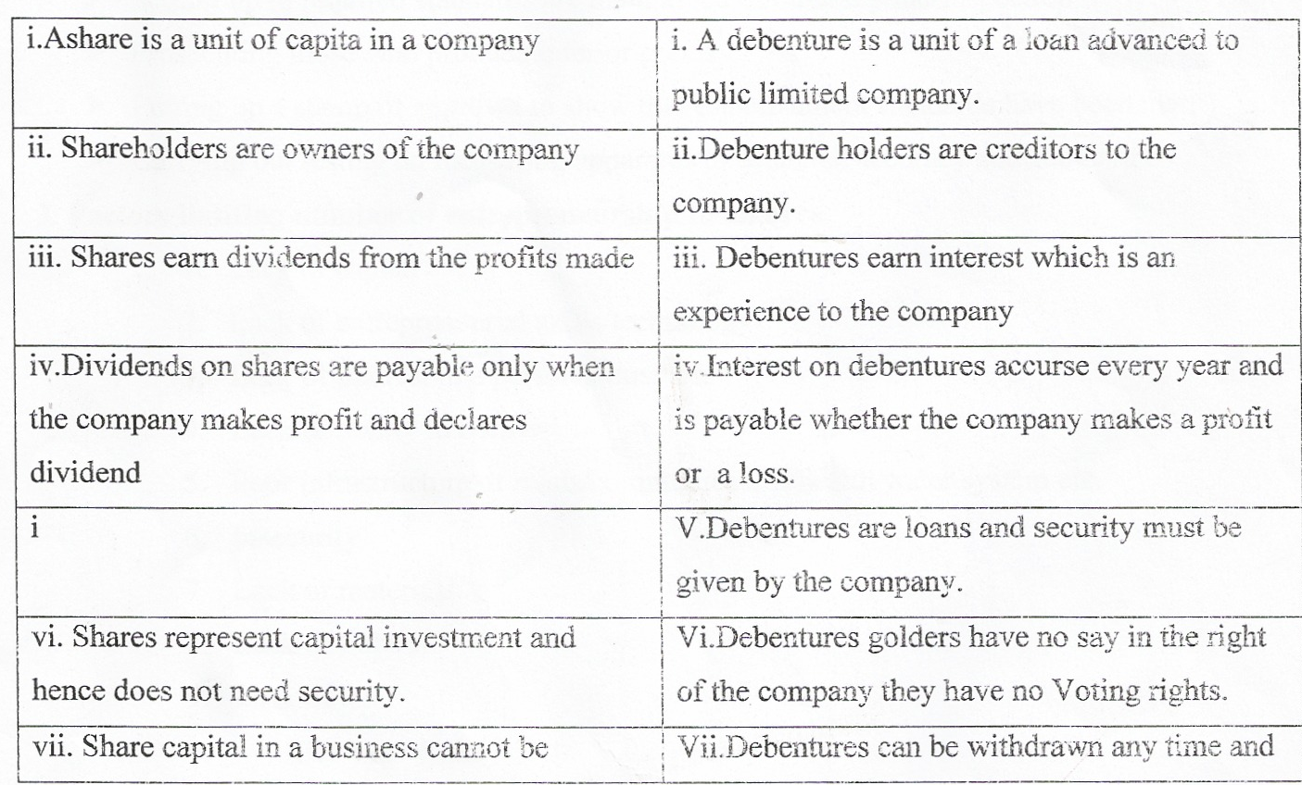
4.a) Free good — Goods available in abundance as gifts of nature.
b) Producer goods - Goods used in production other goods.
c) Public goods — Goods that belong to no one in particular but are owned by government or by all of us collectively.
d)Non-material goods — commodities that are intangible.
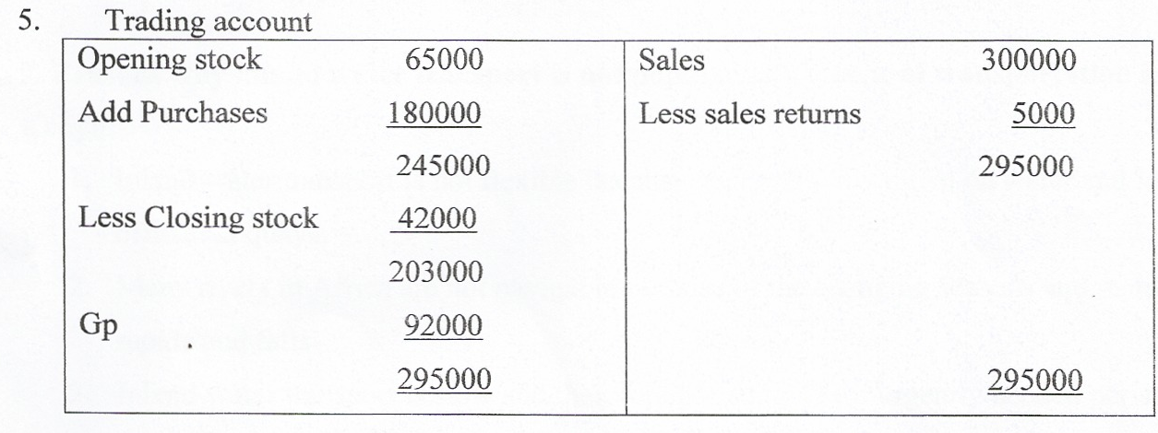
6. Four Functions of Kenya Bureau of standards (KEBS)
> Setting up to required standards are maintained through regular inspection
> Prosecuting those who produce inferior goods
> Putting up a stamp of approval to show that establishment standards have been met,
> Carrying out testing on measuring apparatus to establish accuracy and standards 7. Factors limiting number of entrepreneurship in an area.
1. Lack of capital
2. Lack of entrepreneurial skills/technology
3. Lack of interest in a personal business
4. Lack of ability to borrow
5. Poor infrastructure of roads/ communication/health water system etc.
6. Insecurity
7. Lack of materials
8. Lack of Labour
9. Lack of land any 4x4=4mks
8. Possible causes that have led to the situation
- Decrease in cost of production
- Availability of inputs
- Increase in the supply of a commodity jointly produced with it.
- Improvement in technology.
- Government policy e.g. subsides and financial assistance. 4 x 1 4 marks
9. Reasons why inland water transport is not popular as a means of transportation in Kenya.
1. Inland water transport is not flexible because boats can only travel on water and load offloads at quays.
2. Many rivers in Africa are not navigable because of the changing seasons and many rapids and falls.
3. Inland water transport is slow and therefore nor suitable for urgently needed perishable goods.
4. These Rivers are usually affected by strong winds and storms.
5. Many rivers are narrow and shallow hence do not allow use of large verses.
6. The rivers are usually affected by strong winds and storms
7. They are affected by water weeds e.g hyacinth. Any 4x1=4mks.
10. Errors causing trial balance not to balance.
- Transactions recorded on only one account
- Different amount for the same transaction entered in the accounts.
- Posting a wrong balance to the trial balance.
- Posting a wrong balance to the wrong side of trial balance.
- Recording a transaction on the same side of affected accounts.
- Arithmetical mistakes when balancing ledger accounts.
- Arithmetical errors in balancing the trial balance. 4x1.4marks
11. Sources of oligopoly POWER
a. High initial cost of production beyond ability of other firms.
b. Patent rights or trade marks
c. Exclusive control of crucial raw materials by a few firms.
d. Use of unique technology by a few firms.
e. Merger of several related firms into a few larger firms.
f. Small size of the markets —best served by few firms
g. Government protectionist policy-allow a few firms to operate. Any4 correct answers = 4 mks.
12. Benefits of national income
(• It provides information of the economy over a given period.
+ It helps to measure the standards of a living.
+ It helps to compare standards in different countries.
13. —Availability of hinds for construction
- Number of employees
-Availability/adequate office equipment
- Office space available
14. How consumers may benefit when producers compete
a) Reduction in prices of products
b) Improvement in quality of products
c) Providing information on prices and where to buy
d) Providing education on how to use the products
e) Providing entertainment to consumers
0 Providing a variety of goods
g) Competition and demonstration where consumers can win prizes
15. Net profit closing capital+Drawings
15. Net profit closing capital+Drawings
Additional capital — opening capital
=135000+6000-105000 - 15000
=210000
16.—Increase
- No effect
- Decrease
- No effect
17. i) Open and voluntary membership
ii) Democratic administration
iii) Dividend payment — is bared on members contribution to the surplus in the co-operative
iv) Limited interest on share capital
v) Promotion of co-operative education
vi) Co-operation with other co operations
18. i) An order
ii) Bought note
iii) Solid note
iv) Acknowledgement note
v) Credit status inquiry
vi) Perform an invoice
19.- He could be old as far as age is concerned
- He could be in a risky occupation
- He could be of poor health
- He could be engaged in risky hobbies e.g. Mountain climbing
- His place of residence could be risky
20. Disadvantages of an ageing population
i. Decline in labor supply
ii. Fall in quality of labor
iii. Decline in demand for goods for the young population
iv. Increase on welfare benefits
v. High dependency ratio
21. Benefits of effective communicating
a. It provides and obtains information in good time
b. It clarifies issues and instructions
c. It enhances decision making
d. It enhances co ordination among various departments
e. It enhances public relations
f. It improves customers services
22i) Increase in income of an individual
ii) Drop in the price of the product
iii) Increase in price of substitute goods
iv) Subsidies by the government
v) Increase in population
vi) Future expectation in price
vii) Increase of the product
23.(i) The government gets revenue
ii) The government controls entry of handful goods into the country
iii) The government is able to verify documents for the goods in transit
iv) The government can check the quality of goods imported
v) The government is able to inspect the nature of goods imported
vi) The government is able to check on illegal goods entering the country
24. Some documents
a) Cash sale slip
b) Invoice issued
c) Credit note issued
d) Credit note received
25. The services that the Central bank of Kenya may offer as a banker to commercial banks
- Issue of currency — it is the only institution authorized to issue currency in the country
- Banker to commercial banks -r as commercial banks are required by law to deposit a certain percentage of their customers deposits in the central bank
- Acts as a link bank to external financial institutions

