231/3 - BIOLOGY - Paper 3


1 ³/₄ Hours

NAME……………………………………………………..ADM…………….CLASS………

2022 TRIAL 2 JULY INTERNAL EXAMINATION

Answer ALL the questions

- FOR EXAMINER'S USE ONLY

QUESTION | SCORE | CANDIDATES SCORE
1 | 11
2 | 14
3 | 15
TOTAL | 40

- You are provided with the following materials;
A tablet labelled K
Pestle and mortar
2cm³ Copper sulphate solution
2cm³Sodium hydroxide solution
2cm³ DCPIP solution
3 test tubes
3 droppers
- Using a pestle and mortar, crush the tablet K then add 4cm³ of distilled water to form a solution. Divide into two portions each containing 2cm³. Carry out tests to determine the food substance (s) in K (8mks)
Substance | Food substance being tested for | Procedure | Observations | Conclusion
K

K

- Give one deficiency disease brought by lack of the food substance identified in the table above in the human body (1mk)
....................................................................................................................................
- Identify two ways by which the food substance identified in the table above can be destroyed (2mks)
....................................................................................................................................
....................................................................................................................................
- Observe the organisms below and answer the questions that follow.
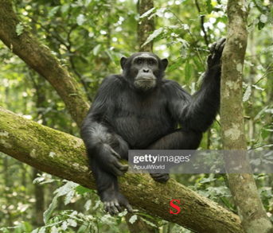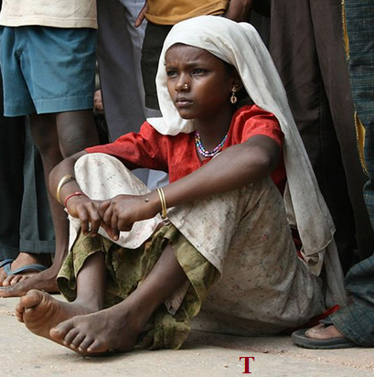
- Give two structural differences between the organisms above (2mks)
S | T

- The photographs below show organisms that are closely related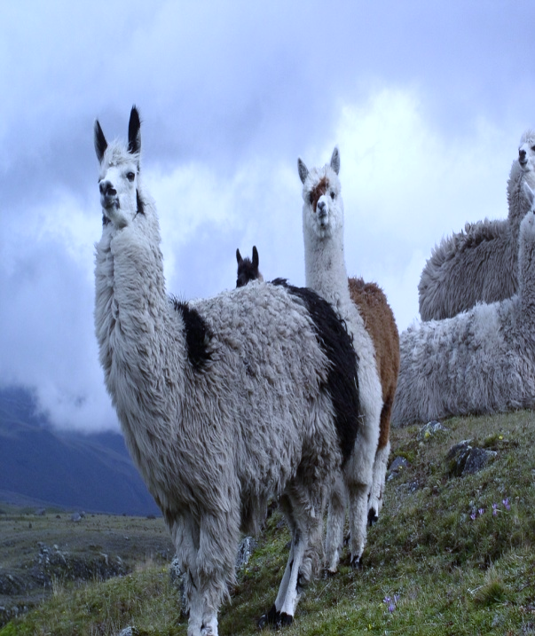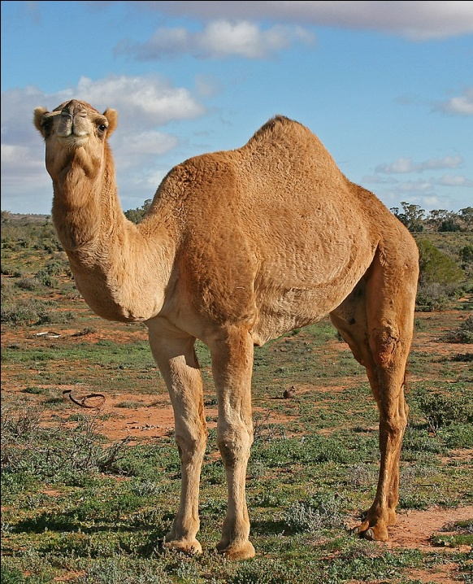
- Identify the evidence for organic evolution exhibited by the two organisms above (1mk)
…………………………………………………………………………………………
(ii) Give any other two evidence that supports organic evolution (2mks)
....................................................................................................................................
....................................................................................................................................
- Observe the two organisms interacting in an ecosystem.
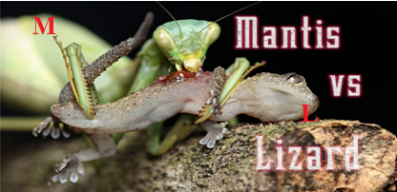

(a)(i) Identify which of the two animals M and L will have the least biomass (1mk)

………………………………………………………………………………………………

(ii) Give a reason for your answer in (b) (i) above (1mk)

……………………………………………………………………………………………………………………………………………………………………………………………..
(b) Explain the concept of “Survival for the fittest” in relation to the organisms illustrated in the photograph. (3mks)

………………………………………………………………………………………………………………………………………………………………………………………………
………………………………………………………………………………………………………………………………………………………………………………………………
(c) Explain two visible survival adaptive features for the organisms illustrated in the photograph (4mks)

……………………………………………………………………………………………………………………………………………………………………………………………..
………………………………………………………………………………………………………………………………………………………………………………………….
- The photographs below show various developmental stages of an insect
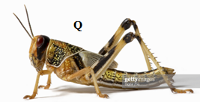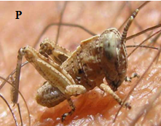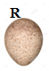
- (i)Identify the stages labelled P, Q and R (3mks)
P ………………………………………………………………………………………
Q ………………………………………………………………………………………
R ……………………………………………………………………………………....
(ii) Give the differences between stage Q and P (2mks)
Q | P
- Hormones play a major role in insect metamorphosis. Identify two hormones and their roles (4mks)
Hormone | Role

- ‘Hundreds of millions of locusts have swept over several counties in Kenya, devouring tens of thousands of hectares of crops. This massive destruction has threatened food security in Kenya…..’ this is an extract from one of the local dailies dated 2nd February, 2020.
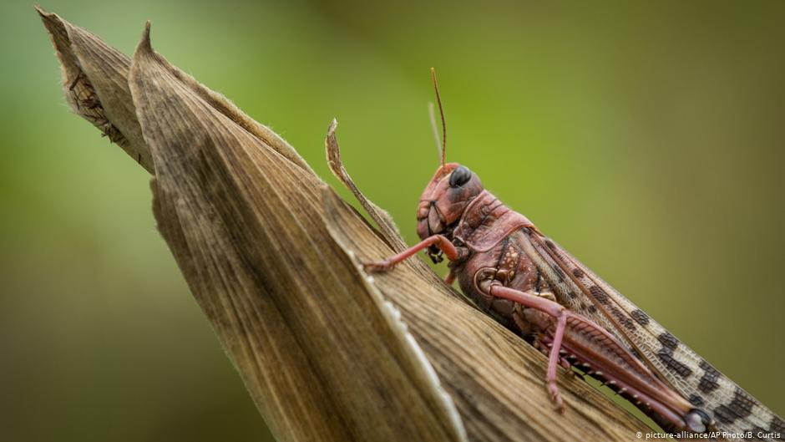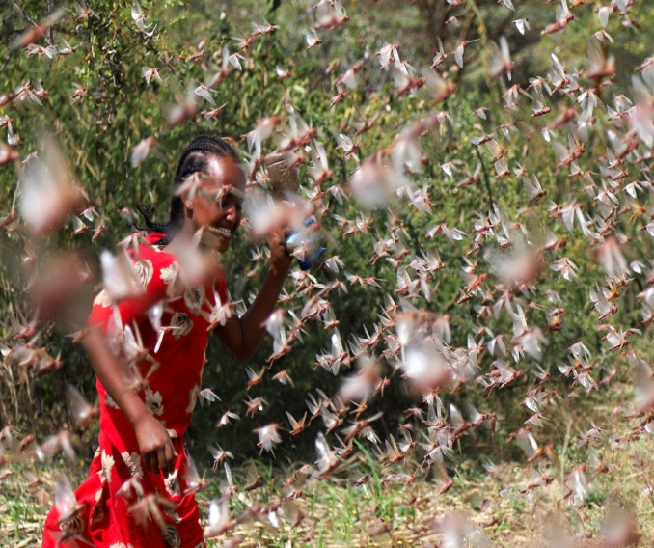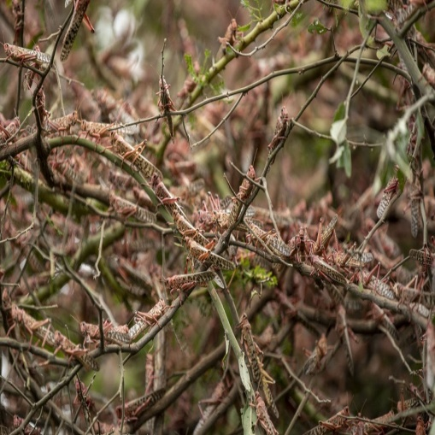
In view of the above statement, explain any two observable features that enable the organism Q above to be such a menace to food security in the country (2mks)
....................................................................................................................................
....................................................................................................................................
- The photograph below shows a longitudinal section through a root
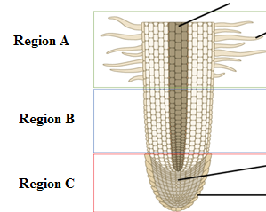
- Identify the regions labelled A and B (2mks)
A ………………………………………………………………………………………………
B ……………………………………………………………………………………………..
(ii) Give two characteristics of cells found in region C (2mks)
…………………………………………………………………………………………………………………………………………………………………………………………………..

