231/3 - BIOLOGY - Paper 3


1 ³/₄ Hours

NAME……………………………………………………..ADM…………….CLASS………
2022 TRIAL 2 JULY INTERNAL EXAMINATION

- Answer ALL the questions

- FOR EXAMINER'S USE ONLY

QUESTION | SCORE | CANDIDATES SCORE
1 | 11
2 | 14
3 | 15
TOTAL | 40

- You are provided with the following materials;
A tablet labelled K
Pestle and mortar
2cm³ Copper sulphate solution
2cm³Sodium hydroxide solution
2cm³ DCPIP solution
3 test tubes
3 droppers
- Using a pestle and mortar, crush the tablet K then add 4cm³ of distilled water to form a solution. Divide into two portions each containing 2cm³. Carry out tests to determine the food substance (s) in K (8mks)
Substance | Food substance being tested for | Procedure | Observations | Conclusion
K | Proteins | Put 2cm³ of solution K into the testtube  Add 2cm³ of Sodium hydroxide solution  Add 2cm³ of Copper sulphate solution | No colour change | Proteins absent
K | Vitamin C/Ascorbic acid | Put 2cm³ of DCPIP solution into the testtube  Add 2cm³ of solution K | Orange /colour of DCPIP disappears | Vitamin C present

- Give one deficiency disease brought by lack of the food substance identified in the table above in the human body (1mk)
Scurvy
- Identify two ways by which the food substance identified in the table above can be destroyed (2mks)
High temperature
Alkaline solution
- Observe the organisms below and answer the questions that follow.
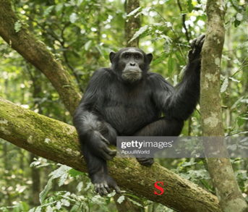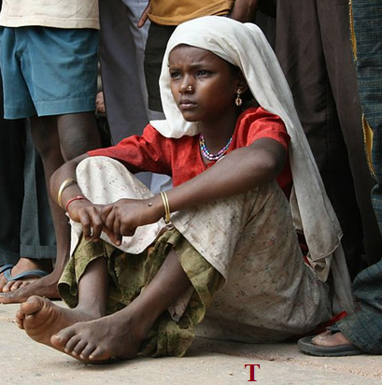
- Give two structural differences between the organisms above (2mks)
S | T
Quadripedal | Bipedal
Presence of opposable toe | Opposable toe absent
Sloping forehead | High forehead
Flattened nose/nasal bridge | Prominent nose

- The photographs below show organisms that are closely related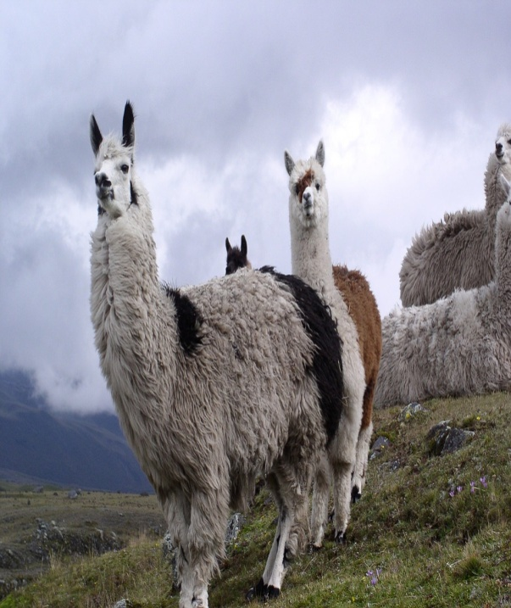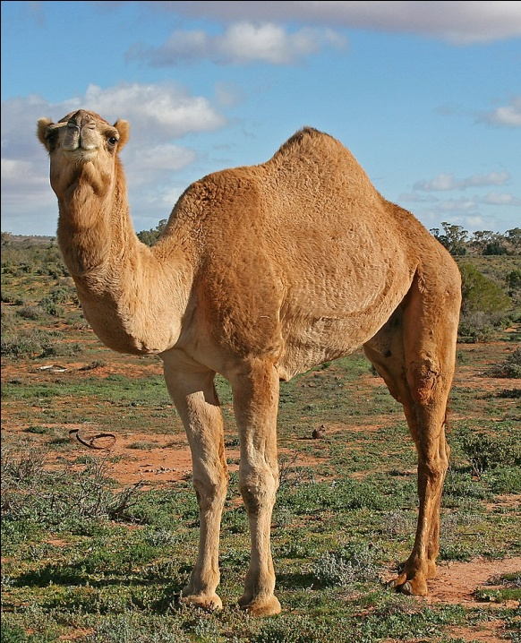
- Identify the evidence for organic evolution exhibited by the two organisms above (1mk)
Geographical distribution
(ii) Give any other two evidence that supports organic evolution (2mks)
Fossil records
Comparative anatomy
Comparative embryology
Serology
Cell biology
- Observe the two organisms interacting in an ecosystem.
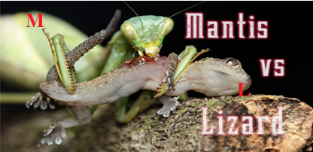

(a)(i) Identify which of the two animals M and L will have the least biomas (1mk)

M
(ii) Give a reason for your answer in (b)(i) above (1mk)

Animal M is at a higher trophic level than L/M feeds on L/M is a tertiary consumer while L is a secondary consumer; biomass reduces upwards in a food chain/energy is lost from a lower trophic level to upper trophic level/energy is lost from the producers to the consumers;
(b) Explain the concept of “ Survival for the fittest” in relation to the organisms illustrated in the photograph. (3mks)
The ecosystem consists of different organisms that compete for resources/struggle to exist;the well adapted ones survive; perpetuating these traits to the next generation; M is more powerful/stronger/well adapted/more endowed attacks/kills and feeds on L;4 max. 3
(c) Explain two visible survival adaptive features for the organisms illustrated in the photograph
-Both animals/M and L camouflage/blend well with environment ; concealing/hiding themselves from their predators/prey ;
- L covered with scales ; to minimize dessication//protect against sharp objects/stones /thorns mechanical injury/damage ;
-Animal M is stronger/more muscular;to attack/ kill/suffocate/strangle the prey ; (4mks)
- The photographs below show various developmental stages of an insect
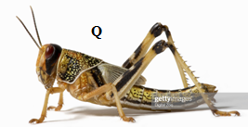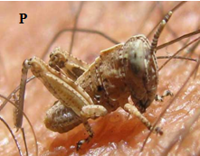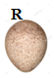
- (i)Identify the stages labelled P, Q and R (3mks)
P Nymph
Q Adult/Imago
R Egg
(ii) Give the differences between stage Q and P (2mks)
Q | P
Presence of wings | Wings absent
Sexually mature | Sexually immature
Large | Small
- Hormones play a major role in insect metamorphosis. Identify two hormones and their roles (4mks)
Hormone | Role
Moulting hormone | Formation of larval cuticle
Juvenile hormone | Moulting in insects

- ‘Hundreds of millions of locusts have swept over several counties in Kenya, devouring tens of thousands of hectares of crops. This massive destruction has threatened food security in Kenya…..’ this is an extract from one of the local dailies dated 2nd February, 2020.
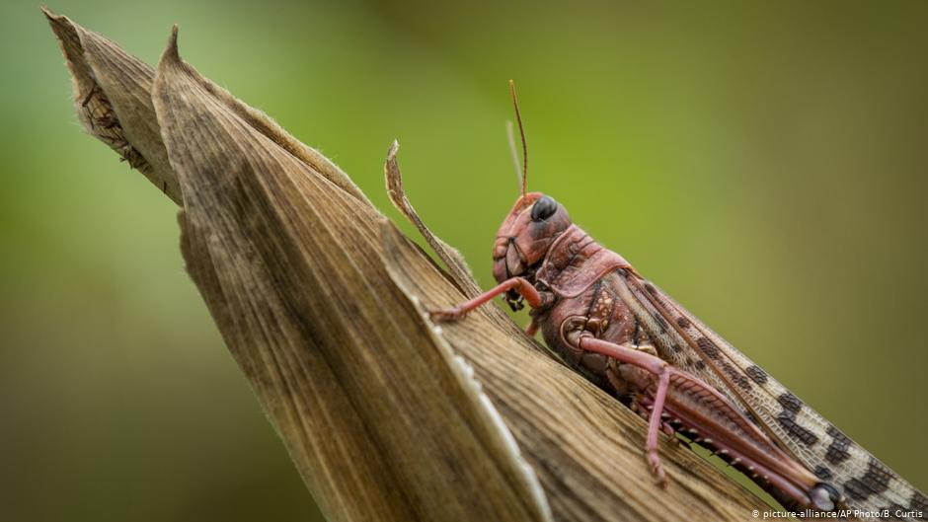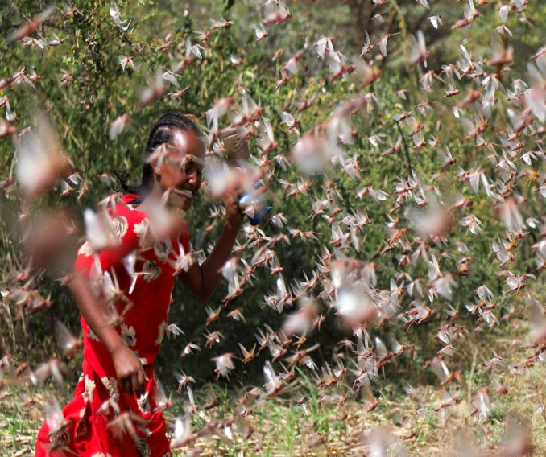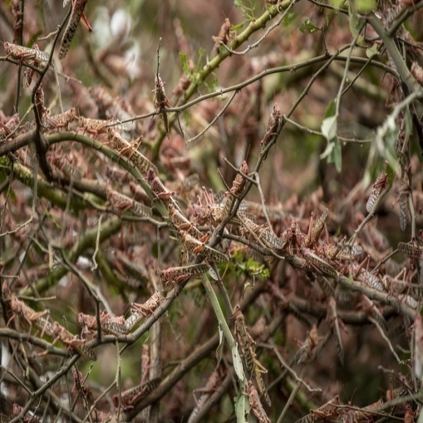
In view of the above statement, explain any two observable features that enable the organism Q above to be such a menace to food security in the country (2mks)
Has wings hence can fly over large distances
Move in swarms hence difficult to control them
Muscular hind limb to hop from plant to plant

- The photograph below shows a longitudinal section through a root
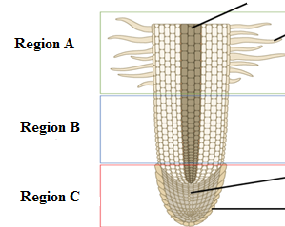
- Identify the regions labelled A and B (2mks)
A cell maturation
B cell elongation
(ii) Give two characteristics of cells found in region C (2mks)
Dense cytoplasm
Thin cells
No vacuoles

