231/3
BIOLOGY
PAPER 3
(PRACTICAL)
1HR 45 MINUTES
NAME…..……………………………………… INDEX NO…………… SIGN………..
INSTRUCTIONS TO CANDIDATES
- Write your name and Index Number and sign in the spaces provided above.
- Answer ALL questions in the spaces provided in the question paper.
- You are NOT allowed to start working with the apparatus for the first 15 minutes of the 1³/₄ hours allowed for this paper. This time is to enable you to read the question paper and make sure you have all the chemicals and apparatus that you may need.
- All workings MUST be clearly shown where necessary.
- Mathematical tables and silent electronic calculators may be used.

For Examiners use only.
Question | Maximum Score | Candidates Score
1 | 14
2 | 13
3 | 13
TOTAL SCORE | 40

- You are provided with olive oil, liquids labeled L1 and L2, and an Irish potato. Label test tubes A and B. Place 2cm³ of water into each test tube. Add 8 drops of olive oil into each test tube. To test tube A, add 8 drops of liquid L1. Shake both test tubes. Allow to stand for 2 minutes.
(a) (i) Record your observations (2 marks)
Test Tube A
…………………………………………………………………………………………………………
…………………………………………………………………………………………………………
Test Tube B
…………………………………………………………………………………………………………
(ii) Name the process that has taken place in test tube A (1 mark)
…………………………………………………………………………………………………………
(iii) State the significance of the process named in (a) above (1 mark)
…………………………………………………………………………………………………………
(v) Name the digestive juice in humans that has the same effect on oil as
liquid L1 (1 mark)
…………………………………………………………………………………………………………
(v) Name the region of the alimentary canal into which the juice is secreted (1 mark)
…………………………………………………………………………………………………………
(b)
(i) Label two test tubes C and D place 2cm3 of liquid L2 into each test tube. Add a drop of iodine solution into each test tube. Record your observations. (1 mark)

…………………………………………………………………………………………………………
…………………………………………………………………………………………………………
(ii) Suggest the identity of L2 (1 mark)

…………………………………………………………………………………………………………
(iii) Cut a cube whose sides are 1cm³ from the Irish potato. Crush the cube to obtain a paste. Place the paste into a test tube labeled C and D. add 2cm³ of amylase solution. Leave the set up for at least 30 minutes.

Record your observations (2 marks)
C
………………………………………………………………………………………………………
D
………………………………………………………………………………………………………
(iv) Account for the result in (b)(iii) above (2 marks)

………………………………………………………………………………………………………
………………………………………………………………………………………………………
(c) Cut another cube whose sides are 1cm from the Irish potato. Crush the cube. Place the crushed paste into a test tube. Carry out food test with reagents provided. Record your procedure and results.

Procedure: (1 mark)
………………………………………………………………………………………………………
………………………………………………………………………………………………………
Results: (1 mark)
………………………………………………………………………………………………………
……………………………………………………………………………………………………….

- Study the photographs A and B that shows part of plants in natural habitat.
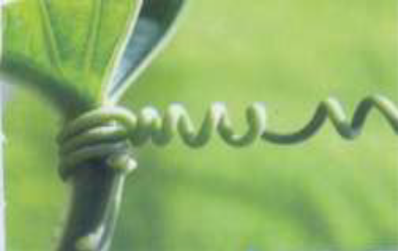
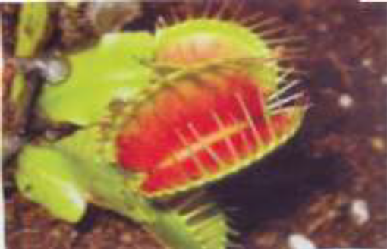
A B

- Name the type of the plant response shown in:

i) A......................................................................................................................... ........(1 mark)

ii) B.................................................................................................................................(1 mark)

b) Explain the mechanisms of the response in
A ……………………………………………………………………………………………………(3 marks)
………………………………………………………………………………………………………………………….
……………………………………………………………………………………………………..........................................................................................................................................................................................................................
B …………………………………………………………………………………………………………..(5 marks)
……………………………………………………………………………………………………………………………………………………………………………………………………………………………………………………………………………………………………………………………………………………………………………………………………………………………………………………………………………………………………………………………………………………………………………………………………………………………………
c) State the biological significance of the response to plants in
A ……………………………………………………………………………………………………………..(1 mark)
…………………………………………………………………………………………………………………………
B ………………………………………………………………………………………………………………(1 mark)
………………………………………………………………………………………………………………………

d) Suggest the nature of the habitat that plants with the type of response A grows. (1 mark)
…………………………………………………………………………………………………………………………………………………………………………………………………………………………………………

- Study photographs shown below then answer the questions.
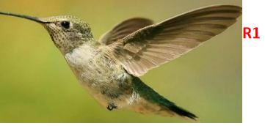
R1

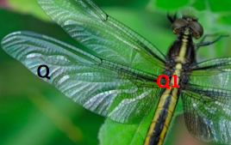

Q1
Q

C
M
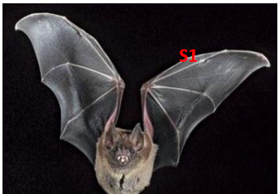
S1
S
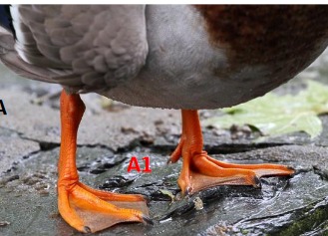
A1
A
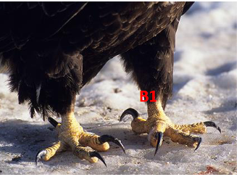
B1
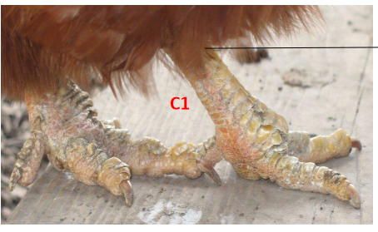
C1
R
B
(a) State the type of evolution represented by structures Q1, R1 and S1. (1mk)
……………………………………………………………………………………………………
b) Explain the type of evolution identified in (a) above. (1mk)
……………………………………………………………………………………………………
(c) Give the evolution term used to describe structures;
(i) Q1, R1 and S1. (1mk)
(ii)A1, B1 and C1. (1mk)
d). what type of evolution is illustrated by the limbs (A1, B1 and C1)? (1mk)
………………………………………………………………………………………………………
e). (i) Name classes for organisms labeled Q, R and S.
Q……………………………………………………………...……………………… (1mk)
R………………………………………………………………………...…………… (1mk)
S…………………………………………………………………………………...… (1mk)
(ii) Give two reasons for placing S in the class above (2mks)
………………………………………………………………………………………………………………………………………………………………………………………………………………………………………………………………………………………………………………………
f) (i) Suggest the diet of animals B and R.
B…………………………………………..………………………………………… (1mk)
R………………………………………………….……………………………….... (1mk)
(ii) How is beak of animal B adapted to its function? (1mk)
………………………………………………………………………………………………………………………………………………………………………………………………………

