Name ……MARKING SCHEME…….……Index No…………..……

School………………..….……………….. Date………………………………

Kenya Certificate of Secondary Education
CHEMISTRY
Paper 2
THEORY
2 hours

Instructions
Write your name, Index number and class in the spaces provided above.
Answer ALL the questions in the spaces provided.
Mathematical tables and silent electronic calculators may be used.
All working MUST be clearly shown where necessary.

For Examiner’s use only
Question | Maximum  Score | Candidate’s  Score
1 | 11
2 | 12
3 | 12
4 | 12
5 | 11
6 | 11
7 | 11
Total | 80

This question paper has 10 printed pages.
Confirm that all the pages are printed as indicated and
No questions are missing.

- a) Consider the following reaction:
A_{2(g)} + B_{2(g)} 2AB_{(g)}, ΔH = +75 kJ
Sketch an energy level diagram showing the relative activation energies for the catalysed and uncatalysed reactions using the axes below. (2mks)
Catalysed
Uncatalysed

Energy (kJ)

Reaction path

            - Given that; ΔH_{f} (Al₂O₃) = – 1590 kJmol⁻¹
ΔH_{f} (Cr₂O₃) = -1134kJmol⁻¹

Calculate the heat of reaction for; 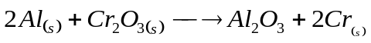(2mks)

            - The following data was obtained during an experiment
Mass of ethanol burnt = 0.2g
Mass of water in the calorimeter = 200g
Specific heat capacity of water = 4.2 jg⁻¹k⁻¹
Initial temperature of water = 23.5 ⁰C
Final temperature of water = 28.0 ⁰C
                - How was the mass of ethanol that burnt determined? (1mk)
By sybtracting the mass of the burner and ethanol before igniting and the mass of the burner and ethanol after the burning
                - How much heat was required to raise the temperature of water from 23.5 ⁰C to 28.0⁰C? (2mks)
Heat produced ∆H = mass of water(m) x specific heat capacity (c)x∆T
=> 200 x 4.2 x 4.5 = 3780 Joules = 3.78 kJ
                - Two assumptions were made in calculating the enthalpy of combustion for ethanol. State them. (1mk)
No heat loss to the environment
The calorimeter did not absorb any heat

                - Determine the molar enthalpy of combustion of ethanol.(C= 12,H=1,
O=16) (2mks)
Moles of ethanol used = 0.2/46
=0.0043 moles 3.78kJ
1 Mole ?
= 3.78x1/0.0043
= -879.069kJ/mol
                - Write a thermochemical equation for the combustion of ethanol given the accurate value for enthalpy of combustion is – 1368 kJmol⁻¹. (1mk)
C₂H₅OH +3O_{2(g)} →2CO_{2(g)}+3H₂0_{(l)} – 1368 kJmol⁻¹.
- Two half cells were connected as shown to form a voltaic cell. The reduction potentials are given.
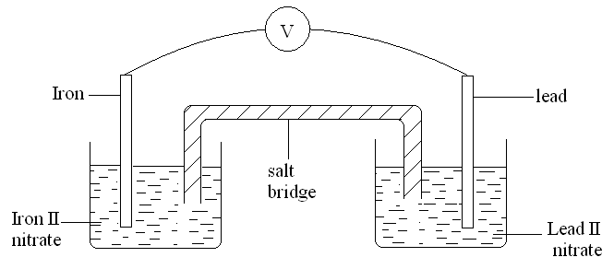
Pb²⁺_{(aq)} +2e Pb_{(s)} E^{Ө} = – 0.13V
Fe²⁺_{(aq)} + 2e Fe_{(s)} E^{Ө} = – 0.44V
  - Calculate the e.m.f of the cell. (1mk)
E_{REDOX}=E_{RED}-E_{OX} = -0.13--0.44
=+0.31V
  - Sodium Chloride is used as the salt bridge.State the two functions of the salt bridge. (2mks)
complete the circuit
maintain balance of charges /ions on both half cells.
  - Show the direction of the electron flow in the external circuit. (1mk)
  - The e.m.f of the cell will reduce with time. Give a reason for this. (1mk)
…………………………………………………………………………………….…….
…………………………………………………………………………………….…….
  - During electrolysis of water acidified with Sulphuric acid, two gases were produced at the electrodes:
      - State which ions are preferentially discharged at the electrodes. Explain with aid of half ionic equations.
Anode. (2mks)
OH⁻_{(aq)} from water (H₂O)
4OH⁻_{(aq)} 2H₂O_{(l)}+O_{2(g)}+4e
OH⁻ ions selectively discharged instead of SO₄²⁻ ions at the anode
Cathode. (2mks)
H⁺_{(aq)} from either sulphuric(VI) acid (H₂ SO₄) or water (H₂O)
H⁺_{(aq)}+4e 2H_{2(g)}
      - Calculate the volume of the gases at s.t.p produced when a current of 0.025A is passed for 4 hours. (1 Faraday=96500C) (3mks)
Quantity of electricity (in Coulombs) =Current(I)xtime(t)
Substituting /converting time to second = 0.025x (4x60x 60)
= 360 C
ANODE; 4 moles of electrons = 4 Faradays = 96500x4 C 22400cm³
360C -> 360x 22400
96500x4
=20.89cm³
CATHODE; ratio 1;2
20.89x2=41.78cm³
- a) The fermentation of glucose is catalysed by enzymes from yeast. Yeast is added to aqueous glucose, the solution starts to bubble and becomes cloudy as more yeast cells are formed.
C₆H₁₂O_{6(aq)} 2C₂H₅OH_{(aq)}+2CO_{2(g)}
The reaction is exothermic. Eventually the fermentation stops when the concentration of ethanol is about 12%.
- On a large scale, the reaction mixture is cooled. Suggest a reason why this is necessary. (1mk)
-kil yeast or denature enzymes (due to increase in temperature)
(ii) Why does the fermentation stop? Suggest one reasons. (1mk)
-All glucose used up
-yeast killed or denatured or damaged by ethanol/alcohol
(iii) What technique is used to concentrate the aqueous ethanol? (1mk)
Fractional distillation
b) A compound X contains carbon, hydrogen and oxygen only. X contains 54.54% of carbon by mass, 9.09% of hydrogen by mass and 36.37% of oxygen by mass. (C=12, O=16, H=1)

- Determine the empirical formula of compound X. (2mks)

Element | C | H | O
Mass | 54.54 | 9.09 | 36.37
R.A.M | 12 | 1 | 16
Moles | 54.54/12  = 4.545 | 9.09/1  = 9.09 | 36.37/16  = 2.273
Mole ratio | 4.545/2.273  2 | 9.09/2.273  3.999>>4 | 2.273/2.273  1
 | C₂H₄O
- Compound X has a relative molecular mass of 88. Draw the structural formula of compound X. (2mks)
(C₂H₄O)_{n}=88 H H H H
(12x2+1x4+16)n=88 H C C C C O H
44n=88 H H H
N=2
(C₂H₄O)₂= C₄H₈O₂
c) The table below gives formulae of three organic compounds A, B and CH
Compound | Formulae
A | C₂H₄O₂
B | C₂H₆O
C | C₂H₆
Giving a reason in each case, select the letter(s) which represent a compound that
- Decolourises acidified potassium manganate (VII). (1mk)
B Its an alkanol hence oxidized to alkanoic acid
- .Gives effervescence with sodium hydrogen carbonate. (1mk)
A Reacts to produce CO₂
- Undergoes substitution reaction with chlorine gas. (1mk)
C its saturated
d) The following is a small reaction of polystyrene polymer. Study it and answer the questions that follow.
H H H H

C C C C

H C₆H₅ H C₆H₅
(i) Draw the structure of the monomer unit of polystyrene. (1mk)
H H

C C

H C₆H₅
(ii) Calculate the number of monomers used to form the polystyrene of relative molecular mass of 18096. ( H = 1, C = 12 ) (1mk)
18096/104
= 174 monomers
- An experiment was carried out using magnesium ribbon and dilute hydrochloric acid of different concentrations. The time needed to produce 50cm³ of the gas for every experiment was recorded in a table.
Concentration of HCl (moles per litre) | 2.0 | 1.75 | 1.50 | 1.25 | 1.00 | 0.75 | 0.50 | 0.25
Time (seconds) | 8.8 | 10.0 | 11.7 | 14.0 | 17.5 | 18.7 | 35.0 | 70.0
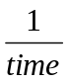( Sec⁻¹) | 0.1140 | 0.1000 | 0.0854 | 0.0714 | 0.0571 | 0.0534 | 0.0286 | 0.0143
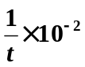 | 11.4 | 10.0 | 8.54 | 7.14 | 5.71 | 5.34 | 2.86 | 1.43

  - Complete the table above for ¹/_{time}. (4mks)
  - Plot a graph of rate i.e ¹/_{time} against concentration. (3mks)
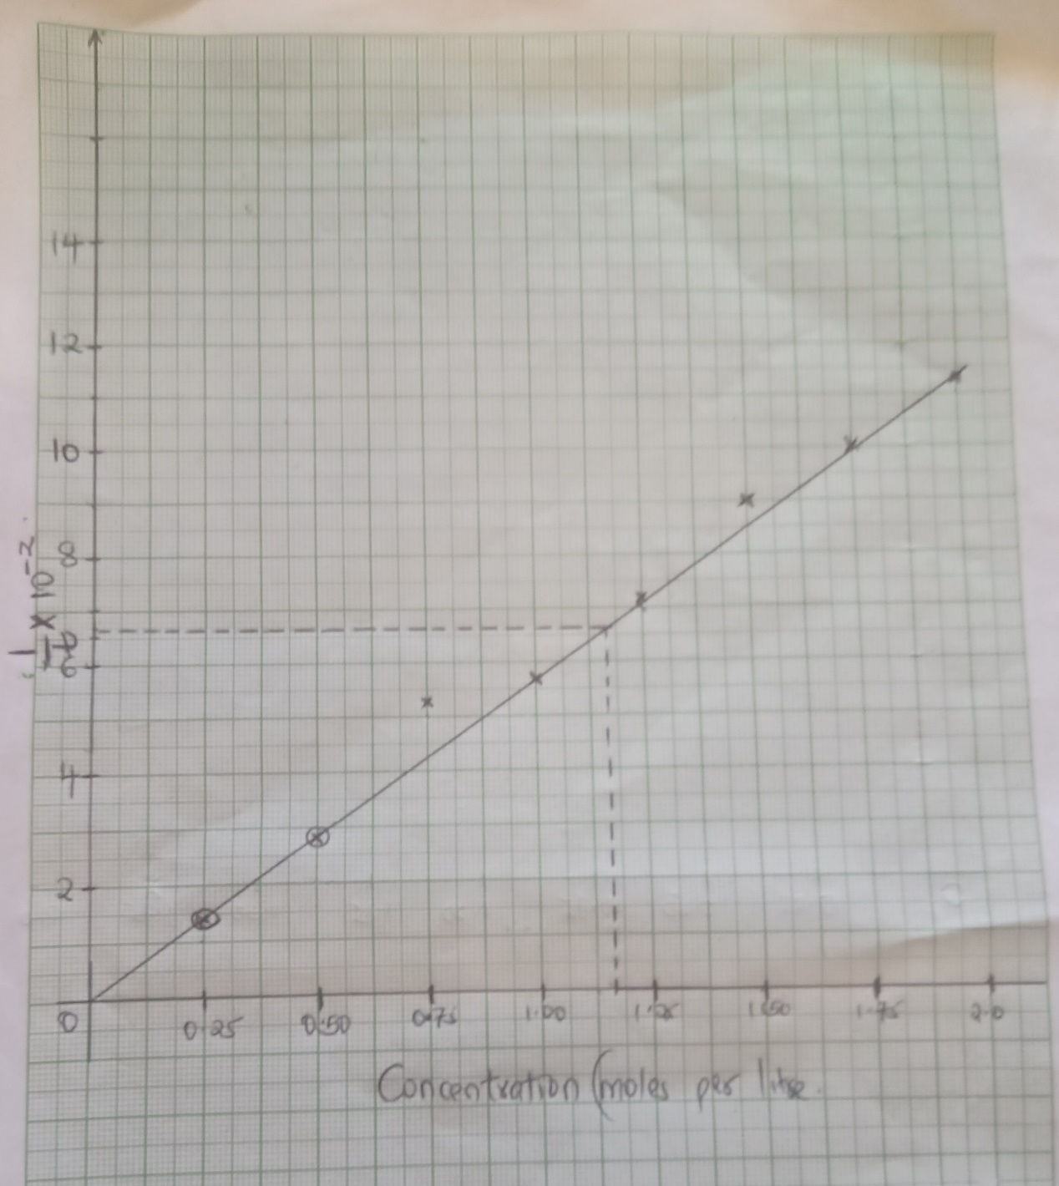

  - From your graph determine the concentration needed to produce 50cm³ of hydrogen gas when time is 15.0 seconds (1mks)
T=15
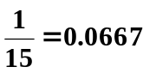
= 1.1625
  - From your graph state the relationship between the rate of reaction and concentration. Give a reason. (1mks)
Rate of reaction increases with increase in concentration
  - A state of equilibrium between dichromate (vi) and chromate ions is established as shown below
Cr₂O₇²⁻_{(aq)} + 2OH⁻_{(aq)} 2CrO₄²⁻_{(aq)} + H₂O_{(l)}
Orange (Yellow)
- What is meant by dynamic equilibrium? (1 mk)
a reaction in which the rate of forward reaction is equal to the rate of backward reaction
balance of the rate of formation of products and reactants.
State and explain observation made, when a few pellets of Hydrochloric acid are added to equilibrium mixture (2 mks)
solution mixture makes it to be more Orange in colour.
Hydrochloric acid/ H+ (aq) is added to the equilibrium mixture a stress is created on the reactant side on the OH⁻ (aq). H+ ions react with OH⁻ (aq) to form water.
The equilibrium shift backward to the left to add/replace the 2OH- (aq) that have reacted with the H+ (aq) ions .More Cr₂O₇ (aq)ions formed in the
- I) The table below shows properties of some elements represented by symbols W,X,Y and Z. Study the information in the table and answer the questions that follows
Element | No. Of protons | Atomic radius(nm) | Boiling point ⁰C
W | 2 | 0.93 | -269
X | 10 | 1.31 | -246
Y | 18 | 1.54 | -186
Z | 36 | 1.89 | -152

- Write down the electron arrangement for elements W and X (1mk)
W 2
X 2:8
- In which group of the periodic table are the elements in the table above?Give the name of the group (2 mk)
Group VII
Halogens
- Explain why the atomic radius of W is smaller than that of X (1mks)
X has more/2 energy levels than W (1 energy levels).

- state one use of element X (1mk)
Use in making neon advertising coloured signs
Used to make high voltage indicators
Neon and helium are used in making gas lasers
Liquid helium is an economical refrigerant
II. The section below represents part of the periodic table. Study it and answer the questions that follow. The letters are not the actual symbol of the elements.
 |  |  |  |  |  | Q
X |  |  |  |  | B | H |  | M | T
Y |  | A |  |  |  |  |  |  | V
Z |  |  |  |  |  |  |  |  | S

  - Select the most reactive non-metal. (1mk)
M
  - Which of the elements has the greatest tendency of forming covalent compounds in nature? Explain your choice. (1mk)
Q or H,group IV ,have a valency of 4 hence can share its 4 pairs of electrons
  - Explain why the atomic radius of T is smaller than that of M. (2mks)
T has more protons(18) hence higher nuclear charge than M (17 protons) attracting outermost electrons closer to the nucleaus reducing the atomic radius
  - Compare the electrical conductivity of element X and B. (2mks)
B has higher conductivity,it has 3 delocalised electrons X has 1 delocalised electrons

- Extraction of iron involves two main processes, smelting and refining. Below is the blast furnace which is used to smelt iron from its ore.
CO₂, CO
as waste

300⁰C

500⁰C

600⁰C

800⁰C

1600⁰C

C
Carbon (IV) oxide recycled

B

A
Fire brick lining
Hot air blast from stove

Slag tap
Slag
Iron
Molten iron from tap

(a) (i) The chief ore is Haematite. Name one other ore used in extraction of iron (1 mark)
Magnetite / Siderite
(ii) Name the reducing agent in the process. (1 mk)
Carbon(II)oxide
- What is the role of the hot air blast in the process?(2 mks)
Reacts with coke/charcoal/carbon to form carbon(IV)oxide gas
raises the temperature at the bottom of the furnace to about 2000K(1650ºC).
(b) Write equations for the reactions that take place at the region marked A, B and C. (3 mks)
A C_{(s)}+O_{2(g)} → CO_{2(g)}
B Fe₂O_{3(s)}+3CO_{(g)} →2Fe_{(s)}+CO_{2(g)}
Fe₃O_{4(s)}+4CO_{(g)} →3Fe_{(s)}+4CO_{2(g)}
C CaCO_{3(s)} →CaO_{(s)} + CO2_{(g)}
(c) What is the purpose of limestone in the extraction process? (1 mk)
decomposes to quicklime /calcium oxide which reacts to remove impurities and produce more carbon(IV)oxide gas.
(d) Write equations to show how impurities are removed from the ore.(2 mks)
CaO_{(s)} + SiO_{2(s)}→ CaSiO_{3(l)}
CaO_{(s)} + Al₂O_{3(s)}→CaAl₂O_{4(l)}
(e) State one environmental effect of the process. (1mk)
- Carbon(IV)oxide(CO2) gas is a green house gas that causes/increases global warming if allowed to escape/leak from the furnace.
- Carbon(II)oxide(CO)gas is a highly poisonous/toxic odourless gas that can kill on leakage. It is preferentially absorbed by the haemoglobin in mammals instead of Oxygen to form a stable compound that reduce free hemoglobin in the blood.
- Haematite (Fe2O3), Magnetite(Fe3O4) and Siderite (FeCO3) are extracted through quarrying /open cast mining that cause soil / environmental degradation .
- a) Read the following passage and answer the questions.
A salt K was heated with slaked lime (calcium hydroxide). A colourless gas L with a characteristic smell and turns red litmus paper blue was evolved. A large quantity of this gas was passed through an inverted filter funnel into Copper(II)sulphate solution, and a deep blue solution M was obtained.
- Identify gas L (1 mk)
Ammonia
- What is K most likely to be? (1 mk)
Ammonium chloride
- Write an equation for the reaction between K and slaked lime (1 mk)
Ca(OH)2(s)+NH4Cl(s)→CaCl2(aq)+H2O(l)+2NH3(g)

- Write an ionic equation for the reaction with copper(II)sulphate forming the deep blue solution (1 mks)
Cu(OH)2_{(s)} + 4NH3_{(aq)} → [Cu(NH3)4]²⁺_{(aq)}+2OH–_{(aq)}

b) Study the flow chart below and answer questions that follow:

H_{2(g)}
Step I
Catalyst gas B

Burn in CuO Products Z
Gas Q+water
Ammonia gas
Oxygen Step II

Oxygen + catalyst
Step III Water

Compound P
Potassium Nitrate solution
Nitric(v)acid
Step V Step IV
NH₃

- State one source of gas B (1 mk)
Fractional distillation of liquid air
- Name the catalysts used in; (1 mk)
- Step I
Finely divided Iron
- Step III
Platinum or platinum rhodium
- Write chemical equations for reactions in; (3 mks)
- Step I
Fe
N_{2(g)}+3H_{2(g)}→ 2NH_{3(g)}
- Step II
2NH_{3(g)}+3CuO_{(s)}→N_{2(g)}+3H₂O_{(l)}+3Cu_{(s)}
- Step V
NH_{3(aq)} + HNO_{3(aq)}→NH₄NO_{3(aq)}
- Identify any other gas that can be used instead of Ammonia in step II (1 mk)
Hydrogen/Carbon(II)oxide
- State one use of gas Q (1mk)
- Used in the Haber process in the manufacture of ammonia.
- Due to its inert nature, it is mixed with argon to fill electric bulbs (to avoid soot formation).
- In liquid state it is used as an inert refrigerant e.g. storage of semen for artificial insemination.
- Due to its inert nature, it is used in food preservation particularly for canned products i.e. it prevents combination of oxygen and oil which tends to enhance rusting.
- It is used in oil field operation called enhanced oil recovery where it helps to force oil from subterranean deposits.

