SET 2
CHEMISTRY EXAMINATIONS

CHEMISTRY PAPER 2
233/2

Question number |  | Maximum marks
1 |  | 11
2 |  | 9
3 |  | 12
4 |  | 12
5 |  | 12
6 |  | 12
7 |  | 12
TOTAL |  | 80

Note: Throughout paper all equations 1 mark, ½ mark if missing/wrong state symbols (except in organic chemistry). Penalize fully if equation is not balanced

Q1. a) T (1 mark) b) Halogens (1 mark)

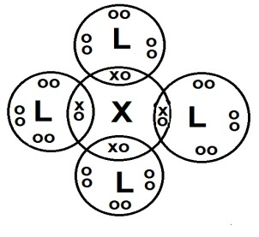
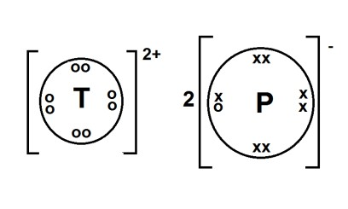
c) (i) WQ3 (1 mark) (Penalize fully for Q3W) (ii) RQ2 (1 mark) (Penalize fully for Q2R) d (i) (1 mark) (ii)

(1 mark)Penalize fully if square brackets and or charge absent

Allow if inner shells drawn, also allow if no circles drawn.

- X has a bigger atomic radius than Y (1 mark). Atomic radius decreases across a period (1/2 marks) because the nuclear charge/proton attraction increases. (1/2 marks)

- It has a filled electronic configuration (w.t.t.e.)

- pH >7(1/2 marks). G is a metal and so would form a basic oxide (1/2 marks)

Q2. a) Nitrogen (1/2 mark) hydrogen (1/2 mark)

- 4NH3(g) + 5O2(g) Pt 4NO(g) + 6H2O(l) (1 mark)
(Award full mark even if Pt not shown)

- Neutralisation (1 mark)
- Nitric acid oxidises sulphur (1 mark) to sulphur (V) oxide / sulphuric acid (Allow even if products of oxidation not given)
Nitric acid is reduced (1/2 marks) to nitrogen (IV) oxide (1/2 mark)

- (i) Hydrogen/ammonia/carbon(II) oxide(1/2 mark)
(ii) Zinc/iron/aluminium/magnesium/. (1/2 mark) (Allow any moderately reactive metal
above lead in the reactivity series excluding K, Na and Ca).

- (i) NH4NO3 (1 mark) (Penalize fully if name given)

- RFM NH4NO3 = 80 (1/2 mark) 28g are contained in 80g (1/2 mark) 140kg are
contained in (1/2 mark) = 400kg (1/2 marks) (Give full marks if worked out in

terms of moles)

Q3. a) A positively charged electrode/terminal in an electrical circuit (1mark)

b) (i) A shiny grey coating forms (1mark) (Allow silvery coating/ silver coloured deposit)

  - 4OH-(aq) 2H2O(l) + O2(g) + 4e

  - OH-/hydroxide ions are removed (1 mark), leaving an excess of H+/hydrogen ions (1 mark) making the solution acidic.

c) (i) Q=It = 8X5X60(1/2 mark) =2400C (1/2 mark)
(ii) 1F = 96500C forms 108g of Ag (1/2 mark) 2400C forms (1/2 mark) = 2.686g

(1/2 mark)

d) (i) Fe(s) + 2Fe+2(aq) 3Fe+3(aq) (1mark)

(ii) Oxidation of Fe + reduction of Fe3+ = 0.33v (1/2 mark)

0.44 + reduction of Fe3+ = 0.33v (1/2 mark)
Reduction of Fe3+ = 0.33v-0.44 (1/2 mark) = -0.11v (1/2 mark)

Q4. a). (i) propanoic acid (1 mark) (ii) pent-1ene (1 mark) (iii) but-2-yne (1 mark)

- (i) Ethane (1 mark) (ii) 1,2 dichloro propane (1 mark) (penalize fully if positions not given)
(iii) 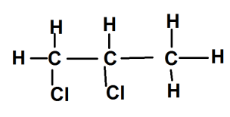(1 mark) Allow CH2ClCHClCH3

- Give the reagent that can be used in:

Step I Concentrated sulphuric acid (1 mark)

Step II Acidified K2Cr2O7/KMnO4 (any acceptable oxidising agent). (1 mark)

- CH3CH2CH2OH + Na CH3CH2CH2ONa + ½ H2 (1 mark)

- The molecule has a ‘head’ which is polar and water soluble/hydrophilic (1/2 mark) and a hydrocarbon ‘tail’ which is non-polar and grease soluble/hydrophobic (1/2 mark). The hydrocarbon tails dissolve in the grease while the polar heads remain in the water. When agitated, the grease is gathered up into a small globules/clusters/micelles (1/2 mark) which are then washed away by the water (1/2 mark)

Q5. a) (i) Fractional distillation (1 mark)

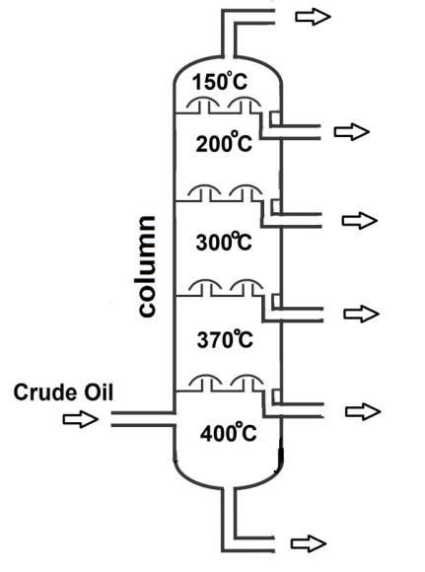
- On diagram

  - Bitumen (1 mark)

  - Asphalt/all weather roads/ water proofing roofs (1 mark)

  - The column is divided into several compartments, the crude oil vapour rises up the column with the different fractions condensing (1/2 mark) in different compartments according to their boiling point/volatility (1/2 mark)

  - Changamwe / Mombasa (1 mark)

- (i) To allow enough time for contact between copper and air/ to ensure all the oxygen was used up. (1 mark)

- Copper metal turned black / volume of air reduced (1 mark)

- No. (1/2 marks) Reaction would be violent/explosive potassium would also react with nitrogen (1/2 mark)
- (i) Hydrated iron (III) oxide/ brown coating that forms on iron/steel /objects made from iron
- Fe2O3.nH2O (n/1/2/3). (1 mark)

- Coating iron sheets with zinc (1 mark)

Q6. a) (i) Heat/enthalpy of combustion of carbon/enthalpy of formation of carbon
(IV) oxide (1mark)

(ii) Heat/enthalpy of formation of methane (1 mark)

c) By Hess’s Law: ΔH4 = ΔH1 + ΔH2 - ΔH3 (1/2 mark) = -393-582-(-750) = -225kJ (1/2 mark)

e) (i) Breaking H-H, Cl-Cl forming 2H-Cl (1 mark)
ΔH= 435+243-2(431) (1/2 mark) = -184kJ (1/2 mark)

(ii) Breaking C-H, Cl-Cl forming C-Cl, H-Cl(1 mark)
ΔH= 415+243-339-431 (1/2 mark) = -112kJ (1/2 mark)

f) (i) C4H10(g) + 61/2O2(g) 4CO2(g) + 5H2O(l) = ΔHc (1/2 mark)

By Hess’s Law: ΔHc =- ΔHf(C4H10) + 4ΔHf(CO2) + 5ΔHf(H2O) (1/2 mark)

= - (-275) = 4(-393) + 5(-286) (1/2 mark) = -2727kJ (1/2 mark)

(ii) ΔH =mcθ = 5 X 4.2 x (100-18) (1/2 mark) = 1722 kJ (1/2 mark)
I mole butane weighs 58g and produces 2727 kJ (1/2 mark)
1722 kJ would be produced by (1/2 mark) = 36.6 g (1/2 mark)

Mass of burner = 798 – 36.6 (1/2 mark) = 761.4g (1/2 mark)

Q7. a) (i) Sulphur (IV) oxide (1 mark) (Penalty sulphur dioxide1/2 mark)

- 2CuFeS2(s) + 4O2(g) 2Cu2S(s) + 3SO2(g) + 2FeO(s) (1 mark)

- Fe2+ (1 mark)

- Carbon (IV) oxide (1 mark) (Penalize carbon dioxide fully)

- Redox/Reduction (1 mark) the copper (II) oxide is reduced to copper metal by the coke (1 mark)

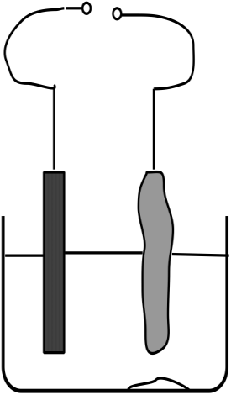



Cell /potential difference (1/2 mark)
b)

Cathode (1/2 mark) Pure copper (1/2 mark)
Anode (1/2 mark)

Impure copper (1/2 mark)

Copper (II) sulphate solution (1/2 mark)

c) (1/2 mark) =1.5 % (1/2 mark)

d) -Sulphur (IV) oxide causes acid rain
-Carbon (IV) oxide responsible for the greenhouse effect
-Land dereliction / makes the land uninhabitable
-Dust pollution.
-Sound pollution because of explosives used in mining (any two) (2 marks)

