CHEMESTRY PAPER 2 SET 4
MARKING SCHEMES

- The grid below shows part of the periodic table. Use it to answer the questions that follow. The letters do not represent actual symbols. (10 marks)

 |  |  |  |  |  | S | U | V
P | R |  |  |  |  | T | X | W
Q

- Which of the elements has the highest atomic radius? Explain. (2 marks)
Q- This is because it has the highest number of energy levels.
- Identify the most reactive non-metal. Explain. (2 marks)

U – This is because U has the highest nuclear change due to its small atomic radius among the hon metals.
- Compare the atomic radius of P and R. (1 mark)

P has bigger atomic radius than R. this is because P has higher nuclear charge than R.
- Give the formula of one stable ion with an electron arrangement of 2.8 which is:
- Negativity charged divalent ion. (2mks)
S²⁻
- Positively charged monovalent.
R²⁺
- Given that the mass number of W is 40. Write down the composition of its nucleus. (1 mark)
P = 18 N = 40 – 18 = 28
P = 18
N = 22
- Write the formula of the compounds formed between.
- Element R and X. (1 mark)
= RX₂
- Give one property of the structure formed when R and X bond. (1 mark)

- Compounds with the above structures are soluble in water but insoluble in organic conduct.
- Compounds with the above structure conduct electricity in molten and aqueous state but they are non conductors in solid state.
- Compounds with the above structure exist in crystalline form
- Compounds with the above structure have very high melting and boiling point.
Any 1
- The flow chart below shows how a fertilizer can be manufactured. Use it to answer the questions that follow.

H₂ N₂ Air SO₂

Catalyst D: 500⁰C
Catalyst C; 5600⁰C, high pressure

98% concentrated
R
P
Sulphuric (VI)
acid

S
Reaction vessel Q
Enough water

- (a) Name catalyst C and catalyst D. (1 mark)
C – Finely divided iron D – vanadium (v) oxide
(b) Give the identifies of substance: (1 ½ marks)

P: Ammonia
Q: Ammonium sulphate
R: Sulphur (VI) oxide
(c) Give the identity of the fertilizer formed. ( ½ mark)

Ammonium sulphate fertilizer
(d) Write an equation for the reaction at vessel Q. (1 mark)

2NH_{3(g)} + H₂SO_{4(l)} (NH₄)₂ SO_{4 (aq)}
(e) Explain why substance R is absorbed in 98% sulphuric (VI) acid first betone
adding water. (1 mark)

Sulphuric (IV) acid is not absorbed directly into water because the reaction is highly exothermic causing the acid to boil and form mist of tiny droplets of the acid
(f) Name the methods by which pollution is controlled in contact process
(1 mark)
Scrubbing process
- Which industry can be set next to the plant (1mark)

- (a) When hydrogen sulphide gas was bubbled into an aqueous solution of Iron
(III) chloride, a yellow precipitate was deposited.
- State another observation that was made. (1 mark)

The solution turned from brown to green solution.
- Write an equation for the reaction that took place. (1 mark)

FeCl_{3(aq)} + H₂S_{(g)} 2 FeCl_{2(aq)} + 2HCl_{(aq)} + S _{(s)}
- (a) Explain why old newspapers slowly turn brown when exposed to air and
sunlight. (1 mark)

This is because of the restoration of oxygen which was lost during bleaching.
(b) Describe a chemical test that can be used to distinguish sodium sulphate and
sodium sulphite. (2 marks)

Sodium sulphate form a white precipitate with acidified Barium chloride but sodium sulphite doesn’t form a precipitate.
- (a) What is solubility as used in chemistry? (1 mark)
This is the maximum mass of a solute required to saturate 100g of the solvent at a particular temperature.
(b) By using the same axes, plot graphs of solubility of substances X and Y against
temperature from the data below. (5 marks)

Temp (⁰c) | 15 | 25 | 35 | 45 | 55 | 65 | 75
Sol. of X  (g/100 gH₂O) | 26 | 38 | 53 | 72 | 98 | 124 | 155
Sol of Y  (g/100 gH₂O) | 35.8 | 36.2 | 36.6 | 37 | 37.4 | 38 | 38

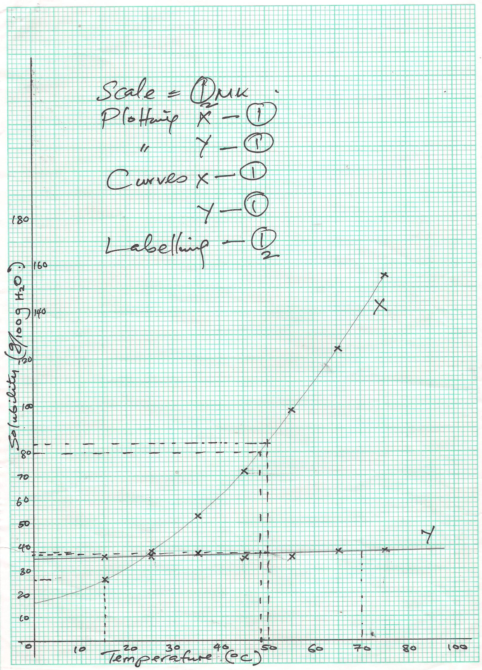

(c) From the graph, answer the following question:
(i) At what temperature are the solubilities of X and Y the same? (1 mark)

24⁰c
(ii) By how many grams of solute does solubility of substance Y exceed that of substance Y at 50⁰C? (1 mark)

X – 84 g/100 g H₂O
Y – 37 g/100 g H₂O
84 – 37 = 47 g + 1g (46g – 48g)
(d) Given a mixture of equal masses, 80g each, of X and Y, how would you obtain some
pure substance Y and how much? (2 marks)

80g
At 48.5⁰ c + 0.5 (48 – 49⁰c)
Solubility of X = 80 g/100 g H₂O
Solubility of Y = 37 g/100g H₂O
Put the salts in 100g of H₂O warm to 48.5⁰C, All x salt dissolves, 80 – 37 = 43g of salt Y crystallizes out.
(e) 40g of X solution saturated at 60⁰C are cooled to 15⁰C. What mass of solid will
separate out? (1 mark)

At 15⁰C, solubility of X = 26 g/100g H₂O 40 – 26 = 14g salt
- Excess marble chips (CaCO₃) was put in a beaker containing 100cm³ of dil. Hcl. The beaker was then placed on a balance and the total loss in mass recorded after every 2 minutes as shown in the table below.

Time (min) | 0 | 2 | 4 | 6 | 8 | 10
Total loss is mass (g) | 0 | 1.8 | 2.45 | 2.95 | 3.2 | 3.3

- Why was there loss in mass? (1 mark)

Due to production of CO₂ which escapes.
- Calculate the average rate of loss in mass between: (2mks)
- 0 and 2 minutes.

$\frac{1.8-0}{2-0}= \frac{1.8}{2}$ = 0.9 g/min
- 6 and 8 minutes.

$\frac{3.2-2.95}{8-6}= \frac{0.25}{2}$ = 0.125 g/min

- Explain the difference in the average rates of reaction in (i) and (ii) above.
(1 mark)
In (i) the concentration of acid and quality of CaCO₃ is high but has greatly reduced in (ii).
- Write the equation for the reaction that takes place in the beaker. (1 mark)

CaCO_{3 (s)} + 2HCl_{(aq)} CaCl_{2(aq)} + H₂O_{(l)} + CO_{2 (g)}
- State two ways in which the rate of the reaction above could be increased.(2 marks)

- Increase conc. of Hcl
- Increase temperature.
- The solution in the beaker was evaporated to dryness. Explain what would happen if the open beaker and its contents were left in the laboratory overnight. (2 marks)

Will form a colourelss solution, CaCl₂ is deliquescent hence absorbs water and dissolves.

- Finally some water was added to the content of the beaker. When aqueous sodium sulphate was added to the content of the beaker, a white ppt was found.
- Identify the white ppt. (1 mark)

CaSO_{4 (s)} / Calcium sulphate
- State one use of the substance identities in f (i) above. (1 mark)

Manufacture of plaster of paris
- Use the flow chart below to answer the questions that follow.

L

HBr
J
CH₃CHCH₂
Polymer K
Step I High temperature
Ni/H₂ High pressure

Conc H₂SO₄
Gas P
Substance M
Na_{(s)}

H⁺/KMnO₄

Gas S
Substance N
Na₂CO_{3(s)}

Step II NaOH
R

Sodalime + Heat
CH₃CH₂Cl
Q
Step III

- Name the following: (1 ½ marks)
- Gas S Carbon (IV) oxide
- Gas P hydrogen
- Gas J propane

- Name the process involved in the following step. (1 ½ marks)

- Step I Hydrogenation / Addition
- Step II Neutralisation
- Step III substitution

- Draw two possible structure of compound L. (2 marks)

H H Br H Br H
| | | | | |
H — C — C — C — H or H — C — C — C — H
| | | | | |
H H H H H H

- Write equation for;
- The complete combustion of substance M (1 mark)
C₃H₇ OH_{(l)} + 5O_{2 (g)} 3CO_{2 (g)} + 4H₂O_{(l)}
- Formation of substance R. (1 mark)
C₃H₅ CooH_{(aq)} + NaoH C₂H₅CooNa_{(aq)} + H₂O

- Name the condition and reagent in step III. (2 marks)

Reagent: Chlorine
Condition: UV light
- Draw the structure formula of compound N. (1 mark)

H H O
| | ||
H — C — C — C — OH
| |
H H

- Chlorine is used to prepare vinylchloride (chloroethene), (CH₂ = CHCl).
- State why chloroethene, undergoes addition polymization. (1 mark)

Has a double band which allows addition reaction
- Name the polymer formed (1 mark)

Polyvinylchloride / polychloroethene

- Complete the following equation to show the two monomers combined during the polymerization. (1mark)

CH₂ = CHCl + CH₂ =CHCl ${\left[{CH}_{2}CHCl{CH}_{2}CHCl\right]}_{n}$

- The diagram below shows the set up of the apparatus by a student to determine the enthalpy change of combustion of ethanol. The heat produced by burning fuel warms known mass of water.
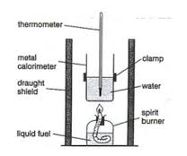
Ethanol

Results
Volume of water in the beaker = 500 cm³
Initial temperature of water = 12⁰C
Final temperature of water = 31.5⁰C
Mass of ethanol burnt = 1.50g
Density of water = 1 g/cm³
Specific heat capacity = 4.2 jg⁻¹K⁻¹

- Define standard heat of combustion. (1 mark)

It is the enthalpy change when 1 mole of a substance. Completely burns in oxygen under standard conditions of temperature and pressure
- Calculate the heat required to raise the temperature of the water from 12⁰C to 31.5⁰C. (2 marks)

ΔH = MCΔT
500 x 4.2 x 19.5 = -40.95 kJ
- Find the molar enthalpy of combustion of ethanol. (2 marks)

R.F.M. = 46 $\frac{46 x 40.9}{1.5}$
1.5G $→$40.9 KJ
466G -1254.27 kJ/mol
- An accurate value for ΔHC of ethanol is -1368 kJmol⁻¹. State two sources of errors for the low figure obtained. (2 marks)

- Some heat is lost to the surrounding
- Some heat is absorbed by the apparatus
- Inaccurate readings
- Draw an energy level diagram for the combustion of ethanol. (2 marks)

E_{a}

Energy kJ C₂H₅OH_{(l)} +3 O_{2(g)}

H = -1254.27 kJ/mol

2 CO_{2(g)} + 3 H₂O_{(l)}

Reaction path

- Calculate the heating value of ethanol. (C = 12, H = 1, O = 16 (2 marks)

$$\frac{1254.27}{46}=27.27 kJ/g$$

- The extraction of copper from copper pyrites is done in three main stages before pure copper is obtained.
- The concentration of the ore to remove impurities.
- Roasting of the ore and reduction.
- Purification of blister copper.
- Name the methods used to purify the ore. (1 mark)

Froth floatation
- One of the equation in stage (ii) to form blister copper is

Cu₂S + 2Cu₂O_{(s)} Cu_{(s)} + SO_{2(g)}

- Name the reducing agent. (1 mark)

Copper (I) sulphide
- Explain why this type of Copper is called “blister copper”. (1 mark)

Forms blister like surface due to escaping SO₂

- One of the uses of copper is to make electrical conductors and it must be 99.99% pure.
- Draw a diagram to illustrate how blister copper is purified. (2 marks)

Pure copper impure copper
Copper (II) Sulphate soln

- State one other uses of copper. (1 mark)

Making coins / alloys
- (i) State two properties of aluminium that makes if possible to be used in
making overhead electric cables. (2 marks)

- Lighter . low density
- Resistant to corrosion

(ii) A typical electrolysis cell uses a current of 40,000 amperes. Calculate the
mass in kgs of Aluminium produced in ten hours. (IF = 96500C, Al = 27) (3 marks)
Q = I x t = 40,000 x 10 x 3600 = 1.44 x 10⁹C
Al³⁺_{(l)} + 3e⁻ Al_{(s)}
27g Al 3 x 96500C
$$\frac{27 x 1.44 x {10}^{9}}{3 x 96500}= \frac{134,300.52g}{1000}=134.3 kg$$

