233/2
CHEMISTRY
PAPER 2
(THEORY)
TIME: 2 HOURS
SET 5

MARKING SCHEME

- The figure below represents a section of the periodic table. Study it and answer questions
(a) to (h). Note that the letters do not represent the actual symbols of the elements.

A |  |  |  |  |  |  | D
B |  |  | G | J |  | F | H | E
C |  |  |  |  |  |  | I

- Consider elements D H and I.
(i) Give the chemical family of these elements. (1 mk)
Halogens
(ii) How do their ionic size compare. (1 mk)
Ionic radius increases from D to I. this is due to the increase in number of energy levels from D to I.
(iii) Compare and explain the reactivity of the three elements. (2 mks)
Reactivity reduces from D to I due to increase in atomic radius down the group which leads to a decrease in the strength of nuclear force of attraction.
- (i) Write the electronic configuration of:
Element H
2,8,7
(1 mk)
The ion of element G. (1 mk)
2,8
- A molecule of one of the elements is shown below.
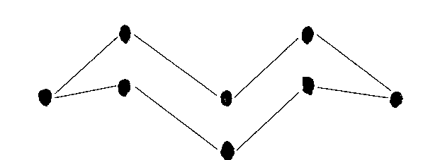

- Identify this element from the section of the periodic table and give its actual symbol and name. (2 mks)
F- S- Sulphur
- Explain why this element has a higher boiling point compared to that of oxygen. (2 mks)
A molecule of sulphur is made of Packard ring of eight atoms joined together by strong covalent bonds while a molecule of oxygen has weak van der waal forces between the molecules hence higher boiling point in sulphur than oxygen.

- Write an equation to show the reaction between the element named above with oxygen. (1 mk)

S_{(s)} + O_{2(g)} SO_{2(g)}

- Predict the pH of the oxide of the above element when in water. (1 mk)
pH will be below 7 because sulphur (IV) oxide dissolves in water to form acidic solution of sulphurous acid .

- Use the flow chart below to answer the questions that follow.

P
Q
Ammonia
Ammoniated Brine

Ammonia NH₄Cl + NaHCO₃
T
R
CaCl₂

Substance Y
NaHCO₃
Slaker
Water
CO₂
Heat

CaO
S
CaCO₃
Substance X
Na₂CO₃

- Name the substances labelled: (2 mks)
X- carbon (IV) oxide
Y- calcium hydroxide
- Name 2 substances being recycled in the process represented by the flow chart. (2 mks)
- Ammonia gas - Water
- Carbon(IV) Oxide
- Name the process that takes place in: (2 mks)
S- Thermal decomposition
R – Filtration
- Give 2 uses of calcium chloride. (1 mk)
- Used in extraction of sodium metal
- Used as a drying agent
- Used in countries which experience very low temperatures to aid in defrosting of ice
- Used in road construction because its highly deliquescent so as to minimize dust
- Write equations for the reaction that take place in: (2 mks)

Q NH_{3(g)} + NaCl(aq) + CO_{2(g)} + H₂O_{(l)} NH₄Cl _{(aq)} + NaHCO3_{(aq)}
(split two equations to be awarded full marks ie-1mk for each equation)
T CaO(s) + H₂O_{(l)} Ca(OH)_{2(aq)}

- Using ionic equation explain how sodium carbonate can be used to soften hard water. (2mks)
Mg²⁺ _{(aq)} + CO²⁻ _{3(aq)} MgCO_{3(s)}

Ca²⁺ _{(aq)} + CO²⁻ _{3(aq)} CaCO_{3(s)}

Carbonate ions react with either Ca²⁺ and Mg²⁺ in hard water to form insoluble calcium carbonate and magnesium carbonate which is precipitated out. (without equation no mark)

- Other than softening of hard water give 2 other uses of sodium carbonate. (1 mk)

- Manufacture of glass
- Manufacture of detergents
- Manufacture of bleaches used in paper industry.(any two correct half a mark each)

- Consider this group of reaction energy profiles for some different reactions (A, B, C).
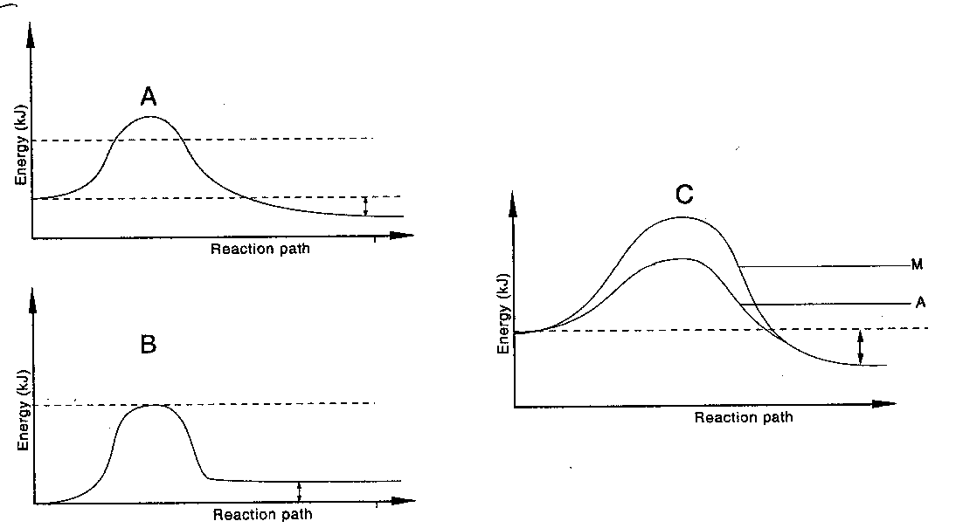
- Which reaction(s) is: (2 mks)
(i) Exothermic – A, C ( half a mark each)
(ii) Endothermic - B
- Explain why the activation energy of A in diagram C is lower than the activation enrgy energy of M in the same diagram. (1 mk)
M has a catalyst which lowers the activation energy
- In an experiment to determine the heat of combustion of methanol. CH₃OH, a student set up apparatus as shown in the diagram below. Study the set up and the data and answer the questions that follow.
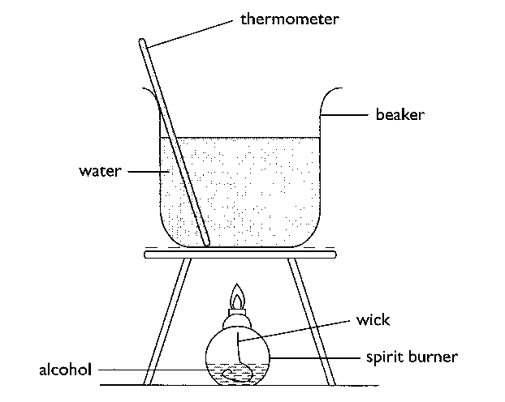

Volume of water = 100cm³
Final temperature of water = 22.0⁰c
Initial temperature of water = 36.0⁰c
Final mass of lamp an methanol = 84.75g
Initial mass of lamp and methanol = 85.10g
Density of water = 1 g/cm³
(S.H.C of water = 4.23 g⁻¹K⁻¹)

(i) Write an equation for the combustion of methanol. (1 mk)

2CH₃OH_{(l)} + 3 O₂ _{(g)} 2CO_{2(g)} + 4H₂O_{(g)}

- Calculate:
- Number of moles of methanol used in this experiment. (1 mk)

Mass of methanol = ( 85.10- 84.78) = 0.32 g

Moles = $\frac{0.32}{32 }=0.01$ moles

- The heat change for this experiment.

$100×4.2 ×$14 = 5880 J OR 5.88 k J

- The heat of combustion per mole of methanol. (1 mk)

0.01= 5.88
1= ?
$$\frac{1×5.88}{0.01}=-588 Kj/mol$$

- Explain why the molar heat of combustion for methanol obtained above is different from the theoretical value. (1 mk)

- Heat might be lost to the surrounding
- Heat absorption by the apparatus.(half a mark each)

- State two factors to consider when choosing a fuel. (1 mk)
- Cost
- Heating value
- Availability
- Ease of transport and storage
- Environmental effect (half a mark for each correct factor)
- Outline two disadvantages of using hydrogen as a source of fuel. (1 mk)
- Not readily available
- Its explodes when ignited in air.
- (a) Give the IUPAC names of the following organic compounds. (2 mks)

(i) CH₃ – CH₂ – CH – CH₃ 2,3- dimethylpentane
|
CH – CH₃
|
CH₃

(ii) CH₃ – C $≡$ C – CH₃ But-2-yne

(b) Study the flow chart below and answer the questions that follow:

A
D
H₂SO₄(aq)

H₂/ Pt
Step I
CH₃CH₃
C
Soda lime

B

(i) Identify (2 mks)
A- Ethene
B- Sodium carbonate
C- Sodium propanoate
D- Ethylhydrogensulphate (Formula to be awarded)
(ii) Explain how substance A and CH₃CH₃ could be distinguished by burning. (1 mk)
- Burn the two separately using non- luminous flame in which A burns in a yellow sooty flame while CH₃CH₃ burns in a blue non- sooty flame.

- Give one reason why soda lime is preferred to pure sodium hydroxide in step I. (1 mk)
- Pure Sodium hydroxide is highly deliquescent hence melts easily leading to attack to the glass

(c) Write down the equation for the reaction between substance A and hydrogen when equal numbers of moles are used. (1 mk)

CH₂CH_{2(g)}+ H_{2(g)} CH₃CH_{3(g)}

- A student found a bottle containing CH₃CH₂COO CH₃.
- Name the process of formation of the substance above. (1 mk)
Esterification
(ii) Identify the two substances from which the substance in (d) (i) is derived. (1 mk)
- Methanol
- Propanoic acid

(e) The formulae below represents the active ingredients in a soapless detergent and in soapy
detergents respectively.

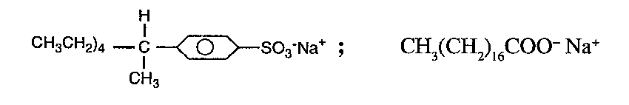
- Give one advantage and one disadvantage of using soapless detergent.(1 mk)
Advantage – it doesn’t form scum with hard water
Disadvantage- it’s a pollutant because it’s non- biodegradable

(ii) Explain briefly how the soapless detergents given above may be manufactured. (2 mks)
-Mix oil with sodium hydroxide solution. Heat and stir. Add sodium chloride to salt out the soap. Filter and wash with cold water.

- (a) The flow chart below outlines some of the processes involved during extraction of copper
from copper pyrites. Study it and answer the questions that follow.

Gas K Gas P
Hot air Gas K Silica (SiO₂) Hot air COKE
Chamber N
2rdRoasting furnace
Smelting furnace
1stRoasting
Furnace
Cu₂S+ FeO CU₂S Cu +
Cu₂O

Slag M Cu
- Name gas K. (1 mk)
Sulphur (IV) Oxide
- Write an equation for the reaction that takes place in the 1st roasting furnace. (1 mk)
2CuFeS_{2(s)} + 3O₂(g) Cu₂S_{(s)} + 2 FeO_{(s)} + 3SO_{2(g)}

- Write the formula of the cation present in the slag M. (1 mk)

Fe²⁺

- Identify gas P. (1 mk)
Carbon (IV) Oxide
- What name is given to the reaction that takes place in chamber N? Give a reason for the answer. (2 mks)
Redox reaction- because Cu₂O is reduced to Cu while the carbon is oxidesed to carbon (IV) Oxide

(b) The copper obtained from chamber N is not pure. Draw a labeled diagram to show the set up you would use to refine the copper by electrolysis. (3 mks)

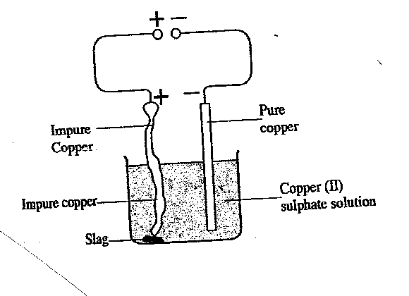

(c) Given that the mass of copper obtained from the above extraction was 210kg, determine the percentage purity of the ore (copper pyrites) if 810kg of it was fed to the 1st roasting furnace. (Cu = 63.5, Fe = 56, S = 32.0) (2 mks)

$$CuFeS2 =183.5$$
183.5= 63.5
810=?

$\frac{810×63.5}{183.5}=280.2997 \frac{210}{280.29997}$= 74.92 $\%$

(d) Give 2 effects that this process could have on the environment. (2 mks)
- Acid rain due to production of sulphur (IV) Oxide which leads to corrosion of iron sheets.
- leads to land degradation

- Study the scheme below and use it to answer the questions that fol XClow:

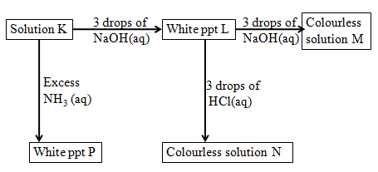

(a) Write the formula of:

(i) Cation in solution K (1 mk)

Al³⁺
(ii) White precipitate L (1 mk)
Al (OH)₃

(iii) Colorless solution M (1 mk)

$\left\lceil Al\left(OH\right)4\right\rceil$

(iv) Colorless solution N (1 mk)
AlCl ₃

- White precipitate P
Al (OH)₃
(1 mk)

(b) Write the ionic equation for the reaction for the formation of white precipitate L. (1 mk)

Al ³⁺ _{(aq)} + 3OH_{(aq)}⁻ Al (OH)_{3(s)}

- What property of L is illustrated in the formation of colorless solution M and N. (1 mk)

Amphoterism

(d) Electrical conductivity decreases when temporary hard water is heated. Explain. (2 mks)

When hard water is heated the hydrogen carbonate decomposes to solid carbonate salts hence the ions are fixed.
(e) When excess iron fillings were dissolved in dilute sulphuric IV acid, a pale green solution was obtained. The solution was filtered and divided into two portions.
(i) Write an equation for the reaction (1 mk)
Fe_{(s)} + H₂SO_{4(aq)} FeSO_{4(aq)} + H₂ _{(g)}

(ii) To the first portion aqueous ammonia was added till in excess. State observation
made. (1 mk).
Green precipitate insoluble in excess.

(iii) Write an ionic equation for the reaction in (ii) above. (1 mk)

Fe²⁺ _{(aq)}+ 2OH⁻_{(aq)} Fe(OH)_{2(s)}

7. a) State the Faraday’s law of electrolysis (1mk)
The amount of substance discharged at the electrodes is directly proportional to the quantity of electricity passed.

b) Calculate how long it would take an aqueous gold (III) chloride cell to coat 2.5 g of gold
on a bracelet using a current of 2.5 A. The half reaction has been provided for you. (3mks)
(Au =197)
Au³⁺ _{(aq) +} 3e⁻ Au_{(s)}

$$1 F=96500$$

3F= $96500×3=289500 C$
$289500=197$
$$=2.5$$

$\frac{2.5 ×289500}{197}=3673.86 C$

$Q=It=3673.86=2.5×t$

$$t=\frac{1469.59}{60}=24.49 mins$$

c) Two half-cells are connected under standard conditions to make an electrochemical cell.
The two half-cells are a copper-copper (I) ion (Cu/Cu⁺) and an aluminum-aluminum ion (Al/Al³⁺). Using your the Standard Reduction Potentials below answer.

Al³⁺_{(aq)} + 3e⁻ → Al_{(s)} -1.66 V
Cu⁺_{(aq)} + e⁻ → Cu_{(s)} 0.52 V

- Write the cell diagram for the cell obtained when the two half cells are connected. Al_{(s)} Al_{(aq)} Cu⁺_{(aq} Cu _{(s)} (1mk)

- Identify which reaction is the anode and which is the cathode. (2mks)
Anode- Al_{(s)} Al ³⁺ _{(aq)} +3e⁻

Cathode - Cu⁺ + e⁻ Cu_{(s)}

- Calculate the emf for the cel.l (1mk)
Emf= E_{Reduced} - E_{Oxidised}
$$0.52- -1.66= +2.18V$$
- Write the overall balanced redox reaction for the electrochemical cell. (1mk)

Al_{(s)}+ 3Cu⁺_{(aq} Al³⁺_{(aq)} + 3Cu _{(s)} +2.18

d) An excess of copper solid is dropped into a solution which contains AgNO₃ , Fe (NO₃)₃ and Zn (NO ₃)₂. Write the ionic equations for any reduction half cell-reactions that occur over time under standard conditions. (1mk)

Ag⁺_{(aq)} + e⁻ Ag _{(s)}

