Name --------------------------------------- index no -----------------------------------------
School --------------------------------------------- date --------------------------------------
Candidate’s signature ----------------------------

SET 7

233/2
Chemistry
Paper 2
Theory
Time: 2 hours

Instructions to the candidates
- Answer all questions in this paper in the spaces provided
- Mathematical tables and electronic calculators may be used for calculation
- All working must be clearly shown here necessary

For examiners use only
Question | Maximum score | Candidates score
1 | 13
2 | 11
3 | 12
4 | 12
5 | 11
6 | 14
7 | 08
Total | 80

This paper consists of 12 printed pages.
Candidates should check the question paper to ensure that all
pages are printed as indicated and no questions are missing

- A) Study part of the periodic table below. The letters do not represent the actual symbols. Use the letters to answer the questions that follows.
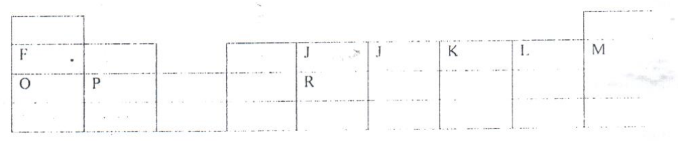
- Which one element would from a divalent anion? (1 mark)
------------------------------------------------------------------------------------------------------------------------------------------------------------------------------------------------------------
- Write formula of the compound formed when P reacts with L. (1 mark)
------------------------------------------------------------------------------------------------------------------------------------------------------------------------------------------------------------
- Monovalent cation of X electrons configuration 2.8.8. Indicate its position in the periodic table above. (1 m ark)
------------------------------------------------------------------------------------------------------------------------------------------------------------------------------------------------------------
- Identify most reactive metallic element (1 mark)
B) The table shows some properties and electron arrangements of common ions of elements represented by letters Q to X. Study the information provided then answer the questions that follow
Element | Formula of ion | Ionic electron arrangement | Atomic radius | Ionic radius
Q | Q⁻ | 2.8 | 0.072 | 0.136
R | R⁺ | 2.8.8 | 0.231 | 0.133
S | S³⁺ | 2.8 | 0.143 | 0.050
T | T²⁺ | 2.8.8 | 0.133 | 0.074
U | U²⁺ | 2.8 | 0.160 | 0.064
V | V⁺ | 2.8 | 0.186 | 0.095
W | W³⁻ | 2.8.8 | 0.110 | 0.190
X | X⁻ | 2.8.8 | 0.099 | 0.181

- Give the atomic numbers of elements T and Q (2 marks)
T --------------------------------------------------------------------------
Q ------------------------------------------------------------------------
- Select two non- metals that belong to the same period. (1 mark)
----------------------------------------------------------------------------------------------------------------------------------------------------------------------------------------------
- Which two elements would react violently with water to produce hydrogen? (2 marks)
----------------------------------------------------------------------------------------------------------------------------------------------------------------------------------------------
c) i) Why is the atomic radius of R larger than its ionic radius? (2 marks)
--------------------------------------------------------------------------------------------------------------------------------------------------------------------------------------------------
ii) Element S is suitable for making cooking pans. Explain (2 marks)
--------------------------------------------------------------------------------------------------------------------------------------------------------------------------------------------------
- A) Gives the names of the following compounds
- CH₃CHCHCH₂CH₃ (1 mark)
-------------------------------------------------------------------------------------------------

- CH₃(CH₂)₂COOH (1 mark)
-------------------------------------------------------------------------------------------------
B) Ethane and ethane react with Bromine according to the equations given below.
- C₂H₆ _{(g)} + Br_{2(g)} C₂H₆Br_{(l)} + HBr_{(g)}
- C₂H_{4 (g)} + Br_{2(g)} C₂H₄Br_{2(l)}
Name the type of bromination reacting taking place in (i) and (ii) above.(1 mark)
- ----------------------------------------------------------------------------------------------
- ----------------------------------------------------------------------------------------------
C) Study the diagram below and answer the questions that follow.
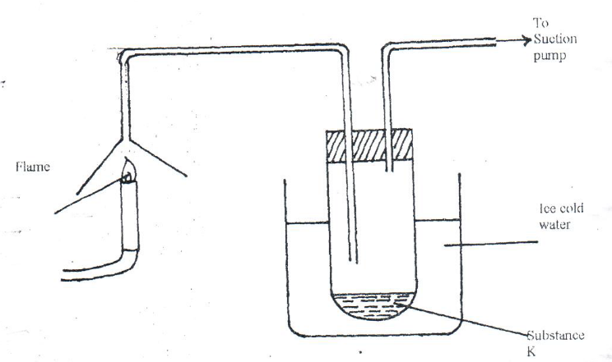
- Write the equation for the complete combustion of butane.
----------------------------------------------------------------------------------------------
- The Ph of substance K was found to be less than 7.
Explain the observation (2 marks)
----------------------------------------------------------------------------------------------------------------------------------------------------------------------------------------------
D) The polymerization of tetra fluorocarbon (2F4) is similar to that of ethane (C2H4)
- What is meant by polymerization? (1 mark)
----------------------------------------------------------------------------------------------------------------------------------------------------------------------------------------------
- Draw the structural formula of the polymer obtained from monomer C2H4 (1 mark)
------------------------------------------------------------------------------------------------------------------------------------------------------------------------------------------------------

- Sate any two advantages of synthetic polymers over natural polymers. (2 marks)
CH3CH2CH2OH(aq) + CHCOOH(aq) R(aq) n+H2O(l)
- Give the name of product R (1 mark)
------------------------------------------------------------------------------------------------------------------------------------------------------------------------------------------------
- Name the type of reaction that produces R. (1 mark)
----------------------------------------------------------------------------------------------------------------------------------------------------------------------------------------------
- Study the standard electrode potential for the half-cells given below and answer the questions that follow. The letters do not represent the actual symbol of the elements.
E° - volts
N⁺ (aq) + e⁻ -2.92
J⁺(aq) +e⁻ J(s) +0.52
K⁺ (aq) + e⁻ ½ K_{2(g)} 0.00
M2+ (aq) + e- -0.44

- Identify the strongest oxidizing agent. Give a reason for your answer (1 ½ marks)
----------------------------------------------------------------------------------------------------------------------------------------------------------------------------------------------------

- Which two half-cells would produce the highest potential difference when combined? (1 mark)
--------------------------------------------------------------------------------------------------------------------------------------------------------------------------------------------------------
- Explain whether the reaction represented below can take place (2 marks)
M(s) + 2N+ (aq) M2+ (aq) + 2N(s)
--------------------------------------------------------------------------------------------------------------------------------------------------------------------------------------------------------
B) 100cm3 of 2M sulphur (iv) acid was electrolyzed using the set –up represented diagram below.
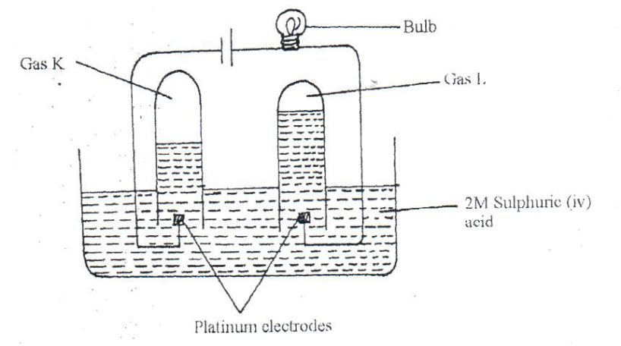
- Write an equation for the reaction that produces gas L. (1 mark)
--------------------------------------------------------------------------------------------------------------------------------------------------------------------------------------------------------
- Describe how gas K can be identified (1 ½ marks)
------------------------------------------------------------------------------------------------------------------------------------------------------------------------------------------------------------

- Explain the differences in;
- Volume of gases produced at electrodes (1 mark)
------------------------------------------------------------------------------------------------------------------------------------------------------------------------------------------
- Brightness of the bulb if 1100cm3 of 2M ethanoic acid was used in place of 2MSulphur (vi) acid (2 marks)
------------------------------------------------------------------------------------------------------------------------------------------------------------------------------------------
C) A current 0.5a was passed for 2 hours. Calculate the mass of lead deposited (Pb = 207, if =96500c) (2 marks)
---------------------------------------------------------------------------------------------------------------------------------------------------------------------------------------------------------------------------------------------------------------------------------------------------
- A) Below is a simplified diagram of a down’s cell used in manufacture of sodium. Study it and answer the questions that follow.
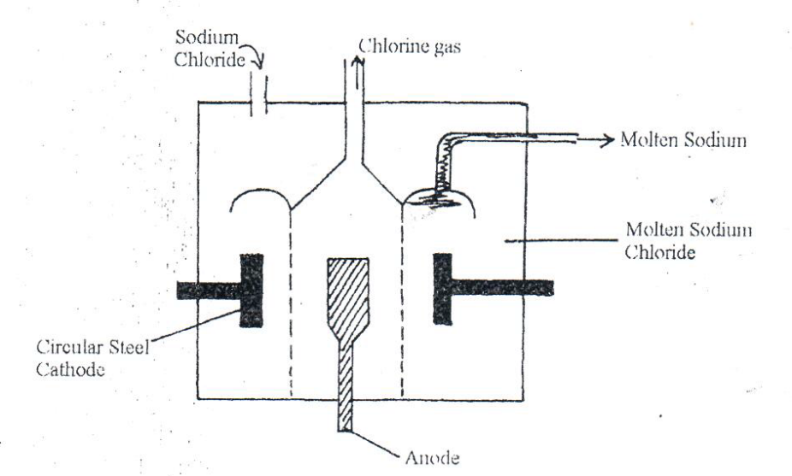

- What materials is the anode made of? Give a reason (2 marks)
------------------------------------------------------------------------------------------------------------------------------------------------------------------------------------------------------------
- What precaution is taken to prevent chlorine and sodium from recombining (1 mark)
------------------------------------------------------------------------------------------------------------------------------------------------------------------------------------------------------------
- Write a ionic equation for the reaction in which chlorine gas is formed (1 mark)
--------------------------------------------------------------------------------------------------------------------------------------------------------------------------------------------------------
B) In the Down’s cell, a certain salt is added to lower the melting point of sodium chloride from 800°C to 600° C.
a. Name the salt that is added (1 mark)
--------------------------------------------------------------------------------------------------------------------------------------------------------------------------------------------------
- State why it is necessary to lower melting point (1 mark
--------------------------------------------------------------------------------------------------------------------------------------------------------------------------------------------------
C) Explain why it’s not suitable to use aqueous sodium chloride for the manufacture of sodium in the Down’s process. (2 marks)
--------------------------------------------------------------------------------------------------------------------------------------------------------------------------------------------------
D) Sodium metal reacts with air to form two oxides. Give the formulae of the two oxides (2 marks)
--------------------------------------------------------------------------------------------------------------------------------------------------------------------------------------------------
E) State two uses of sodium metal. (2 marks)
--------------------------------------------------------------------------------------------------------------------------------------------------------------------------------------------------
- A) Define the standard enthalpy of formation of a substances (1 marks)
--------------------------------------------------------------------------------------------------------------------------------------------------------------------------------------------------
B) Use the thermo chemical equations below to answer the questions that follow.
- C2H6(g) + 7/2 O2 2CO2(g) + 3H2O(g) H1 =- 1560 kjmol⁻¹
- C (graphite) + O2(g) CO2 (g) H2 =- 394 kjmol⁻¹
- H2(g) + ½ O2 (g) H2O (g) H3 =- 286 kjmol⁻¹

- Name two types of heat changes represented by H3 (2 marks)
----------------------------------------------------------------------------------------------------------------------------------------------------------------------------------------
- Draw an energy level diagram for the reaction represented by equation 1. (2 marks)

- Calculate the standard enthalpy of formation of ethane (2 marks)
--------------------------------------------------------------------------------------------------------------------------------------------------------------------------------------------------
- When a sample of ethane was burnt, the heat produced raised the temperature of 500g of water by 21.5k (specific heat capacity of water 4.2 Jg⁻¹k⁻¹)
Calculate
- Heat change for the reaction. (2 mark)
------------------------------------------------------------------------------------------------------------------------------------------------------------------------------------------
- Mass of ethane that was burnt (relative formula mass of ethane – 30)(1mark)

- A. Define the term solubility (2 marks)
------------------------------------------------------------------------------------------------------------------------------------------------------------------------------------------
B)
Mass of Kcl(g) | 20 | 20 | 20 | 20 | 20 | 20
Volume of water (cm3) | 40.0 | 45.0 | 50.0 | 55.0 | 60.0 | 65.0
Temperature at which crystals first appears (°C) | 77.0 | 56.0 | 40. | 26.0 | 15.0 | 8.0
Solubility in g per 100g of water

- Complete the table above by calculating the solubility of KCL in grammes per 100g of water. (3 marks)

- Plot the graph of solubility in g/100g of water (y-axis) against temperature (x-axis) (3 marks)

- From the graph determine solubility at 50° C. (1 mark)

- If a saturated solution of potassium chloride is cooled from 70°C to 10°C. What mass of the crystal s would be obtained? (2 marks)

- Calculate the concentration of the saturated at 50°C. (K-39.0, CL=35.5) (2 marks)

c) The set up below was used t remove hardness in water.
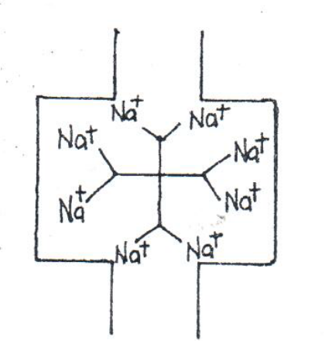

- Identify the above method of removing water hardness. (1 mark)
--------------------------------------------------------------------------------------------------------------------------------------------------------------------------------------------------
- The above system eventually lack the ability to soften hard water. Explain it can be reactivated. (1 mark)
------------------------------------------------------------------------------------------------------------------------------------------------------------------------------------------------------------
- State any advantage of hard water. (1 mark)

- The following scheme represents the steps followed in the contact process, study it and answer the questions which follow.

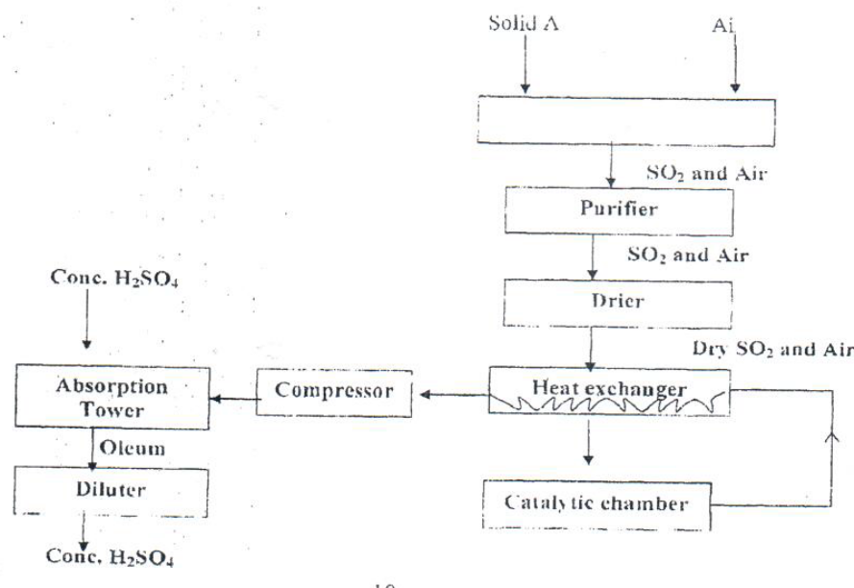
- Name three possible identities of solid A. (1 mark)
--------------------------------------------------------------------------------------------------------------------------------------------------------------------------------------------------
- Name two impunities removed by the purifier. (1 mark)
--------------------------------------------------------------------------------------------------------------------------------------------------------------------------------------------------
- Why is it necessary to remove impunities (1 mark)
--------------------------------------------------------------------------------------------------------------------------------------------------------------------------------------------------
C) The following equation shows a reactor taking in the catalytic chamber/ converter.
2SO2(s) + O2(g) 2SO3(g) H° = - 197 KJmol⁻¹
- How would the following factors affect the production of sulphur (IV) oxide?
- Increase in temperature (1 mark)

- Decrease the pressure (1 mark)
------------------------------------------------------------------------------------------------------------------------------------------------------------------------------------------
- Name the catalyst which is commonly used in this process and why? (1 mark)
--------------------------------------------------------------------------------------------------------------------------------------------------------------------------------------------------
- Tate and explain one environmental effect of sulphur (Iv) oxide in the atmosphere. (2 marks)
--------------------------------------------------------------------------------------------------------------------------------------------------------------------------------------------------

