SET 7

CHEMISTRY
PAPER THREE
MARKING SCHEME

- .
Volume of solution X used (cm³) | 15.9 | 15.8 | 16.0

$$\frac{15.9+15.8+16.0 }{3}=15.90cm 3$$
I)
0.2 1000
15.90
$\frac{15.90 ×0.2}{1000}$

$=0.00318$

$moles of Y=\frac{0.00318}{2}$
$$=0.00159 moles$$
$molarity=0.00159 ÷0.021=0.063 mol$

II) $Con.=4.8 ×4=19.2 g$
$RFM=\frac{19.2}{0.0636} = 301.89$
III) $18n 301.89-46-4\left(10.8\right)- 7(16)$
$=100.69$
$n=5.5$
- A.
Temp. of solution ° C | 19.0 | 27.0 | 32.0 | 36.0 | 34.0 | 32.0 | 31.0 | 29.5 | 29.5

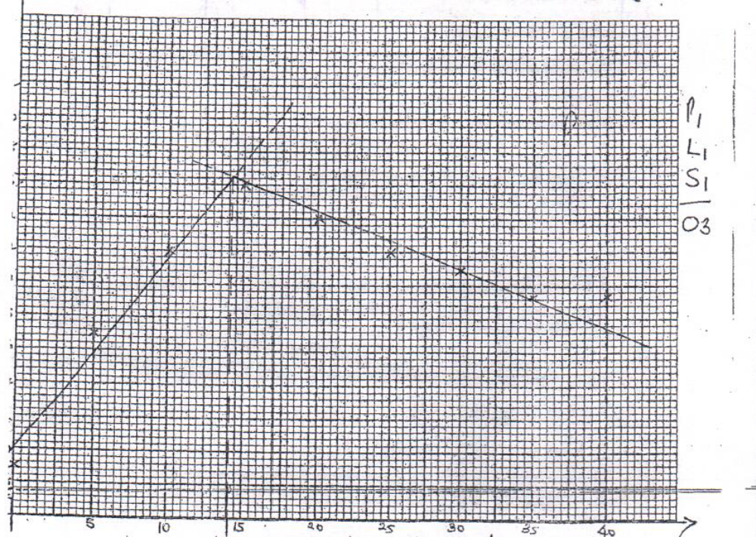
- $36.4 ±0.2$
- $14 cm3$
- $total volume=14+30=44 cm3$
$$∆H=44×4.2 ×16.4$$
$$=3030.72 J$$
$$=3.03072 KJ$$
- 2 1000
30
$\frac{2 ×3}{1000}$
$=0.06 moles$
$0.06 moles 3.03072 kj$
$1 moles -50.51 kj/mole$

$\frac{2 ×30}{Ma ×14}=\frac{2}{1}$
$Ma= \frac{2 ×30 }{14 ×2}=\frac{30}{14}=2.1 m$
- . I (a)

Observation | Deductions
- Colorless filtrate  - White solid residue | - Absence of colored ions e.g. Fe²⁺, Fe³⁺, Cu²⁺

Observation | Deductions
- White precipitate soluble in excess NaOH | - Zn ²⁺, Al³⁺, Pb²⁺ present

Observation | Deductions
- White precipitate | - So₄²⁻, So₃²⁻, Cl⁻ present  - Absence of Co₃²⁻

Observation | Deductions
- No effervescence | - So₃²⁻ absent  - So₄²⁻, Cl⁻ present
b)
Observation | Deductions
- Effervescence noted with evolution of a gas | - Co₃²⁻, So₃²⁻ absent

Observation | Deductions
- White precipitate soluble in excess | - Zn ²⁺, Al³⁺, Pb²⁺ present

Observation | Deductions
- White precipitate noted | - Pb²⁺ present

Observation | Inferences
- P burns with a sooty smoky flame leaving no residue | - Is unsaturated hydrogen  - P is a high carbon percentages or P has a high C:H ratio
- I)
Observation | Deductions
- Purple acids KMnO4 is decolorized | - -C=C-; -C= C-or R – Oh present

II)
Observation | Deductions
- Effervescence noted | - P is acidic or H₃O⁺

