
451/1 - COMPUTER - Paper 1

2 Hrs 30mins

NAME…………………………………………………ADM…………….CLASS……………………. 2022 TRIAL 2 JULY INTERNAL EXAMINATION

Kenya Certificate of Secondary Education (K.C.S.E)

COMPUTER STUDIES
PAPER 1
(THEORY)
TIME: 2½ HOURS

451/1
Computer Studies
Paper 1
INSTRUCTIONS TO CANDIDATES:
- Write your name and Admission number in the spaces provided above.
- This paper consists of TWO sections A and B.
- Answer ALL the questions in section A.
- Answer question 16 and any other THREE questions from section B.
- All answer should be written in the spaces provided
- This paper consists of 14 printed pages.
- Students should check the question paper to ascertain that all the pages are printed as indicated and no question is missing.
- Candidates should answer the questions in English.
SECTION | QUESTIONS | CANDIDATE’S  SCORE
A
B | 16
B | 17
B | 18
B | 19
B | 20
TOTAL

- Mention any TWO reasons why command-based operating systems are not common in today’s business computer systems. (2marks)
  - It is difficult to remember commands.
  - Cannot process graphics e.g. pictures, drawings or videos.
  - Hardly makes use of emerging hardware and software technologies.
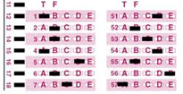
2. (a) Name the type of scanner used to capture data from the following document format below (1mark)

OMR
(b) Mention any TWO features that are considered before buying a main memory module. (2marks)
o Type of memory package e.g. DDR, DDR II
o Whether there is empty memory slot in the computer.
o Compatibility with other installed modules.
o Capacity of the module - how much data it can hold.
3. Briefly describe how the following data security measures function (3marks)
Audit trail : A study to evaluate if a system is secure / identifies weaknesses in a computer system
Log files: Records the activities taking place in a computerized system
Fire walls : filters data being exchanged between networks
4. (a) Explain the following (2 marks)
i. Search engine – specialized programs that help that help the user easily search for information on the internet.
ii. Web browser – a program that lets the user to surf or browse the internet
(b) The diagram below shows an e-mail extract.
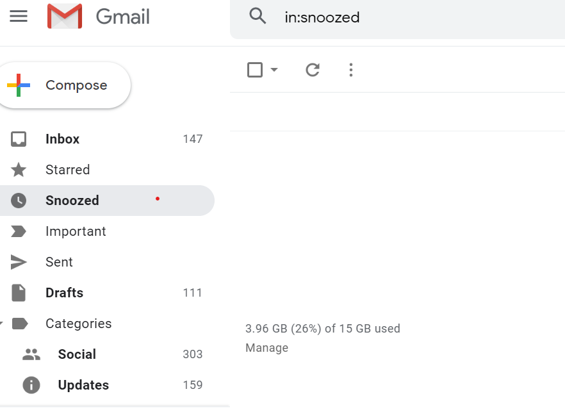

(i) What is purpose of the following folders? (2 marks)
a) Inbox
Contains received messages
b) Drafts
Contains unsent messages / saved messages about to be sent
- Describe two types of errors that may be detected during program testing (2marks)
  - Syntax errors
  - Logical errors
  - Runtime errors
- Perform the following binary operation (2 marks)
11001 + 1101 – 1101

11001
1101
100110
1101
11001

7. State two possible causes of fire outbreak in a computer laboratory. (2marks)
- Flammable liquids
- Short circuits
- Power surges
8. a) What do you understand by the term ‘soft system’ in a system development using an example? (3mks)
This is a system whose goals keep on changing, have no specific boundaries, and its performance is based on emotions, thus it is hard to measure. e.g a political system in a country.

b) State two tools that a system analyst may use to design a system (2 mks)
- Flowcharts
- Data Flow Diagrams(DFDs)

c) List down any four characteristics of a system (4 Mks)

- Holistic thinking
- Made of Subsystems
- Has a boundary
- Has an environment
- System entropy
- Has an Objective and purpose
- Accepts input
- Carries out processing
9. State three reasons why users may resist the introduction of information and communication Technology (ICT) to their place of work
(i) Fear of change-
(ii) Fear of losing their jobs:
(iii) Fear of failure
(iv) Loss of control
10. State three ways in which horticultural farmers can benefit from the use of information and communication technology (3 marks)
- use of Internet to advertise their products
- use of Internet to sell their products
- use of spreadsheets to calculate their sales

11. State four differences between an intranet and the internet (2 marks)

Internet is public network. | Intranet is private network.
The Internet is a wide network of computers and is open for all. | An intranet is a small network designed for a specific group of users.
The number of users who use the internet is Unlimited. | The number of users who use intranet is limited.
Internet contains more traffic compare to intranet. | Intranet contains less traffic compare to internet.
Internet contains different source of information and is available for all. | Intranet contains only specific group information.
The Internet can be accessed by everyone. | Intranet can be accessed only by the members of an organization.
The Internet is not safe as it is a public network | Intranet is safe as it is a private network.
Can access websites (Google, YouTube, Facebook, etc.) | Cannot access website (Google, YouTube, Facebook, etc.)

  - Differentiate between a select query and action query as used in databases.(2 marks)
Select query is used to analyze data from one or more tables whereas Action query is used to modify data in an existing table(s)
13. The following is a spreadsheet relating to a farmer produce at harvest
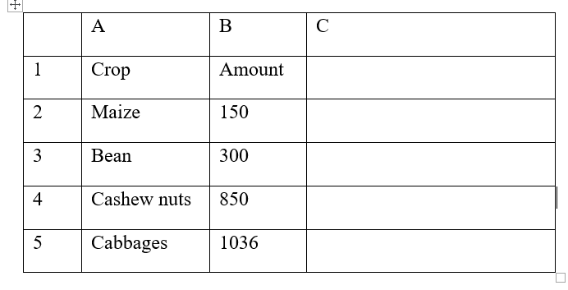
(i) A function = IF(B2<200,”Poor Yield”, IF(B2>300, “Moderate”, IF(B2>1000,”Great Yield”))).
Give the appropriate result returned in cells C2, C3, C4, and C5 (2marks)
C2 - Poor Yield
C3 - False
C4 - Moderate
C5 - Great Yield
14. A computer user may interact with a computer either through Graphical User Interface (GUI) or though typed commands
(a) Give one advantage of using GUI based operating system over a command line interface
( 1 mk)
¨ User friendliness
¨ Easy to learn & use even by those who do not have much knowledge about them
¨ One does not need to master any commands
¨ It is faster to work with than a command line interface as it only relies on clicking the icons by use of a pointing device
(b) Some computer systems still use command line interfaces. State two advantages of command line interface
- They are more flexible than menu- driven interfaces
- There is security of data as only those who know how to use the commands will access it.
- They use cheap hardware & software facilities
- One has a better control over the system resources
15. (a) Distinguish between data verification and data validation as used in data processing
Verification is checking data manually to ensure/ ascertain that it has been entered correctly.
Validation involves subjecting data to checks built in a program to check for its appropriateness or integrity before it is processed.
(b) List any two file organization methods (1 mark)
- Serial
- Sequential
- Random
- Indexed sequential

SECTION B
16. a) Study the following flowchart and answer the questions that follow
Start
Sum = 0
R = 0
R = R + 1
Term = R*(2)^2
Sum = Sum +Term
R=3?
Print sum
Stop

No

Yes

- Dry run the above flowchart clearly showing how the output will be arrived at (4mks)
R | Term | Sum
1 | 1*(2)² = 4 | 0 + 4 = 4 √1
2 | 2*(2)² =8 | 4 + 8 = 12 √1
3 | 3*(2)² =12 | 12 + 12 = 24 √1
Printed Output = 24 √1
- Convert the above flowchart into a pseudocode (6mks)
Start √0.5
Sum = 0 √0.5
R = 0 √0.5
Repeat √1
R= R+1 √0.5
Term = R*(2)^2 √0.5
Sum = Sum +Term √0.5
Until R = 3 √1
Print Sum √0.5
Stop √0.5

b) Explain three types of documentations that a programmer needs to prepare (3mks)
(i) User – gives procedures of accomplishing various tasks to the user
(ii) Operator – guides the operator in maintaining/ fixing errors in the program
(iii) Programmer – helps another programmer modify/ upgrade the program
c) State two differences between a compiler and an interpreter (2mks)
Compiler | Interpreter
Translates entire code at once | Translates one line/statement at a time
Needs more memory ( since it stores the object code) | Needs less memory ( does not store the object code)

17.a) Define data integrity (1mk)
Correctness and completeness of data
b) Explain any four threats to data integrity in computer systems (4mks)
- Viruses/ Other malware
- Accidents
- System failure
- Computer crimes/ criminals e.g. hackers, eaversdroppers, strangers
- Power failure
c) Giving examples differentiate between Transposition and misreading errors (3mks)
Transposition – interchanging of characters √1 e.g 4567 instead of 4657 √0.5
Misreading – mistaking a character for another √1 e.g. S667 instead of 5667 √0.5
d) The following records were extracted from two files contained in a students’ database
File A
Registration Number Student name Gender Address
3001 Tom Onyancha M 4646 Kisii
3002 Amina Amima F 4322 Garissa
3003 Jane Anita F 2333 Nairobi
3004 Jack Kalweo M 3822 Meru

File B
Registration Number Fees Paid Date of Payment
3001 12,090 04/01/2020
3002 11,000 06/02/2020
3003 12,000 07/01/2020
3004 15,000 08/01/2020
i) Which of the two files above represents a transaction file ? (1mk)
File B
ii) Give reason for your answer in17 a) i) above (2mks)
Contains details to update on File A
- Name the other type of file represented above (1mk)
Master File
- Identify the most appropriate primary field from the above data (1mk)
Registration Number
e) Differentiate between multiprocessing and multitasking systems (2mks)
Multiprocessing | Multitasking
Has several/ parallel processors | Has a single processor
Several tasks executed simultaneously | Several tasks executed concurrently

18. a) State three advantages of using a laptop over desktop computer (3mks)
- Has a battery for power backup
- Portable
- Inbuilt with several peripherals, no need for separate devices
b) Explain three ways computers would be made more friendly to people with physical disabilities like the blind and handicapped (3mks)
- Use of speech recognition devices
- Use of line of sight devices
- Use of brain wave systems

(c) I. Differentiate between system review and system maintenance. (4 marks)

System review is constant evaluation of the system performance to determine how best it can continue to meet it’s objectives while in system maintenace modifications are carried out after implementation aimed at fixing errors, making the system better in carrying out it’s functions and enabling it adapt to changes.

II. Mention THREE characteristics of a good interface design (3 marks)

Has a consistent layout in the entire system
It is user friendly
Should prompt the user clearly
The colours, font and layout should be appealing to the user
Should have a layout that is consistent with the manual data form. For example, the interface should capture the same number of items of data as indicated in the manual data capture form.

19 a. Rehema school electoral system clerk stores the results of elections in folders. The school has five streams each in form one, form two, form three and form four. The student administrative structure is in three levels, school level, form level and class level. The school level student leadership positions comprise of the head boy, the head girl, dining hall captain, games captain and the library captain. The form level positions comprise form captains who are in charge of all the streams in their respective forms. The class level positions comprise of the class prefects who are in charge of their respective classes and they are answerable to their respective form captains. A folder labeled 2020 is stored in a root directory C hold these information. Draw a tree directory to represent the information above. (6 marks)

b. What do you understand by the following terms as used in Operating Systems? (4 marks)
i) Deadlock
A deadlock is a situation that occurs when a task is requesting for another resource but does not want to release the resource it is holding for use by other tasks.
ii) Interrupt
An interrupt is a break from the normal sequential processing of the instructions in a program.
c. i) Fill in the blank spaces with the most appropriate answers of the open systems interconnection (OSI) reference model layers.
Layer no. | Layer | Function
7 | Application layer | User applications run here and generate request for data transmission or open received information
1 | Physical layer | The data packets are finally transmitted via the network card through the transmission media in form of bits
4 | Transport layer | Sets up the transmission sessions between two communication devices
6 | Presentation layer | Adds formatting, display and encryption information to the data being sent.

ii) Differentiate between baseband and broadband transmissions. (2 marks)
In baseband transmission a digital signal is generated and applied to the transmission medium directly without modulation while in broadband transmission, an analog signal is sent over the transmission medium using a particular frequency.
20. a) i. List THREE possible threats to data in a network (3 marks)
Computer virus
Eavesdropping
Surveillance
Unauthorized access (Hacking, cracking, sabotage)
Industrial espionage
ii. State THREE control measures that can be taken to mitigate the threats above (3 marks)
Password
Firewall
Data encryption
b) Explain THREE uses of information systems in an organization (6 marks)
Data collection – enables collection of data through automated methods, interviews and questionnaire and other methods
Data processing – this can be done manually, mechanically or electronically
Information sharing- this can be done electronically through networks or verbally.
Decision making – they help in decision making by collecting data, analyzing it and generating reports.
c) Give THREE types of data that can be used to test a developed system (3 marks)
Extreme data
Normal data
Abnormal data

