COMPETENCE BASED CURRICULUM
7
2024
JUNIOR SCHOOL
CREATIVE ARTS MARKING SCHEME

- Name the following types of eye views. ( 3mks)
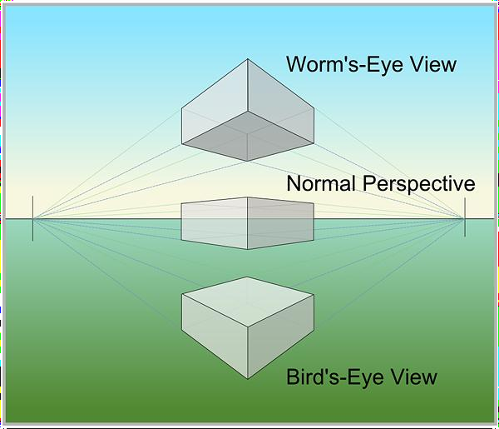

- What are 3d art forms?( 3 mks)
These are artworks that have length, width and height. These artworks have volume. They can be turned around and viewed from more than one direction.
- Name three examples of 3d artworks (3 mks)
- Pottery.
- Sculpture.
- Basketry.
- Ornaments.

- Define ( 6 mks)
  - A still life drawing
Is a drawing of non-moving objects on a surface. Can be done from observation, memory or imagination.
  - A composition
Means arranging or placing different objects together.
  - Painting
Is a picture making technique that involves application of colour on a surface.

- List down three tools and materials used in painting.( 3 mks)

- Papers.
- Pencils.
- Ruler.
- Paint.
- Sponge.
- Paint brush
- Pair of compasses.
- Protractor.
- Palettes.

- What is a colour wheel?( 2 mks)
A colour wheel is an arrangement of colours on a circular diagram to show how they and are related to each other.
- Name three primary colours. (3 mks)
  - Yellow
  - Red
  - Blue
- On the circles below, insert the colours you have identified as primary colours.( 6 mks)

- Name some examples of analogous colours: (2mks)

- Red.
- Red orange.
- Orange.

- There are three basic properties of colours. Namely(3 mks)
- Hue.
- Intensity.
- Value.
- What is perspective?( 2mks)
- Perspective is a way objects appear in relation to each other depending on the distance from and position of the viewer.
- State three components of perspective. (3mks)
- Projection lines or Convergence lines.
- Vanishing points.
- Horizon.
- By adding white to make the colour lighter. This is called tinting.(1mk)
- By adding black to make the colour darker. This is called shading. (1mk)
- Demonstrate using painting to show intensity scale. Mix primary colour to get orange then using appropriate procedure, paint to show intensity(7 mks)

Red +Yellow = Orange
- Using the strip below, make a colour gradation strip by appropriately mixing red and yellow in their appropriate proportions

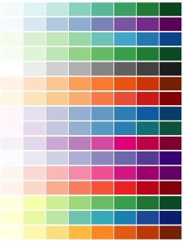

Learners must appropriately mix yellow and red to get orange (shading of colour)

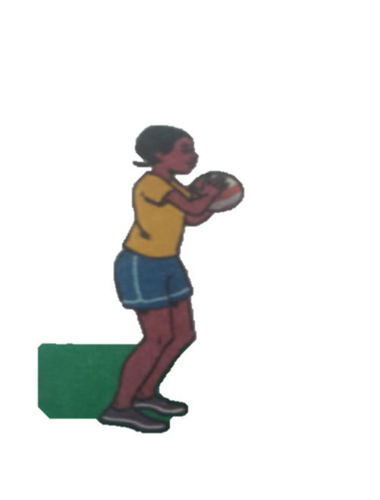
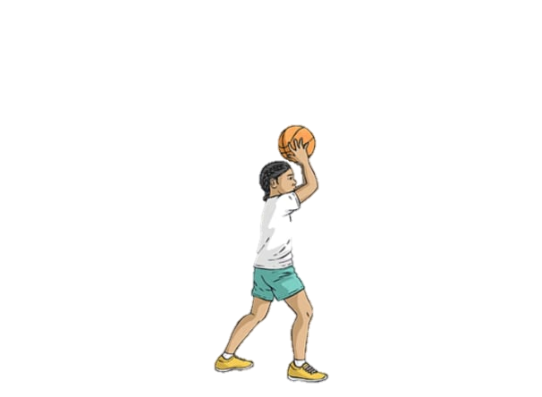
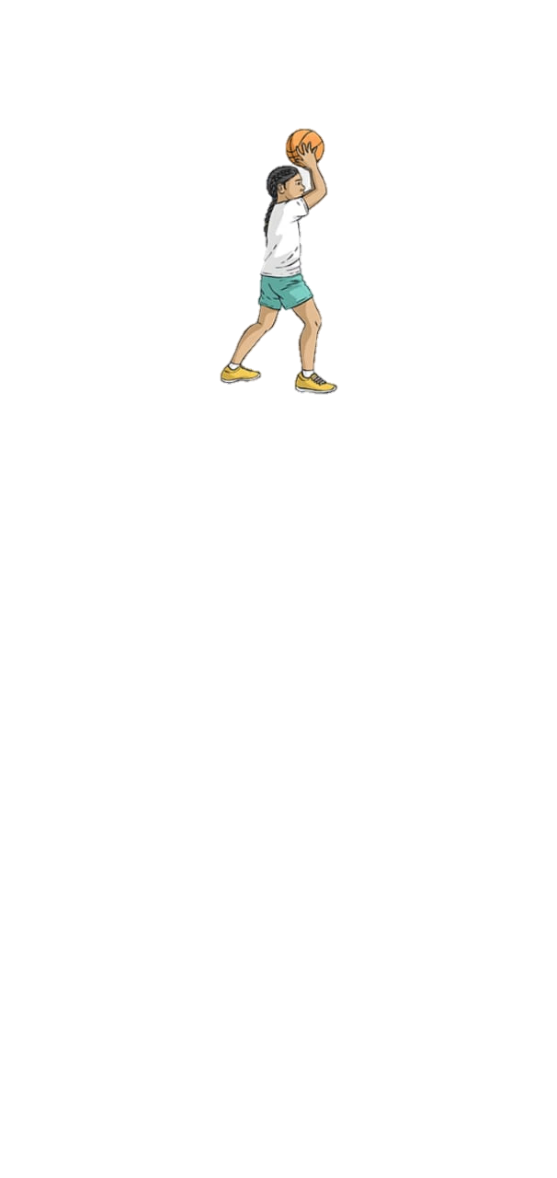
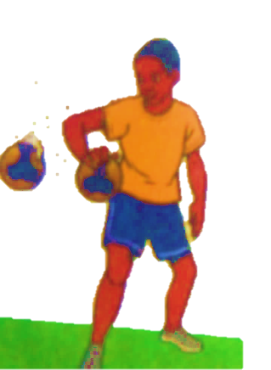
- Identify the type of pass demonstrated below.(3 mks)

Underarm pass
Overhead pass
Chest pass

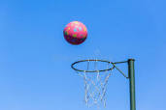
- Which type of game is shown below? netball(1 mk)

- Identify the type of marking illustrated below.( 2 mks)
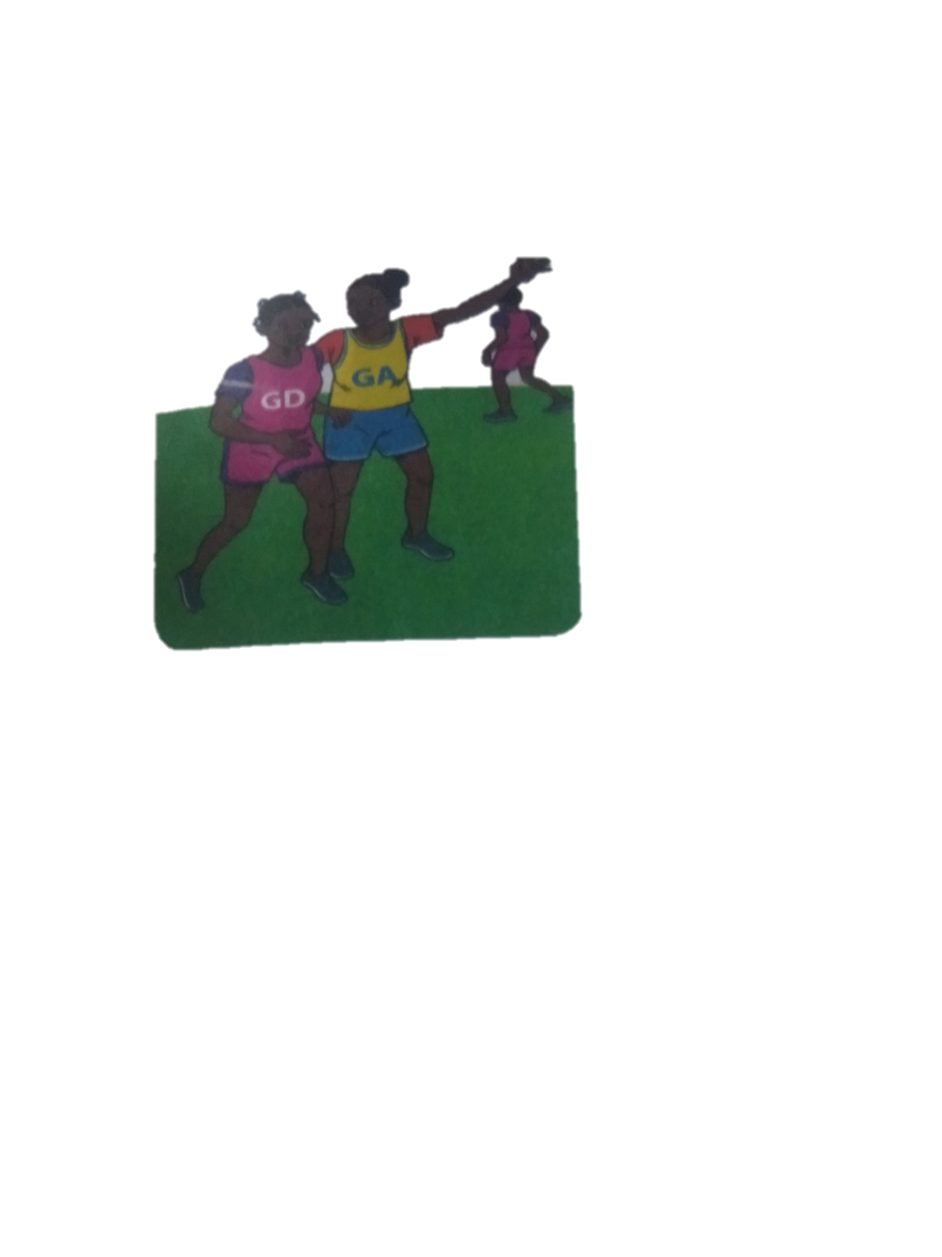
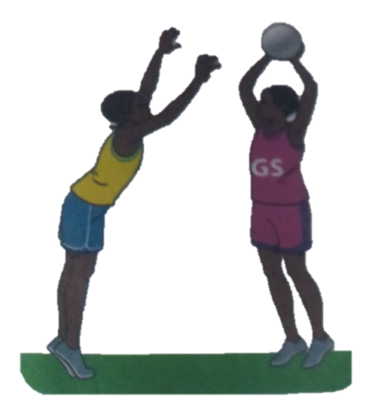

Marking player with a ball marking player without a ball
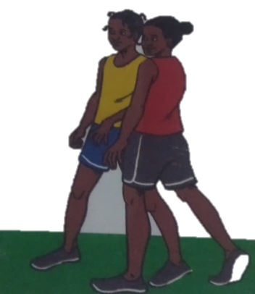
- From the game of netball, what do you think these two players are doing? (1 mk)

Marking
- Which of the following is not a punishment in the game of handball?
- 5 minutes suspension
- Yellow card
- 2 minutes suspension
- Red card
- A centre player if offside whether he of she enters which part of the netball court?
Goal area (1 mk)
- Which is the most common type of injury in a netball game?
- sprains,
- bruising,
- fractures and
- dislocation(1 mk)
- What does a referee do to start a netball game ?(1 mk)
By blowing the whistle.
- Identify the materials needed in the game of handball.(2 mks)
- Balls
- Red Cards
- Whistle
- Yellow Cards
- Give two types of passes in a game of handball. (2 mks)
- Jump pass
- Side pass
- flick pass
- Define the following terms. (4 mks)
- Reception.
Is the act of receiving the ball with one or both hands.
- Passing
It is delivering the ball to a team mate during play in a handball game.
- Pivoting
It is the act of turning with one foot on the ground while the other foot makes repeated short steps.
- Marking
It is a defensive action that limits the chances of attacking players gaining possession of the ball.
- What size is a handball court?(1 mk)
- 20 by 30m
- 20 by 40m

- 20 by 40m
- 20 by 50 m
- 20 by 60 m
- Penalties are thrown from what distance in a game of handball? 7 Metres from the goal line.(1 mk)

- Identify the type of game played using the ball below.(1 mk)
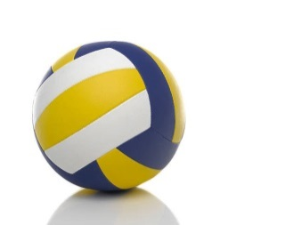Netball
- How many seconds after catching the ball does a player have to pass or shoot in netball game?
3 Seconds(1 mk)
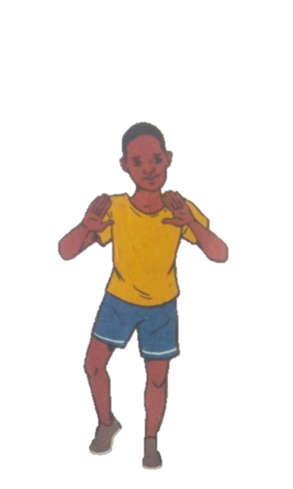
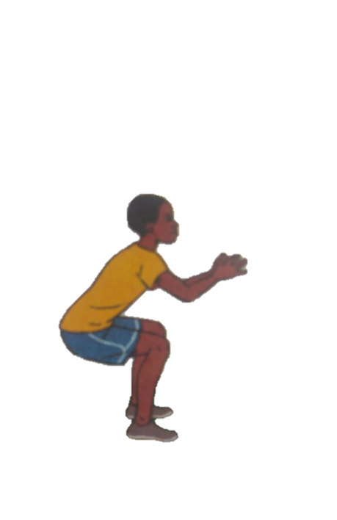
- Identify two landing techniques in footwork in netball.(2 mks)

Single Foot Landing
Double Foot Landing

- How many players from each team are allowed to be on the field in a netball game?
7 Players (1 mk)
- How long does a netball game last?
- Minutes (1 mk)
- Which type of performance has been shown below?
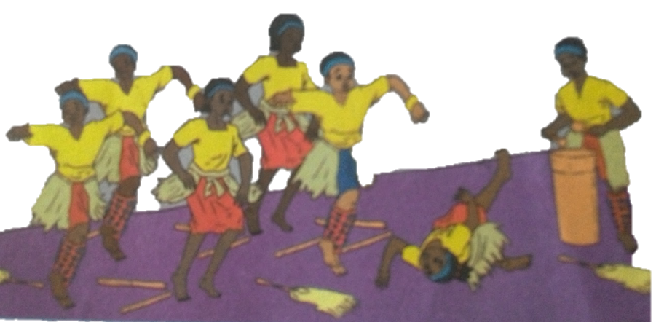

Dance

- Say why the injuries happened above
    - Too high speed
    - Sticks on the floor
    - Slippery floor
    - Poor stage formation
    - Unconsciousness of the dancer
    - Uncoordinated body movements etc
- State four ways to make sure that you are safe when dancing
  - Maintaining correct speed
  - Good stage formation
  - Avoiding too much use of props
  - Proper rehearsal before stage performance to avoid panic and falling unconscious
  - Checking stage to remove things that might cause falls
  - Ensuring the floor/stage is properly dry
  - Proper spacing of the dancers etc
- Name some of the activities dancers need to do before a performance on stage.
  - Rehearsal
  - Taking water to avoid panic
  - Exercise and relieving oneself
  - Making sure one is conversant with the stage etc

- A person who leads a song performance is called a soloist
- What are the functions of a soloist in a song performance?
  - Lead the song
  - Give clues
  - Change tone
  - Change formations
  - Starting the dance
  - Ending dance
  - Help capture the message and the mood of the dance
  - Pitching the dance songs
  - Cuing dance on the change of melodies, movements and dance
formations.
4
- Tufanye sote bidii is a line in Kiswahili Kenya National Anthem. In which verse is the line found?3
- Write the French rhythms for the following.
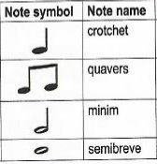

- A guitar produces sound when it is plucked
- What is the function of a resonator in a drum?
Amplify sound

THIS IS THE LAST PRINTED PAGE
……………….Every learner counts …………

