COMPETENCE BASED CURRICULUM
7
2024
JUNIOR SCHOOL
CREATIVE ARTS
TIME
2 HRS 15 MINS

Question paper
SCHOOL: …………………….……….………………………………………..…
NAME: …………………………….…………………………..…………………..
ASSESSMENT NO: ………….……. SIGN: …..……..... DATE: ………..….
RUBRICS (for official use)
MARK SCORE RANGE | Below 40 | 40-59 | 60-79 | 80-100
PERFORMANCE LEVEL | Below expectation | Approaching expectations | Meeting expectations | Exceeding expectations

OUT OF | 100%
LEARNERS SCORE
PERCENTAGE SCORE
PERFORMANCE LEVEL

FOR FACILITATOR’S USE ONLY

INSTRUCTIONS TO CANDIDATES
- Answer all the questions in the spaces provided.
- Ensure your work is neat.

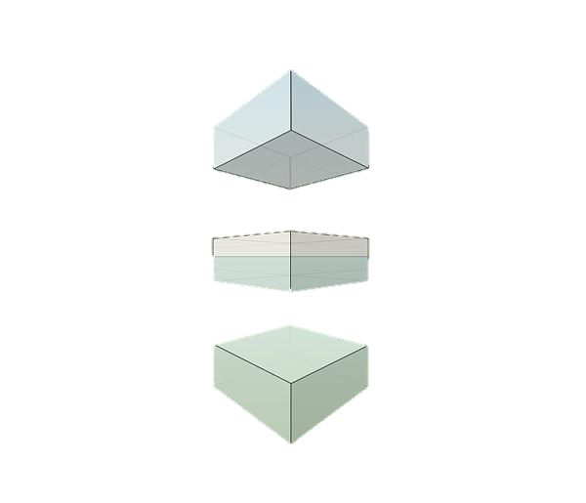
- Name the following types of eye views. ( 3mks)

- What are 3D art forms?( 3 mks)
………………………………………………………………………………………………………………………………………………………………
- Name three examples of 3D artworks (3 mks)
- …………………………………………
- …………………………………………
- …………………………………………

- Define ( 6 mks)
  - A still life drawing
………………………………………………………………………………………………………………………………………………………………
  - A composition
………………………………………………………………………………………………………………………………………………………………
  - Painting
……………………………………………………………………………………………………………………………………..…………………………….
- List down three tools and materials used in painting.( 3 mks)

- ……………………………………….
- ………………………………………
- ……………………………………..

- What is a colour wheel?( 2 mks)
……………………………………………………………………………………………………………………………………………………………………
- Name three primary colours. (3 mks)
  - ……………………………….
  - ………………………………..
  - ………………………………..

- On the circles below, insert the colours you have identified as primary colours.( 6 mks)

- Name some examples of analogous colours: (2mks)

- …………………………….
- …………………………….
- …………………………….

- There are three basic properties of colours. Namely(3 mks)
- ………………………….
- ………………………….
- …………………………..
- What is perspective?( 2mks)
…………………………………………………………………………………………………………………………………………………..
- State three components of perspective. (3mks)
- ................................................
- ………………………………
- ……………………………….

- By adding white to make the colour lighter. This is called ……………………………..(1mk)
- By adding black to make the colour darker. This is called …………………………... (1mk)

- Demonstrate using painting to show intensity scale. Mix primary colour to get orange then using appropriate procedure, paint to show intensity(7 mks)

+ =

Red +yellow=orange

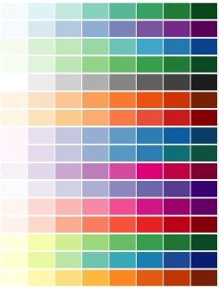
- Using the strip below, make a colour gradation strip by appropriately mixing red and yellow in their appropriate proportions

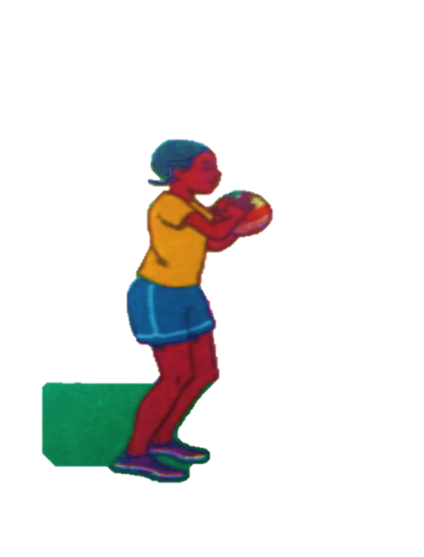

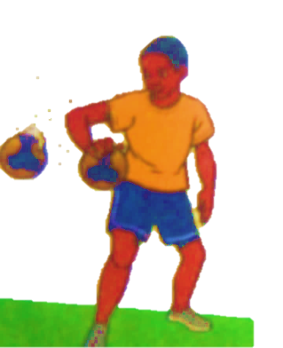
- Identify the type of pass demonstrated below.(3 mks)

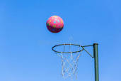
- Which type of game is shown below? (1 mk)
……………………………………….

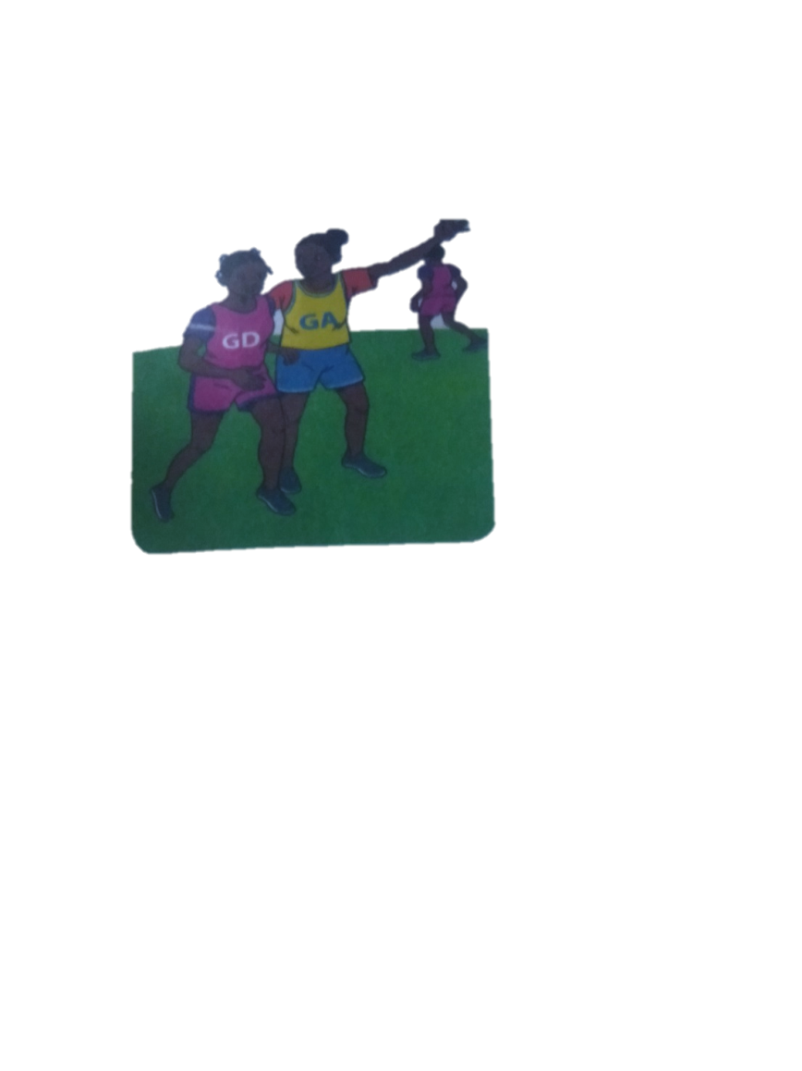
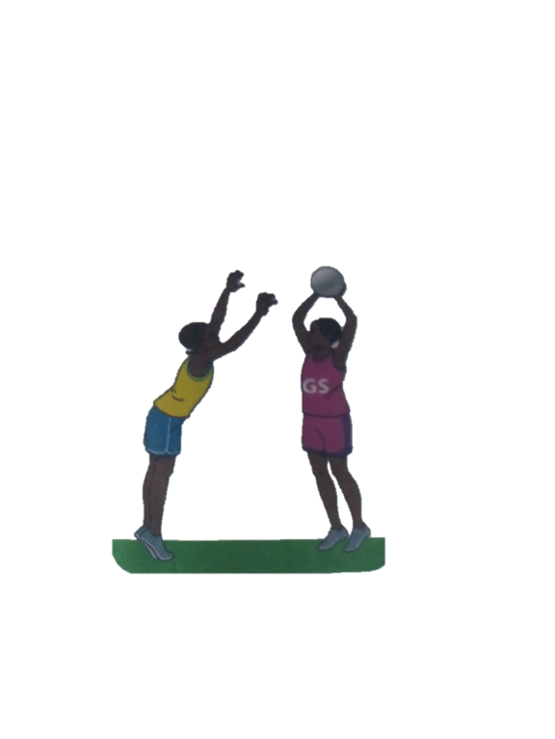
- Identify the type of marking illustrated below.( 2 mks)

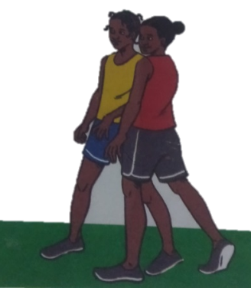
- From the game of netball, what do you think these two players are doing? (1 mk)

- Which of the following is not a punishment in the game of handball?
- 5 minutes suspension
- Yellow card
- 2 minutes suspension
- Red card
- A centre player if offside whether he of she enters which part of the netball court?................................. (1 mk)
- Which is the most common type of injury in a netball game?......................................................(1 mk)
- What does a referee do to start a netball game ?(1 mk)
…………………………………………………………..
- Identify the materials needed in the game of handball.(2 mks)
- …………………………………..
- ………………………………….
- ………………………………….
- Give two types of passes in a game of handball. (2 mks)
- …………………………………….
- ………………………………………
- Define the following terms. (4 mks)
- Reception.
………………………………………………………………………………………………
- Passing
………………………………………………………………………………………………
- Pivoting
………………………………………………………………………………………………
- Marking
……………………………………………………………………………………………..
- What size is a handball court?(1 mk)
- 20 by 30m
- 20 by 40m
- 20 by 50 m
- 20 by 60 m
- Penalties are thrown from what distance in a game of handball? ……………………………………………………..1 mk)
- Identify the type of game played using the ball below.(1 mk)

- How many seconds after catching the ball does a player have to pass or shoot in netball game?..................................................1 mk)
- Identify two landing techniques in footwork in netball.(2 mks)
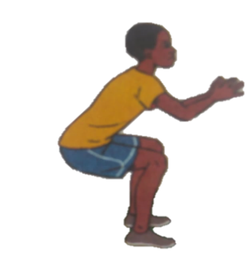
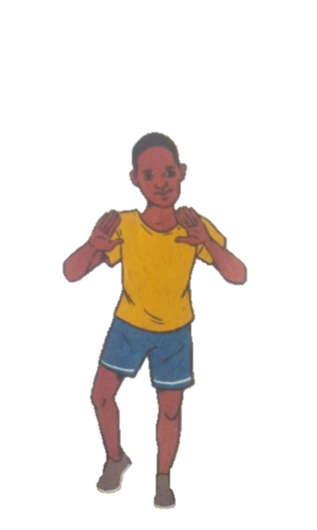

- How many players from each team are allowed to be on the field in a netball game?.............................................(1 mk)
- How long does a netball game last?..................................(1 mk)
- Which type of performance has been shown below?
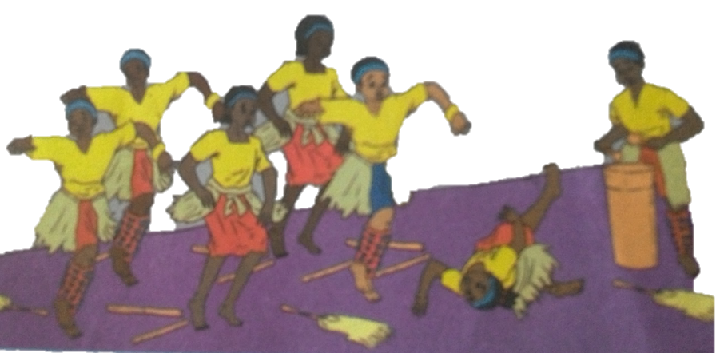

_______________________

- Say why the injuries happened above
    - _______________________________________________________________
- State four ways to make sure that you are safe when dancing
  - _____________________________________________________________________
  - _____________________________________________________________________
  - _____________________________________________________________________
  - _____________________________________________________________________
- Name some of the activities dancers need to do before a performance on stage.
  - __________________________________
  - __________________________________
- Name two materials needed when making a sisal skirt.
  - ___________________________
  - ___________________________
- A person who leads a song performance is called a __________________________
- What are the functions of a soloist in a song performance?
  - _____________________________________________
  - _____________________________________________
  - _____________________________________________
- A whistle produces sound when_____________________________
- Write two examples of percussion instruments
  - __________________________________________
  - __________________________________________
- Tufanye sote bidii is a line in Kiswahili Kenya National Anthem. In which verse is the line found?____________________________________
- Write the French rhythms for the following.
Quaver __________________________________
Crotchet________________________________
Semibreve _____________________________
Minim ________________________________
- A guitar produces sound when it is ____________________________
- What is the function of a resonator in a drum?
_______________________________________________________________________

THIS IS THE LAST PRINTED PAGE
……………….Every learner counts …………

