FORM TWO END TERM CHEM MARKING SCHEME
- Complete the table below for the characteristics of the sub atomic particles( 2marks)

sub atomic particle | Relative mass | Electrical charge
Proton | 1 | 1 √1
neutral | 1 | 0 √1

- A sample of air contaminated with carbon monoxide and sulphur (IV) oxide was passed through the apparatus shown in the diagram below.
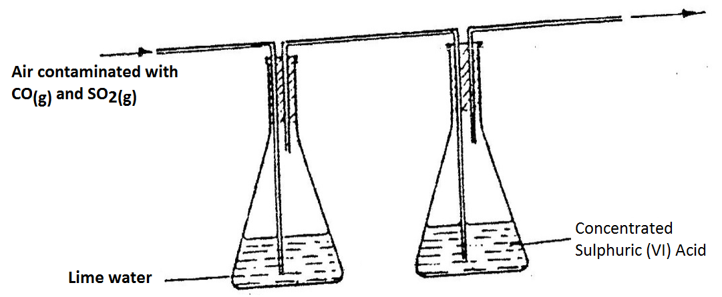

Which contaminant was removed by passing the contaminated air through the apparatus? Explain. Sulphur (IV) oxide√1, it reacts with limewater being an acidic gas √1

- Explain how you would obtain solid lead carbonate from a mixture of lead carbonate and sodium carbonate powders.
Add water √1, filter to remove lead carbonate as a residue √1, wash and dry the residue √1

- Describe how the following reagents can be used to prepare copper (II) hydroxide, solid copper (II) sulphate, solid sodium hydroxide and distilled water.
Add distilled water to solid copper (II) sulphate and solid sodium hydroxide in separate beakers to obtain their solutions. √1 mix the solutions to obtain copper (II) hydroxide precipitate √1 filter, wash and dry the residue √1
- Aluminium metal is a good conductor and is used for overhead cables. State any other two properties that make aluminium suitable for this use.

Has low density// it is light √1
Forms a protective oxide coating on its surface √1

- Type of change Reason
I Physical Change to gas then back to solid
II Chemical New substance formed
III Physical Color changes to yellow then back to white
- The table below shows the relative molecular masses and the boiling points of methane and water
 | Relative molecular mass | Boiling point(ºC)
Methane | 16 | -161
Water | 18 | 100

Explain why the boiling point of water is higher than that of methane.
The molecules of water interact through strong hydrogen bonding √1
while molecules of methane have weak van der Waals forces√1

- (a) J is basic
Bases turn litmus blue and methyl orange yellow
(b) Water, NaCl (any neutral substance)

- Air was passed through several reagents as shown in the flow chart below.
Escaping gases

Excess heated
Mg powder

Excess heated
Copper turnings
Concentrated KOH
solution

AIR

  - Write an equation for the reaction, which takes place in chamber with magnesium powder

3Mg _{(s)} + N₂ _{(g)} Mg₃N_{2(s)} √1

  - Name one gas, which escapes from the chamber containing magnesium powder. Give a reason for your answer.
Argon // Neon (name of a noble gas) √1
Because they are inert and not likely to have reacted with any of the reagents. √1

- a) To occupy space previously occupied by oxygen that was used by smouldering
phosphorous. 01
b) Because oxides of phosphorous formed still occupy space enviously occupied by oxygen.
(P₂O₅, P₂O₃) 01
c) Let all the fumes dissolve in water before final reading is taken 01

- (a) M &L
(b) NL₃
(c) Ionic radii is bigger. It gains electrons to form ions
- In temperate countries, salt is sprayed on roads to defrost and clear roads but the long term effect on this practice is costly to motorist.

- Explain the role of salt in defrosting the ice. (1mk)
It acts as an impurity in the ice hence lowering its melting point. ½

- Explain why the long term effect is costing to motorists. (1mk)
Salt accelerates the rate of rusting of the iron parts of the motor vehicles. ½

13. The grid below shows part of a periodic table. The letters do not represent the actual symbols of the elements
J
F
H
I
G

- Select the:

(i) a) Element which has the largest atomic radius.
F √1
(ii) Most reactive non-metal.
I √1
b) Show on the grid the position of the element J which forms J²⁻ ions with electronic configuration 2, 8, 8. (1mk)

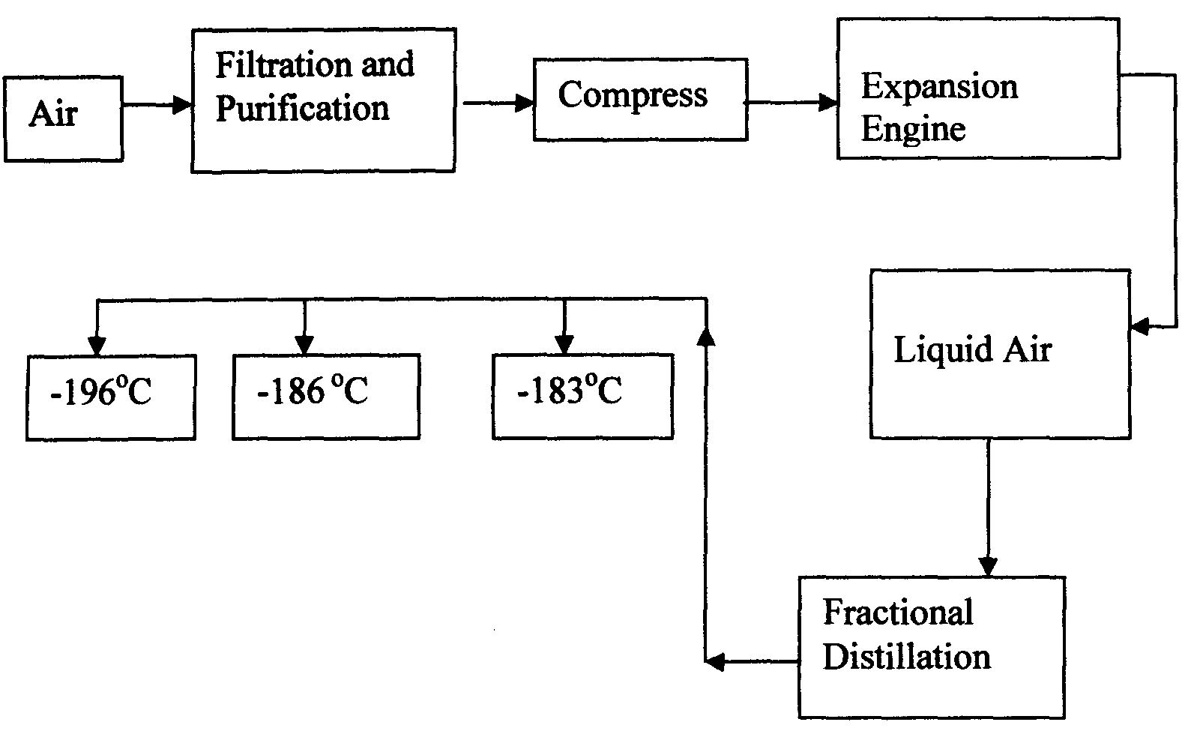
- Oxygen is obtained on large scale by the fractional distillation of air as shown on the flow chart below.

a) Explain why air is considered as a mixture (1mk)

- Various components can be separated using a physical means / method.
- Components in air are not in fixed proportions.
Any 1 x 1 = 1 mk

b) Identify the substance that is removed at the filtration stage (1mk)
- dust particles 1

c) Explain why Carbon (IV) oxide and water are removed before liquefaction of air (1mk)
- They would readily solidify ½ and block the pipes ½

d) Identify the component that is collected at -186°C (1mk)
Argon 1
- Study the table below and answer the questions that follow:-
Substance  Melting Point (ºC )  Boiling point (ºC) |  | A | B | C | D | E | F
 |  | 801 | 113 OR 119 | -39 | 5 | -101 | 1356
 |  | 1410 | 445 | 457 | 54 | -36 | 2860
Electrical  Conductivity | Solid | Poor | Poor | Good | Poor | Poor | Poor
Electrical  Conductivity | liquid | Good | Poor | Good | Poor | Poor | Poor

Identify with reasons the substances that:
(i) Have a metallic structure (2mks)
C 1 Good conductor of electricity 1 in both solid and liquid state due to delocalised

(ii) Have a molecular structure (2mks)
D or E 1 Are poor conducts in both solid / liquid state.
Have relatively low M.P and B.P due to molecular structure.

(iii) Suggest a reason why substance B has two melting points (1mk)
Exists as allotropes 1

(iv) Substances A and C conduct electric current in the liquid state. State how the two
substances differ as conductors of electric current (2mks)

A – mobile / free ions
B – Delocalized electrons

16. Atoms of element X exists as $\begin{matrix}14 \\ 6\end{matrix} X$and $\begin{matrix}12 \\ 6\end{matrix} X$
(a) What name is given to the two types of atoms.
Isotope √1
(b) Use dot (∙) and cross (x) diagrams to illustrate the atomic structure of $\begin{matrix} 14 \\ 6\end{matrix} X$
Nucleus composition √1

E c 2.4 √1

- (a) Give 2 reasons why most laboratory apparatus are made of glass. (1mk)

- Glass does not react with most chemicals ½
- It is transparent one can see when reaction is taking place. ½
- It is easy to clean. ½ any 2

(b) The diagrams below are some common laboratory apparatus. Name each apparatus and state its use. (2mks)

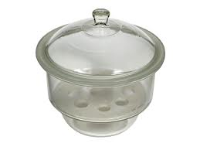
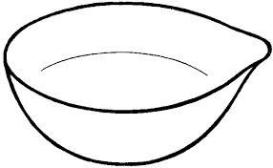
Name: Desiccator Name Evaporating dish

Use Drying or keeping substances from moisture Use Evaporating liquids to obtain crystals

18. Soot is one of the environmental pollutants .
(i) Explain the term pollutant.
Harmful substance released into the environment √1

(ii) State how soot is formed from hydrocarbons.

Soot is formed when hydrocarbons burns in a limited supply of oxygen √1 // incomplete combustion

19. (a) (i) Phosphorus (III) oxide
(ii) Phosphorus (V) oxide
(b) Acidic
20. (a) (i) Smallest particle of an element that can take part in a chemical reaction.
(ii) Number of protons and neutrons in the nucleus of an atom.
- T₂(SO₄)₃
Chips

21. Crystals of sodium carbonate decahydrate (Na₂CO₃.10H₂O) were exposed to air for about four days.
(i) State what was observed.
A white powder was formed √1
(ii) Name the process that took place.
Efflorescence √1
(ii) Write an equation for the reaction that occurred.
Na₂CO₃.10H₂ O_{(s )} Na₂CO₃.H₂O_{(s )} + 9H₂O_{(l)} √1

22. Explain why molten calcium chloride conducts electricity while silicon (IV) oxide does not.
Molten calcium chloride contains delocalized ions which carry charge√1 but silicon (IV) oxide does not √1

23. The table below gives the first ionization energy of three elements.
Element | A | B | C
1st ionization energy(kJ/mol) | 496 | 419 | 520

(i) Define the term first ionization energy.
First ionization energy is the minimum amount of energy required to remove the first electron
From a gaseous atom √1
(ii) select the element that is the most reactive. Explain.
B √1 it has the least ionization energy therefore loses electrons most readily √1

30. State the colour of the indicators in the solutions given in the table below:
 | Colour in
Indicator | Acid | Base
Litmus | Red | Blue √1
Methyl orange | Orange √1 | Yellow
Phenolphthalein | Colourless | Pink √1

