KENYA JUNIOR SCHOOL EDUCATION ASSESSMENT.
GRADE 8
Pretechnical studies- (Theory)
Time: 1¹/₂ Hours.
September 2024.

Learner’s Name:______________________________________________________________
Assessment No:_____________________________ Grade:___________________________
Date:________________________________________________________________________

FOR EXAMINERS USE ONLY.
Score Range | Performance Level | Tick
80-100 | Exceeding Expectation
60-79 | Meeting Expectations
40-59 | Approaching Expectations
Below 40 | Below Expectations
OUT OF | 60 MARKS
Learners Score.
Learners %
Instructions to Learners.
- Write your name, Assessment Number, Grade/Stream and the Date in the spaces provided above.
- Answer all questions in this question paper.
- All your answers must be written in the spaces provided below each question.
- This paper consists of printed pages. Learners should check the questions in each paper to ascertain that all the papers are printed as indicated and that there is no question missing.
- Answer all the questions in English.
QUESTIONS.

1. Write down any five composite materials found in the environment. (5mks)
_________________________________________________________________________________________________________________________________________________________________________________________________________________________________________________________________________________________________________________________________________________________________________________________________

2. Name three components used to make ceramic materials. (3mks)
_______________________________________________________________________________________________________________________________________________________________________________________________________________________________________

3. Give four properties of ceramic materials. (4mks)
____________________________________________________________________________________________________________________________________________________________________________________________________________________________________________________________________________________________________________________

4.
a.) Give the identity of the following tools. (4mks)
Tool A Tool B Tool C Tool D
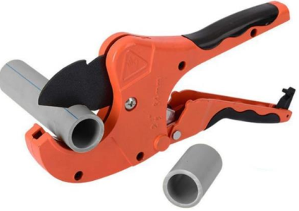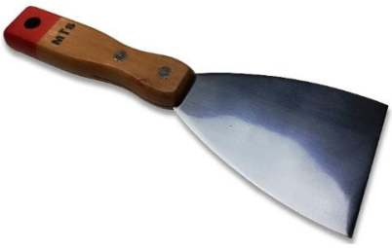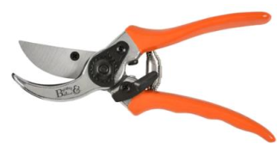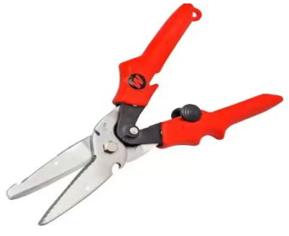
_________________ __________________ ___________________ __________________

b.) State the use of tools labelled A and C. (2mks)
A ___________________________________________________________________________
C ___________________________________________________________________________

5. Grade seven learners from Voi junior secondary school were asked by their class teacher to discus and fill the table below with examples of various classifications of computers. Fill the table below appropriately. (6mks)
Computer classified according to size | Computers classified according to purpose | Computer classified according to functionality
1._______________________  2._______________________ | 1.______________________  2.______________________ | 1.______________________  2.______________________

6. Identify IF the following are goods or services. (5mks)
Item | Indicate of it is a good or a service
Teaching
Food
Security
Furniture
Entertainment

7. Complete the abbreviations used in Pretechnical studies below. (2mks)
a.) C.P.U ________________________________________________________________
b.) S.S.D ________________________________________________________________

8. The buying of items you had not planned to buy is referred to as (2mks)
_____________________________________________________________________________

9. Give five examples of written communications. (5mks)
_________________________________________________________________________________________________________________________________________________________________________________________________________________________________________________________________________________________________________________________________________________________________________________________________

10. Name three output devices that give output inform of softcopy. (3mks)
_______________________________________________________________________________________________________________________________________________________________________________________________________________________________________

11. The practice of recording and tracking on a regular basis the financial transactions of a business is referred to as _____________________________________________ (2mks)

12. Metallic materials are described to be sonorous. What does this characteristic suggest about metallic materials. (2mks)
__________________________________________________________________________________________________________________________________________________________

13. Give the example of data entered in the computer using the following devices. (4mks)
a.) Keyboard __________________________________________________________________
b.) Scanner ___________________________________________________________________
c.) Microphone _______________________________________________________________
d.) Camera ___________________________________________________________________

14. Name any two common examples of visual programming applications. (2mks)
__________________________________________________________________________________________________________________________________________________________

15. Give three factors to consider when selecting a channel of communication. (3mks)
_______________________________________________________________________________________________________________________________________________________________________________________________________________________________________

16. Make drawings of the following lines. (2mks)
a.) Spiral line

b.) Dotted line

17. Name four sectors in which computers are used today. (4mks)
_______________________________________________________________________________________________________________________________________________________________________________________________________________________________________

THIS IS THE LAST PRINTED PAGE.

