KENYA JUNIOR SCHOOL EDUCATION ASSESSMENT.
GRADE 8
SOCIAL STUDIES.
Time: 1¹/₂ Hours.

Learner’s Name:______________________________________________________________
Assessment No:_____________________________ Grade:___________________________
Date:________________________________________________________________________

FOR EXAMINERS USE ONLY.
Score Range | Performance Level | Tick
80-100 | Exceeding Expectation
60-79 | Meeting Expectations
40-59 | Approaching Expectations
Below 40 | Below Expectations
OUT OF | 50 MARKS
Learners Score.
Learners %
Instructions to Learners.
- Write your name, Assessment Number, Grade/Stream and the Date in the spaces provided above.
- Answer all questions in this question paper.
- All your answers must be written in the spaces provided below each question.
- This paper consists of printed pages. Learners should check the questions in each paper to ascertain that all the papers are printed as indicated and that there is no question missing.
- Answer all the questions in English.
QUESTIONS.
1. Give three importance of fossil records. (3mks)
_______________________________________________________________________________________________________________________________________________________________________________________________________________________________________

2. Who were the early visitor to the East African coast? Give four examples. (4mks)
____________________________________________________________________________________________________________________________________________________________________________________________________________________________________________________________________________________________________________________
3. Give three main causes of population growth in Africa. (3mks)
_______________________________________________________________________________________________________________________________________________________________________________________________________________________________________

4. Write down three factors influencing self-esteem. (3mks)
_______________________________________________________________________________________________________________________________________________________________________________________________________________________________________

5. State three values that enhance effective resilience in life. (3mks)
_______________________________________________________________________________________________________________________________________________________________________________________________________________________________________

6. Give three situations that that leads to conflict in life. (3mks)
_______________________________________________________________________________________________________________________________________________________________________________________________________________________________________

7. Give three non-violent methods of solving conflicts. (3mks)
_______________________________________________________________________________________________________________________________________________________________________________________________________________________________________

8. Write down the three stages of human evolution represented by letters x, y and z. (3mks)
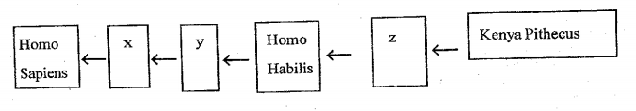
_______________________________________________________________________________________________________________________________________________________________________________________________________________________________________

9. Write down four reasons why the Europeans came to Africa. (4mks)
____________________________________________________________________________________________________________________________________________________________________________________________________________________________________________________________________________________________________________________

10. Explain how the following enhanced the growth of East African city states. (3mks)
a.) Monsoon winds.
__________________________________________________________________________________________________________________________________________________________
b.) Deep natural harbours
__________________________________________________________________________________________________________________________________________________________
c.) Bantu migration and arrival of the Arabs.
__________________________________________________________________________________________________________________________________________________________

11. Write down five elements of a map. (5mks)
_________________________________________________________________________________________________________________________________________________________________________________________________________________________________________________________________________________________________________________________________________________________________________________________________

12. State any four classes of human rights. (4mks)
____________________________________________________________________________________________________________________________________________________________________________________________________________________________________________________________________________________________________________________

13. The structures below were used by the Ogiek community to carry out a certain economic activity. Structure A Structure B
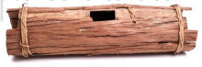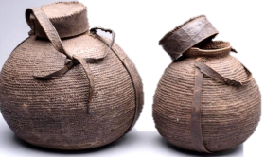
- Identify the structures above. (2mks)
A ___________________________________________________________________________
B ___________________________________________________________________________
- Give the use of the structures. (2mks)
A ___________________________________________________________________________
B ___________________________________________________________________________
- Identify the economic activities the Ogiek carried out using the structures above. (1mk)
__________________________________________________________________________

14. Give two physical features that can be represented on topographical maps. (2mks)
__________________________________________________________________________________________________________________________________________________________

15. Name any two-equipment you can use to measure distance on a map. (2mks)
__________________________________________________________________________________________________________________________________________________________
THIS IS THE LAST PRINTED PAGE.

