COMPETENCE BASED ASSESSMENT
GRADE NINE
EXTRA-ACTIVITY ASSESSMENT
AGRICULTURE
NAME: ____________________________________________________
SCHOOL: ___________________________________________________
DATE: _____________________________________________________

1. Grade 8 learners used different ICT tools to obtain information about inputs in agriculture.

State any two inputs they may have seen. (2mks)

_____________________________________________________________________________

_____________________________________________________________________________

- State three challenges associated with use of innovative waterers in the community. (3mks)

_____________________________________________________________________________

_____________________________________________________________________________

_____________________________________________________________________________

_____________________________________________________________________________

- Grade 9 prepared the following during conservation of forage. Use the picture to answer the questions that follow.

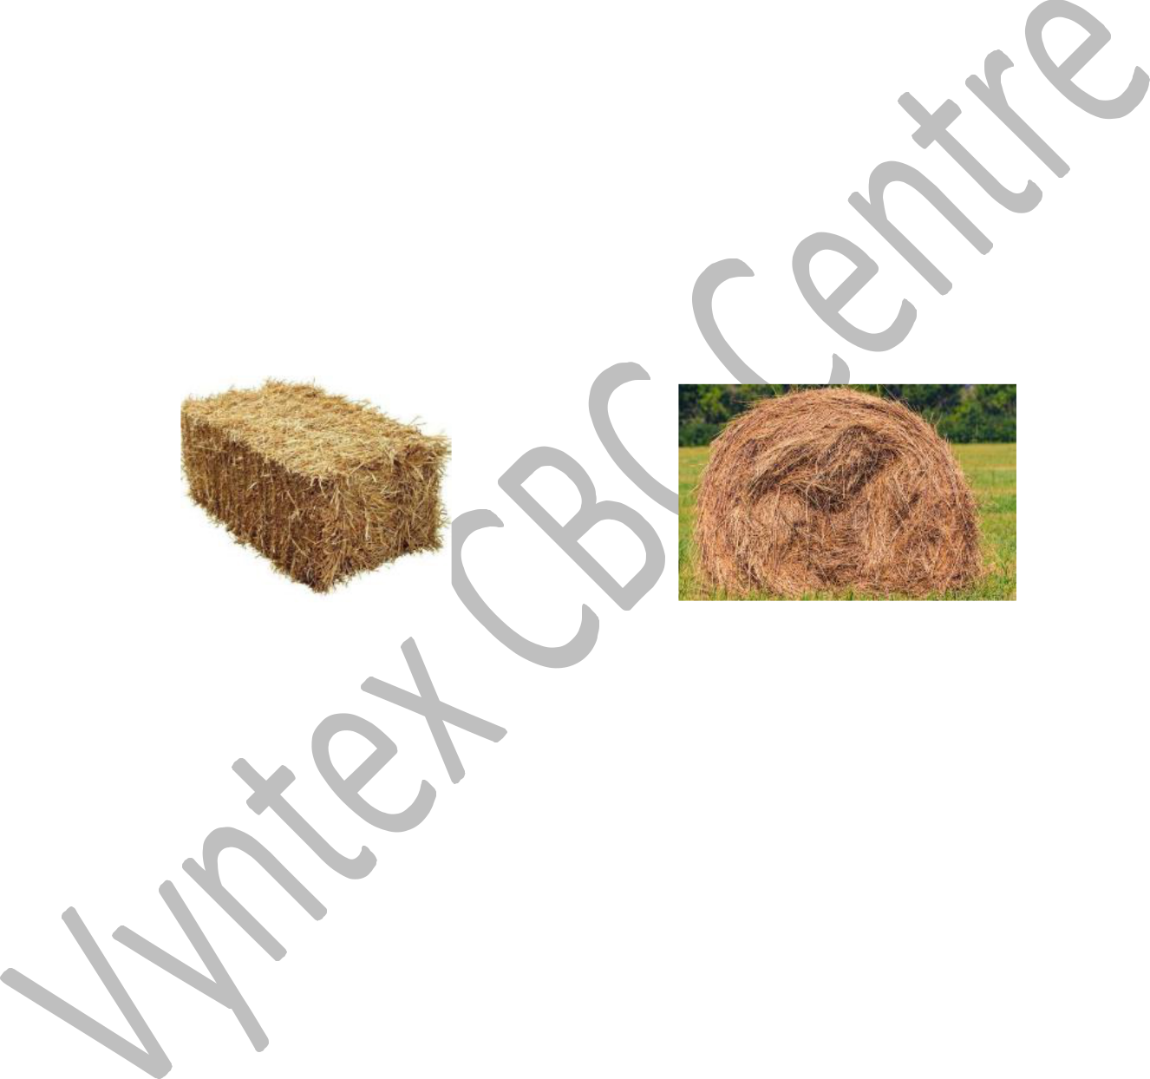
A B

a.) Name the two methods of conserving hay above. (2mks) Method A ____________________________________________________________________

Method B ____________________________________________________________________

b.) State three advantages of conserving hay using method A compared to method B. (3mks)

_____________________________________________________________________________

_____________________________________________________________________________

_____________________________________________________________________________

c.) List down four materials required when making hay using method A. (4mks)

_____________________________________________________________________________

_____________________________________________________________________________

_____________________________________________________________________________

_____________________________________________________________________________

d.) Give three factors to consider when selecting the methods of conserving forage. | (3mks)

_____________________________________________________________________________

_____________________________________________________________________________

_____________________________________________________________________________

4. Grade 7 learners from a certain school took pictures while planting trees as shown below.

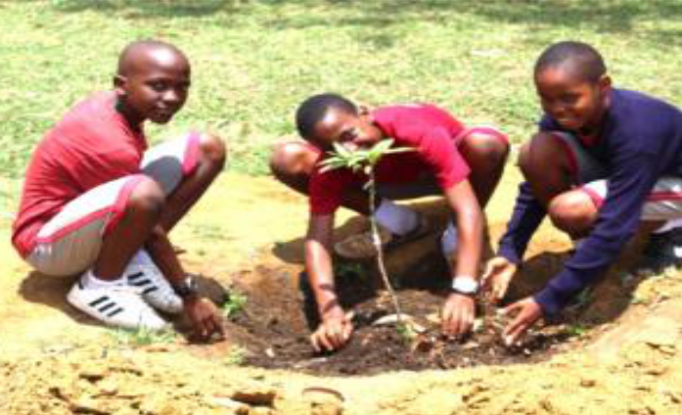

a.) Give two ways the learners used to avoid soil pollution during the exercise above. (2mks)

_____________________________________________________________________________

_____________________________________________________________________________

b.) State three practices the learners might have used to take care of the trees planted. (3mks)

_____________________________________________________________________________

_____________________________________________________________________________

_____________________________________________________________________________

_____________________________________________________________________________

c.) Give three roles played by trees in soil and water conservation. (3mks)

_____________________________________________________________________________

_____________________________________________________________________________

_____________________________________________________________________________

_____________________________________________________________________________

5. Name three crops in which earthing up is required. (3mks)

_____________________________________________________________________________

_____________________________________________________________________________

_____________________________________________________________________________

- The diagram below shows a certain poultry structure. Use it to answer the questions that follow.

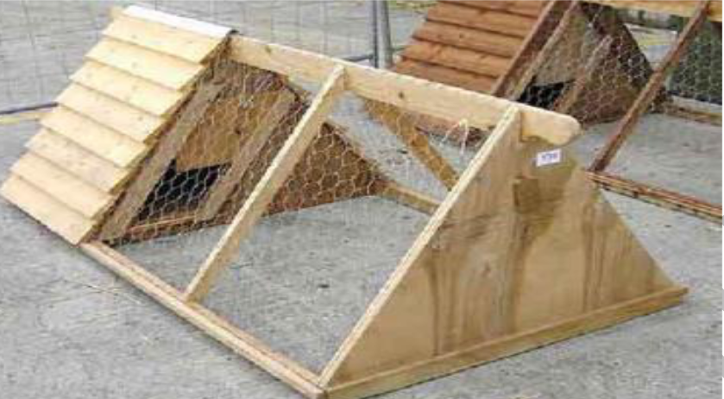

a.) Identify the structure above. (1mk)

_____________________________________________________________________________

b.) State any four locally available materials that can be used when constructing the structure. (4mks)

_____________________________________________________________________________

_____________________________________________________________________________

_____________________________________________________________________________

_____________________________________________________________________________

c.) Grade 8 learners have been asked by their teacher to locate a suitable site where the structure above can be located. State three factors the learners should consider when siting the structure.
(3mks)

_____________________________________________________________________________

_____________________________________________________________________________

_____________________________________________________________________________

d.) Give three routine management practices required when using the structure above in rearing

poultry. (3mks)

_____________________________________________________________________________

_____________________________________________________________________________

_____________________________________________________________________________

_____________________________________________________________________________

- The pictures below shows two different types of innovative kitchen gardens used by learners from Horizon Junior secondary school.

Garden A Garden B

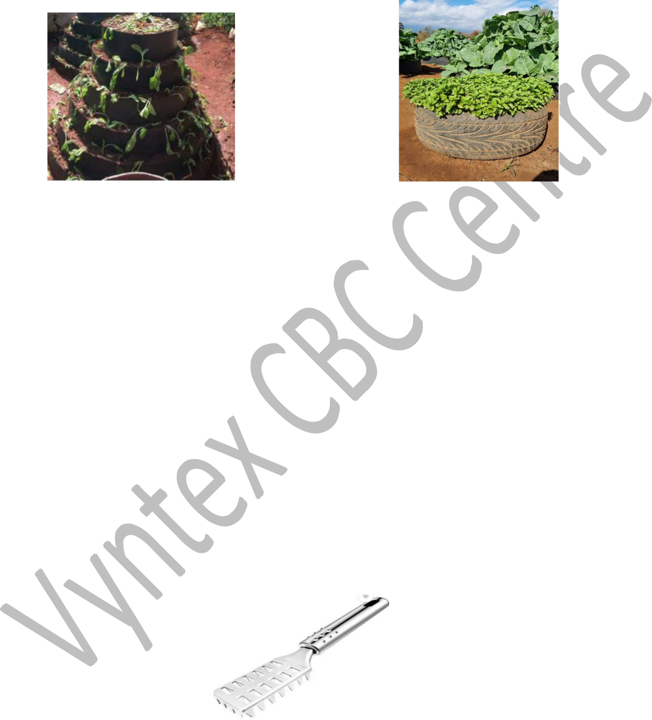

a.) Identify the two types of innovative kitchen gardens in pictures above. (2mks)

- ___________________________________________________________________________

- ___________________________________________________________________________

b.) State three roles played by the innovative kitchen gardens above. (3mks)

_____________________________________________________________________________

_____________________________________________________________________________

_____________________________________________________________________________

_____________________________________________________________________________

c.) State three indications learners can use to know the vegetables planted in the kitchen

gardens are attacked by pests. (3mks)

_____________________________________________________________________________

_____________________________________________________________________________

_____________________________________________________________________________
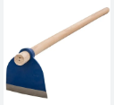

8

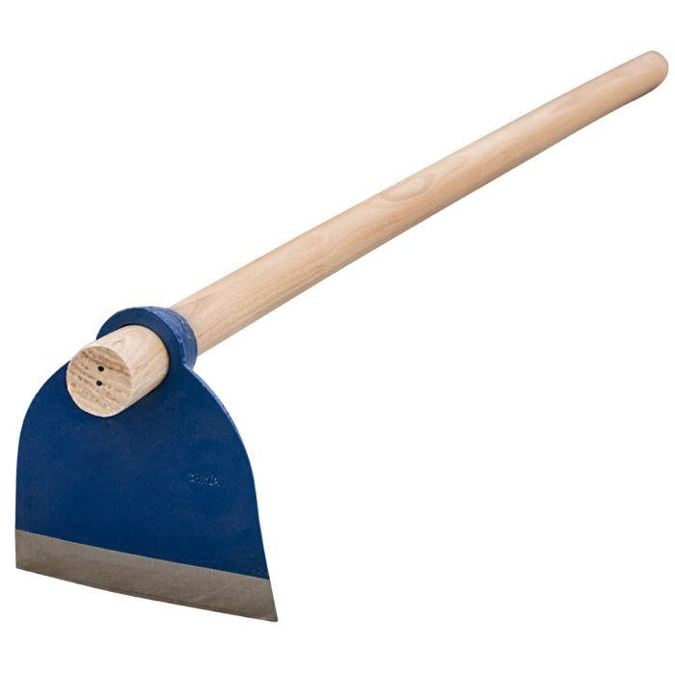

This is a ______________ used for _____________________ during ______________ (3mks)

THIS IS THE LAST PRINTED PAGE.

1. ICT Tools and Agricultural Inputs
Two agricultural inputs they may have seen:
- Seeds
- Fertilizers

2. Challenges of Innovative Waterers
Three challenges:
- High initial cost of purchasing and installing the waterers
- Possible breakdowns due to mechanical issues
- Limited knowledge in operating and maintaining the system

3. Conservation of Forage

a.) Methods of Conserving Hay
- Method A: Baling
- Method B: Stacking

b.) Advantages of Method A (Baling) over Method B (Stacking):
- Easier to transport and store
- Protects hay from weather damage
- Reduces wastage during feeding

c.) Four materials required for making hay using method A:
- Cutting tools (sickle/mower)
- Binding twine
- Bale press/machine
- Dry grass

d.) Three factors to consider when selecting a method of conserving forage:
- Cost of conservation method
- Availability of storage space
- Climate conditions in the area

4. Tree Planting Activity

a.) Ways learners avoided soil pollution:
- Using organic manure instead of chemical fertilizers
- Properly disposing of plastic and non-biodegradable waste

b.) Three practices used to take care of the trees:
- Regular watering of the trees
- Mulching to retain soil moisture
- Weeding around the tree base

c.) Three roles of trees in soil and water conservation:
- Prevent soil erosion by holding the soil
- Improve water infiltration into the ground
- Provide shade that helps retain soil moisture

5. Crops Requiring Earthing Up
Three crops:
- Potatoes
- Maize
- Carrots

6. Poultry Structure

a.) Name of the Structure
- Poultry house (Chicken coop)

b.) Four locally available materials for constructing the structure:
- Timber
- Wire mesh
- Iron sheets
- Nails

c.) Three factors to consider when locating the structure:
- Should be well-ventilated
- Should be near a water source
- Should be safe from predators

d.) Three routine management practices:
- Cleaning the poultry house
- Providing food and water
- Disease control and vaccination

7. Innovative Kitchen Gardens

a.) Identifying the two types:
- A: Sack garden
- B: Vertical garden

b.) Three roles of innovative kitchen gardens:
- Provide fresh vegetables
- Utilize small spaces efficiently
- Promote organic farming

c.) Three signs of pest attack in vegetables:
- Leaves with holes or eaten edges
- Wilting or stunted growth
- Presence of insects or larvae on leaves

8. Identify the Tool and Its Use
- This is a hoe
- Used for digging and weeding
- During land preparation

