KENYA JUNIOR SCHOOL EDUCATION ASSESSMENT.

TERM 1 2025

GRADE 9.

905 - INTEGRATED SCIENCE.

 | Time: 2 Hours.
NAME: ______________________________________________________________________
SCHOOL: ____________________________________________________________________
STREAM: ____________________________ | DATE: __________________

INSTRUCTIONS

Write your name, school, stream and the date in the spaces provided.

Answer all the questions in the booklet using the spaces provided after every question.

All questions are answered I n English.

All answers must be given according to the guidelines of each question.

ASSESSMENT RUBRICS.

RANGE LEVEL

80% to 100% | Exceeding Expectations.
60% to 79% | Meeting Expectations.
40% to 59% | Approaching Expectations.
0% to 39% | Below Expectations

LEARNER’S SCORE

OUT OF 50 MARKS

Score

% Score

1

1. Calcium has an atomic number = 20. Determine:
a.) The number of electrons in calcium. | (1mk)
_____________________________________________________________________________

b.) Its electronic arrangement. (2mks)
_____________________________________________________________________________

c.) Its electronic structure. (3mks)

2. Define the term compressibility. (2mks)
_____________________________________________________________________________
_____________________________________________________________________________
_____________________________________________________________________________

- Mwalimu Moses brought a chart shown below in grade 7. He asked the learners to name the parts labeled by the letter as shown in the chart.
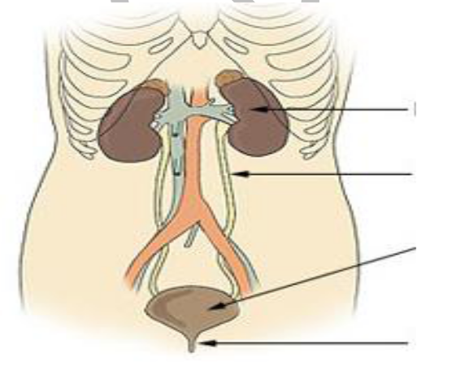

A

B

C

D
a.) Name the parts labeled A, B, C and D. (4mks)
- ___________________________________________________________________________
- ___________________________________________________________________________

- ___________________________________________________________________________
- ___________________________________________________________________________
b.) Write down four healthy lifestyle practices that keeps part A healthy. (4mks)
_____________________________________________________________________________
_____________________________________________________________________________
_____________________________________________________________________________

_____________________________________________________________________________

2

c.) Which part:
i. Temporarily stores urine. | (1mk)
_____________________________________________________________________________

ii. Carry urine form the kidney to the bladder. (1mk)
_____________________________________________________________________________

d.) State four excretory waste products required to be eliminated from the body. |  | (4mks)
___________________________________ | _____________________________________
___________________________________ | _____________________________________
e.) Name any three disorders that affects part labeled A. |  | (2mks)
_____________________________________________________________________________

_____________________________________________________________________________

- Grade 8 learners from a certain school set an experiment using a peeled potato as shown below. Use it to answer the questions that follow.
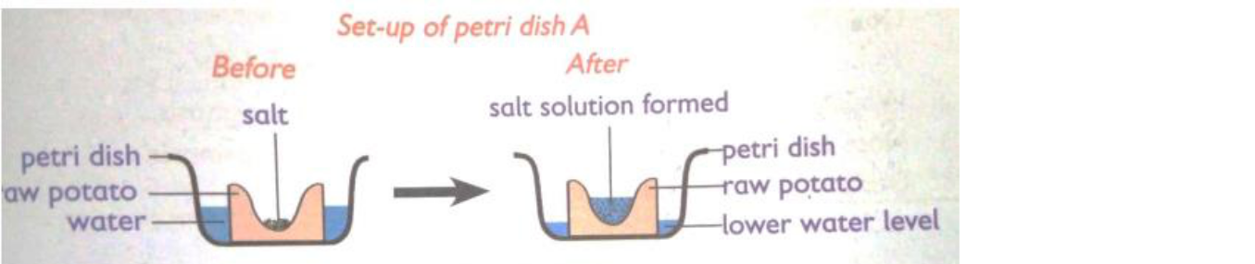

a.) Name the process being investigated through the set up above. (1mk)
_____________________________________________________________________________

b.) Why was it necessary to peel off the potato before using it in the experiment. (2mks)
_____________________________________________________________________________
_____________________________________________________________________________

c.) State the two observations after the experiment was set up. (2mks)

_____________________________________________________________________________
_____________________________________________________________________________
_____________________________________________________________________________

c.) Explain the observations in (b) above. (2mks)
_____________________________________________________________________________
_____________________________________________________________________________

e.) Explain the results in case the learners used a boiled potato. (2mks)

3

_____________________________________________________________________________
_____________________________________________________________________________

6.
a.) What are metalloids? (2mks)
_____________________________________________________________________________

_____________________________________________________________________________

b.) Name two examples of metalloid. _________________________________

(2mks)
____________________________________

7.
a.) Give two main reasons for making metal alloys. (2mks)

_____________________________________________________________________________
_____________________________________________________________________________

b.) Give one common use of the following metals. (2mks)
- Aluminium ________________________________________________________________
- Copper ____________________________________________________________________

8.
a.) For rusting to occur, there must be _________________ and __________________ (2mks)

b.) State four ways used to prevent rusting. _____________________________________ _____________________________________

(4mks)
_____________________________________

_____________________________________


9. Use the picture below to answer the questions that follow.

M

 |  | N
a.) Name the parts labelled M and N. |  |  |  | (2mks)
M_________________________ | N __________________________
c.) Identify the process that takes place when the two parts meet. |  |  |  | (1mk)
_____________________________________________________________________________
THIS IS THE LAST PRINTED PAGE

4

