KENYA JUNIOR SCHOOL EDUCATION ASSESSMENT

TERM 1 2025

G9 – MATHEMATICS.

Time: 2 Hours.

NAME: ______________________________________________________________________

SCHOOL: ____________________________________________________________________

STREAM: ____________________________ DATE: __________________

INSTRUCTIONS

Write your name, school, stream and the date in the spaces provided.

Answer all the questions in the booklet using the spaces provided after every question.

All questions are answered I n English.

All answers must be given according to the guidelines of each question.

ASSESSMENT RUBRICS.

RANGE LEVEL

80% to 100% | Exceeding Expectations.
60% to 79% | Meeting Expectations.
40% to 59% | Approaching Expectations.
0% to 39% | Below Expectations

LEARNER’S SCORE

OUT OF 50 MARKS

Score

% Score

1

1. Work out the operation below. | (4mks)
a.) 5 + (-7) x 3 – 8

b.) -12 x (-2) +20

2. Round off the following number to the nearest ten thousand; 38679. (2mks)

- The government spend sh.8000045000 for buying medicine in the country last year. Write the number in

words.(2mks)

__________________________________________________________________________________________

__________________________________________________________________________________________

- The GCD of two numbers is 12 and their LCM is 240. If one of the numbers is 60, find the other number.

(3mks)

2

5. If x = -2, y = -6 and z =4, find the value of; | (4mks)
a.) ^{4xy}/z

b.) 4z + 2y - x

6. A girl spent ²/₅ of her pocket money on bread and ¹/₆ of the remainder in stationery. If she had Ksh.200 left,

how much pocket money did she have at the beginning. (3mks)

7. The area of 10 square plots is 160 acres. Find the length in metres of the side of each plot. (3mks)

8. The diagram below shows a pipe. Work out the surface area of the pipe below. Take
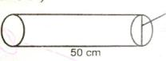

= 3.14

(4mks)

15 cm

3

9. Use a calculator to find the square root of 1098.19. give your answer in 4 significant figures. (2mks)

10. The diagram below shows a section of a polygon. How many sides does the polygon have? (2mks)

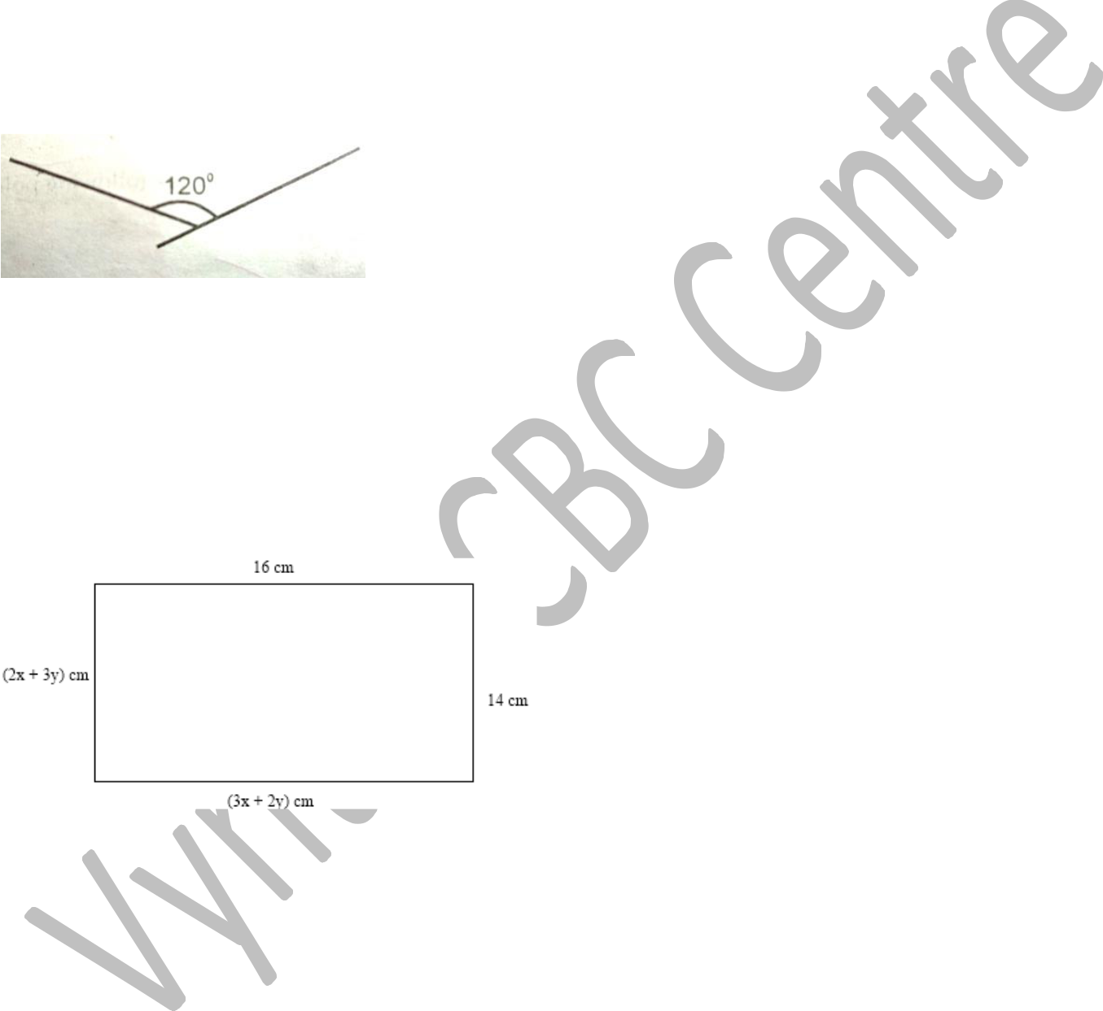

11. The sides of a rectangle flower bed are shown in the figure below.

a.) Form two simultaneous equations from the information represented in the diagram. (2mks)

b.) Solve the simultaneous equations by elimination method. (3mks)

4

G9T102-2025

c.) Work out the area of the figure. (2mks)

- The cash price of a refrigerator is sh.50,000. Nyongesa bought the refrigerator on hire purchase terms by paying a deposit of sh.10,000 followed by 12 monthly instalments of sh.4,000 each. Calculate the hire purchase

price of the refrigerator. (4mks)

13. Work out the length of the arc shown below to the nearest whole number. (2mks)

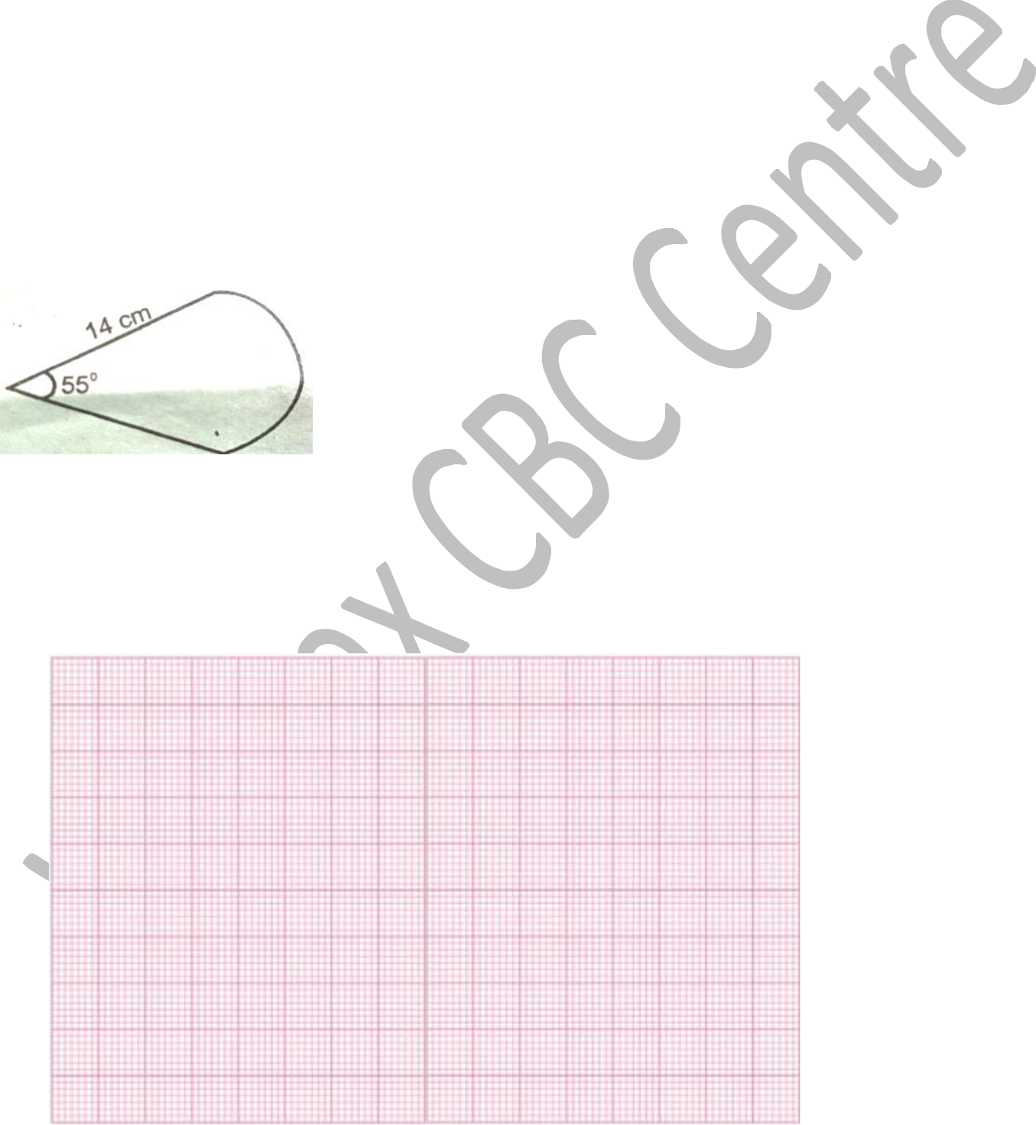

14. In the graph paper provided, draw a Cartesian plane and locate the following points. P(-6, 3) M(6,5) X(-1,-4) O(0,0)

(4mks)

5

15. Covert 2.3 as a fraction. (3mks)

16. On a map the scale is 1:50000. What is the actual length of the path that measures 5cn on the map in kilometers?

(2mks)

THIS IS THE LAST PRINTED PAGE

6

