
KENYA JUNIOR SCHOOL EDUCATION ASSESSMENT
KEJSEA ENDTERM ONE 2025
GRADE 9
912/1- PRETECHNICAL STUDIES (THEORY)
Name: ____________________________________________________________.
School: ___________________________________________________________.
Signature: _________________________ Date: ________________________.
Duration: 2 ¾ Hours
Total Marks: 70 marks
FOR FACILITATOR’S USE ONLY
SCORE RANGE | 40-50 | 28-40 | 14-27 | 0-13
LEVEL | EXCEEDING EXPECTATION | MEETING EXPECTATION | APPROACHING EXPECTATION | BELOW EXPECTATION
LEARNER’S SCORE
TICK LEVEL

General Instructions:

General Instructions:
- Answer all the questions.
- Time allowed: 2 hours.
- Write your answers clearly and legibly.
- Ensure that you understand each question before attempting to answer.
SECTION A: MULTIPLE CHOICE (20 marks)
- Which part is an output component?
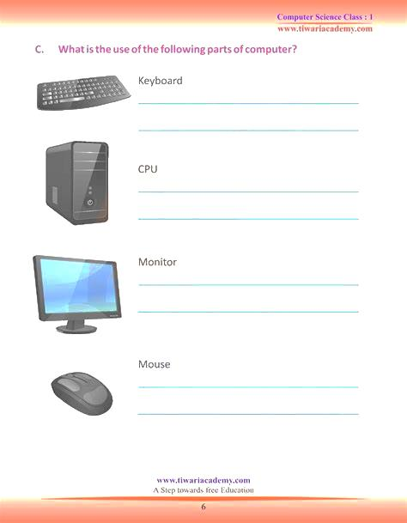
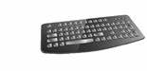

A B C D
- Which of the following is a type of software used to browse the internet?
  - Word processor
  - Web browser
  - Database
  - Spreadsheet
- What does CPU stand for in computer technology?
  - Central Process Unit
  - Central Processing Unit
  - Central Power Unit
  - Central Program Unit
- Which of these devices is considered an input device?
  - Monitor
  - Keyboard
  - Speaker
  - Printer

- Which type of metal has been used to make the following item?
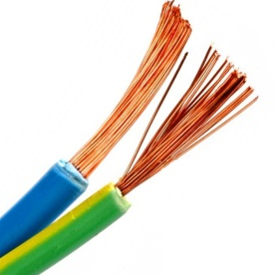
  - Copper
  - Iron
  - Bronze
  - Aluminum
- Which of the following tools is used for measuring angles?
  - Vernier caliper
  - Protractor
  - Ruler
  - Hammer
- What type of material is commonly used for the body of a car?
  - Steel
  - Wood
  - Glass
  - Paper
- What does the following symbol stand for?

  - Parallel
  - Perpendicular
  - Horizontal
  - Vertical

- What is the main theme in the following Kenyan currency?
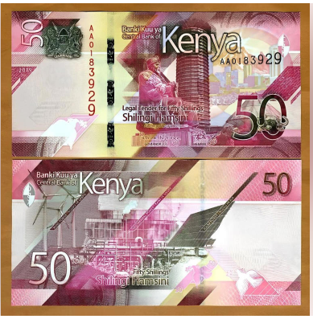
  - Agriculture
  - Healthcare
  - Green energy
  - Tourism

- A business that provides services rather than goods is called:
  - Manufacturing business
  - Service business
  - Retail business
  - Wholesale business
- Which of the following is a characteristic of a sole proprietorship?
    - Shared ownership
    - Limited liability
    - Single ownership
    - Joint decision-making

- Which of the following is NOT a hand tool used in woodworking?
a) Try square
b) Sledgehammer
c) Chisel
d) Jack plane
- What does CAD stand for in technical drawing?
a) Computer Aided Drafting
b) Computer Assisted Development
c) Computer Architecture Design
d) Computer Automated Drawing
- The most common material used for making electrical wiring is:
a) Iron
b) Copper
c) Aluminium
d) Lead
- The main function of a motherboard in a computer is to:
a) Store data permanently
b) Connect and communicate with all hardware components
c) Print documents
d) Protect against viruses
- A printer is an example of a:
a) Storage device
b) Processing device
c) Output device
d) Communication device
- Which of these storage devices has the largest capacity?
a) CD-ROM
b) Flash drive
c) Hard disk
d) Floppy disk
- The part of a computer that temporarily holds data and instructions during processing is:
a) Hard drive
b) RAM
c) ROM
d) Power supply
- Which of the following is a characteristic of an entrepreneur?
a) Risk-taking
b) Laziness
c) Fear of failure
d) Avoiding responsibility
- The process of buying and selling goods and services is called:
a) Trade
b) Capital
c) Profit
d) Production
- A receipt is used in a business to:
a) Record expenses
b) Show proof of payment
c) Advertise a business
d) Store goods
- Which factor affects the demand for a product?
a) The number of suppliers
b) The cost of raw materials
c) The selling price
d) The weather condition
- Which type of business is owned by two or more people?
a) Sole proprietorship
b) Partnership
c) Cooperative society
d) Public corporation
- The main purpose of bookkeeping in a business is to:
a) Attract customers
b) Record financial transactions
c) Manufacture goods
d) Store products
- Which of the following is NOT an advantage of e-commerce?
a) It allows 24/7 sales
b) It reduces business costs
c) It eliminates all risks
d) It increases market reach
- Which of the following is an example of a service business?
a) A bakery
b) A tailor shop
c) A taxi company
d) A car manufacturing company
- The legal document that gives a business permission to operate is called a:
a) Business plan
b) Trading license
c) Invoice
d) Sales record
- Which of the following is NOT a function of money in business?
a) Medium of exchange
b) Store of value
c) Creation of goods
d) Standard of deferred payment
b) List two sources of capital for a small business.
___________________________________________________________________________________________________________________________________________________________________________________________________________________________________________________________________________

MARKING SCHEME

  - Which part is an output component?

  - Web browser
  - Central Processing Unit
  - Keyboard
  - Copper
  - Protractor
  - Steel
  - Perpendicular
  - Green energy
  - Service business
  - Single ownership
  - (a) Computer Aided Drafting
  - (b) Copper
  - (b) Connect and communicate with all hardware components
  - (c) Output device
  - (c) Hard disk
  - (b) RAM
  - (a) Risk-taking
  - (a) Trade
  - (b) Show proof of payment
  - (c) The selling price
  - (b) Partnership
  - (b) Record financial transactions
  - (c) It eliminates all risks
  - (b) Profit
  - (c) A taxi company
  - (b) Trading license
  - (c) Creation of goods
  - Two sources of capital for a small business:
  - Personal savings
  - Bank loans

