COMPETENCE BASED ASSESSMENT
GRADE NINE
EXTRA-ACTIVITY ASSESSMENT
PRETECHNICAL STUDIES
NAME: ____________________________________________________
SCHOOL: ___________________________________________________
DATE: _____________________________________________________

1.
a.) Name the following raised platforms. |  |  | (4mks)
A | B | C | D

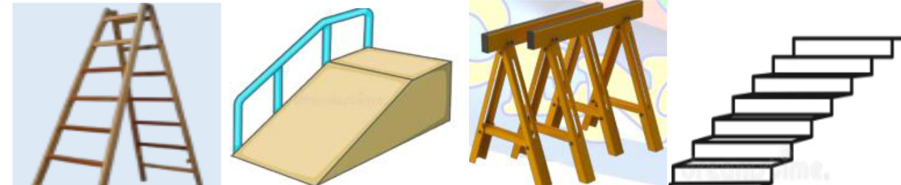

- ________________________________________________________________________

- ________________________________________________________________________

- ________________________________________________________________________

- ________________________________________________________________________

b.) State three safety measures to observe when using the raised platforms above. (3mks)

__________________________________________________________________________

__________________________________________________________________________

__________________________________________________________________________

__________________________________________________________________________

c.) Give two importance of observing safety when using raised platforms. (2mks)

_____________________________________________________________________________

_____________________________________________________________________________

_____________________________________________________________________________

2.

a.) Give three characteristics of computers. (3mks)

_____________________________________________________________________________

_____________________________________________________________________________

_____________________________________________________________________________

b.) State three ways one can use to secure data in an electronic device. (3mks)

_____________________________________________________________________________

_____________________________________________________________________________

_____________________________________________________________________________
3.
a.) Name four drawing instruments. | (4mks)

_____________________________________________________________________________

_____________________________________________________________________________

_____________________________________________________________________________

_____________________________________________________________________________

b.) Define the term dimensioning. (2mk)

_____________________________________________________________________________

_____________________________________________________________________________

c.) State the three types of dimensioning. (3mks)

_____________________________________________________________________________

_____________________________________________________________________________

_____________________________________________________________________________

4.

a.) What is free hand sketching? (2mks)

_____________________________________________________________________________

_____________________________________________________________________________

b.) List down any four instruments used in free hand sketching. (4mks)

_____________________________________________________________________________

_____________________________________________________________________________

_____________________________________________________________________________

_____________________________________________________________________________

c.) Grade 7 learners were practicing different freehand drawing techniques. Name the two

techniques shown by the pictures they drew below. (2mks)

Technique H Technique P
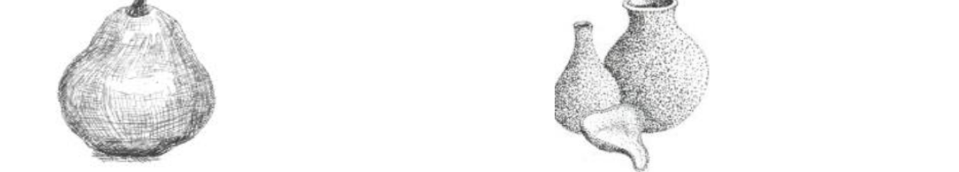

__________________ ____________________
5. Give three ways we can sustainably use economic resources. | (3mks)

_____________________________________________________________________________

_____________________________________________________________________________

_____________________________________________________________________________

_____________________________________________________________________________

6. Giving one example in each, State the two categories of computer output devices. (4mks)

_____________________________________________________________________________

_____________________________________________________________________________

7. Name three examples of visual programming applications. (3mks)

_____________________________________________________________________________

_____________________________________________________________________________

_____________________________________________________________________________

8.

a.) Define the term entrepreneur. (2mks)

_____________________________________________________________________________

_____________________________________________________________________________

b.) Give four ICT tools used in marketing of good and services. (4mks)

_____________________________________________________________________________

_____________________________________________________________________________

_____________________________________________________________________________

_____________________________________________________________________________

c.) What is impulsive buying? (2mks)

_____________________________________________________________________________

_____________________________________________________________________________

THIS IS THE LAST PRINTED PAGE.

Marking scheme

1. Raised Platforms
a.) Name the following raised platforms:
(A) Scaffold
(B) Step Ladder
(C) Trestle Platform
(D) Aerial Lift
b.) Three safety measures to observe when using raised platforms:
- Always ensure the platform is stable and well-secured.
- Wear personal protective equipment (PPE) like helmets and harnesses.
- Avoid overloading the platform beyond its weight limit.
c.) Two importance of observing safety when using raised platforms:
- Prevents accidents and injuries.
- Ensures efficient and smooth completion of tasks.

2. Computers and Data Security
a.) Three characteristics of computers:
- Speed – Computers process data quickly.
- Automation – Once programmed, they perform tasks without manual intervention.
- Multitasking – Can perform multiple tasks simultaneously.
b.) Three ways to secure data in an electronic device:
- Use strong passwords and two-factor authentication.
- Install antivirus and security software.
- Regularly back up important data.

3. Drawing Instruments & Dimensioning
a.) Four drawing instruments:
- T-square
- Compass
- Set squares
- Drawing board
b.) Definition of dimensioning:
Dimensioning is the process of adding measurements and specifications to a technical drawing to define the size, shape, and location of features.
c.) Three types of dimensioning:
- Parallel dimensioning
- Chain dimensioning
- Combined dimensioning

4. Freehand Sketching
a.) Definition of freehand sketching:
Freehand sketching is the process of drawing without the use of drawing instruments, relying only on one's hand and vision.
b.) Four instruments used in freehand sketching:
- Pencil
- Eraser
- Sharpener
- Sketchbook
c.) Two freehand drawing techniques:
- Technique H: Hatching
- Technique P: Pointillism

5. Sustainable Use of Economic Resources
Three ways to sustainably use economic resources:
- Practicing recycling and waste management.
- Using renewable energy sources like solar and wind.
- Conserving natural resources through responsible consumption.

6. Categories of Computer Output Devices
- Softcopy Output Devices – Example: Monitor
- Hardcopy Output Devices – Example: Printer

7. Visual Programming Applications
Three examples of visual programming applications:
- Scratch
- Blockly
- MIT App Inventor

8. Entrepreneurship and Marketing
a.) Definition of entrepreneur:
An entrepreneur is a person who identifies business opportunities, takes risks, and organizes resources to create and run a business.
b.) Four ICT tools used in marketing of goods and services:
- Social media platforms (e.g., Facebook, Instagram)
- Email marketing
- Websites and e-commerce platforms
- Search Engine Optimization (SEO) tools
c.) Definition of impulsive buying:
Impulsive buying is the act of purchasing goods or services without prior planning, often driven by emotions or attractive promotions.

