
KENYA JUNIOR SCHOOL EDUCATION ASSESSMENT
GRADE 9
907: SOCIAL STUDIES
Time: 1 Hour 30 Minutes
NAME: ____________________________ SIGN: ___________ DATE: _________________
CANDIDATE'S ASSESSMENT NUMBER: _______________________________________
SCHOOL: ___________________________ SCHOOL CODE: ________________________

INSTRUCTIONS TO CANDIDATES
- Write your name and assessment number correctly.
- Write the name and code of your school in the spaces provided.
- Write the date of the assessment.
- This paper consists of two sections: A and B. Section A comprises Multiple-Choice Questions, while Section B consists of Structured and Essay Questions.
- Answer ALL the questions in Section A on the separate ANSWER SHEET provided.
- Answer ALL the questions in Section B in the spaces provided on this question paper.
- Do NOT remove any page from this question paper.
- Answer the questions in English.

SECTION A: (20 Marks)

- The main economic activity of early humans was:
A. Farming
B. Hunting and gathering
C. Fishing
D. Trading
- Which factor led to the decline of the Trans-Saharan trade?
A. Introduction of railway transport
B. Decline in gold mining
C. Arrival of Portuguese traders
D. Increased desertification
- Which one of the following statements is true about the Asante Kingdom?
A. It was located in present-day Sudan
B. It was known for its strong military and gold trade
C. It was ruled by Pharaohs
D. It declined due to European colonization
- Which of the following is a form of direct democracy?
A. Voting for a president
B. Electing Members of Parliament
C. Public participation in decision-making
D. Appointment of leaders by the executive
- The highest mountain in Africa is:
A. Mount Kenya
B. Mount Kilimanjaro
C. Mount Elgon
D. Mount Ruwenzori
- Which of the following is a major cause of climate change?
A. Planting trees
B. Overgrazing
C. Renewable energy use
D. Sustainable farming
- One of the major duties of the Judiciary in Kenya is to:
A. Create new laws
B. Interpret and enforce laws
C. Collect taxes
D. Make government policies
- The early visitors to the East African coast included:
A. Arabs, Portuguese, and British
B. Americans, Chinese, and Indians
C. Egyptians, Italians, and Germans
D. Greeks, Spaniards, and Dutch

- The two major types of migration are:
A. Urban and international migration
B. Voluntary and forced migration
C. Seasonal and permanent migration
D. Political and economic migration
- Which of the following is NOT a function of the county government in Kenya?
A. Issuing national ID cards
B. Collecting property taxes
C. Providing health services
D. Managing county roads
- The main source of historical information is:
A. Television
B. Newspapers
C. Oral traditions
D. Social media
- The Trans-Saharan trade was mainly between:
A. East Africa and the Middle East
B. North Africa and West Africa
C. Southern Africa and Europe
D. Central Africa and Asia
- The symbol that shows direction on a map is called a:
A. Title
B. Scale
C. Key
D. Compass rose
- Which of the following is NOT a component of weather?
A. Rainfall
B. Air pressure
C. Ocean currents
D. Temperature
- A major function of money is to:
A. Increase poverty
B. Promote conflict
C. Act as a medium of exchange
D. Create political instability
- The most commonly spoken language in Africa is:
A. English
B. Arabic
C. French
D. Swahili
- Which human right ensures freedom of movement?
A. Right to life
B. Right to association
C. Right to education
D. Right to liberty
- The main physical feature along the Great Rift Valley in Kenya is:
A. Mount Elgon
B. Lake Victoria
C. Menengai Crater
D. Aberdare Ranges

- The first European country to colonize Kenya was:
A. France
B. Britain
C. Germany
D. Portugal
- The two main categories of trade are:
A. Large-scale and small-scale trade
B. Domestic and international trade
C. Barter trade and retail trade
D. Wholesale and informal trade

SECTION B: (80 Marks)
(Answer all questions in the spaces provided)
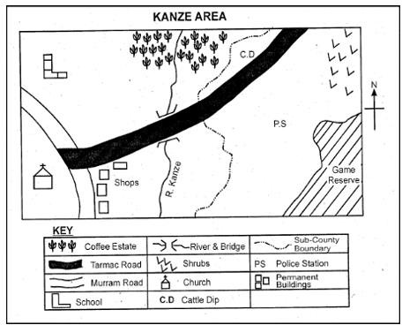
- study the map of Kanze Area and answer the following questions

  - Outline two elements of the map shown above. (2 marks)

  - Convert the scale 1:100,000 into a statement scale. (2 marks)

  - Which element of a map is missing from the map above? (1 mark)
__________________________________
  - Determine the contour interval of the terrain drawn below. (2 marks)
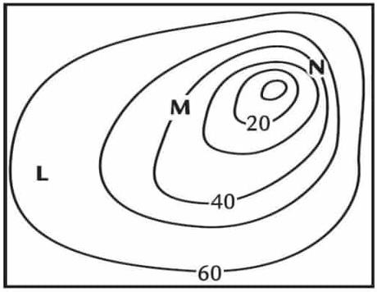

  - Give two physical features that can be represented on topographical maps.(2 marks)

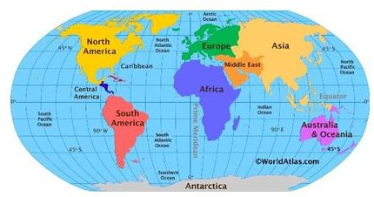
  - Name the type of map shown below . (1 mark)

________________________________________________
- (a) Define the term citizenship. (2 marks)
___________________________________________________________________________________________________________________________________________________________________________________________________________________________________________________
(b) List two ways of acquiring Kenyan citizenship. (2 marks)
i. _____________________________________________________________
ii. _____________________________________________________________
- (a) Mention three types of natural disasters. (3 marks)
i. _____________________________________________________________
ii. _____________________________________________________________
iii. _____________________________________________________________
(b) Suggest two ways of reducing the impact of natural disasters. (2 marks)
i. _____________________________________________________________
ii. _____________________________________________________________
- (a) Explain two causes of conflicts in Africa. (2 marks)
i. _____________________________________________________________
ii. _____________________________________________________________
(b) State two peaceful ways of resolving conflicts. (2 marks)
i. _____________________________________________________________
ii. _____________________________________________________________
- (a) Give two reasons why early humans settled along river valleys. (2 marks)
i. _____________________________________________________________
ii. _____________________________________________________________
(b) Mention two economic activities of early African civilizations. (2 marks)
i. _____________________________________________________________
ii. _____________________________________________________________
- (a) State three major changes brought by the Arabs at the Kenyan coast. (3 marks)
i. _____________________________________________________________
ii. _____________________________________________________________
iii. _____________________________________________________________
(b) List four basic human needs. (4 marks)
i. _____________________________________________________________
ii. _____________________________________________________________
iii. _____________________________________________________________
iv. _____________________________________________________________
- (a) Identify two advantages of barter trade. (2 marks)
i. _____________________________________________________________
ii. _____________________________________________________________
(b) Explain two reasons why money replaced barter trade. (2 marks)
i. _____________________________________________________________
ii. _____________________________________________________________
- (a) Name two major mineral resources in Kenya. (2 marks)
i. _____________________________________________________________
ii. _____________________________________________________________
(b) State two ways in which minerals contribute to Kenya’s economy. (2 marks)
i. _____________________________________________________________
ii. _____________________________________________________________

ANSWERS

SECTION A: (20 Marks, 1 mark each)
- B – Hunting and gathering
- A – Introduction of railway transport
- B – It was known for its strong military and gold trade
- C – Public participation in decision-making
- B – Mount Kilimanjaro
- B – Overgrazing
- B – Interpret and enforce laws
- A – Arabs, Portuguese, and British
- B – Voluntary and forced migration
- A – Issuing national ID cards
- C – Oral traditions
- B – North Africa and West Africa
- D – Compass rose
- C – Ocean currents
- C – Act as a medium of exchange
- D – Swahili
- D – Right to liberty
- C – Menengai Crater
- B – Britain
- B – Domestic and international trade

SECTION B: (80 Marks)

21.
  - Outline two elements of the map shown above. (2 marks)
Key/legend,title,compass direction,frame
  - Convert the scale 1:100,000 into a statement scale. (2 marks)
- 1 centimeter on the map represents 1 kilometer on the ground.

  - Which element of a map is missing from the map above? (1 mark)
Scale
  - Determine the contour interval of the terrain drawn below. (2 marks)

- Contour interval is 10.

  - Give two physical features that can be represented on topographical maps.(2 marks)
  - Mountains
  - Rivers
  - Valleys
  - Lakes
  - Plateaus
  - Name the type of map shown below . (1 mark)
atlas map

22. Citizenship (4 Marks)
(a) Definition of citizenship:
Citizenship is the legal status of being a recognized member of a country. (2 marks)
(b) Ways of acquiring Kenyan citizenship:
i. By birth
ii. By registration or naturalization
(Each correct point = 1 mark)

23. Natural Disasters (5 Marks)
(a) Three types of natural disasters:
i. Earthquakes
ii. Floods
iii. Droughts
(Each correct point = 1 mark)
(b) Ways to reduce impact of natural disasters:
i. Planting trees to prevent soil erosion and flooding
ii. Constructing strong buildings to withstand earthquakes
(Each correct point = 1 mark)

24. Causes and Resolution of Conflicts (4 Marks)
(a) Two causes of conflicts in Africa:
i. Political differences
ii. Competition for resources
(Each correct point = 1 mark)
(b) Two peaceful ways of resolving conflicts:
i. Negotiation and dialogue
ii. Mediation by neutral parties
(Each correct point = 1 mark)

25. Early Human Settlements (4 Marks)
(a) Two reasons why early humans settled along river valleys:
i. Availability of water for drinking and farming
ii. Fertile soil for growing crops
(Each correct point = 1 mark)
(b) Two economic activities of early African civilizations:
i. Trade
ii. Farming
(Each correct point = 1 mark)

26. Arab Influence and Basic Human Needs (7 Marks)
(a) Three major changes brought by Arabs at the Kenyan coast:
i. Introduction of Islam
ii. Growth of Swahili language
iii. Introduction of new trade items like spices
(Each correct point = 1 mark)
(b) Four basic human needs:
i. Food
ii. Shelter
iii. Clothing
iv. Water
(Each correct point = 1 mark)

27. Barter Trade and Money (4 Marks)
(a) Two advantages of barter trade:
i. No need for money to trade
ii. It allowed direct exchange of goods
(Each correct point = 1 mark)
(b) Two reasons why money replaced barter trade:
i. Barter trade was inefficient due to lack of a common measure of value
ii. Money is easier to store and transport
(Each correct point = 1 mark)

28. Minerals and Economy (4 Marks)
(a) Two major mineral resources in Kenya:
i. Soda ash
ii. Fluorspar
(Each correct point = 1 mark)
(b) Two ways minerals contribute to Kenya’s economy:
i. Creating employment opportunities
ii. Generating revenue through exports
(Each correct point = 1 mark)

