KENYA JUNIOR SCHOOL EDUCATION ASSESSMENT

GRADE 9
907: SOCIAL STUDIES

Time: 1 Hour 30 Minutes
NAME: _________________________________________ SIGN: _______________ DATE: ____________.
CANDIDATES ASSESSMENT NUMBER: ____________________________________________________.
SCHOOL: _______________________________________ SCHOOL CODE: ______________________ _.
INSTRUCTIONS TO CANDIDATES

- Write your name and assessment number correctly.

- Write the name and code of your school in the spaces as indicated above.

- Write the date of the assessment.

- This paper consists of two sections: A and B. Section A comprises Multiple choice Questions. Section B comprises structured questions and essay questions.

- Answer ALL the questions in Section A on the separate ANSWER SHEET provided.

- Answer ALL the questions in Section B in the spaces provided on this question paper.

- Do NOT remove any page from this question paper.

- Answer the questions in English.
For official use only

SECTION B

Task | Task 1 |  |  |  | Task 2 |  |  | Task 3 |  |  |  |  |  | Task 4
Question | 28 |  | 30 | 23 | 25 | 26 | 32 | 21 | 24 |  | 29 | 22 | 27 | 31 | 33 | 34
Candidate’s Score per
Question
Maximum Score
Candidate’s Score per Task
This paper consists of 9 printed pages. Candidates should check the question paper to ascertain that all the pages are printed as indicated and that no questions are missing.
Turn Over
SECTION A: MULTIPLE-CHOICE QUESTIONS (20 Marks) (Choose the correct answer )

- The scientific theory of human origin suggests that humans evolved from:
A. Apes B. Reptiles
C. Fish D. Birds
- Which African kingdom was famous for the Great Zimbabwe stone walls?
A. Kongo Kingdom
B. Egyptian Kingdom
C. Zimbabwe Kingdom
D. Asante Kingdom
- Which of the following was a major good exchanged during the Indian Ocean slave trade?
A. Electronics B. Ivory
C. Petroleum D. Cotton
- Which list contains the three the arms of the Kenya government?
A. Executive, Parliament, County Government
B. Legislature, Judiciary, Executive
C. Senate, Judiciary, Executive
D. Legislature, Governors, Ministers
- Which of the following is not a stage in human evolution?
A. Homo Habilis B. Homo Erectus
C. Homo Sapiens D. Homo Cyborg
- Grade 9 learners observed a certain topographical of a map. The main purpose of a topographical map is to show:
A. Political Boundaries
B. Relief Features
C. Road Networks
D. Weather Conditions
- Which One is the main source of historical information?
A. Textbooks
B. Oral Traditions
C. Internet
D. Newspapers
- Which of the following is not an element of weather?
A. Humidity
B. Temperature
C. Altitude
D. Wind
- The main cause of the Trans-Saharan slave trade was:
A. High Demand For Labor
B. Religious Conflicts
C. Discovery Of America
D. Gold Mining
- Which map element shows the meaning of symbols used like the one shown below?
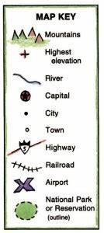

A. Scale
B. Key
C. Compass Rose
D. Title

- What factor led to the growth of Kiswahili civilization along the coast?
A. Introduction of gold coins
B. Intermarriage between Arabs and locals Bantus.
C. Discovery of oil
D. Warfare
- The main components of the solar system include:
A. Moon and earth only
B. Stars, planets, and satellites
C. Continents and oceans
D. Clouds and rainfall
- Which human right ensures that everyone can express their opinions?
A. Right to life
B. Right to education
C. Freedom of expression
D. Freedom of movement
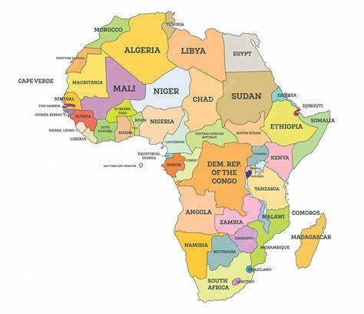
- From the map below, which African country has Cairo as its capital city?

A. Kenya
B. Nigeria
C. Egypt
D. Ethiopia
- The Asante Kingdom was mainly located in present-day:
A. South Africa
B. Ghana
C. Nigeria
D. Sudan
- Which is a non-violent way of solving conflicts in a family?
A. Shouting at each other
B. Engaging in dialogue
C. Using force
D. Ignoring each other
- What caused the population growth in Africa during the 20th century?
A. Advancements in medicine
B. Civil wars
C. Slave trade
D. Drought
- One of the qualities of a good citizen is:
A. Breaking laws
B. Respecting authority
C. Refusing to pay taxes
D. Ignoring community issues
- The main economic activity of early humans was:
A. Trade
B. Agriculture
C. Hunting and gathering
D. Fishing
- The planet closest to the sun is:
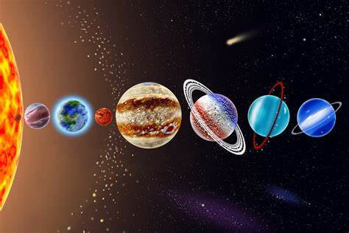
A. Earth B. Venus
C. Mars D. Mercury

SECTION B: STRUCTURED QUESTIONS (80 Marks)
(Answer all the questions in the spaces provided.)
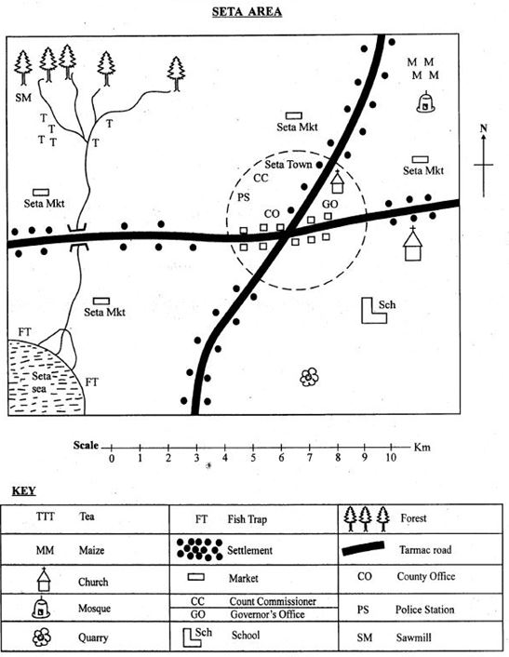
- Use the map of seta area to answer question 21 only

      - What is the direction of the school from the market?(1 mark)
_____________________________________________________________
      - The highest point in the area is likely to be at the?(1 mark)
_______________________________________________________________
      - Mention four economic activity likely to be carried out in seta area.(4 marks)
- ________________________________________
- ________________________________________
- ________________________________________
- _______________________________________
      - During a field trip at seta area. Learners saw various physical features. Mention at least three they likely saw. (3 marks)
  - __________________________________________
  - _________________________________________
  - _________________________________________
      - Measure the total length of the tarmac roads in seta are in kilometers. (1 mark)
___________________________________________________
- (a) Name two theories explaining the origin of the earth. (2 marks)

  - _____________________________________________________________.
  - _____________________________________________________________.
(b) State three characteristics of the planets in the solar system. (3 marks)
  - ______________________________________________________________.
  - ______________________________________________________________.
  - ______________________________________________________________.
- (a) Name three Stone Age periods as learnt before. (3 marks)
  - ____________________________________________
  - ____________________________________________
  - ____________________________________________
(b) Mention two tools used during the Stone Age period. (2 marks)
  - __________________________________
  - __________________________________
- (a) Identify two social-economic practices of early humans. (2 marks)
  - ________________________________________________________________.
  - ________________________________________________________________.
(b) List two causes of conflict in schools. (2 marks)
  - ________________________________________________________________.
  - ________________________________________________________________.

- (a) Define peace and conflict resolution. (2 marks)
  - ____________________________________________________________________________________________________________________________________
(b) Explain two ways of solving conflict in school. (2 marks)
  - __________________________________________________________________.
  - __________________________________________________________________.
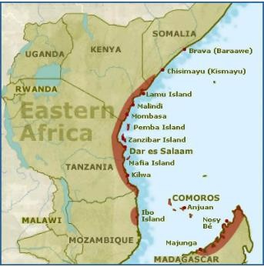
- (a) Describe three major changes Arabs brought to the culture at the Kenyan coast. (3 marks)

  - ______________________________________________________________.
  - ______________________________________________________________.
  - ______________________________________________________________.
(b) State four human rights enshrined in the Constitution of Kenya. (4 marks)
  - ________________________________________________________________.
  - ________________________________________________________________.
  - ________________________________________________________________.
  - ________________________________________________________________.
- (a) List three sources of historical information. (3 marks)
  - _______________________________________________________________.
  - _______________________________________________________________.
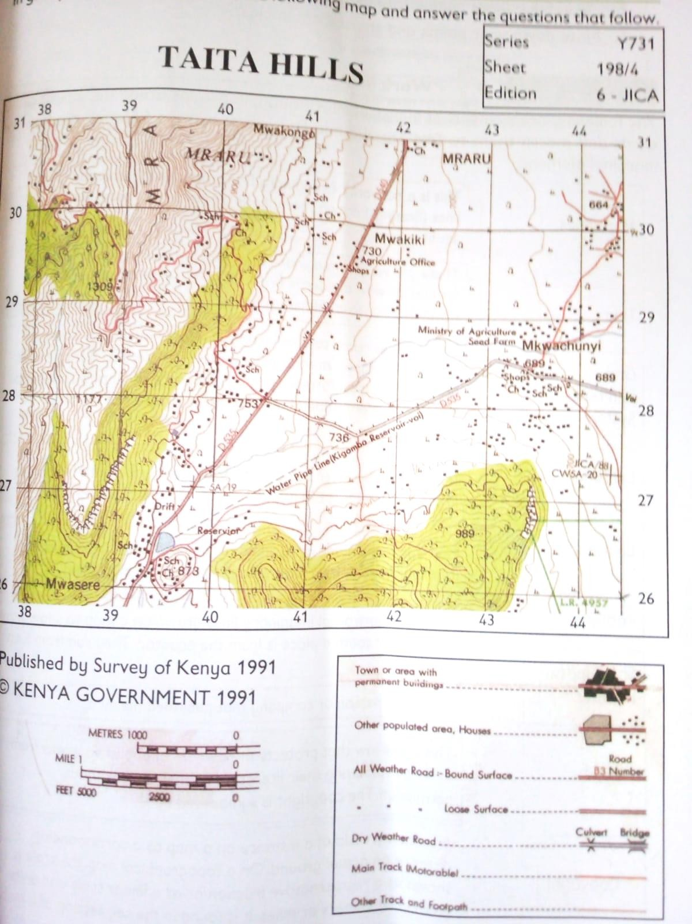
  - _______________________________________________________________.
(b) Study the map of Taita Hills shown below and then mention three marginal information found in the topographical map. (3 marks)

- (a) Name two elements of weather. (2 marks)
    - _________________________________________
    - _________________________________________
(b) Describe the factors affecting climate in Kenya. (2 marks)
    - _________________________________________________________________
    - _________________________________________________________________
- (a) Give two ways in which the slaves were mistreated during the Indian Ocean Slave Trade. (3 marks)
  - ________________________________________________________________
  - ________________________________________________________________
(b) State two ways in which the Trans-Sahara Trade influenced the growth of Africa. (2 marks)
  - __________________________________________________________________
  - __________________________________________________________________
c) Mention two factors that led to the growth of East Africa city-states.
  - __________________________________________________________________
  - __________________________________________________________________
- (a) Differentiate between topographical maps and sketch maps. (2 marks)
______________________________________________________________________________________________________________________________________________________________________________________________________
(b) List three types of map scales. (3 marks)
  - _____________________________________________________________
  - _____________________________________________________________
  - _____________________________________________________________
- (a) Identify two causes of poverty in Africa. (2 marks)
  - ______________________________________________________________
  - _______________________________________________________________
  - _______________________________________________________________

  - (b) Suggest two ways to reduce poverty in Africa. (2 marks)
  - _______________________________________________________________
  - _______________________________________________________________
  - ______________________________________________________________

THIS IS THE LAST PRINTED PAGE
MARKING SCHEME:

SECTION A: MULTIPLE-CHOICE ANSWERS (20 Marks)
- A – APES
- C – ZIMBABWE KINGDOM
- B – IVORY
- B – LEGISLATURE, JUDICIARY, EXECUTIVE
- D – HOMO CYBORG
- B – RELIEF FEATURES
- B – ORAL TRADITIONS
- C – ALTITUDE
- A – HIGH DEMAND FOR LABOR
- B – KEY/LEGEND
- B – INTERMARRIAGE BETWEEN ARABS AND LOCALS
- B – STARS, PLANETS, AND SATELLITES
- C – FREEDOM OF EXPRESSION
- C – EGYPT
- B – GHANA
- B – ENGAGING IN DIALOGUE
- A – ADVANCEMENTS IN MEDICINE
- B – RESPECTING AUTHORITY
- C – HUNTING AND GATHERING
- D – MERCURY

SECTION B: STRUCTURED ANSWERS (80 Marks)

      - What is the direction of the school from the forest?(1 mark)
South East
      - The highest point in the area is likely to be at the?(1 mark)
North East/at the forest
      - Mention four economic activity likely to be carried out in seta area.(4 marks)
- Lumbering/saw milling
- Fishing
- Trading
- Quarrying
- Farming
      - During a field trip at seta area. Learners saw various physical features. Mention at least three they likely saw. (3 marks)
  - Forest
  - River
  - Hills
  - Plains
  - Valleys
      - Measure the total length of the tarmac roads in seta are in kilometers. (1 mark)

Teacher to assess

- (a) Two theories explaining the origin of the Earth:
- Big Bang Theory
- Nebular Hypothesis /Nebular Cloud Theory
- Collision theory
- Super nova theory
- (2 marks)
(b) Three characteristics of the planets:
- They revolve around the sun
- Formed around the same time
- They have different sizes and compositions
- Some have moons while others do not
- Some are gaseous while others are rocky
- They rotate on their own axes (3 marks)
- (a) stone age periods:
- Early stone age
- Middle stone age
- Late stone age (3 marks)
(b) Four tools used during the Stone Age:
- Hand axe
- Scrapers
- Spearheads
- Arrowheads
- Daggers etc (4 marks)
- (a) Three social-economic practices of early humans:
- Hunting and gathering
- Farming
- Barter trade (3 marks)
(b) Three causes of conflict in schools:
- Bullying
- Competition for resources
- Peer pressure (3 marks)
- (a) Peace and Conflict Resolution:
Peace is the absence of violence, while conflict resolution is the process of solving disputes amicably. (2 marks)
(b) Two ways of solving conflict in school:
- Mediation by teachers
- Forgiveness
- Open communication between students (4 marks)
- (a) Three major changes Arabs brought to the culture at the Kenyan coast:
- Introduction of Islam at the coast
- Introduction of Swahili language
- New architectural styles
- New foods eg mahamri,pilau
- New way of dressing eg kanzus,hijab,(3 marks)
(b) Four human rights in the Kenyan Constitution:
- Right to life
- Right to live anywhere on the land
- Right to movement
- Freedom of speech
- Right to education
- Right to own property (4 marks)
- (a) Three sources of historical information:
- Oral traditions like stories
- Archaeological remains
- Written records like books
- Monuments
- Museums
- Specialists
- Digital sources like internet etc (3 marks)
(b) marginal information in a topographical map.

Map series/map number

Title

Grid reference system

Latitudes

Longitude

Publisher’s name

Sheet index number

Scale

Copyright

Edition number

Key

Compass direction (3 marks)
- (a) Two elements of weather:
- Temperature
- Sunshine
- Wind
- Cloud cover
- Air pressure
- Humidity (2 marks)
(b) Factors affecting climate in Kenya:
- Altitude
- Latitude
- Distance from the sea
- Nearness to water bodies
- Ocean currents
- Human activities
- Physical features around the area eg mountain (3 marks)
- (a) mistreatments of African slaves :
- Africans were captured forcefully
- Families were separated
- Slaves were treated inhumanely
- Slaves were transported for long hours over the seas
- Slaves were not given enough food
- Slaves were not treated when injured or sick
- Slaves were treated like animals
- Some were embarrassed in front of people
- Some were killed
- Were given a lot of work with no rest
- Were not given water
- Sexual mistreatment
- No proper sleep or rest(3 marks)
(b) How the Trans-Saharan trade influenced Africa:
- Spread of Islam
- Growth of trade centers
- Introduction of new goods (2 marks)

c)Factors that led to the growth of East Africa city-states.

Bantu migration and arrival of the Arabs.
🠢 Migration of Bantu speaking people to the east African coast where they interacted with the Arabs.
🠢 Bantus practiced agriculture while Arabs were traders. This helped in the establishment
of trading centres that grew into city-states.

Trade.
🠢 There were trading activities between the East Africa merchants and traders from India, China, Persia and Arabia.
🠢 The East African cities exported agricultural products and slaves.

Monsoon winds.
🠢 Facilitated the movement of vessels of traders to travel from one coast to another.
- Rise of Islam.
🠢 Conversion of Islam linked Swahili states to massive trade networks that crossed the coastal area.

Good deep natural harbours.
🠢 The natural harbours along the coast ensured the safe docking of vessels.

Swahili language and culture.
🠢 City-states are considered the product of Swahili language and cultural heritage.
(2 marks)
- (a) Difference between topographical maps and sketch maps:
Topographical maps show detailed land/physical and manmade features, while sketch maps are simple drawings without scale. (2 marks)
(b) Three types of map scales:
- Linear scale
- Statement scale
- Ratio scale (3 marks)
- (a) Three causes of poverty in Africa:
- Poor governance
- Corruption
- Unemployment (3 marks)
(b) Three ways to reduce poverty in Africa:
- Promoting education
- Creating job opportunities
- Supporting small businesses (3 marks)

MARKING SCHEME SUMMARY:
Section A: 20 multiple-choice questions × 1 mark = 20 marks
Section B: 30 structured questions = 80 marks
TOTAL: 100 MARKS

