MARKING SCHEME
Kenya Certificate of Secondary Education (K.C.S.E)
GEOGRAPHY PAPER 2
2 ¾ HRS

SECTION A
ATTEMPT ALL THE QUESTIONS FROM THUS SECTION
1.a) Identify two methods used to reclaim land in Kenya. 2mks
- Irrigation of arid and semi arid areas.
- Draining of swamps and marshals
- Introduction of drought resistant crops like katumani
- Planting trees where they never existed before
- Control of soil erosion
- Control tsetse flies
b) i) State two methods that were used to reclaim the Yala swamp. 2mks
Construction of canals and ditches to reclaim excess water
Construction of dykes on parts of river yala, R Nzoia and the shores of Lake Victoria
- Construction of dams to control the speed of the water in the river.
- Construction of artificial levels along the banks of rivers
- Construction of channels to divert the water

ii) identify the main crops grown in each of the following irrigation schemes 3mks
Bura – cotton
Turkwel – chillies, onions
Ahero- rice

2. a) State three reasons why Tanzania produces more fish than Kenya. 2mks
- Tanzania is blessed with more lakes than Kenya that are even large e.g. L Tanganyika.
- she has many rivers than Kenya’s e.g. R. Rujifi..
- The fishing history in Tanzania is larger than that one of Kenya.
- Tanzania has a larger fish market than Kenya.
- Some of the Kenya’s fishing grounds are located in remote areas e.g. L Turkana

b) Identify three reasons why fish farming should be encouraged in Kenya. 3mks

- To allow better us of land and water resource.
- To create employment opportunities e.g. net makers.
- To earn Kenya foreign exchange when exported.
- It helps meet the demand for food.
- It can encourage research on fish.
- It can lead to the conservation of fish.
- Can bring about development of other related industries e.g. boat making industries.
-
3. a) Define the term dereliction. 2mks
- It is the outcome/ result of uncontrolled mineral extraction where land is abandoned as useless.

b) suggest three measures that can be used to combat dereliction and its dangers in Kenya. 3mks
- companies should be forced to rehabilitate land.
-companies should be supervised to throw their wastes into large supervised heaps.
- companies should also be forced to reclaim land.
Any other relevant answer 1 x 3= 3mks

4. a) State two problems facing small scale farming in Kenya. 2mks
- Inadequate rainfall/ unreliable
- Inadequate capital to buy farm inputs.
- Poor transport systems. Impossible roads during rainy seasons.\price fluctuations
-Damage of crops by pests and diseases.

b) Identify three importance’s of market gardening to the economy of Kenya. 3mks
- it produces/ supplies fruits, vegetables and flowers to urban centres
- it ears the farmer’s income
- it is a source of employment
It supports industries such as fruit canning industries at Thika.

5. State three roles of domestic tourism. 3mks
- it offers opportunities for recreation.
- it sustains the tourist industry during the low season.
- it promotes peaceful co- existence among people of different community.
- it educates the citizens on the importance e of management and conservation of wild- life
6. use the data below to answer the questions that follow.

Destruction of forest covers in Kenya between 2017 -2019 in “000” tonnes
Type of forests | 2017 | C.T | 2018 | CT | 2019 | CT
Planted | 1800 | 1800 | 1750 | 1750 | 1500 | 1500
Coniferous | 1600 | 3400 | 1400 | 3150 | 1300 | 2800
Indigenous | 1400 | 4800 | 1200 | 4350 | 900 | 3700
Exotic | 1280 | 6080 | 1050 | 5400 | 800 | 4500
Montane | 500 | 6580 | 450 | 5850 | 420 | 4920

a.i) Using a scale of 1cm to represent 500 tonnes present the above data using a compound bar graph. 6mks
Destruction of forests covers in Kenya between 2017-2019 in ‘000’ tones

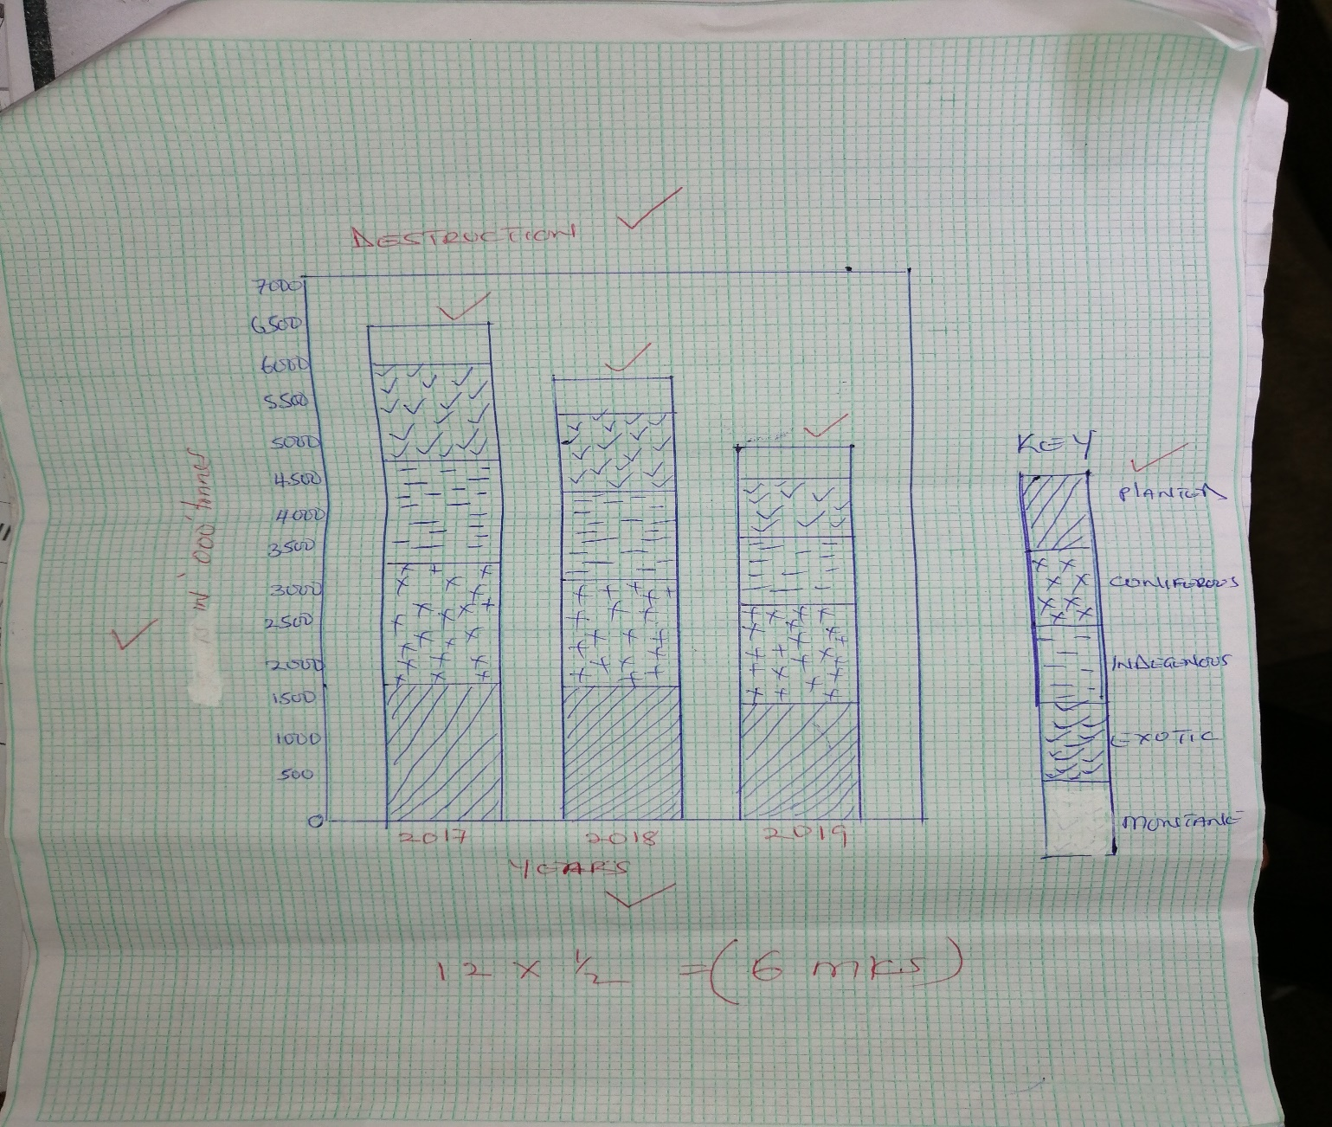

a.ii) Identify any three forest reserves in Kenya. 3mks
- Arabuko sokoke
-witu
-mt. kenya forest
-kakamega forest

b.i) state two advantages of presenting data using compound bar graphs. 2mks
- it gives a clear visual impression of the total value.
- it is easy to compare the items on the same graph
- it is easy to read/ interpret i.e. at first sight
-shaded segments make it easy to quantify the components
- different variables can be presented on one bar.
- there is clear comparison of the production quantities
Any 2 x1 = 2mks

ii) Distinguish between a forest and forestry. 2mks\
A forest is a continuous and extensive tract of land covered with a close stand of trees usually of commercial value while forestry is the science of developing or cultivating a forest.

c. Give the differences between softwood forests in Kenya and Canada under the following sub- headings.
i) Tree harvesting. 2mks
In Kenya, tree harvesting is done throughout the year, while in Canada harvesting is done in winter and early springs

ii) Marketing 2mks
in Kenya forest products are mainly sold locally where as forests products in Canada are mainly for export.
Any 1 x 2= 2mks

d) describe the steps taken by the Kenyan government to realize effective management of forests. 4mks
- carry out public companies on the newspapers, posters, radios and Televisions.
-carry out research on the suitability of the soil and the effects of pests and diseases on forests.
- Establishment of training institutions dealing with forestry e.g. londiani training college and KEFRI
- Reduction in waste in the forestry industry by recycling the waste to produce other useful products e.g. energy saving jikos
- Improvement in the cutting practices through rotational felling of trees.
- provision of infrastructural facilities e.g. roads, trucks, machinery, mills and seed beds to improve management of trees.
- Creation of forest reserve to protect indigenous trees from depletion e.g. Arabuko sokoke. Forests reserve (kilifi).
- Enactment of laws to govern the use of forests and preservation of water catchment areas.
(Any 2 x2=4mks)

e) Explain four problems facing forest exploitation in Canada. 4mks
- Some trees especially in rugged mountains zones are not accessible. This makes exploitation of forests difficult.
- The country has a very small local market for softwood products.
- Extreme low temperatures and precipitation in form of fog in eastern Canada has led to very slow growth of trees.
- Large areas of Canada face stiff competition from Norway, Finland, Sweden and Russia.
- Trees are affected by pests and diseases while lower the quality of tree products.
- Sometimes trees are destroyed by wild forces.
4 x 1= 4mks

7.a.i)Define dairy farming. 2mks
This is the rearing of cattle for milk production
ii) Name three major dairy breeds in Kenya. 3mks
- Friesian
- Ayshire
- Sahiwal
- Jersey
- Guernsey

b.i) Identify three features of nomadic pastoralist. 3mks
-Animals grazed commonly
- Animals kept for meat, milk and blood
- keep different types of animals
- Emphasis is on quantity and not quality.
- A lot of movements in search of water and pasture.
- found in areas o flow and unreliable rainfall
- Frequent raids by neighboring communities is experienced.

ii) State three measures the government has taken to improve livestock rearing among the pastoralists. 3mks
- Provision of water- dams, boreholes.
- Control of diseases by vetinary or extensive officers.
- Planting improved pastures like planting fodder
- Dips and spraying encouraging
- Revival of Kenya meat commission for the meat market.
- Road construction has take place
- Encouraging them to keep a small number of animals to reduce
- Animal research centres are established to combat animals’ pests and diseases.
- Introduction of improved animal breeds through A.I (cross breeding)

c.i) Name two areas in Kenya where dairy farming is practiced. 2mks
- Nakuru
- Uansingishu
- Tranzoia
-Nyandarua

ii) Highlight four characteristics of dairy breeds. 4mks
- Udders are well developed and firm.
- Have big milk veins
- Have wide hind quarters, big stomach and small chest
- High milk content with protein and butter content.
- Highly fertile and calve regularly.
- Short legs and well set to support their heavy bodies.

d) Explain four reasons why dairy farming is mainly located in the Kenyan highlands. 8mks
- Kenyan highlands receive heavy rainfall that is reliable to provide water constantly.
- The regions have low temperatures above 180c best for exotic breed’s survival.
- Highlands have humid conditions
- Highlands have population that offers ready market for dairy farming activity.
-there is enough nutritious grass in the highlands that favour dairy farming activities.
- The areas have very fertile soils that support the growth of high quality cover grass.

8.a.i) Identify three formations in which minerals may occur. 3mks
-veins and lodes
-seams and layers
-alluvial deposits
-weathering products

ii) State three health hazards associated with mining. 3mks

- Injuries caused by collapsing mines which may lead to loss of life.
- Miners may suffer from lung diseases due to dust
- May also suffer from skin diseases

b) Explain five effects of mining on the economy of South Africa. 10mks

- It has led to the growth of towns in the mining areas such as Johannesburg.
- When minerals are exported, they earn the country foreign exchange
- Mining has created jobs for many South Africans raising their living standards.
- It has led to the development of infrastructure such as roads and railways.
- It has led to the development of social amenities in the mining centres to take care of the growing population
- Industries have grown e.g. iron and steel

c) Use the map below to identify the minerals labeled; 3mks
A- Copper
B -gold, iron ore, tin
C, Gold
D- diatomite

d) Your geography teacher has organized a field study trip to Lake Magadi in the southern part of the Rift Valley of Kenya.
i) Name the mineral mined in this lakes. 1mk
- Soda ash
-salt

ii) Identify two methods you will use to collect information. 3mks
- Taking photographs
- Note taking
- Tape recording/video
- Field sketching
- Filling in questionnaire

iii) state two problems you are likely to encounter during your study. 2mks

- Noise from dredging machines.
- Attack by snakes.
- Bad weather – high temperatures
- Fatigue

(Any other relevant answer.)

9. a.i) Define fish farming. 1mk

This is the artificial rearing/ breeding of fish in artificial ponds and man- made lakes.

ii) Identify three fishing methods used by the local fishermen in Kenya. 3mks
- - Basket
- -Fish Traps
- - Barrier Traps
- - Gill Nets
- -Harpoons
- -Handlines
b.i) Give five reasons why fish farming should be encouraged in Kenya. 5mks
– to help meet the demand for food.
- to create employment opportunities.
- to facilitate scientific research
- fish farmers will earn income
- fish when exported will earn foreign exchange.
- to assist in conservation of rare endangered species
- allows better use of land and water resources

ii) Highlight five factors that have promoted fishing in Japan. 5mks

- Shallow and broad continental shelf.
- Japan has both internal and external market for fish.
-Japan being a mountainous country cannot favour farming making fish to be a major source of protein
- japan is made up 3000 iislands making the Japanese people to develop a culture for fish farming.
- meeting of warm korosiwo and cold onyasio currents help to produce ideal conditions for planton growth.
- Japanese coastline is highly indented with numerous bays and sheltered inlets which provides good fishing sites.
c) Name three major fishing grounds of the world. 3mks
- North East Atlantic
-North West Atlantic
- The North East Pacific
- The North West Pacific
d) Explain four physical factors that influence the distribution of world fishing grounds. 8mks
- ool climate which provides suitable conditions for the survival of marine life.
- Availability of planktons which provides fish food.
- Has irregular coastlines with many sheltered inlets and estuaries that provide ideal sites for development of fishing parts.
- Environmental influences in that some regions have rugged mountainous terrain that hinders agricultural activities. Due to this people engage in fishing as an alternative economic activity.
- where farming is hindered by short growing season, people also engage in fishing.
10, a.i) Name two areas where swamps have been drained in Kenya. 2mks
- Yala swamp
- Bunyala in Western Kenya
ii) Highlight four problems facing Mwea Tebere irrigation scheme in Kenya. 4mks
- Siltation
- High evaporation rate
- Water borne diseases
- Insufficient capital
- Overpopulation
- Mismanagement of the scheme
- Poor farming practices
b.i) name two main reclaimed projects in Netherlands. 2mks
- Delta plan
- Zoyder zee project

ii) describe how a polder is reclaimed. 10mks
- Construction of ring dykes to separate the polders from the rest of the water body.
- construction of ring canal outside and surrounding the ring dyke to drain water that is pumped out of the polders.
- Construction of polder ditches to remove water out at the polders.
- Creation of a water pump for pumping water out of the polder.
- allow land to dry
- Desalinize water by use of artificial chemicals or flushing fresh water or planting of hardy plants.
- Deep ploughing to mix the soil with leached nutrients.
- Use of fertilizer to improve soils

Any 2 x 5= 10mks
c. Your class carried out a field study to a polder in Netherlands.
.i) Name two main crops you identified grown in the polder. 2mks
- - fodder crops
- Wheat
- Sugar beat
- potatoes
-
ii) identify three benefits the people of Netherlands experiences as a result of reclaiming a polder. 3mks

- Provision of fresh water for domestic use and industries
- Tourism has been promoted hence foreign exchange.
- Fresh water has promoted horticulture and livestock breeding
- Coastline was shortened due to the construction of 30km dam thus easing transportation.
- Region is now well drained
(any other relevant)
iii) highlight two follow up activities. 2mks
- Displaying of photographs
- Playing videos/ tapes
- Group presentations

