KASU JET JOINT EXAMINATION
Kenya Certificate of Secondary Education
312/1
Paper 1
GEOGRAPHY
SECTION A
MARKING SCHEME

Paper 1

1. (a) The diagram below shows the internal structure of the earth.
G
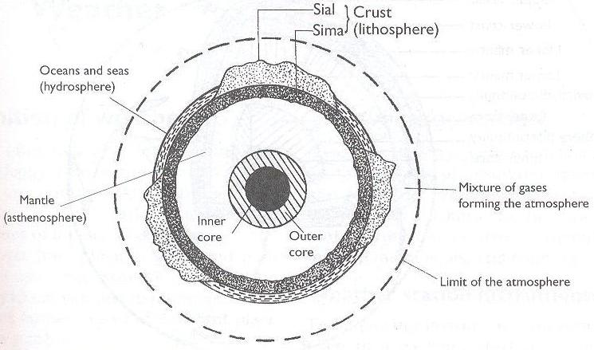
H

(i) Name the parts marked G and H. (2 marks)

G - Continental crust/sial
H - Inner core

(ii) Name the dominant mineral in the mantle. (1 mark)

- Olivine/ ferromagnesian silicate

2. (a) Differentiate between absolute and relative humidity. (2 marks)

- Absolute humidity is the actual amount of water vapour or moisture in a given mass of air at a particular temperature while relative humidity is the ratio of the absolute humidity of a given mass of air to the maximum amount of moisture that this mass of air could hold at the same temperature.

(b) State the significance of humidity in the atmosphere. (3 marks)

- The amount of water vapour in a given volume of air indicates the atmospheres potential capacity to hold moisture:
- It determines the amount of precipitation that a given area is likely to receive.
- Water vapour is important in absorbing radiation hence regulates the heat loss from the earth.
- The amount of water vapour determines the amount of energy stored in the atmosphere for the development of storms

3. The diagram below shows some features formed by faulting. (2 marks)
heave
Y

upthrow
throw

downthrow

X

(a) Name the parts marked X and Y. (2 marks)

X - Hade
Y - Fault scarp/escarpment/scarp face.

(b) State three effects of faulting on drainage of an area. (3 marks)

- Down warping due to faulting may lead to formation of depressions which may be filled by water to form lakes.
- Fault lines due to fracturing of crustal rocks may change the course of river making the river to start flowing a long the fault line forming faulting - guided drainage pattern.
- Fault scarps forming across rivers course may lead to formation of waterfalls.
- Faulting may lead to formation of lines of weakness in earth’s crust which becomes passages for hot water from the underground to the earth’s surface to form hot springs and geysers.

4. (a) Name two crater lakes in Kenya (2 marks)

- Lake Challa
- Lake Paradise
- Lake Sonanchi
- Lake Simbi Nyaima
- Crater lake on the central island in lake Turkana

(b) State three characteristics of rift valley lakes (3 marks)

- Most are narrow,
- Most of them are long,
- Most are steep sides,
- Most of them are saline,
- Some are freshwater

5. (a) Differentiate between a watershed and a catchment area. (2 marks)

- A watershed is a ridge line boundary separating drainage basins or rivers systems while a catchment area is a wetland which a river draws its waters from.

(b) What processes do the arrows labelled K, L and N represent?(3 marks)

K - Radiation/insolation/sun’s rays
L – Percolation
N – Evapotranspiration

6. (a) (i) What type of map is KIJABE map extract? (1 marks)
- A topographical map.
(ii) Give the six figure grid reference of the cattle dip near Kenton. (2 marks)
- 279014
(iii) Give the longitudinal extent of the map. (2 marks)
- From 36⁰30’E to 36⁰45’E
(b) (i) Calculate the area to the south of the power line. Give your answer in km². (2 marks)
Full squares: 16
Half squares: 28
Total: 16+14= 30km² (+- 0.5km²)
(ii) Describe settlement distribution in the area covered by the map. (5 marks)
- There are no settlement within the Ewaso Kedong valley
- There are nucleated settlement in the markets/shopping centres/villages
- Some areas with steep slopes /ridges /river valleys have fewer /no settlement
- There are fewer settlement within the forest
- Kinale/Kinari forest station has dense settlement
- There are no settlement within the plantations
- There are few settlements to the west of Naivasha-Narok road
- The area covered by the map is generally sparsely settled
- There are linear settlement along some roads in the area covered by the map
(c) Explain three factors favoring cattle rearing in the area covered by the map. (6 marks)
- The presence of scrub and scattered trees show that there is natural pasture for cattle
- The presence of many rivers/sources of water show that there is adequate water for cattle
- The area has high altitude/above 1000m which provide cool conditions suitable for cattle rearing
- The many cattle dips for treatment show that there is access to veterinary services
- There are large tracts of land with few settlements ensuring extensive areas available for grazing
- Availability of transport as shown by roads/railway for movement of cattle/cattle products
- Dense settlement to provide market for cattle/cattle products

(d) (i) Draw a square 10cm by 10 cm to represent the area enclosed by Eastings 30 and 40 and northings 90 and 00. (2 marks)
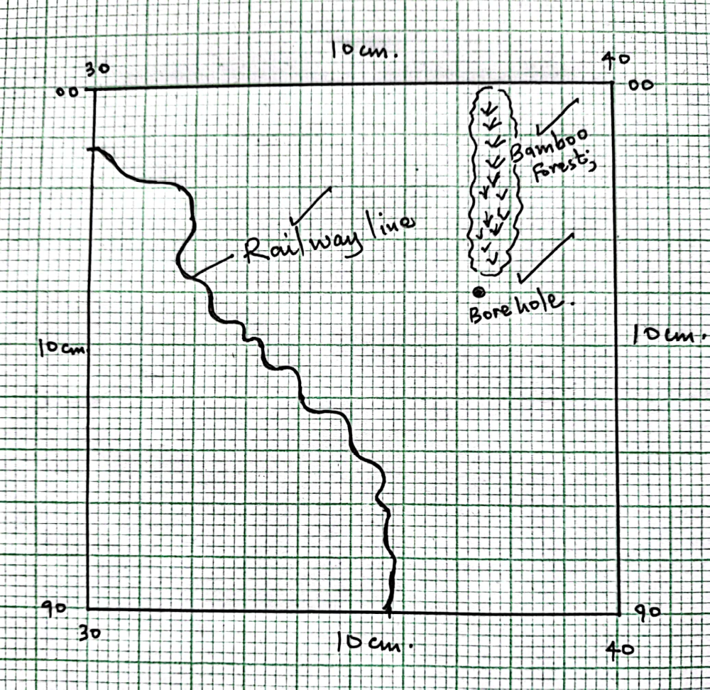
(5 marks)
- A railway line.
- A bamboo forest.
- A borehole.
- New scale.
(Reduction 2 marks, features 3 marks, new scale 2 marks).

7. (a) (i) Distinguish between minerals and rocks. (2 marks)
- Minerals are inorganic homogeneous substances occurring naturally at or below the earth’s surface while rocks are naturally occurring substances that are aggregates of mineral particles.
(ii) State three characteristics of minerals. (3 marks)
- Minerals have different degree of hardness
- Minerals have a varying number of elements
- Some minerals have atoms arranged in an orderly manner to form crystals.
- Minerals have different abilities to allow light to pass through
- Minerals have specific colours
- Minerals have different textures
- Minerals differ in streak
- Minerals have different densities.

(iii) Name three types of minerals. (3 marks)
- Metallic minerals
- Non-metallic minerals
- Energy minerals
(b) (i) Describe how intrusive igneous rocks are formed (5 marks)
- Earth movements form cracks, fissures or vents in the rocks of the crust
- Due to heat and pressure magma in the earth’s interior is forced through the cracks and vents into the rocks of the crust
- The magma is trapped or intruded inside the rocks of the crust.
- Magma cools and solidifies slowly forming rocks with large crystals hence referred to as coarse grained.
- Some are formed deep in the earth’s crust are called plutonic rocks
- Others are formed near the earth’s surface and are called hypabyssal rocks.
(ii) State three characteristics of intrusive igneous rocks. (3 marks)
- Are hard and highly resistant to erosion
- Coarse texture/have large crystals
- Some are formed deep in the crust while others are formed in shallow depths of the crust.
(c) (i) What is rock metamorphism? (2 marks)
- A process where existing rocks undergo physical and chemical changes to form new rocks due to heat and pressure.
(ii) State three factors that influence rock metamorphism.(3 marks)
- Rock resistance/hardness
- Rock texture and structure /grain size
- Rock porosity
- Solubility of rock minerals
- Chemical properties of rock minerals
- Stability of new minerals produced.
(d) Explain two economic benefits of coral limestone rocks. (4 marks)
- It is raw material for cement manufacture which promotes industrial development.
- Some coral rocks form attractive features which attracts tourists who bring in foreign exchange.
- Coral reefs are breeding grounds for fish hence they help to promote the fishing industry.
- Limestone provides stones for building houses and for decorative purposes e.g. marble promoting the building industry.
- Pieces of coral reefs are sold as ornaments for income and beauty value
- Used to produce lime which is used for mortar and in agriculture to reduce soil acidity.
8. (a) (i) Differentiate between orogenic and epeirogenic earth movements? (2 marks)
- Orogenic earth movements are the horizontal /lateral displacements occurring within the crustal rocks due to tectonic forces while epeirogenic earth movements are the vertical displacements occurring within the crustal rocks
(ii) Describe the origin of continents according to the theory of plate tectonics. (4 marks)
- The earths lithosphere /sima and sial is divided into several rigid blocks called tectonic plates
- The plates extend from the surface of the crust to about 100km deep
- The plates float on semi-molten mantle that lies beneath
- The plates move horizontally due to convectional currents within the mantle
- The plates move in three ways. Either towards one another, away from one another or sides by sides parallel to each other
- They form distinct boundaries along the plate margins
(b) (i) Apart from an overthrust fold, name three other types of folds. (3 marks)
- Simple fold/simple symmetrical fold
- Asymmetrical fold
- Overfold
- Isoclinal fold
- Recumbent fold
- Overthrust/Nappe/thrust
- Anticlinorium and synclinorium complex
(ii) Using well labelled diagrams, describe how fold mountains are formed. (10 marks)
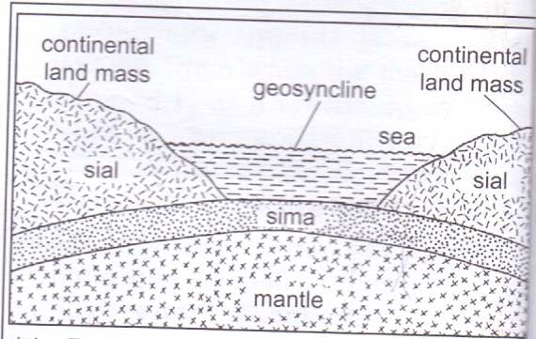
- Prolonged and extensive erosion occurs on the surrounding higher grounds.
- Sediments are deposited in the geosynclines forming thick layers.
- The weight of the sediments causes subsidence of the geosynclines leading to accumulation of more sediments to great thickness.
- Further subsidence of the geosynclines triggers off compressional forces which cause the sediments to fold.
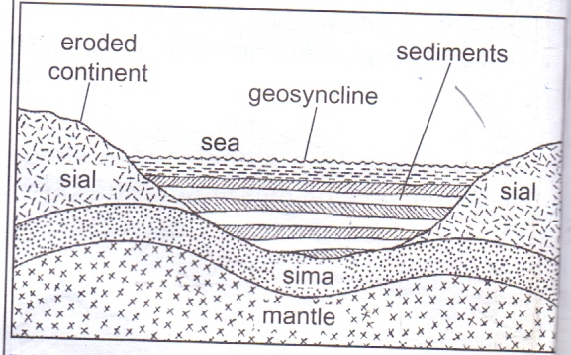
- The folded layers of sediments in the geosynclines are thrust upwards to form fold mountains along the edges of the geosynclines.
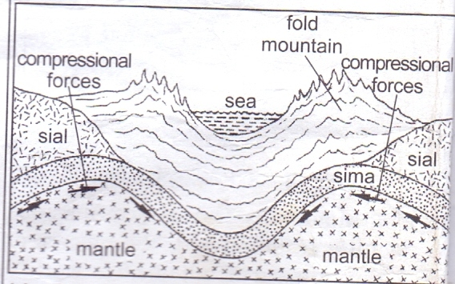
(c) Explain three negative effects of folding to human activities.(6 marks)
- Leeward sloped of fold mountains receive little/no rainfall/dry conditions which discourage settlement/crop farming.
- The rugged nature of folded landscape discourage settlement.
- Folded mountains are barrier to transport and communication/make construction of transport and communication lines expensive/difficult.

9. The diagram below shows a karst scenery. Study and use it to answer the question that follow.
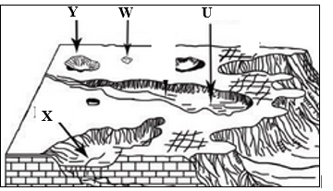
(a) (i) Identify the features labeled W and Y. (2 marks)
- Sink-hole.
- Doline
(ii) Four conditions necessary for the formation of a karst landscape. (4 marks)
- The surface rock should be thick, limestone, chalk or dolomite rock to allow solubility by rainwater.
- The rock should be hard, well jointed to allow rainwater to percolate through the lines of weaknesses.
- The place should be hot and humid to facilitate chemical weathering / reaction / carbonation.
- The water table should be far below the surface to allow formation of features.

(iii) Describe the formation of a stalagmite. (5 marks)
- Rainwater dissolves / absorbs CO₂ in the atmosphere to form carbonic acid.
- Carbonic acid falls on a jointed limestone rock below which is a cave.
- The rainwater percolates along the joints.
- Percolating rainwater reacts with CaCO₃ to form calcium bicarbonate which is soluble.
- The solution drips to the floor of the cave.
- Some of the water evaporates and CO₂ is released leaving behind deposits of CaCO₂ which grows upwards from the floor of the cave.
- The CaCO₃ accumulate with time and eventually lead to the formation of finger like projections on the floor of the cave called Stalagmites.

(b) (i) Name two water erosional features on a desert landscape. (2 marks)
- Mesas and Buttes.
- Gorges and canyons.
- Wadis.
- Dry river valleys/ Laghas.
- Inselbergs.
(ii) Describe the formation of zeugens. (4 marks)
- Forms in deserts areas where alternating horizontal hard and soft rock layers are found.
- The top layer of hard rocks is jointed / has cracks.
- Weathering opens up the joints / cracks making it easier for rocks to be removed by abrasion.
- Wind abrasion erodes / opens the joints / cracks deepening and widening them to reach the soft layers of rocks.
- Deflation blows away the loose broken materials,
- The furrows are formed and are gradually widened and deepened as abrasion continues into the soft rock.
- The hard-resistant rock forms ridges called zeugens separated by furrow. this process creates a ridge and furrow landscape.

(iii) Explain four significance of desert landforms to human activities. (8 marks)
- Desert features e.g. zeugens, Yardangs rock pedestals are tourist attraction.
- Deflation hollows may contain water used for domestic use, livestock or irrigation.
- Loess forms fertile soils used for farming.
- Seasonal oils streams may be dammed to provide water for irrigation or during the dry season.
- Desert landscape / areas is an area for testing military weapons and military training.
- Sand dunes may cover roads making transport difficult.
- The wadis / bed lands make transport facilities difficult and expensive / barriers to lines of transport.
- The dessert has high solar insolation for solar energy production.
- Desert scenery and skies (clear) provide good sites for shooting of films.
- During period of torrential rains, the flash floods along the wadis cause deaths when people are carried away by the water that is furiously flowing through the wadis.
- Rocky desert surface discourage settlement.

10. (a) (i) Define soils (2 marks)

- It is the accumulation of rock particles, minerals, organic matter, water and air found on the surface of the earth on which plants grow
- Soil is a thin layer of unconsolidated loose rock materials and decayed organic matter on the earth’s surface in which plant grow

(ii) Explain how the following factors influence soil formation
Parent material

- Hard rocks are weathered slowly because they are more resistant. This slows down soil formation process. /Soft rocks are weathered faster because they are less resistant. These speeds up the soil formation process.
- Large grained rocks are weathered down to form coarse soils. /Small grained rocks are weathered down to form fine soils.
- The texture of the rocks determines the type of soil e.g. Sandy, loamy or clay.
- Mineral of parent rock are transferred to the top soil during weathering.
(4 marks)
- Human activities (2 marks)

(b) The diagram below shows a soil profile. Use it to answer question (i) and (ii).

(i) Name the parts marked X and Y. (2 marks)

(ii) Describe the characteristics of the top soil (4 marks)
- Dark in colour,
- Some are light in colour
- Contains humus,
- Has true soils – solum,
- A zone where leaching occurs – eluviation
- Divided into A₀₀, A_{0,}A_{1,}A_{2,}A₃

(c) Explain three causes of physical soil degeneration (6 marks)

- Overgrazing leads to removal of vegetation exposing soil to agents of erosion and excessive evaporation from soil (water loss)
- Overgrazing results in loose and fine textured soils due to rock pounding by animals.
- Frequent ploughing weakens soil structure making it easy for agents of soil erosion to carry away the top fertile soils.
- Heavy rainfall washes down the top soil leading to thin / shallow soil,
- Heavy rainfall may also alter the structure of soils from crumb to blocky / columnar which are unsuitable for cultivation on
- Heavy rainfall may result in water logging in flat and lowland areas making the soils unsuitable for plant growth.
- Prolonged drought causes the soils to lose water to become dry thus become susceptible to wind erosion.
- Prolonged drought causes the soil to lose water / moisture thus soil particles held together become loose / disintegrate.

(d) State five ways of conserving soils (3 marks)

- Crop rotation
- Mixed farming
- Application of chemical fertilizers
- Creation of drainage ditches / trenches
- Intercropping
- Mulching
- Bush fallowing
- Ploughing along the contours
- Controlled grazing
- Strip cropping
- Construction of cut off drains
- Terracing on steep slopes
- Afforestation/reafforestation/agroforestry

