
GRADE 1 ASSESSMENTS TERM ONE 2024
CREATIVE ARTS
NAME :……………………………………..

LANGUAGE ACTIVITIES

- Name the musical instruments below;
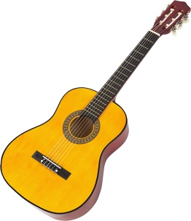
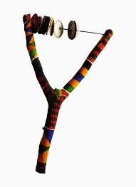
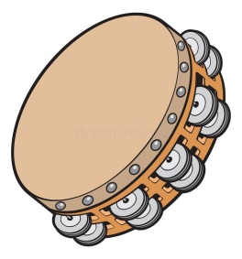
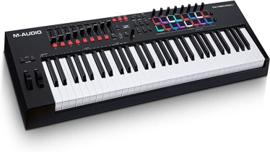

_____________ ___________ __________ ____________

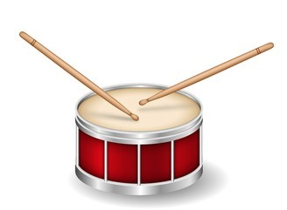
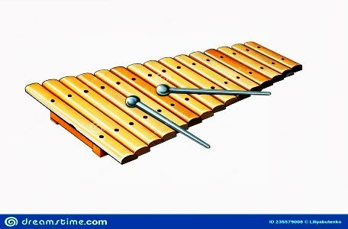
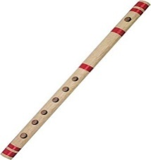
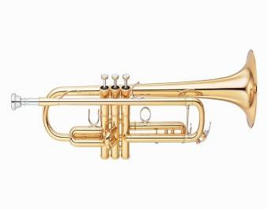

___________ _____________ ____________ ___________

Drum xylophone trumpet flute guitar shaker tambourine keyboard

- An ambulance carries __________ people. [ sick, fat ]

- We __________ abell to produce sound. [ beat ring ]

- How do they produce sound?
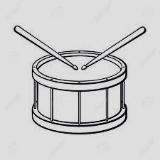
A drum blowing

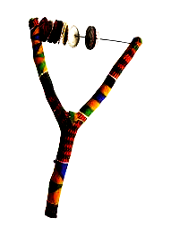

A shaker beating

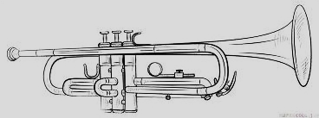
A trumpet plucking

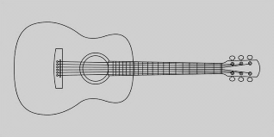
Aguitar shaking

- Screaming means that there is __________ [ party danger ]

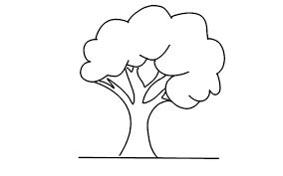
Colour the following
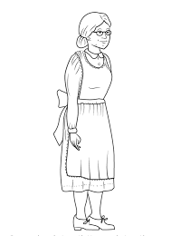
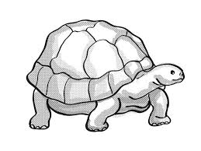



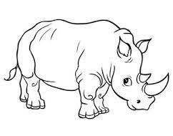



Αssessment Rubric:

Exceeds Expectαtion | Meets Expectαtion | Αpproαching Expectαtion | Below Expectαtion
98-100 | 80-97 | 50-79 | 0-49

