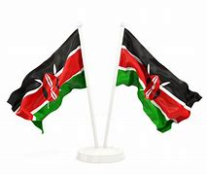
GRADE 1 ASSESSMENTS TERM ONE 2024
ENVIRONMENT AND NUTRITION
NAME :……………………………………..

LANGUAGE ACTIVITIES

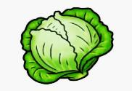
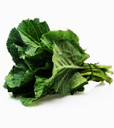
- We eat the ______ of kales and cabbage [stem leaves ]
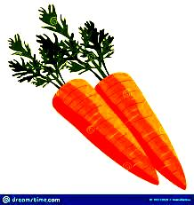
- We eat the roots of ___________ [ sugar cane carrots ]
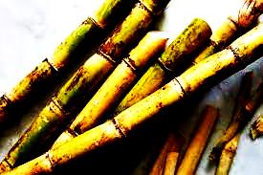
- We eat the __________ of sugarcane. [ leaves stem ]

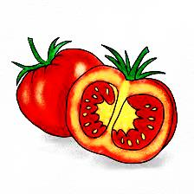
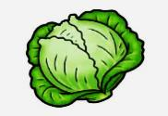
- Name the vegetables below:
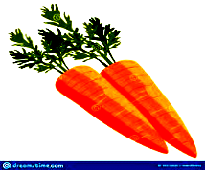
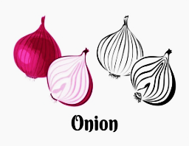

__________ _______ _________ _______ _______
[ onions tomato cabbage kales carrot ]
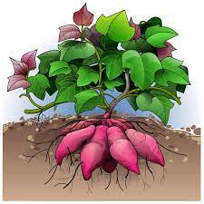
- We eat the roots of?
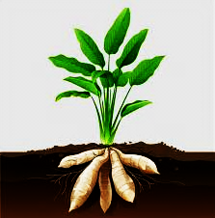
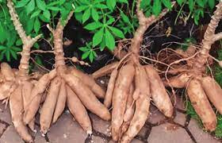

______________ _______________ ___________
[ Arrow roots potatoes cassava ]
NUTRITION
- When we are hungry we eat __________________ [ water food ]

- Foods make us strong and _________________ [ healthy, sick ]

- Name these foods we eat

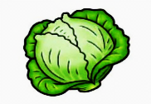
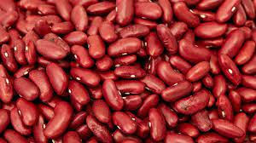
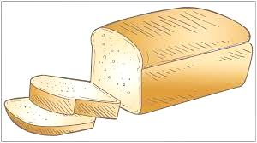

____________ ___________ __________ ___________

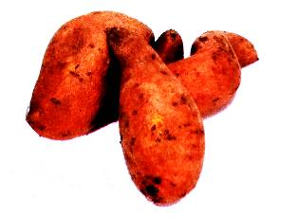
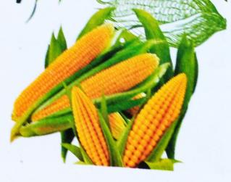
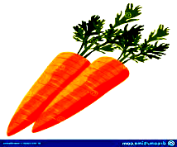
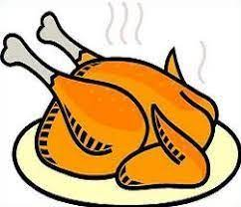

__________ _________ __________ ___________

Maize potatoes carrot milk cabbage bread beans

- Match the foods below with their taste
Juice salty

Unripe fruit no taste

Water bitter

Lemon sugary

Soup sour

Αssessment Rubric:

Exceeds Expectαtion | Meets Expectαtion | Αpproαching Expectαtion | Below Expectαtion
98-100 | 80-97 | 50-79 | 0-49

