COMPETENCE BASED CURRICULUM
TERM ONE 2024
MATHEMATICS
GRΑDE 3


Name:
School:
Grade:
Date: .

- What is the place value of digit 4 in each number?

124 = __________________

488 = __________________

340 = _________________
(__/3mks)
- What is the total value of these numbers?

H T O H T O

3 4 1 5 2 3
(__/2mks)
- Complete the following patterns

50, 100, 150, ________, _______,_______, 300

100, 200, _______, ______, _______, _______, 700.

5, 10, 15, ______, _______, _______, 35, ______, ____
(__/12mks)
- Write these numbers in words;
66 = __________________________________

99 = __________________________________

14 = __________________________________

40 = ___________________________________
(__/4mks)

- Work out the following;

2 1 4 4 2 4
+ 5 4 3 + 1 7 0

(__/2mks)
- Kolubo has 40 cows and Kulukube has 60 cows. How many cows do they have altogether? __________________(__/2mks)

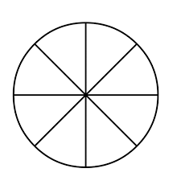

- Shade the fractions given;


$\frac{1}{4}$ $\frac{1}{2}$ $\frac{1}{8}$
(__/3mks)
- What is $\frac{1}{4}$ of 12 = _______ (__/2mks)

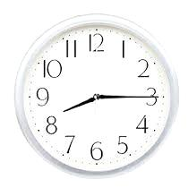
- What is the time by the clocks?
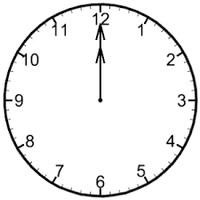

_____________ O ‘clock A quarter past __________ (__/2mks)
- How many days are there in the months of January and march altogether _____________ (__/2mks)

- There are ____________ months in a year. (__/1mk)

- Solve the following sums;

4 9 3 9
- 2 4 - 1 7

- 20 = ___________
(__/3mks)

Mary bought the following items

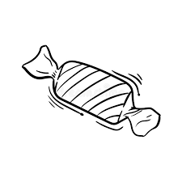
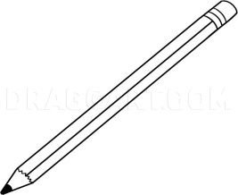

Shs. 5 Shs. 10 Shs. 15

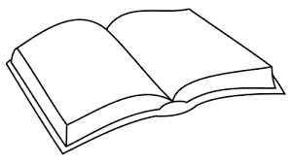
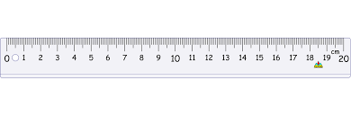

Shs. 30 Shs. 50

- How much did she pay for the book and a pencil? _____________ (__/1mk)

- What will the cost of three pencils? ___________ (__/2mks)

- If I buy a sweet and a ruler, how much would I pay? __________ (__/2mks)

- If I she gave the shopkeeper Shs. 100 for a rubber and a pencil, what will be her balance? _______________________ (__/2mks)
- There are 250 pupils in Babito Academy. If 135 of them are girls how many boys are there? ________________ (__/2mks)
- Divide:

15 $÷5=______$ 12 $÷ 4=______$
(___/2mks)
- Use the diagram below to answer questions

Class 106m Library

80m 92m

65m
Store Kitchen
- Brillion walked from the class to the kitchen through the store. What distance did she cover? ___________ (___/1mk)
Assessment Rubric:
Exceeds Expectαtion | Meets Expectαtion | Αpproαching Expectαtion | Below Expectαtion
48 - 50 | 40-47 | 30-39 | 0-29

COMPETENCE BASED CURRICULUM
TERM ONE 2024
ENGLISH LANGUAGE
GRΑDE 3
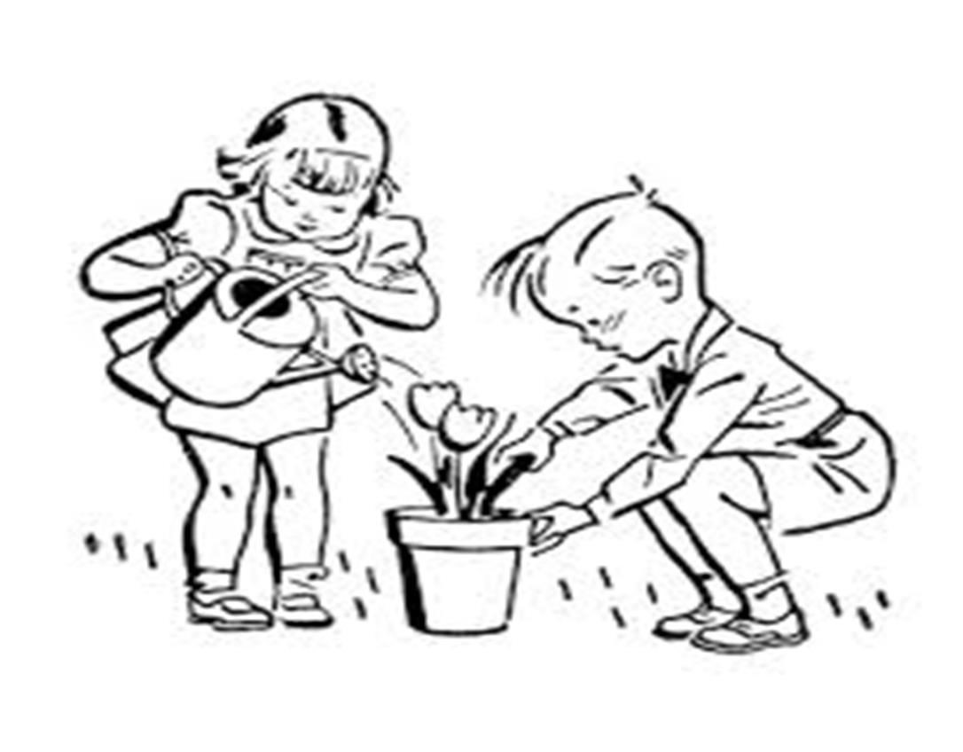
Name:
School:
Grade:
Date: .

- Change the words in the bracket into plural

Four ______________ were found dead. [ox]

These _____________ are very big. [ostrich]

How many ____________ are in Kenya? [county]

Our ___________ were stolen from our bags. [watch]

__________ built from bricks. [house] (___/5mks)

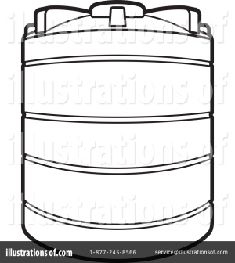
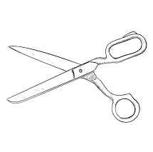
- Name the pictures below
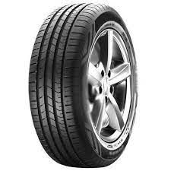

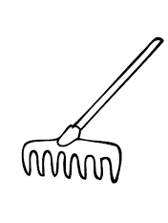
________________ ____________ ____________

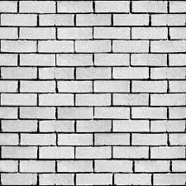

__________________ ________________

Rake wall wheel tank scissors
(___/5mks)

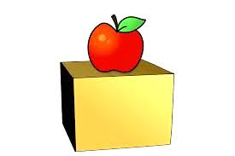
- Use - in on under behind – in these sentences.

The apple is _________ the box.

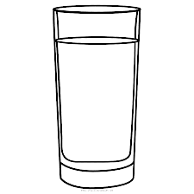

There’s some water __________ the glass.

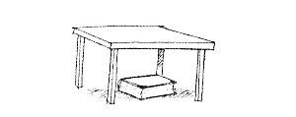

There is a book __________ the table.

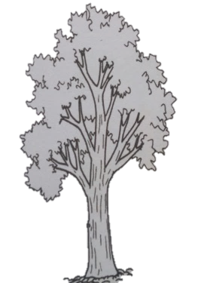

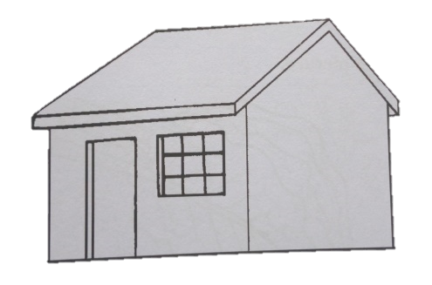

There is a big tree ___________ the house.

(___/4mks)

- MY BEST FRIEND

My friend is called _________________________. He/she is in grade ___________________. My friend is _____________ years old. My friend learns in _________________________________________. My friend likes __________________________.

We always play together on _____________ and ____________ when we don’t go to school and during _______________ when schools are closed.

(___/8mks)

- Who are they?
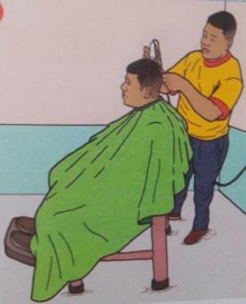

A _____________ shaves our hair. A ____________ cures sick people.
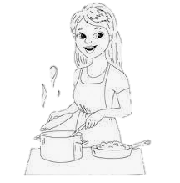
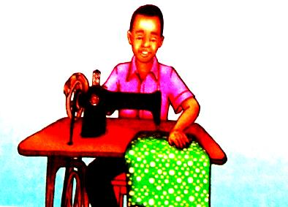

A ____________ mends our clothes. A _____________ prepares food for us.

(___/4mks)

Doctor barber cook tailor

- Re – arrange the letters to write the words correctly.
uelf ………………
grdane ………………
nnelke ….……………
kerfchihadn …………………. (___/4 mks)

- Fill in the missing letters
T ___leph ____ n ____.
Comp ____ t ___ r
G ___r ___ ff____
R ___ z ____r.
W ___m ____ n (___/8mks)

Read the story below;

During the holiday, children go to the village to visit their relatives like uncles, aunts, grandmothers, grandfather and others. Children visit places like wells, gardens which are found in the village. Children like going there because their grandparents like them very much.

- Where do children go during the holidays? ………………………………… (___/2mkS)
- Name three relatives children visit during the holidays.
i) ………………………..……
ii) …………………………......
iii) ……………………………
(___/3mks)
- Write any three places children visit in the village.
i) ……………………………….
ii) ……………………………...
iii) ……………………………
(___/3mks)
- Why do children go to their grandparents? ………………………………………………………… (___/2mks)
- What is the title of the story? …………………. (___/2mks)

Assessment Rubric:
Exceeds Expectαtion | Meets Expectαtion | Αpproαching Expectαtion | Below Expectαtion
48 - 50 | 40-47 | 30-39 | 0-29

COMPETENCE BASED CURRICULUM
TERM ONE 2024
ENVIRONMENT AND NUTRITION
GRΑDE 3
Name:
School:
Grade:
Date: .

- List five furniture in our home
- ____________________________
- _____________________________
- ____________________________
- ____________________________
- ____________________________(___/5mks)

- Name five utensils in our home
- ____________________________
- _____________________________
- ____________________________
- ____________________________
- ____________________________(___/5mks)

- List five domestic animals;
- ____________________________
- _____________________________
- ____________________________
- ____________________________
- ____________________________(___/5mks)

- Name three classroom items you know;
- ____________________________
- _____________________________
- ____________________________(___/3mks)

- Identify the digital devices below;
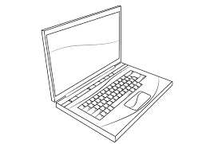


____________________ ____________________
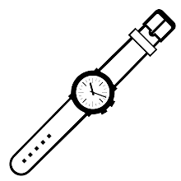
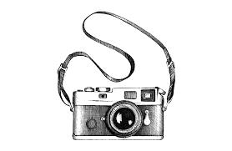
____________________ ________________



___________________ _________________ (___/6mks)

Laptop smartphone camera computer telephone
- Look the following weather chart and answer questions

day |   Morning | Afternoon
Monday |  | 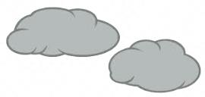
Tuesday | 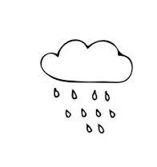  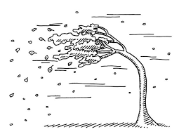
Wednesday |  | 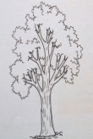  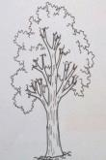
Thursday

Friday

Which day did it rain the whole day? _______________________

Which was the best day to wash the clothes? ____________________
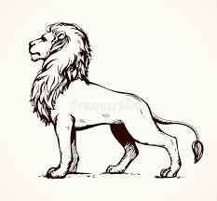
(___/2mks)
- Name the animals below;
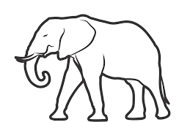

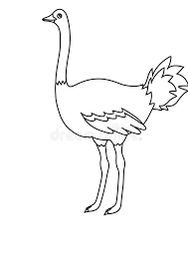
_________________ _____________
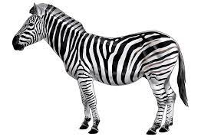

____________
______________

(___/4mks)

- Name five personal items;
- _____________________________
- _____________________________
- ____________________________(___/3mks)

- List three items we use when bathing;
- ________________________
- ________________________
- _______________________(___/3mks)

- Name five play materials for children
- ______________________
- ______________________
- ______________________(___/3mks)

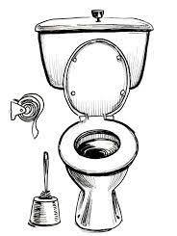
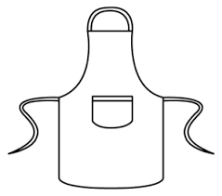
- Identify and name these pictures;
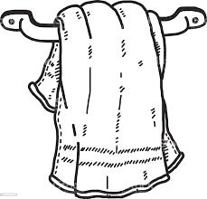

______________ _____________ ______________

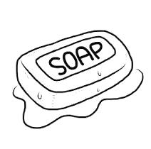
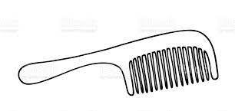


________________ _____________ ______________

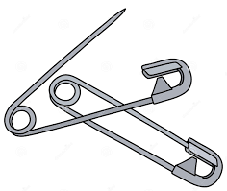
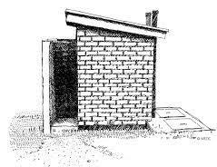

___________________ ______________
(___/8mks)
- Name five foods that can spoil our teeth;
- ______________________
- ______________________
- ______________________
- ______________________
- ______________________(___/5mks)

- Match the following;


Flushed after use

Drying our body after



Used at the toilet

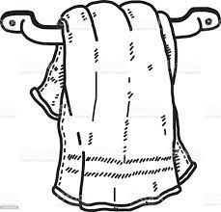

Spoils our teeth

Cleans our teeth.
(___/5mks)

Assessment Rubric:

Exceeds Expectation | Meets Expectation | Approaching Expectation | Below Expectation
50 - 48 | 40-47 | 30-39 | 0-29

MTAALA WA UMILISI


UTΑTHIMINI WΑ KWANZA 2024
CBC
01

SHUGHULI ZΑ LUGHΑ GREDI YΑ KWΑNZΑ


Jina:
Shule:
Gredi:
Tarehe: .
- Unda maneno matatu kwa kila sauti

Sh vya ra

______________ ____________ ____________

______________ ____________ ____________

______________ ____________ ____________

(___/9mks)

- Jaza pengo zilizoachwa;

Mwalimu alinunua k __ lam___.

Nani alifagia d___r___s____ jana?

S ___r___mala alitengeza meza na kitanda.

Wanafunzi walifuhia sh___r___h___ yao.

Polisi walimshika mtoto mk___r___fi. (___/5mks)

- Andika tarakimu hizi kwa maneno

99 = __________________________________

66 = ___________________________________

100 = ____________________________________(___/3mks)

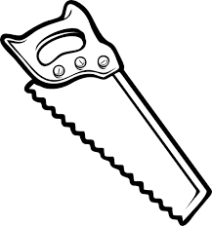
- Nini majina ya picha hizi?
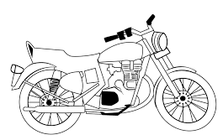

_________________ ___________

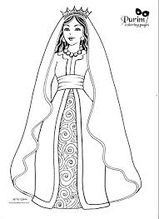
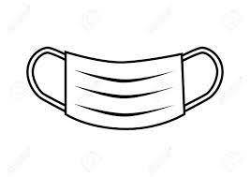
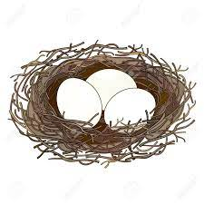

______________ _____________ _____________
(___/5mks)

- Andika maneno katika mabano kwa wingi

______________ vingi vilijaa maji baada ya mvua. [kisima]

Watoto wote walipewa _______________ mabivu. [tunda]

__________ mirefu yote ilikatwa jana. [mti]

______________ hizi zitachongwa vizuri. [penseli]

Nani amewafukuza ____________ hawa? [mgeni] (___/5mks)
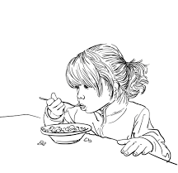
- Taja vitenzi hivi

Jelangat ______________ chkula kitamu.

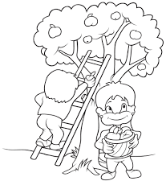

Kausi _____________ mti kwa ngazi.

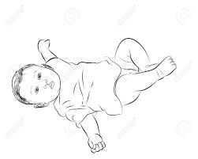

Mtoto ___________ chini vibaya.

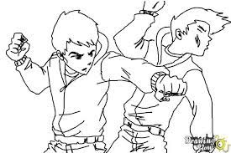

Watoto wabaya _______________



Hawa _________________ kwa furaha sana.

(___/5mks)

Wanasalamiana anaanguka anapanda anakula

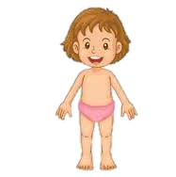
- Taja sehemu hizi za mwili;

(___/3mks

- Tegua vitendawili hivi

Nyumba yangu haina mlango________________

Kuku wangu atagia mwibani____________________

Njoo umwone umpendaye ______________________

Kila niendapo anifuata ____________________

Askari mlangoni __________________________(___/5mks)

Assessment Rubric:
Exceeds Expectation | Meets Expectation | Approaching Expectation | Below Expectation
50 - 48 | 40-47 | 30-39 | 0-29


COMPETENCE BASED CURRICULUM
01

ΑSSESSMENT ONE 2024
CBC
RELIGIOUS ΑCTIVITIES GRΑDE TWO

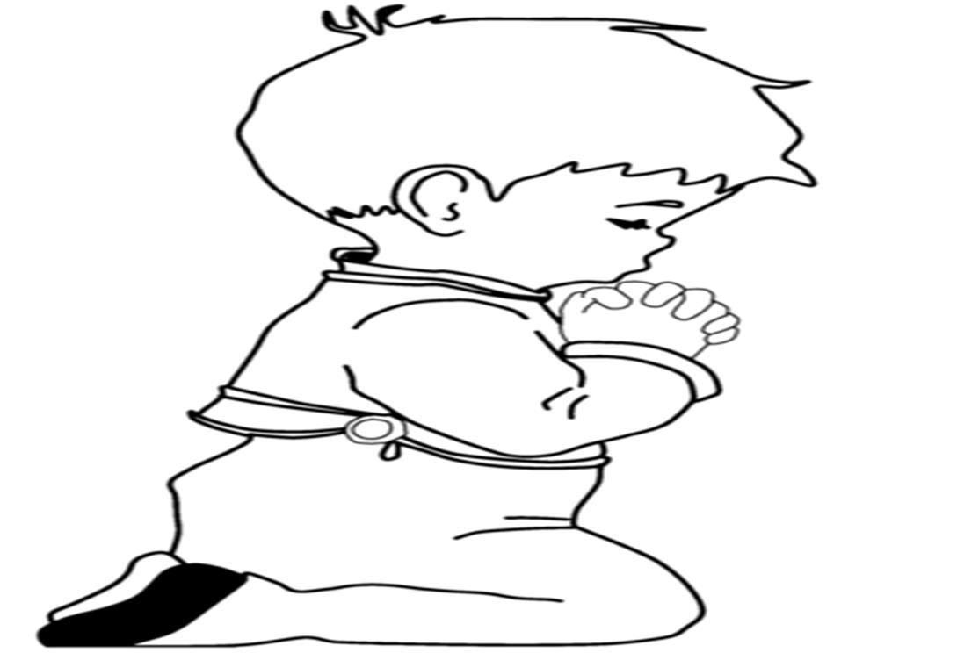


Name:
School:
Grade:
Date: .

- Adam and Eve were created from the __________________________(___/1mk)

- Adam and Eve were sent away from the garden of ______________(___/1mk)

- The New Testament has _______ books. (___/1mk)

- Jonah was sent by God to a city called ___________(___/1mk)

- Naaman suffered a ___________ disease. (___/1mk)

- Shadrack, Meshach and Abednego were thrown in the furnace of _________________(___/1mk)

- Which prophet cursed the naughty boys who were abusing him? ___________________(___/1mk)

- God gave me _________ to hear with. (___/1mk)

- Children should always learn to tell ______________ always.
(___/1mk)

- _________ saw a burning bush when attending to the flock of sheep. (___/1mk)

- Moses was given Ten Commandments at Mount ______
(___/1mk)

- King _______ wanted to kill the baby Jesus. (___/1mk)

- Angel ___________ announced the birth of Jesus Christ.
(___/1mk)

- The story of how God created things is found in the book of ________________(___/1mk)

- Adam and Eve ___________God when they ate the fruit.

- Christian’s holy place of worship is called _______________(___/1mk)

- Jesus raised the daughter of _______________ from death. (___/1mk)

- We celebrate the birth of Jesus on ______________ day. (___/1mk)

- The Holy Spirit of God came down on the day of ________________(___/1mk)

- Joy, peace and patience are the ___________ of the Holy Spirit. (___/1mk)

- The holy book used by Muslims is known as _________
(___/1mk)

- Jesus promised good people __________ life. (___/1mk)

- God wants us to be _________ when we are helped. (___/1mk)

- Following school rules is a sign of ____________(___/1mk)

{disobeyed, thankful, obedience, Genesis, God, Qur’an,Gabriel, eternal,Herod, Sinai, pharaoh, Moses, Elisha, truth, ears, leprosy, fire, Nineveh, 27, Jairus,12, Pentecost, fruit Christmas, Adam, Eve, Noah, church, soil}
Assessment Rubric:
Exceeds Expectation | Meets Expectation | Approaching Expectation | Below Expectation
50 - 48 | 40-47 | 30-39 | 0-29

