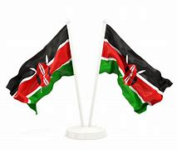
GRADE 3 ASSESSMENTS TERM ONE 2024
CRE
NAME :……………………………………..

- The holy bible is divided into;
________________ Testament
________________Testament.

- We talk to God when we ________________

- _____________ and ____________ were the parents of Samuel

- We should be _____________ when are helped by others.

- We read the word of God from the ___________________

- Only _____________ people were saved in the ark of Noah.

- Jesus had ____________ disciples.

- _____________ led the Israelites from Egypt.

- It is wrong to ___________ from each other.

- ______________ is called our father in heaven.

[ twelve, steal, God, Moses, eight, Old, New, Bible, thankful, pray, Hannah, Elkanah ]

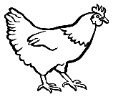
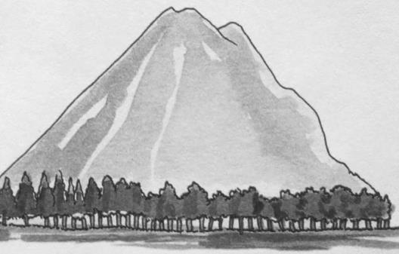
- Name the following creations of God
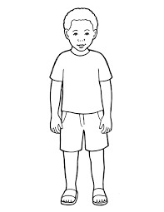

______________ __________ ___________


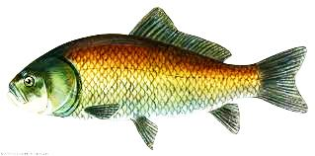

________________ ______________
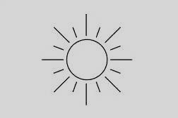

Αssessment Rubric:

Exceeds Expectαtion | Meets Expectαtion | Αpproαching Expectαtion | Below Expectαtion
98-100 | 80-97 | 50-79 | 0-49

