
GRADE 3 ASSESSMENTS TERM ONE 2024
ENGLISH
NAME :……………………………………..

LANGUAGE ACTIVITIES
- Fill in the missing letters on words about our school;
___ ss ___ mbly ___ nif___ rm
T___met___bl __ L __ ibr __ ry
S ___ bj ___ ct


- Present continuous tense [doing words]

What is the choir doing?
The choir is ___________ a song

What is Anyango doing?
Anyango is ______________ juice.

What is Mwajuma doing?
mwajuma is ____________ a ball.

- Health and hygiene
D | M | X | R | T | N | R | A | X | C | E | F | N
O | V | L | D | R | U | D | R | A | S | D | W | E
C | G | K | S | G | R | F | Q | R | H | Y | R | E
T | H | E | A | C | S | H | W | A | R | D | G | D
O | U | Y | Q | W | E | J | T | R | T | W | Y | L
R | L | G | Q | A | V | Y | F | R | T | Q | U | E
S | Y | R | I | N | G | E | S | C | F | G | J | U
F | S | D | Q | A | U | I | N | J | E | C | T | J

Find out at most six words from the table above;
___________________ ____________________
_____________________ _____________________
____________________ _____________________
- Change the words in the bracket into past tense.
All pupils ________ their classroom. [ sweep ]
Our parents ____________ very early. [arrive ]
The visitors _________ in the white tent. [ sit ]
Mr. Fred _________ some words. [ write ]

- Name the pictures below;
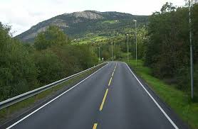


_____________________ ______________________
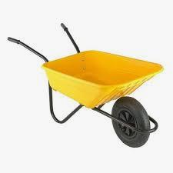


________________________ __________________________

- Use do or does in the following sentences;
____________ he read very well?
__________ they come to school early?
____________ Dorothy sleep early?
____________ you brush your teeth daily?
____________ the teacher help Mary?

READING
Read the story below and answer questions:
Monkey and crocodile were good friends. Monkey lived on the tree by the sea while crocodile lived in the sea. One day crocodile invited monkey to visit him in the sea. Monkey did not know how to swim. Therefore he climbed on crocodile’s back and their journey began.
When they reached in the middle of the sea, crocodile turned back at the monkey and he wanted to kill him for his heart. Monkey was afraid but he quickly planned to trick the crocodile. He told him that monkeys leave their heart at the tree whenever they travel. So he asked crocodile to turn back so that he may go and give him his heart from the tree.
Foolishly, crocodile took him back at the tree. Monkey quickly jumped on the tree and laughed back at the crocodile for his foolishness. Their friendship then ended.
At first monkey and crocodile were _______________________
Who lived on the tree by the sea? ________________________
Who invited monkey to his home? ________________________
What did crocodile want from the monkey? ________________
Did crocodile eat the monkey’s heart? _______________
At last what happened to the two friends? _________________________
Αssessment Rubric:
Exceeds Expectαtion | Meets Expectαtion | Αpproαching Expectαtion | Below Expectαtion
98-100 | 80-97 | 50-79 | 0-49

