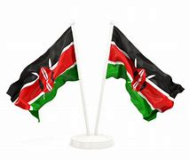
GRADE 3 ASSESSMENTS TERM ONE 2024
ENVIRONMENT AND NUTRITION
NAME :……………………………………..

- Name the colours of our national flag;
_________________________
_________________________
_______________________
_______________________
- List five members of the extended family;
- __________________________
- _________________________
- _________________________
- ___________________________
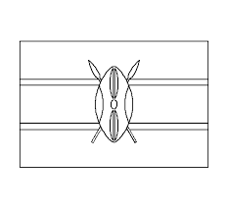
- __________________________

- Colour our national flag below;

- Name four sources of water;
- __________________________
- _________________________
- _________________________
- ___________________________

- Long period without rain causes ___________________
Tanks
Drought
Flood
Rainy

- Too much rain causes ________________________

- We plant our crops during ________________ season

- We can store and conserve water in water ______________

- List five uses of water at home;
- __________________________
- _________________________
- _________________________
- ___________________________
- __________________________

- Identify three types of soils;
- __________________________
- _________________________
- _________________________

- Name the parts of the plant below;
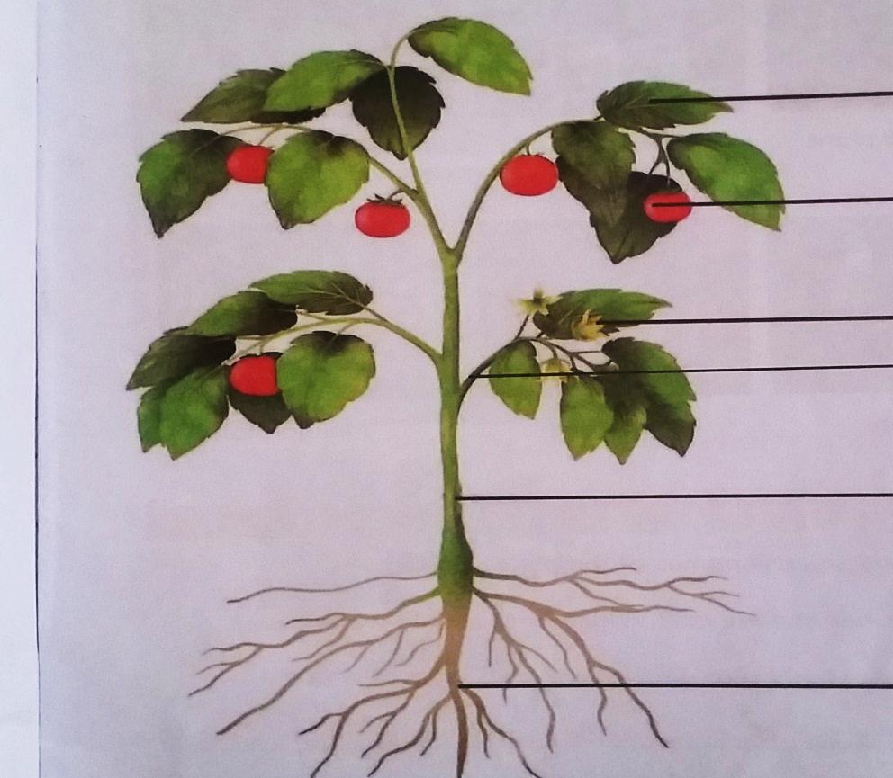

- Name five domestic animals;
_______________________________
______________________________
_____________________________
_____________________________
______________________________
Tourists
Honey
Eggs
Meat
- We get _____________ from bees.

- A hen gives us ____________ and _____________

- People who travel to see wild animals are called _____________
NUTRITION
- _______________ is the ability to see

- The first set of children’s teeth is called? _______________________

- We can use ______________ to clean our ears.

- Name four items we use when bathing;
_____________________
____________________
____________________
____________________

- Urinal is used by ___________ and ________________

- We should ___________ the toilet after use.

- Food makes us __________ and ______________

[ strong, healthy, sight, milk teeth, boys, men, flush, cotton buds ]
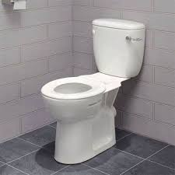
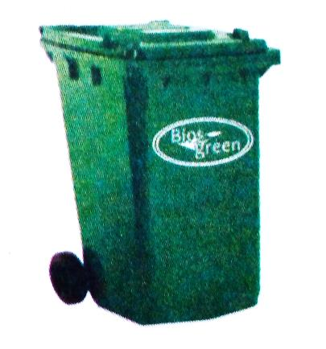
- Name the items below;
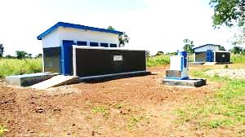

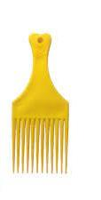
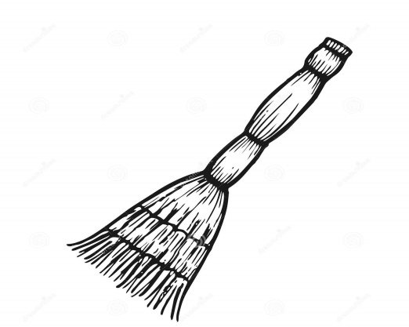
______________ ____________ _______________

_________________ _____________________

[broom dustbin comb toilet latrine ]
- ______________foods are not good for our teeth

- We use a _____________ to trim our finger nails short

- Diseases are caused by ____________ that live in the dirt.
[nail cutter germs sugary ]
- Name at least five foods that we eat at home;
- _________________________
- _________________________
- _________________________
- _________________________
- _________________________

- Name five examples of personal items that should not be shared
- _________________________
- _________________________
- _________________________
- _________________________
- _________________________
- List five examples of health habits;
- ______________________________________
- _____________________________________
- _____________________________________
- _____________________________________
- _____________________________________

- Socks are worn on the ____________________________

- Sick people are treated at the _______________________
Αssessment Rubric:

Exceeds Expectαtion | Meets Expectαtion | Αpproαching Expectαtion | Below Expectαtion
98-100 | 80-97 | 50-79 | 0-49

