GRADE 5 MATHEMATICS NOTES

NUMBERS

Numbers: Place Value of Whole numbers
To understand the place value of different numbers, we are going to use a place value table shown below:
Number | Hundreds of Thousands | Tens of Thousands | Thousands | Hundreds | Tens | Ones

Practice Question 1
What is the place value of 7 in the number 513 764

Answer:
Number | Hundreds of Thousands | Tens of Thousands | Thousands | Hundreds | Tens | Ones
513 764 | 5 | 1 | 3 | 7 | 6 | 4
The place value of 7 in 513 764 is Hundreds

Answer Hint:
The place value of 5 is Hundreds of Thousands
The place value of 1 is Tens of Thousands
The place value of 3 is Thousands
The place value of 7 is Hundreds
The place value of 6 is Tens
The place value of 4 is Ones

Practice Question 2
John is a farmer. Last year, he produced 981 732 kg of maize. What is the place value of 8 in the number?

Answer:
Number | Hundreds of Thousands | Tens of Thousands | Thousands | Hundreds | Tens | Ones
981 732 | 9 | 8 | 1 | 7 | 3 | 2
The place value of 8 in 981 732 is Tens of Thousands

Practice Question 3
What is the place value of the digits in red and underlined, in the numbers below:
a) 893
b) 4 830
c) 29 786
d) 197 853
e) 809 467

Answer:
Number | Hundreds of Thousands | Tens of Thousands | Thousands | Hundreds | Tens | Ones
893 |  |  |  | 8 | 9 | 3
4830 |  |  | 4 | 8 | 3 | 0
29 786 |  | 2 | 9 | 7 | 8 | 6
197 853 | 1 | 9 | 7 | 8 | 5 | 3
809 467 | 8 | 0 | 9 | 4 | 6 | 7
The place value of 9 in 893 is Tens
The place value of 4 in 4 830 is Thousands
The place value of 7 in 29 786 is Hundreds
The place value of 3 in 197 853 is Ones
The place value of 8 in 809 467 is Hundreds of Thousands

Decimals: Place Value up to Thousandths
¹/₁₀ can be written as 0.1. This is known as Tenth
¹/₁₀₀ can be written as 0.01. This is known as Hundredths
¹/₁₀₀₀ can be written as 0.001. This is known as Thousandths
¹/₁₀, ¹/₁₀₀, ¹/₁₀₀₀ are fractions.
0.1, 0.01, 0.001 are decimals.

Practice Question 1
What is the place value of each of the following numbers?
a) 0.089
b) 0.518
c) 9.713

Answer:
For this question, let us draw a place value chart.
Number | Ones | Decimal  Point | Tenths | Hundredths | Thousandths
0.089 | 0 | . | 0 | 8 | 9
0.518 | 0 | . | 5 | 1 | 8
9.713 | 9 | . | 7 | 1 | 3
Look at the last number, 9.713. We can state the place values of all the numbers as:
- 9 → Ones
- 7 → Tenths
- 1 → Hundredths
- 3 → Thousandths
For the number 0.518, can you tell the place value of 1 from the chart?
If you have said Hundredths, you are correct.

Practice Question 2
Let's go a step further.
What is the place value of each of the following numbers?
a) 45.089
b) 192.931

Answer:
For this question, let us draw a place value chart.
Number | Hundreds | Tens | Ones | Decimal  Point | Tenths | Hundredths | Thousandths
45.089 |  | 4 | 5 | . | 0 | 8 | 9
192.931 | 1 | 9 | 2 | . | 9 | 3 | 1

Practice Question 3
What is the place value of the underlined and red digit the following numbers?
a) 20.041
b) 9.21

Answer:
For this question, let us draw a place value chart.
Number | Tens | Ones | Decimal  Point | Tenths | Hundredths | Thousandths
20.041 | 2 | 0 | . | 0 | 4 | 1
9.21 |  | 9 | . | 2 | 1
Hence,
The place value of 4 in 20.041 is Hundredths
The place value of 2 in 9.21 is Tenths

Decimals: Ordering Decimals
Decimals can be order from:
a) Smallest to Largest (Ascending order)
b) Largest to Smallest (Descending order)

Practice Question 1 (Ascending order)
Arrange the following numbers in ascending order:
0.049, 0.591, 0.87, 0.348

Answer:
0.049, 0.348, 0.591, 0.87

Practice Question 2 (Descending order)
Arrange the following numbers in descending order:
0.128, 0.069, 0.598, 0.285

Answer:
0.598, 0.285, 0.128, 0.069

Practice Question 3
A group of Grade 5 pupils walked from their homes to the market. Mary walked 1.35 km, John walked 1.025 km, Stacey walked 1.089 km, and Mark walked 1.592 km.
a) Arrange the distances in ascending order.
b) Which student walked the least distance?
c) Which student walked the most distance?

Answer a)
1.025 km, 1.089 km, 1.35 km, 1.592 km

Answer b)
John (1.025 km)

Answer c)
Mark (1.592 km)

MEASUREMENT

Measuring Length in Kilometres
- A kilometre is a unit of measurement used to measure long distances such as length of a road.
- Here is an example of a road sign that you might have seen:

Practice Question 1
Assume that this road sign is at a Point A
a) Can you tell the distance from Point A to Nairobi?
b) Can you tell the distance from Point A to Eldoret?
c) Can you tell the distance from Point A to Mombasa?

Answer:
a) Point A to Nairobi: 9 km
b) Point A to Eldoret: 320 km
c) Point A to Mombasa: 496 km
Always remember: 1000 metres(m) = 1 kilometre(km)
Here is a better demonstration of length:

Practice Question 2
a) What is the distance from Home to School using a direct route?
b) What is distance from the Shop to Home using a direct route?
c) Today, Susan walked from home to school. In the evening, she walked to the shop to buy milk and walked back home. How many kilometres did she cover?

Answer:
a) Home to School: 4 km
b) Shop to Home: 2 km
c) Home to School - 4 km, school to shop - 5 km and shop to home - 2 km
Therefore: 4 km + 5 km + 2 km = 11 km
Susan covered 11 km today.

Practice Question 3
Each day Susan walks 11 km. If Susan goes through the same route for 5 days, what far does she cover?

Answer:
Each day she walks 11 km, for 5 days she will walk:
11 km + 11 km + 11 km + 11 km + 11 km
11 km x 5 days
55 km

Converting Kilometres into Metres
Remember: 1000 metres(m) = 1 kilometre(km)

Practice Question 4
Martin rides a bicycle to work every day covering a distance of 5 kilometres. How many metres does he ride his bicycle everyday?

Answer:
Distance covered = 5 km
5 km = 5 x 1000 m
5 km = 5000 m
Martin covers 5000 m everyday.

Practice Question 5
Martha ran 4 kilometres and 260 metres today at school during sports day. How many metres did she run?

Answer:
Distance covered = 4 km 260 m
4 km = 4 x 1000 m
4 km = 4000 m
Total distance = 4000 m + 260 m
Martha ran 4260 m.

Converting Metres into Kilometres
Do you remember that 1000 metres(m) = 1 kilometre(km)?

Practice Question 6
Over the school holidays, Trisha visited her grandparents who lived 2000 m away. How many kilometres did she travel?

Answer:
Distance covered = 2000 m
1000 m = 1km
2000 m ÷ 1000 m
2000 m = 2 km
Trisha covered 2 km.

Practice Question 7
Convert 4600 m into kilometres

Answer:
Distance = 4600 m
4600 m = 4000m + 600 m
4000 m ÷ 1000 m
4000 m = 4 km
4 km 600 m

Addition involving Length in Kilometres and Metres

Practice Question 1
The map below shows Mary's route. Let us use it to answer the question below:
Mary cycled from school to the shop through home. What distance did she cover?

Answer:
Mary cycled 7 km 100 m.

Answer Hint:
- Start from the right: 600 m + 500 m = 1 100 m
- Convert 1 100 m to km: You get 1 km 100 m
- Write the 100 in the metres column and carry the 1 km into the kilometres column.
- Lastly, calculate: 4 km + 2 km + 1 km = 7 km.

Practice Question 2
The distance from Rachel's house to the market is 4 km and 400 m while the distance from the market to the church is 3 km and 800 m. What is the total distance from Rachel's house to the church, through the market?

Answer:
- To understand the question being asked, start by drawing a rough sketch of the distances as shown below.
-Hence, the calculation will be:
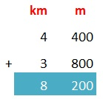
Rachel travelled 8 km 200 m.

Answer Hint:
- Start from the right: 400 m + 800 m = 1 200 m
- Convert 1 200 m to km: You get 1 km 200 m
- Write the 200 in the metres column and carry the 1 km into the kilometres column.
- Lastly, calculate: 4 km + 3 km + 1 km = 8 km.

Subtraction involving Length in Kilometres and Metres

Practice Question 3
Work out:
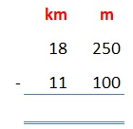

Answer:
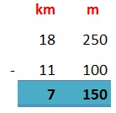
Answer is 7 km 150 m.

Answer Hint:
- Start from the right: 250 m - 100 m = 150 m
- Write the 150 in the metres column
- On the km column, calculate: 18 km - 11 km = 7 km

Practice Question 4
Work out:
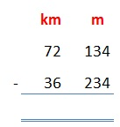

Answer:
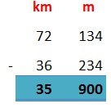
Answer is 35 km 900 m.

Answer Hint:
- Start from the right: Since 134 m is smaller than 234 m, we borrow 1 km from the kilometres column.
- Remember that 1 km = 1000m, we convert the 1km we borrowed to m and add it to the 134 m on the right column: 1000 m + 134 = 1134 m
- Now calculate: 1134 m - 234 m = 900 m
- On the km column, remember that we borrowed 1 km, therefore we remain with 72 km - 1 km= 71 km
- Calculate, 71 km - 36 km= 35 km

Practice Question 5
A driver started a 55 km 40 m journey to a town. He got a puncture 40 km 60 m from his destination. Calculate the distance he covered before the puncture.

Answer:
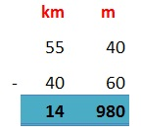
Answer is 14 km 980 m.

Answer Hint:
- Start from the right; the metres column: Since 40 m is smaller than 60 m, we borrow 1 km from the kilometres column.
- Remember that 1 km = 1000m, we convert the 1km we borrowed to m and add it to the 40 m on the right column: 1000 m + 40 = 1040 m
- Now calculate: 1040 m - 60 m = 980 m
- On the km column, remember that we borrowed 1 km, therefore we remain with 55 km - 1 km= 54 km
- Calculate, 54 km - 40 km= 14 km

ALGEBRA

Algebra: Solving Simple Equations Involving Addition and Subtraction

Forming Simple Equations with One Unknown
Consider the following:

Practice Example 1:
We can form a simple equation to represent the total number of apples as:
4 + 5 = b
which can also be written as:
b = 4 + 5

Practice Example 2:
The number of boys in a school is n. The number of girls in the same school is 120. If the total number of student in the school is 330, form a simple equation that can be used to find the value of n.

Answer:
n + 120 = 330
which can also be written as:
n = 330 - 120
Note
When we take the + 120 to the other side of the equation, the sign changes to minus (-) becoming - 120. The + and − signs change to the other when moved to either side of the equation.

Practice Example 3:
John had 14 mangoes and Newton had p mangoes. If the total number of mangoes they had was 45, form a simple equation that can be used to find the value of p.

Answer:
John had 14 mangoes.
Newton had p mangoes.
Total number of mangoes was 45.
14 + p = 45.
p = 45 - 14

Practice Example 4:
The number of bags of beans harvest on Monday was 90. On Tuesday, y bags of beans were harvested. If the total number of bags harvested on Monday and Tuesday was 210, for a simple equation to show the number of bags harvested on Tuesday.

Answer:
Monday: 90 bags
Tuesday: y bags
Total: 210 bags
90 + y = 210
y = 210 - 90

Practice Example 5:
A grade 5 pupil in your school bought k mangoes from the market. On his was home, he ate 4 mangoes. If he arrived home with 6 mangoes, form a simple equation to show how many mangoes he bought from the market

Answer:
Total number of mangoes: k
Ate: 4 mangoes
Arrived with 6 mangoes
If we subtract the number of mangoes he ate, from the total number of mangoes, we get the number of mangoes he was left with.
k - 4 = 6.
The above equation can also be written as:
k = 6 + 4

Solving Simple Equations Involving Addition and Subtraction
In the previous section, we learnt how to form simple equations. In this section, lets learn how to solve them.

Practice Example 6:
Solve: 40 + m = 90

Answer:
The equation can be written as:
m = 90 - 40
m = 50

Practice Example 7:
Martha had 10 kg of beans and y kg of maize. Altogether, she had 25 kg of both maize and beans. How many kilograms of maize did Martha have?

Answer:
→ 1. Lets form a simple equation:
10 kg + y kg = 25 kg
The above equation can also be written as:
y kg = 25 kg - 10 kg
→ 2. Lets solve the simple equation above:
y kg = 25 kg - 10 kg
y kg = 15 kg

Practice Example 8:
Solve: d - 4 = 9

Answer:
The equation can be written as:
d = 9 + 4
d = 13

Practice Example 9:
Solve: f - 419 = 210

Answer:
The equation can be written as:
f = 210 + 419
f = 629

Solve: 20 - t = 12

Answer:
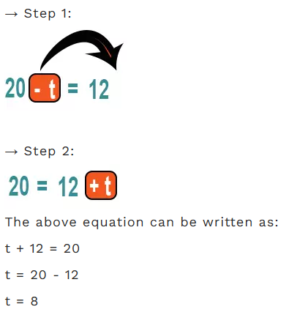

Algebra: Forming and Solving Simple Equations Involving Multiplication and Division

Forming Simple Equations with One Unknown

Practice Example 1: Multiplication
Mary bought 7 box of apples. Each box has 6 apples. If the total number of apples bought was y. Form a simple equation that can be used to find the value of y.

Answer:
Total number of boxes: 7
Number of apples in each box: 6
Total number of Apples bought: y
Equation: 7 x 6 = y

Practice Example 2: Division
Patricia has 40 pens. She wants to back the pens equally into 5 boxes. Once packed, each box will contain t pens. Form an equation to find the value of t.

Answer:
Total Number of Pens: 40
Number of boxes packed: 5
Number of pens in each box: t
Equation: 40 ÷ 5 = t

Practice Example 3: Try it!
In a Grade 5 class, a teacher shared 24 books equally among the learners. Each learner got 3 books. There are a total of n learners in the class. Form a simple equation to use to find the total number of learners, n.

Answer:
Total Number of books: 24
Number of books per learner: 3
Total number of Grade 5 learners: n
To create the equation, we have to determine the sign to use. Is it multiplication or division?
We use division (÷)
Equation: 24 ÷ 3 = n

Solving Simple Equations Involving Multiplication and Division

Practice Example 4: Multiplication
Find the value of p in
p x 3 = 12

Answer:
Note
a x b = c is the same as ab = c
Hence: p x 3 = 12 is the same as p3=12 which is the same as 3p = 12.
We divide both sides by the known value 3:
^{3p}/₃ = ¹²/₃
p = ¹²/₃
p = 4

Practice Example 5: Division
Find the value of y in
y ÷ 4 = 5

Answer:
Note
a ÷ b = c is the same as ª/_{b} = c
Hence: y ÷ 4 = 5 is the same as ^{y}/₄ = 5.
We multiply both sides by the known value 4:
⁴ x ^{y}/₄ = 5 x 4
y = 5 x 4
y = 20

Practice Example 6: Try it!
Brian had 18 marbles. He shared them equally among 3 friends. If each friend got p marbles, how many marbles did each friend get?

Answer:
Total Number of marbles: 18
Number friends: 3
Total number of marbles per student: p
To create and solve the equation, we have to determine the sign to use: multiplication or division.
The simple equation is:
3 x p = 18 which is the same as 3p = 18
We divide both sides by the known value 3:
^{3p}/₃ = ¹⁸/₃
p = ¹⁸/₃
p = 6

GEOMETRY

Horizontal Lines
A horizontal line is a straight line that runs from left to right.

Practice Question 1
Can you identify the horizontal line in the shape below:
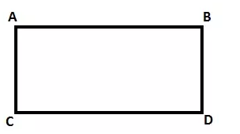

Answer:
The horizontal lines are:
A to B (Also written as AB)
C to D (Also written as CD)

Practice Question 2
Can you identify the horizontal line in the complex shape below:
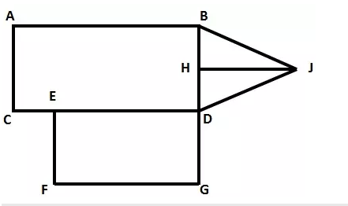

Answer:
The horizontal lines are:
AB
CD
FG
HJ

Vertical Lines
A vertical line is a straight line that runs from top to bottom.

Practice Question 3
Can you identify the vertical line in the shape below:
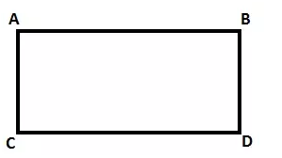

Answer:
The vertical lines are:
AC
BD

Practice Question 4
Can you identify the vertical line in the complex shape below:
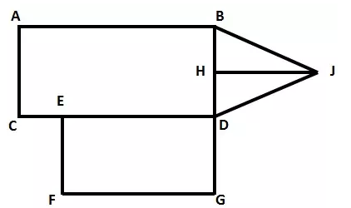

Answer:
The vertical lines are:
AC
BD
EF
BG

Perpendicular Lines
Perpendicular line are two straight lines that meet at a right angle or at 90°.

Practice Question 5
Can you identify the perpendicular lines in the shape below:
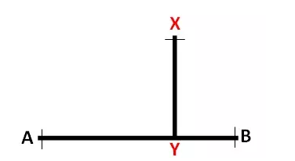

Answer:
The Perpendicular lines are:
Line XY is perpendicular to line AB

Practice Question 6
Can you identify the perpendicular lines in the complex shape below:
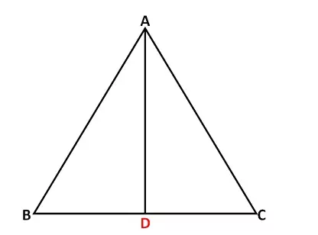

Answer:
Line AD is perpendicular to line BC

Parallel Lines
Parallel line are two straight lines which do not meet or intersect.

Practice Question 7
Are the lines below parallel to each other?
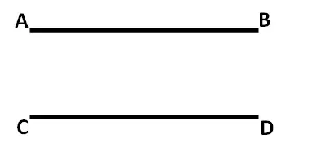

Answer:
Line AB is Parallel to line CD

Practice Question 8
Grade 5 pupils - Mary, Susan, Mark and John, were asked by they teacher to draw parallel lines on a paper. Which pupils drew parallel lines?
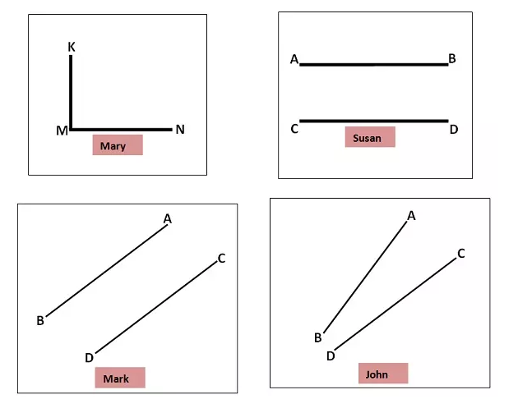

Answer:
Susan and Mark

Answer Hint:
- Mary drew perpendicular lines as they meet at 90°
- John drew lines that would meet. To prove this, extend the lines as shown. The lines would meet at point t, hence they are not parallel to each other.
