

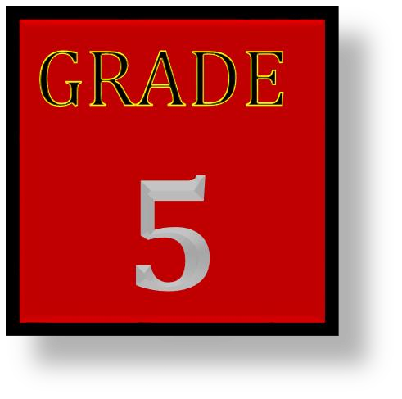
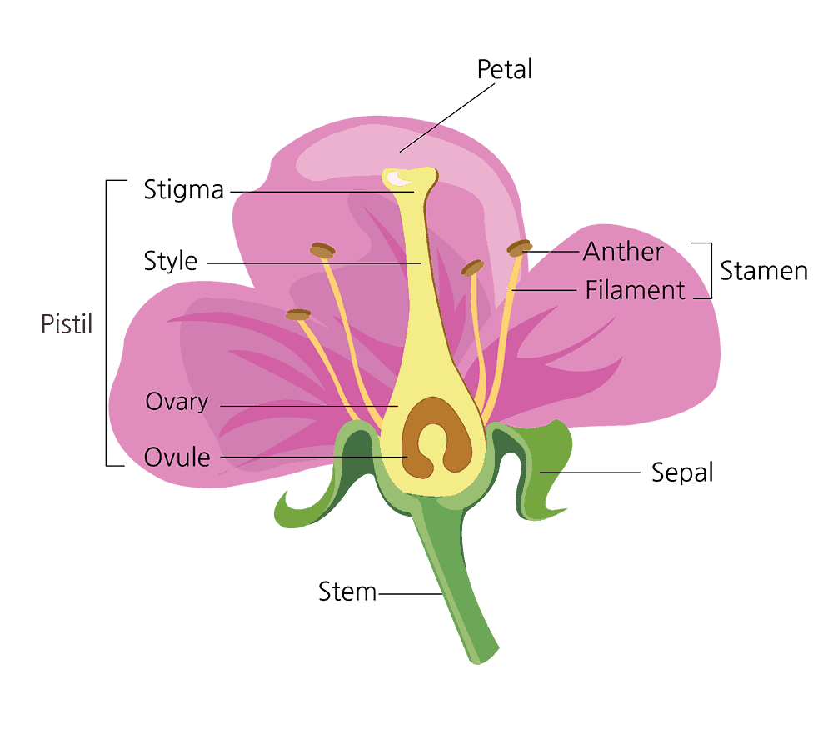
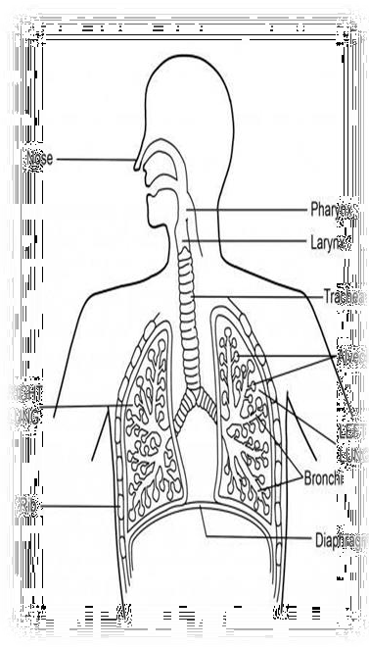
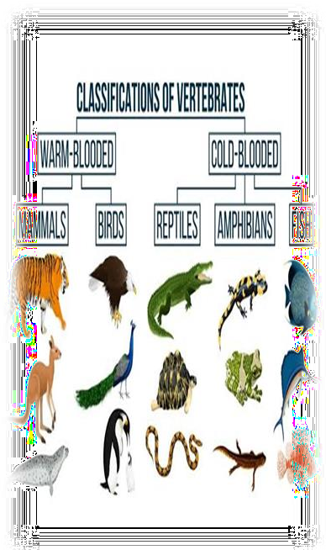
0711299730

LIVING THINGS AND THEIR ENVIRONMENT

Plants

Classification of plants
Plants are living things.
Classifications - is the act or the process of dividing plants in groups, according to the given features.
In grade 5 plants are groups into two categories which include

Flowering plants – these are plants that produce flowers for examples maize, pawpaw and beans.
Non – flowering plants - these are plants that do not produce flowers for examples mosses, fern and algae.

Parts and functions of a flower
A flower is the reproductive part of a plant. Most flowers have both the male and the female reproductive parts. Some flowers have only one reproductive part, either the male or the female.

Parts of a flower
The following are the parts of a flower:

The stalk
It joins the flower to the plant.

The calyx
It consists of small parts that look like leaves called sepals. Sepals are usually green. Sepals protect the inner parts of the flower while it is growing in the bud.

The corolla
It consists of brightly coloured parts called petals.

The stamens
They are the male parts of a flower. They produce the male reproductive cells called pollen grains. A stamen has two parts:
·The anther which contains pollen grains.
·The filament which is a long stalk that holds the anther.

The pistil
This is the female reproductive part of a flower. It consists of: The stigma which receives pollen grains from the anthers.
The style which is a long and narrow tube. The style joins the stigma to the ovary.
The ovary which contains ovules. Ovules are the female reproductive cells.

The nectary
It is at the base of the petals. It produces a sugary substance called nectar. Nectar is food for many insects such as bees and butterflies.

Importance of flowering plants
Flowering plants are very useful They give food
They give shelter They give medicine
They add beauty to the environment

Safety precautions when handling harmful plants Precautions

Safety precautions when handling harmful plants Precautions – are measures taken in advance to prevent harm to the learners when carrying out different activities. They include - - - Wearing protective cloths washing hands after handling plants not eating or tasting or smelling poisonous plants

ANIMALS
Vertebrates
- Animals are divided into two groups, vertebrates and invertebrates
- Vertebrates have vertebral column also called backbone. The backbone runs from the skull, joining the upper limbs and the ribcage to the lower limbs

General characteristics of vertebrates
  - They have a backbone.
  - They have a skull.
  - They have an endoskeleton.
  - They have bilateral symmetry.
  - They have two pairs of appendages.

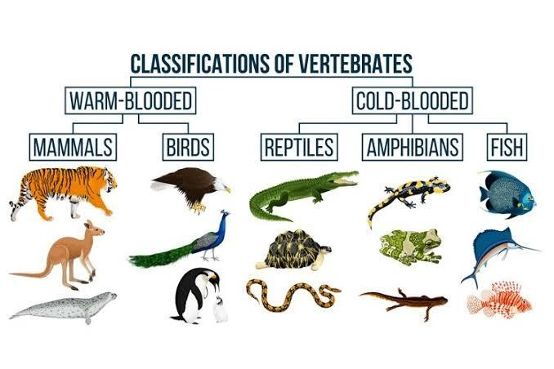
Groups of vertebrates

There are 5 classes of animals in the vertebrates groups
- Mammals
- Birds
- Fish
- Reptiles
- Amphibians
- Mammals and birds are warm blooded, meaning their body temperatures are constant.
- Fish and reptiles and amphibians are cold blooded meaning their body temperature changes according to the surrounding.

Characteristics of mammals
They have memory glands

They range in different sizes They have backbones
They give birth to young on while other lay eggs e. the duck bill platypus and spiny ant eater.
They live in land
Body covered with far or hairs They are warm blooded

Characteristics of birds
These are animals with have feathers and can fly, however some do not fly e.g ostrich which can just run fast.

They have the following characteristics
They are warm blooded They have backbone
Body covered with feathers Birds lay eggs
They have wings

Characteristics of fish
These are animals which live in water
- They have backbones
- They live in water
- They are cold blooded
- They breathe through gills
- Move by swimming
- Their bodies are covered with scales

Characteristics of reptiles
- They have backbones
- They are cold blooded
- Their bodies are covered with scales
- They breathe through lungs

- Most reptiles lay eggs

Characteristics of reptiles
- These are animals that spend their lives in water and on land
- They have the following characteristics;
- They have backbones

Characteristics of amphibians
- They have moist skins
- Live partly in water and partly on land
- They breathe through gills when young and through lungs when mature they are cold blooded
- Most amphibians lay eggs

Importance of vertebrates in the environment
Vertebrates are important to the environment in the following ways;
- They make the environment clean by eating dead animals. For example vultures.
- Some of them act as pollinators. For example bats and monkeys.
- Some vertebrates such as cows, sheep and goats are source of food to human beings.

THE HUMAN BREATHING SYSTEM
PARTS OF HUMAN BREATHING SYSTEM
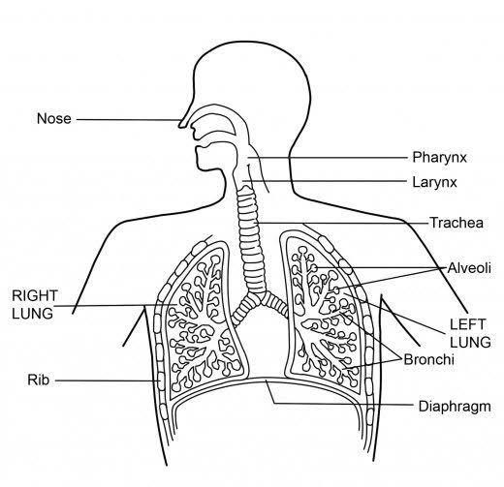

System – the human body is like a factory that is made of many parts. These parts work in groups called system
The breathing system has both visible parts such as the nose, internal parts such as the trachea, lungs and diaphragm. These parts work together to enable human being to breathe.

Breathing – this is the mechanism of taking air and blowing out air.
Air blow from outside into the nose through nostril. The nose has tiny hairs that clean the air by trapping dusts. At the back of the nose these is membrane that produces mucus which makes the air moist, warm and clean.
The trachea is called windpipe, it receives air from the nose, it has C- shaped ring that keep it strong and open. The walls of the windpipe have mucus and tiny hairs that filter air and keep it clean. The trachea acts as a passage for air from the nose into the lungs.
- A human being has two lungs located inside the chest. The lungs are a pair of airfilled organs. The lungs take in the oxygen in the air and take out carbon dioxide that the body does not need.
- The diaphragm is located under the lungs. It controls breathing. It separates the chest from the abdomen. It helps to fill the lungs with air when breathing in. It also helps to take out air when breathing out.
- Breathing is essential for the living process of human beings to continue.

Diseases that affect the human breathing system
The human breathing system is affected by many diseases. They include:

Tuberculosis (TB)
Is a disease that affects the breathing system? It mainly affects the lungs. TB is caused by bacteria. It spreads from one person to another through sneezing, coughing or spitting.

Signs and symptoms of TB

Night sweats Coughing up blood
Unintentional weight loss
Coughing that last for three or more weeks Chest pain or pain when breathing or coughing

Prevention of TB
- Staying dust free, well-ventilated rooms.
- Vaccinating infants.
- Covering the mouth when sneezing.
- Wearing a mask in public if you are already infected.
- An infected person should finish his or her entire course of medication.

Pneumonia
Is caused by germs such as bacteria and viruses. It can also be called fungi.

Signs and symptoms of Pneumonia
  - Chest pains when breathing or coughing
  - Cough that may produce mucus
  - Sweating and shaking
  - Nausea, vomiting or diarrhoea
  - Fatigue
  - Shortness of breath
  - Fever

Prevention of Pneumonia
  - Vaccination against pneumonia
  - Keeping immune system strong
  - Practicing good hygiene
  - Not smoking

Colds
Colds are caused by a virus. The virus affects the nose and the throat. Children under the age of six years are at greatest risk of getting it.

Signs and symptoms
  - Running or stuffy nose.
  - Congestion in the nose.
  - Sneezing.
  - Mild fever and generally feeling unwell.
  - Sore throat and cough Mild head.

Prevention of colds
    - Wash your hands thoroughly with soap and clean water.
    - Disinfecting items
    - Covering the mouth when coughing or sneezing
    - Avoid sharing utensils

Asthma
Is a disease that narrows and swells the airways in the lungs, producing extra mucus. This makes breathing difficult. Being exposed to substances such as pollen, dust mites, infections such as common cold, cold air, pollutants such as smoke, strong emotions and some kinds of medications can cause asthma.

Signs and symptoms of asthma
  - Shortness of breath
  - Chest pains
  - A whistling sound when breathing out.

Prevention of asthma
  - Getting vaccinated for influenza an pneumonia

Coughs
  - Identifying and avoiding asthma triggers
  - Monitoring your breathing
  - Treating early attacks
  - Taking medication as prescribed by the doctor.
  - Carefully following your medication plan.

Can be caused by smoke exposure, infections, asthma and presence of mucus in the throat.

Signs and symptoms
    - Frequent throat clearing and sore throat
    - Wheezing and shortness of breath
    - Persistent coughing
    - Running nose
    - Hoarse voice

Prevention of coughs
    - Avoiding smoke particles and dusty places
    - Avoiding smoking
    - Drinking a lot of water
    - Avoiding unhealthy surroundings and crowded places

Influenza
It is commonly called the flu. It is caused by a virus. The flu is transmitted through the air in droplets when someone with the infection coughs, sneezes or talks.

Signs and symptoms of influenza
  - A high fever
  - Chills and sweats
  - Dry and persistent cough
  - Nose congestions

  - Aching muscles
  - Headache
  - Fatigue and weakness
  - Sore throat

Prevention of influenza
  - Yearly flu vacation for any person who is six months old and above.
  - Thorough and frequent hand-washing
  - Covering your mouth and nose when sneezing or coughing ➔
Avoiding crowds during peak flu season.

Coronavirus Disease 2019 (COVID - 19)
- COVID-19 is a disease of the breathing system. It is caused by a virus, known as coronavirus. The virus looks like a round ball with a spiky crown.
- When an infected person sneezes or coughs, tiny droplets are spread into the air. These droplets contain the virus.
- One can get infected if he or she touches a surface with the virus. The virus enters a person’s system if one touches their nose, eyes or mouth

Signs and symptoms of COVID-19
  - Fever
  - Dry cough
  - Sore throat
  - Headache
  - Tiredness
  - Loss of taste or smell

Prevention of COVID-119
  - Wash your hands well frequently for at least 20 seconds with soap and running water. If soap and water are not available, use an alcohol- based hand sanitizer.
  - Use a handkerchief or tissue when sneezing or coughing. If you do not have one, sneeze or cough into your elbow. ➔ Avoid touching your eyes, nose and mouth ➔ Clean and disinfect surfaces and objects.
  - During an outbreak, stay home. If you need to go out put on the right face mask

  - During an outbreak, keep social distance of about 2 metres from other people
  - If you feel sick, tell your parents or guardians. You will be taken to see a doctor. You will be put on treatment.


MATTER
Mixtures
A mixture is a substance made by combining two or more different materials in such a way that no chemical reaction occurs. A mixture can usually be separated back into its original components.

Types of mixtures
There are two types of mixtures in nature. They include;
- A homogenous mixture is that mixture in which the components mix with each other and its composition is uniform throughout the solution. Example: salt solution, sugar solution, air, etc.

- A heterogeneous mixture is that mixture in which the composition is not uniform throughout and different components are observed.
Example: mixture of salt and sugar, grains and pulses along with some dirt particles (often stone pieces) etc.

Separating heterogeneous mixtures
Depending on whether the solids in a mixture are soluble, insoluble, magnetic or non-magnetic, several methods can be used to separate the substances making up the mixture.
In this sub strand, we are going to investigate the following methods of separation:
- Winnowing
- Sieving
- Picking
- Filtering
- Decanting
- Use of magnets
- Evaporation
- Separating funnel

Picking
Mixtures with big solid particles can be separated by picking. For example, a mixture of maize and beans can be separated by picking out either the beans or the maize. Name other mixtures that can be separated by picking.

Winnowing
A mixture of light and heavy solid particles can be separated by winnowing. Light solids are blown away by the wind. A mixture of rice and husks can be separated by winnowing. The wind will blow away the husks.

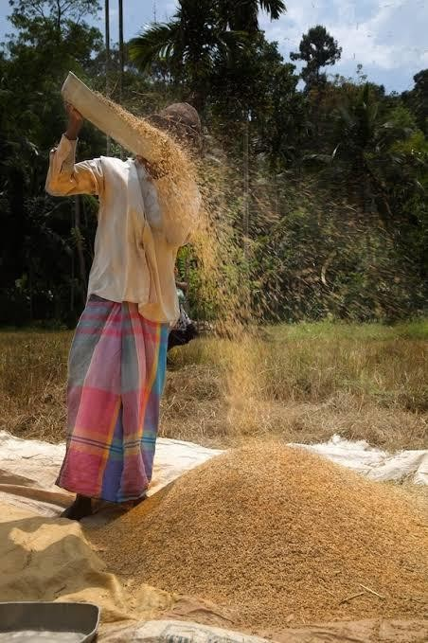

Sieving
When a mixture consists of small and large solid particles, the best way of separating it is by sieving. The small particles will pass through the sieve leaving the large ones. A mixture of wheat flour and husks can be separated by sieving.
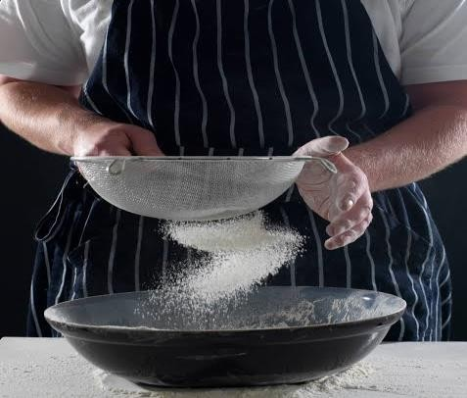

Using a magnet
A mixture of magnetic and non-magnetic particles can be separated using a magnet. Flour and iron filings can be separated using a magnet. The magnet attracts the iron filings.

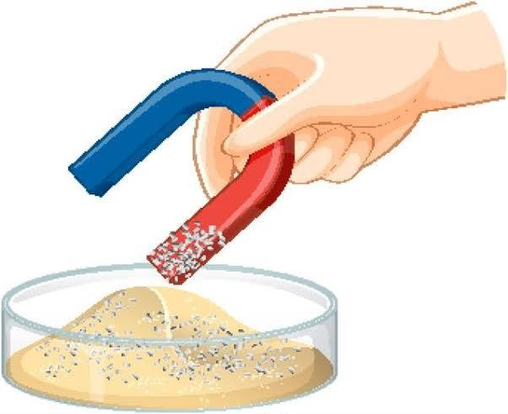

Decanting
Separating mixtures by decanting

Materials needed
Containers such as bottles and jars, sand and water.

Procedure
- Mix some sand and water in a clear bottle or jar and shake well.
- Let it stand for some time.

Questions
  - What happens when you mix the sand and water and shake well?
  - What happens after you let the mixture to stand for some time?
  - How can you separate the water from the mixture?
- After the sand has settled at the bottom, pour water gently into another container.

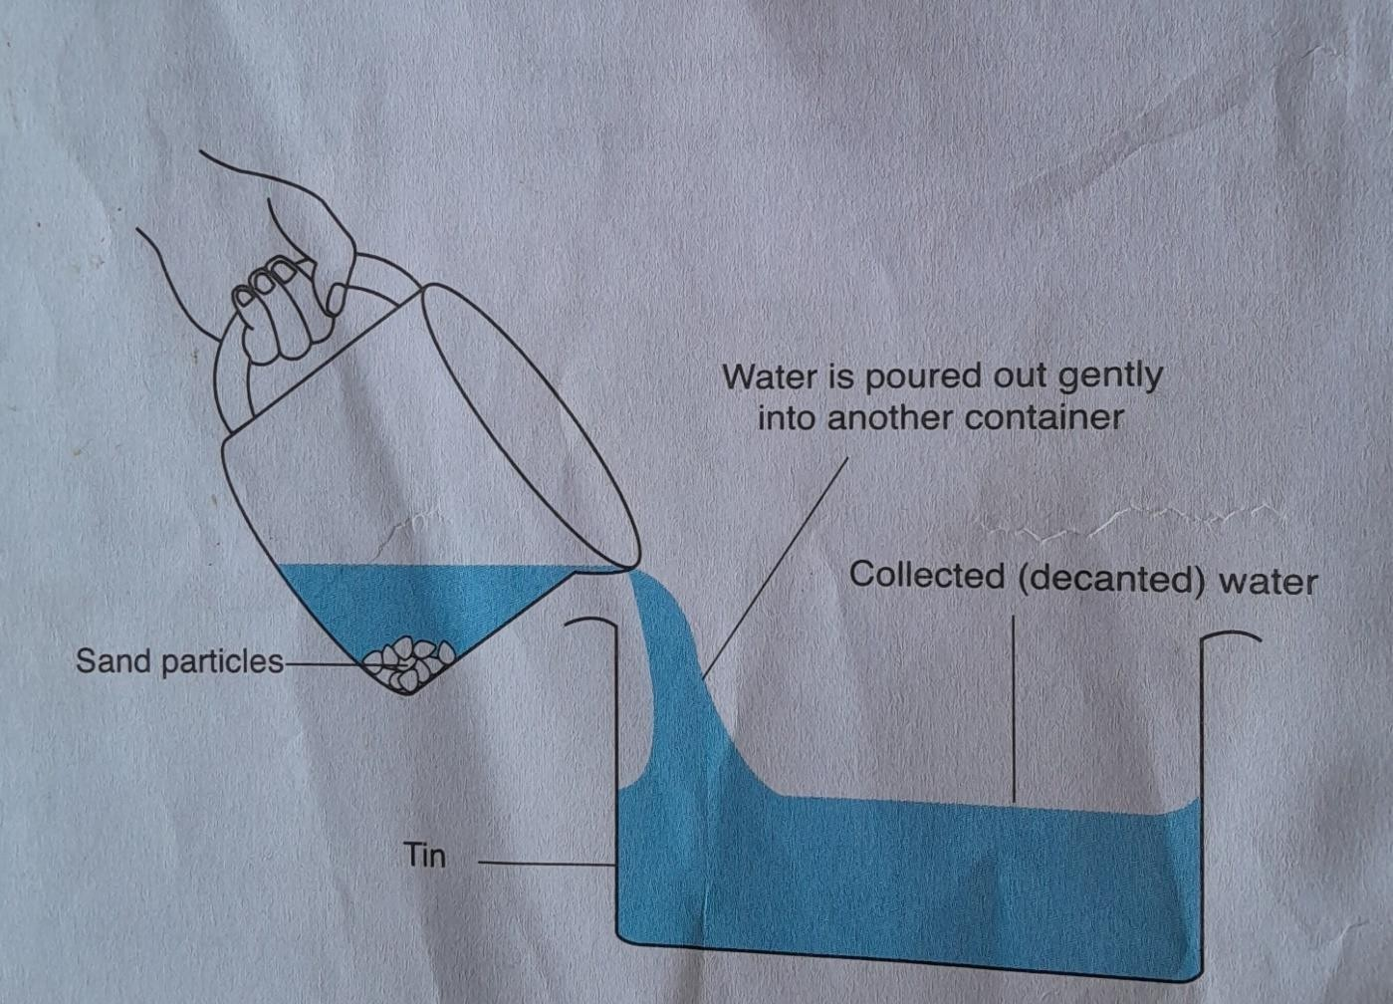

Observations
As the water is poured out gently, the sand particles are left in the bottle. This process is called
Decantation.
Decantation is, therefore, the process of separating an insoluble solid from a liquid by gently pouring. Out the liquid.
Sufuria-
Decantation is used at home in many ways, for example, to separate cooking water from cooked beans as shown in the figure below.

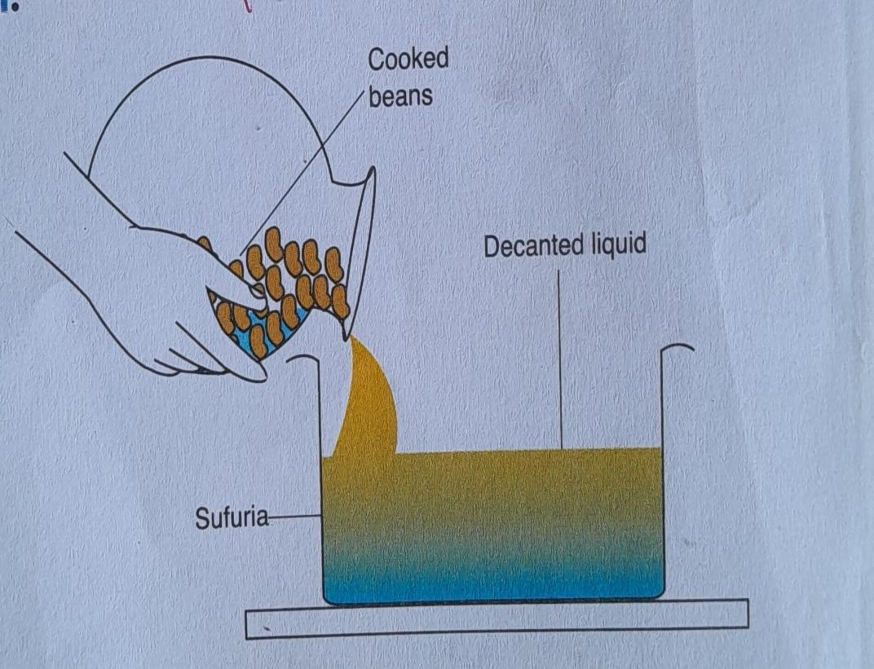

Filtering
In the lower primary, you separated solids from water using a piece of clean cloth. This process is called filtering. In filtration, one can also use a filter paper to separate solids from water.
Activity 7: Separating mixtures by filtering

Materials needed
A white piece of cloth or a filter paper, a bottle, a funnel, a clear container, and a length of string.

Procedure
- Prepare a mixture of soil and water in a clear bottle and shake it well.
- Filter the mixture using a piece of cloth or filter paper as shown in Figure 9.11.
- A filter paper resembles the paper that is used to make teabags. A filter paper, fold the paper into halves, then into quarters to make pockets in the paper as shown in figure.
- Open the pocket with a finger and place it in the funnel. Wet the filter paper with water so that it fits well in the funnel. Do not make a hole in the filter paper.

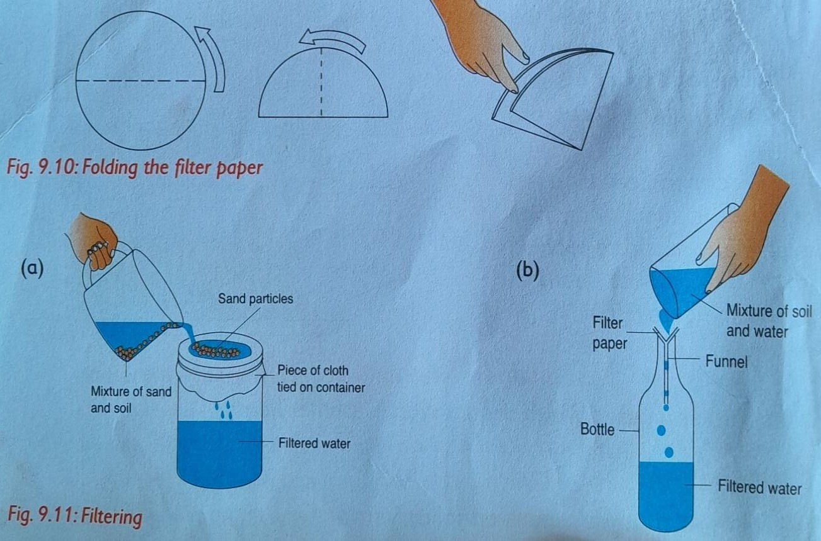

Questions
  - What do you observe on the piece of cloth or the filter paper?
  - What is collected in the jar? Explain your answer.

Making a home-made water filter
In areas where water is fetched directly from the river, home-made water filters are useful.

Materials needed
- A clear bottle whose base has been cut off.
- A container or a jar to collect the water.
- Fine sand, charcoal, coarse sand, pebbles, cotton wool, a jar and dirty/muddy water (water and soil).

Procedure
- Arrange the materials as shown in Figure 9.12 to make a home-made water filter.
- Note the colour of the water. Pour the muddy/dirty water into the home- made water filter.
Cotton wool Tin
- Observe the water that is collected in the container. Again, note the colour of the water.
- Draw the water filter in your exercise book and label it.

Questions
  - What was the colour of the water before filtration?
  - What is the colour of the water that was collected after filtration?
  - What is the difference between the water collected and the water poured into the filter? Is the water collected after filtration safe for drinking? Explain your answer.

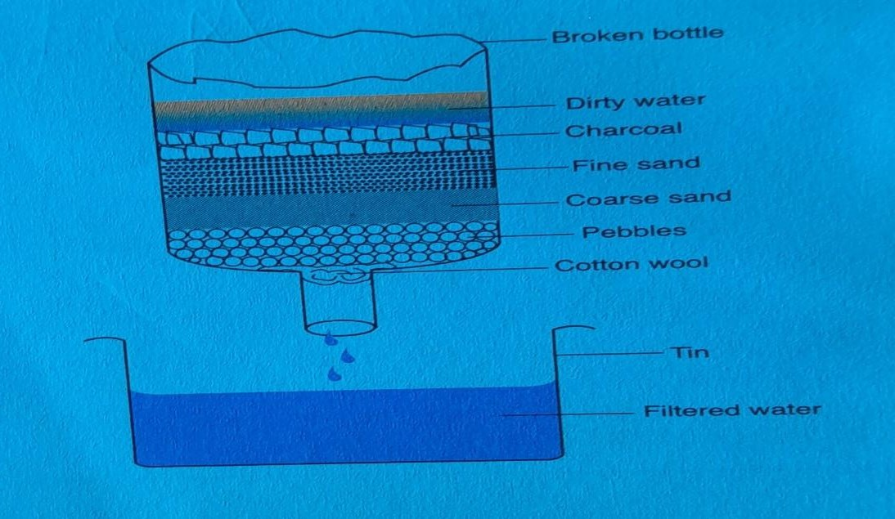

Observation
- Before filtering, the water is brown in colour. It contains soil particles, small parts of leaves and other insoluble particles.
- The water collected in the jar after filtration is clear. Water was separated from solid particles by filtering. This clear water is not safe for drinking.

It may contain disease-causing germs which are too tiny to be filtered. It has to be boiled or treated with chemicals to make it safe for drinking.
- The liquid collected after filtration is called the filtrate. The solids that remain on the cloth, the filter paper or trapped in the materials used to make the home-made filter are called residue.

Separating mixtures by evaporation

Materials needed
Salt, water, a source of heat, containers such as bottles, glasses, small sufurias and a stirring rod.

Procedure
- Mix salt and water in a container and stir well to make a solution.
- Put the solution in a small sufuria and place it on a source of heat.
- Heat the solution until all the water evaporates.
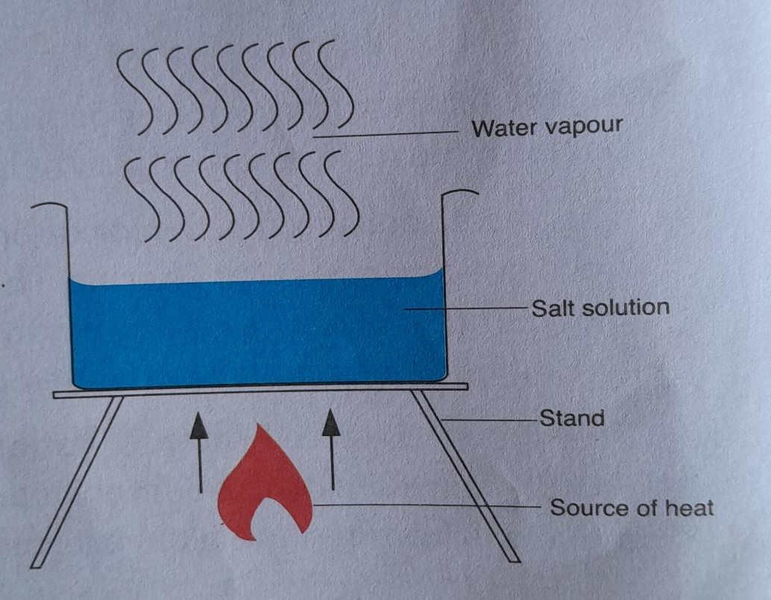

Questions
On heating the solution:

- What happens to the salt?
- What happens to the water?

Observation
On heating the solution, the water evaporates, and the salt remains in the container.
Note that this separation method allows you to recover only the solute (salt). The solvent (water) is lost to the atmosphere through evaporation.
Filtering and evaporation

Recovering salt from a mixture of water, sand and salt

Materials needed
Sand, salt, a filter paper or a clean piece of cloth, a clear bottle, water ,tin, a stirring rod, a rubber band and a source of heat.

Procedure
  - Mix salt and sand in a container.
  - Put the mixture of sand and salt in water and stir the mixture thoroughly.
  - After stirring, let this mixture stand for some time.
Filter the mixture into another container as shown in figure below.
  - Collect the filtrate (salt solution) in another container.
  - Heat this filtrate as illustrated. Allow all the water to evaporate and record your observations.

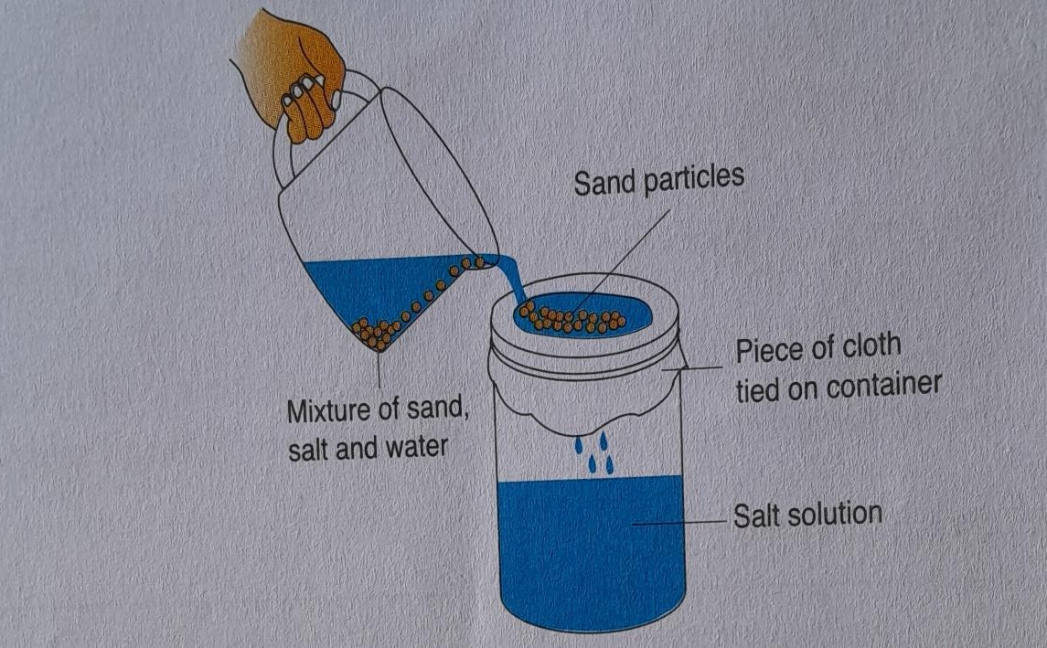

Questions
    - What happens when you mix sand, salt and water and stir well?
    - What happens after the mixture is allowed to stand for some time?
    - After filtering, what is collected in the jar and what remains on the filter paper or piece of cloth?
    - After heating, what remains in the sufuria. What happens to the water?

Observations
      - When you mix sand, salt and water, the salt, which is soluble in water, dissolves. The sand, which is insoluble in water, remains suspended in the mixture.
      - After the mixture is allowed to stand for some time, the sand settles at the bottom of the container.
      - After filtering, the salt solution is collected in the jar as the filtrate. The sand remains on the filter paper as the residue.
      - After heating the solution, the salt remains in the sufuria. The water evaporates into the atmosphere.
      - Filtration is used to separate insoluble solids from water.
      - Evaporation is used to separate some soluble solids from water. It is only the solute, in this case salt, that is recovered. The solvent (water) is lost to the atmosphere.

Water pollution
Water pollution is making water dirty.

Common water pollutants
Some causes of water pollution are:

Floods
When it rains, water becomes muddy and has solid impurities.

Human and animal waste
  - When animals and human beings pass their waste into or near water sources, many types of bacteria and viruses grow and pollute the water, in addition to the waste itself.
  - The animal or human waste may contain some disease-causing germ sand other internal parasites. These will contaminate the water and make it unsafe for drinking and domestic use.

Oil spillage
  - Crude oil is transported using large oil tankers. These oil tankers may have accidents on the high seas or on the lakes and spill oil into the water. This results in large masses of water getting polluted.
  - Oil spillage reduces the amount of oxygen in water. This makes breath in under water impossible. As a result, the fish and other marine life suffocate to death due to lack of adequate oxygen.

Waste from industries
Factories built along rivers or other sources of water may release untreated waste material into water thus polluting it. This makes the water unfit for use.

Uncontrolled use of farm chemicals
  - Uncontrolled use of pesticides and fertilisers by farmers also causes water pollution. When it rains, some of the farm chemicals are washed into water. Some chemicals in fertilisers and pesticides can harm animals living in water. Water contaminated with farm chemicals is unsafe for domestic use.
  - Presence of these chemicals in water leads to excessive growth of algae and other waterweeds which may block water pipes and waterways. Waterweeds start competing with the fish for oxygen.

Acid rain

- In countries where a lot of carbon fuels such as coal are used in industries, large amounts of carbon dioxide and sulphur dioxide gases are released into the air. Exhaust fumes from vehicles also release these gases into the air.
- When it rains, these gases dissolve in water forming acid rain. Acid rain destroys roofing of buildings, especially iron sheet roofs. It may also kill water animals and destroy plants. Sometimes, rainwater may appear coloured due to accumulated amounts of soot and dust in the air.

Effects of Water Pollution on living things
Water pollution has negative effects on plants and animals.

Effects of water pollution on plants
- Plants take water in using their roots through absorption.
- Water is necessary for germination of seeds and proper growth of plants. Plants also use water to make their food during photosynthesis.
- When water is polluted by oil spillage, for example, the oil blocks the root hairs and the plant may wither and dry up.
- Acid rain also causes harm to plants since plants cannot grow well in acidic water. Water that contains excessive fertilisers, pesticides or herbicides can cause plants to dry up.

Effects of water pollution on animals
- Animal waste pollutes water by introducing organisms that cause water-borne diseases. When animals drink contaminated water, they may develop these diseases. Dissolved chemical substances and fertilisers may cause harm to animals or even kill them.
- When oil spills on water, it prevents air from dissolving in the water. The fish, and other water animals and plants suffocate due to lack of adequate oxygen.

Methods of reducing water pollution
Some ways used to control water pollution are:

- Practising proper hygiene, for example, using toilets, latrines and urinals; and not bathing and doing our washing in water sources.
- Practising farming methods that reduce soil erosion such as planting cover vegetation and terracing. This reduces the amount of soil that goes into rivers and lakes during floods.
- Drawing water for animals instead of taking them to water sources. This will prevent them from releasing waste into the water.
- Controlling the dumping of industrial waste into water sources. All waste should be treated to make it harmless to the environment.
- Clearing accidental oil spills as soon as they happen.
- Controlling the use of farm chemicals such as fertilisers, pesticides and herbicides.

Basic method of water treatment
  - Boiling; boiling the water kills disease causing germs such as bacteria, viruses or protozoa. Boiling is the cheapest and safest method of water purification.
  - Filtration; In filtration, solid particles are entirely removed from water. Water treated by filtration is not safe for drinking unless your boil it.
  - Chemical treatment; use of chemicals like chorine in water treatment kills germs.
FORCE AND ENERGY

Floating and sinking
Floating is when an object remains on the surface of water. Sinking is when an object goes to the Bottom of the water surface.

Factors affecting floating and sinking
Factors that affect floating and sinking include;

Types of the material
- Objects made of metal sink while those made of wood, rubber and plastic float.

Shape
-A bottle top which is not crushed floats on water. - When the same bottle top is crushed, it sinks.
The crushed bottle top sinks because of the shape.
A ship made of iron and steel floats because of the shape.
- When the volume of an object increases, its density decreases, making it easier to float.

Weight of the material
- Materials which weigh more sink in water.
- When pebbles are added on a bottle top, it sinks because of increased weight.. The size of material does not affect sinking and floating.

Application of floating and sinking in day to day life
  - Principle of floatation is used in making ships, submarines and boats.
  - It is used in making hot air balloons and air ships.
  - Ice bergs floats on the surface of water due to floatation phenomenon.

Sound energy
Sound is a form of energy that travels in waves and is essential for communication and interaction in our daily lives.

Sources of sound
Sound is the energy that things produce when they vibrate. Sounds are produced when we the following;
    - Clap our hands
    - Stamp our feet
    - When we whistle.
    - When we hit a drum
    - Playing guitar

Movement of sound in nature
Sound travels in all directions.

Effects of loud sound
The effect of sound pollution on human health and behaviour include the following:
- Loss of hearing - the immediate effect of noise pollution to a person, over a period of time is reduced hearing ability. Over a time a person may completely lose his or her hearing.
- Poor concentration - loud and continuous noise makes a person lose concentration on any activity that they are carrying out.
- Irritability - loud and continuous noise at home and at school may result in irritability which lead to aggressive behaviour.
- Sleep disturbances - loud noise disturbs your sleep and keeps you awake.
- Interferences with communication - loud noise makes people unable to communicate freely. You may find it difficult to understand or even hear what someone else is saying.

Role of sound in day to day life
- Communication:
  - One of the primary roles of sound is in communication. We use sound to express our thoughts, feelings, and ideas through spoken language. Without sound, verbal communication would not be possible.

Understanding Others:
  - Sound allows us to understand what others are saying. It helps us to interpret the messages conveyed through speech, which is crucial for effective interaction and social bonding.

Alerting and Safety:
  - Sound plays a vital role in alerting us to dangers or important events. For example, sirens, alarms, and warning signals use sound to grab our attention and inform us of potential hazards.

Entertainment:
  - Sound is also important in entertainment. Music, movies, and theater rely heavily on sound to create an emotional connection and enhance the experience.

Learning and Education:
  - In educational settings, sound is essential for teaching and learning. Lectures, discussions, and presentations all depend on sound to convey information effectively.

Cultural Significance:
  - Sound has cultural importance as well. Different cultures use sound in various forms such as traditional music, rituals, and celebrations, which help to preserve cultural identity.

Heat Transfer
Demonstrating Transfer of heat in liquids

Materials
- Sawdust
- A glass container
- A stand
- Water
- A matchbox
- A source of heat (a candle)

Procedure
a. Fill in the glass container with water
b. Place a small amount of sawdust in the water
c. Allow the sawdust to settle at the bottom of the container
d. Place the glass container on the stand
e. Heat the container using candle as the source of heat
f. Observe what happens.

Observation
- As the water continues to heat, a steady rise of sawdust is observed. This is because the water at the bottom of the glass container gets hotter, expands and rises.
- The cold water at the top then moves downwards and takes the place of the risen hot water.
- The cycle repeats itself. The sawdust particles show a movement in the water called convection currents. Therefore, heat is transferred in liquids through convection.

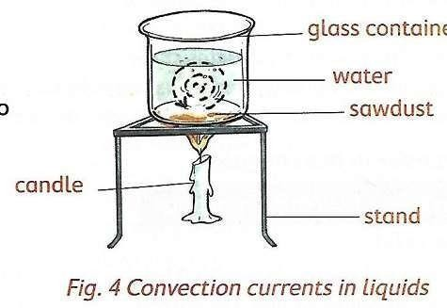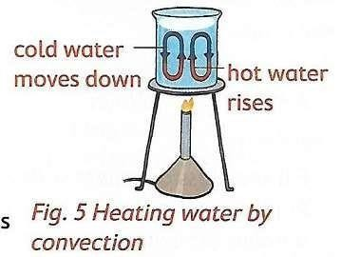

TRANSFER OF HEAT IN GASES
Demonstrating transfer of heat in gases

Materials

- A small carton box with a top
- Hard paper or piece of carton
- A piece of paper
- A short candle
- A matchbox

a. Make a chimney on each end of the top of the box
b. Divide the box with hard paper or a piece of carton to make two chambers A and B. place the transparent glass on the side of the box for viewing.
c. Light up a candle. Put the lit candle below the chimney B on the box. Close the box.
d. Place a burning piece of paper over chimney A as shown in figure 6
e. Observe chimney B and tell what you see.
f. Record your observations.
g.
  - The burning paper produces smoke that moves from chamber A to Chamber B through the opening.
  - The candle in chamber b heats the smoke coming from chamber A, which becomes lighter and rises.
  - As the smoke rises up it moves up through chimney B. Cooler air enters Chamber A through chimney A, creating a circular motion known as convection currents.
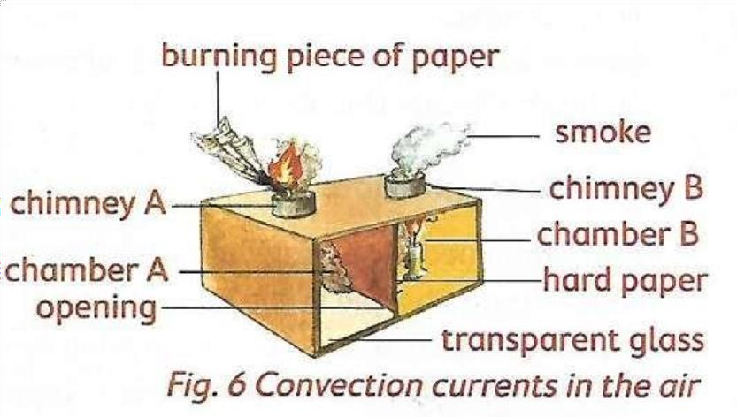
  - These currents can be viewed through the transparent glass. ● The transfer of heat in gases is known as Convection

  - Convection of heat is used in everyday life by many ways. These ways include:
    - Ventilating buildings
    - Inflation of hot air balloons

    - Heating of food in a microwave
    - Formation of land and sea breezes
    - Boiling of water in a sufuria or kettle
    - Vehicle engines

Transfer of heat by radiation
  - When you stand in the sunlight, you can feel the warmth of the sun. The heat energy from the sun is transferred to your skin through radiation.
  - When you sit beside a fire, you feel warm. The warmth of the heat from the fire is transferred from the fire to you through radiation.

Application of radiation in everyday life
  - Radiation is used in everyday life in many ways. These ways include:
    - Warming ourselves using electric heaters
    - Using solar heaters in the house
    - Drying clothes and grains
    - Using greenhouses to aid growth of plants.

Good and poor conductors of heat
- Materials that conduct heat faster than others are called good conductors

- Materials that conduct heat slowly are called poor conductors
- Materials that do not conduct heat at all are called insulators
  - Examples of materials that are good conductors are sufuria, metallic spoons, kettles, iron box
  - Examples of materials that are poor conductors are wood, plastic, cooking sticks, maize cob, rulers, piece of cloth, plastic cups, melamine, cooking pots.

Safety precautions when handling heat
The actions taken to prevent accidents, injuries or harm are known as safety measures. It is important to observe safety measures when handling heat.

The following are safety measures and practices when using heat.
- Use of kitchen gloves: Always wear kitchen gloves when handling hot pots, pans or dishes. This protects your hands from burns.
- Avoid direct contact with open fire: Keep a safe distance from open flames on stoves or grills. Use long utensils to handle food over heat sources.
- Use appropriate clothing: Wear clothing that covers your skin. This protects you from heat and not spills. Avoid loose clothing that could catch fire.
- Wear light and loose-fitting clothing.
- Take cool showers when there is extreme heat.
- Drink a lot of water during extreme heat.
- Avoid working in open environments on a sunny day.

