KENYA JUNIOR SCHOOL EDUCATION ASSESSMENT
901/1 ENGLISH (Reading Comprehension, Oral Skills and Grammar)
Paper 1 Time: 1 hour 40 minutes
INSTRUCTIONS TO CANDIDATES

- You have been given this question paper and a separate answer sheet. The question paper consists of 50 multiple choice questions.

- Answer ALL questions on the ANSWER SHEET provided, NOT on the question paper.

- Do all the necessary rough work on the question paper.

HOW TO USE THE ANSWER SHEET
- Use an ordinary HB pencil.

- Confirm that the answer sheet you have been provided with has the following:

YOUR ASSESSMENT NUMBER YOUR NAME
NAME OF YOUR SCHOOL NAME OF THE SUBJECT

- Keep the answer sheet clean and dry. DO NOT fold it.

- For each of the questions 1 – 50, four options are given. The options are lettered A, B, C and D. In each case, only ONE of the four options is correct. Choose the correct option.

- On the answer sheet, the correct answer is to be shown by drawing a DARK LINE inside the box in which the letter you have chosen is written.

Example
In the Question paper:
  - Which one of the following means the opposite of the word “better”?

    - weak
    - wrong
    - worse
    - wasted

The correct answer is ‘C’.
On the answer sheet, in the set of boxes given for number 40, draw a DARK LINE inside the box with the letter C printed in it as marked below.


- Your dark line MUST be within the box. DO NOT make any marks outside the boxes.
- For each question, ONLY ONE box is to be marked.
This paper consists of 8 printed pages.
Candidates should check the question paper to ascertain that all
the pages are printed as indicated and that no questions are missing.

SECTION A: COMPREHENSION (21 Marks)
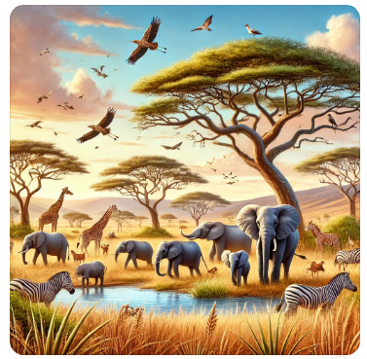
PASSAGE 1: The Role of Elephants in the Ecosystem (Animals)
Elephants are the largest land mammals and play a crucial role in maintaining the balance of the ecosystem. They are often referred to as “ecosystem engineers” because of their ability to shape their environment. Elephants clear paths in dense forests, creating trails used by other animals. They also help in seed dispersal by eating fruits and excreting the seeds, allowing plants to grow in different areas.
Additionally, elephants dig water holes in dry areas using their trunks, providing water for other wildlife. However, due to poaching and habitat destruction, elephant populations are declining. Conservation efforts, such as anti-poaching laws and wildlife reserves, have been put in place to protect them. If elephants disappear, many other species will be affected, disrupting the entire ecosystem.

- What is the main role of elephants in the ecosystem?
A) They eat all the grass
B) They help disperse seeds and create water holes
C) They hunt smaller animals
D) They destroy the environment
- Why are elephants called “ecosystem engineers”?
A) They build houses for animals
B) They create paths and help plants grow
C) They make bridges in the wild
D) They construct water reservoirs
- How do elephants help plants grow?
A) By planting them manually
B) By carrying them to different places
C) By eating fruits and dispersing seeds
D) By watering them every day
- What is a major threat to elephant populations?
A) Excessive rainfall
B) Poaching and habitat destruction
C) Their inability to reproduce
D) Their long lifespan
- How do elephants help other animals in dry areas?
A) By giving them food
B) By carrying them on their backs
C) By digging water holes
D) By sharing their shelters
- What will happen if elephants disappear?
A) The ecosystem will remain the same
B) Many species will suffer
C) Poachers will have more jobs
D) Forests will become greener
- What has been done to protect elephants?
A) Cutting down more trees
B) Keeping them in zoos
C) Creating wildlife reserves
D) Ignoring their plight

PASSAGE 2: The Importance of Trees
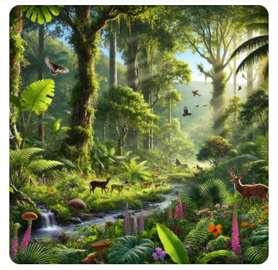
Trees are essential for life on Earth. They provide oxygen, store carbon, stabilize soil, and give shelter to wildlife. Trees also play a key role in controlling climate by absorbing harmful gases and producing clean air. In addition, they provide materials such as wood, paper, and medicine.
However, deforestation is a serious problem in many parts of the world. People cut down trees for farming, urban development, and timber, leading to climate change and loss of biodiversity. To combat this, reforestation programs have been introduced to plant more trees and restore forests. By planting trees and protecting existing forests, we ensure a sustainable future for all.

- What is one main benefit of trees?
A) They produce carbon dioxide
B) They absorb oxygen
C) They provide oxygen
D) They increase pollution
- How do trees help control the climate?
A) By making the air dirtier
B) By absorbing harmful gases
C) By making the weather unpredictable
D) By producing carbon dioxide
- What is a major cause of deforestation?
A) Planting too many trees
B) Lack of rain
C) Cutting trees for farming and urbanization
D) Growing too many crops

- Which of the following is a consequence of deforestation?
A) More biodiversity
B) Climate change
C) Increased rainfall
D) Cleaner air
- What is reforestation?
A) Cutting down more trees
B) Planting more trees
C) Burning forests
D) Selling trees to factories
- Why should we protect forests?
a) To increase pollution
b) To keep animals homeless
c) To ensure a sustainable future
d) To clear land for construction
- What do trees provide apart from oxygen?
A) Rocks and soil
B) Plastic and glass
C) Wood, medicine, and shelter
D) Concrete and steel


PASSAGE 3: The Impact of Technology

Technology has transformed human life in many ways. It has improved communication, healthcare, education, and business. The internet allows people to access information instantly, while medical advancements have saved millions of lives.
However, excessive use of technology has drawbacks. Many people spend too much time on screens, leading to health issues. Cybercrime and data privacy concerns have also increased. While technology brings great benefits, it must be used responsibly to avoid negative consequences.

- How has technology improved healthcare?
A) By creating hospitals
B) By curing all diseases
C) By making medical advancements
D) By replacing doctors
- What is a negative effect of technology?
A) Better education
B) More cybercrime
C) Faster communication
D) Increased knowledge
- How does the internet help people?
A) By blocking information
B) By providing instant access to information
C) By preventing communication
D) By slowing down learning
- Why should technology be used responsibly?
A) To avoid negative consequences
B) To stop communication
C) To replace all jobs
D) To increase pollution
- What has led to an increase in cybercrime?
A) Poor healthcare
B) More screen time
C) Increased use of the internet
D) Lack of schools
- What is one way to prevent health issues from excessive screen time?
A) Staring at screens longer
B) Taking regular breaks
C) Using multiple devices at once
D) Increasing screen brightness
- What is the main idea of the passage?
A) Technology is always bad
B) Technology has both benefits and drawbacks
C) The internet should be banned
D) People should not use mobile phones

SECTION B: ORAL SKILLS

Read the dialogue below and answer the questions that follow.
Employer: Good morning. You’re here for the interview, right?
Employee: Yes, sir. I’m eager to join your company.
Employer: Tell me about your previous work experience.
Employee: I worked as a sales assistant for three years.
Employer: That’s great! Why do you want to work here?
Employee: I admire your company’s values and growth opportunities.
Employer: What skills can you bring to our team?
Employee: I have excellent communication and marketing skills.
Employer: Thank you. We will contact you soon.

- Who is speaking in the dialogue?
A) A teacher and a student
B) An employer and an employee
C) A doctor and a patient
D) A buyer and a seller
- What was the employee’s previous job?
A) A teacher B) A sales assistant
C) A manager D) A secretary
- Why does the employee want to work at the company?
A) Because the salary is high
B) Because they like traveling
C) Because they admire the company’s values
D) Because they have no other job
- What skill does the employee mention?
A) Cooking and cleaning
B) Dancing and singing
C) Communication and marketing skills
D) Typing and printing
- What does the employer say at the end?
A) "You are hired immediately!"
B) "We will contact you soon."
C) "Leave the office now."
D) "Come back tomorrow."

SECTION C: CLOZE TEST

Read the passage below and choose the correct word to fill in each blank.
Technology has changed the way people____________ (27) with each other. In the past, people relied on letters and face-to-face communication. Today, social media platforms and instant messaging apps________________ (28) people to stay connected no matter where they are.
However, excessive use of technology can lead to negative effects, such as eye strain, lack of physical activity, and______________ (29) social interactions. People are spending more time on their screens and less time talking______________ (30) one another. This has led to an increase in loneliness and mental health problems.
To _________________(31) these issues, experts advise people to set limits on screen time and take breaks while using digital devices. Spending time outdoors, exercising, and_______________ (32) with family and friends in person are great ways to maintain a balanced lifestyle.
The advancement of technology has also raised concerns about online safety. Cybercrime,________________ (33) as hacking and identity theft, has become more common. To stay safe online, users should avoid _______________(34) personal information with strangers, use strong passwords, and___________________(35) security updates on their devices.
While technology continues to shape the future, it is important to _________________(36) it wisely and responsibly.
- A) communicate B) cook C) sleep D) walk
- A) force B) allow C) refuse D) ignore
- A) improved B) reduced C) increased D) multiplied
- A) in B) at C) with D) on
- A) solve B) create C) ignore D) increase
- A) fighting B) spending C) playing D) interacting
- A) such B) for C) because D) example
- A) watching B) sharing C) hiding D) printing
- A) update B) delete C) copy D) install
- A) write B) use C) burn D) throw
SECTION D: GRAMMAR
Choose the correct answer for each question.

- Choose the correct sentence.
A) She go to school every day.
B) She goes to school every day.
C) She going to school every day.
D) She went to school every day.
- Identify the correct plural form of the underlined word
The child likes yoghurt.
A) Childs B) Childrens
C) Children D) Childes
- Which sentence is in the past tense?
A) I eat my lunch.
B) I will eat my lunch.
C) I ate my lunch.
D) I eating my lunch.
- Choose the correct conjunction:
A) I was tired, but I continued working.
B) I was tired, so I continued working.
C) I was tired, and I continued working.
D) I was tired, because I continued working.
- Identify the correct adjective in the sentence:
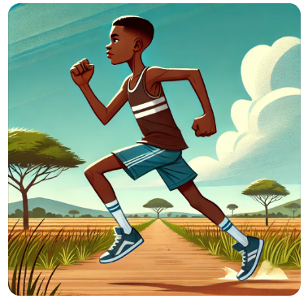
The tall boy ran fast.
A) tall B) boy C) ran D) fast
- What is the correct comparative form of “happy”?
A) More happy B) Happier
C) Most happy D) Happyest

- Identify the preposition in the sentence:

She sat on the chair.
A) She B) Sat C) On D) Chair
- Which word is a pronoun?
A) Table B) He C) Jump D) Beautiful
- Choose the correct form: We _______ our homework yesterday.
A) do B) does C) did D) doing
- Which sentence is correct?
A) He don’t like swimming.
B) He doesn’t like swimming.
C) He isn’t like swimming.
D) He aren’t like swimming.
- Which sentence is in future tense?
A) She will visit her grandmother.
B) She visited her grandmother.
C) She visits her grandmother.
D) She visiting her grandmother.
- Identify the correct article: I saw _____ elephant at the zoo.
A) a B) an C) the D) any
- Which sentence is correct?
A) There is many people in the room.
B) There are many people in the room.
C) There was many people in the room.
D) There has many people in the room.

- What is the opposite of “polite”?

A) Friendly B) Rude
C) Kind D) Nice

ANSWERS

PASSAGE 1:
- B) They help disperse seeds and create water holes
- B) They create paths and help plants grow
- C) By eating fruits and dispersing seeds
- B) Poaching and habitat destruction
- C) By digging water holes
- B) Many species will suffer
- C) Creating wildlife reserves

PASSAGE 2:
- C) They provide oxygen
- B) By absorbing harmful gases
- C) Cutting trees for farming and urbanization
- B) Climate change
- B) Planting more trees
- C) To ensure a sustainable future
- C) Wood, medicine, and shelter

PASSAGE 3:
- C) By making medical advancements
- B) More cybercrime
- B) By providing instant access to information
- A) To avoid negative consequences
- C) Increased use of the internet
- B) Taking regular breaks
- B) Technology has both benefits and drawbacks
SECTION B: DIALOGUE
- B) An employer and an employee
- B) A sales assistant
- C) Because they admire the company’s values
- C) Communication and marketing skills
- B) "We will contact you soon."
SECTION C: CLOZE TEST
- A) communicate
- B) allow
- B) reduced
- C) with
- A) solve
- D) interacting
- A) such
- B) sharing
- D) install
- D) use
SECTION D: GRAMMAR
- B) She goes to school every day.
- C) Children
- C) I ate my lunch.
- A) I was tired, but I continued working.
- A) tall
- B) Happier
- C) On
- B) He
- C) did
- B) He doesn’t like swimming.
- A) She will visit her grandmother.
- B) an
- B) There are many people in the room.
- B) Rude

