KENYA JUNIOR SCHOOL EDUCATION ASSESSMENT
912/1
PRE-TECHNICAL STUDIES THEORY
Time: 1 hour 40 minutes
INSTRUCTIONS TO CANDIDATES
- Write your name and assessment number in the spaces provided above.

- Write the name and code of your school in the spaces provided above.

- Sign and write the date of the assessment in the spaces provided above.

- This paper consists of two sections: A and B.

- Section A comprises Multiple Choice Questions.

- Section B comprises Short Structured questions.

- Answer ALL the questions in section A on the separate ANSWER SHEET provided.

- Answer ALL the questions in section B in the spaces provided in this question paper.

- Do not remove any page from this question paper.

- Answer all questions in English.

For official use only
SECTION B

Task |  |  |  | Task 1 |  |  |  |  |  | Task 2 |  |  |  |  |  |  | Task 3
Question | 31 | 32 | 33 |  | 34 | 35 | 36 | 37 | 38 | 39 | 40 | 41 | 42 | 43 | 44 | 45 | 46 |  | 47 | 48 | 49 | 50
Candidate’s
Score per
Question
Max Score per |  |  |  | 25 |  |  |  |  |  |  | 12 |  |  |  |  |  |  | 13
Task |  |  |  |  |  |  |  |  |  |  | 12
Candidate’s
Score per Task
This paper consists of 7 printed pages. Candidates should check the question paper to ascertain that all the pages are printed as indicated and that no questions are missing.

© 2025, all rights reserved
Turn over

NAME: _________________________________________ SIGN: _______________ DATE: ____________.
CANDIDATES ASSESSMENT NUMBER: ____________________________________________________.
SCHOOL: _______________________________________ SCHOOL CODE: ______________________ _.

SECTION A (30 marks)
Read the instructions carefully.
- You have been given this question paper and a separate answer sheet.
- Answer ALL questions in this section on the ANSWER SHEET provided, NOT in the question paper.
- Do all the necessary rough work in the question paper.

HOW TO USE THE ANSWER SHEET
- Use an ordinary HB pencil.
- Confirm that the answer sheet you have been provided with has the following:
YOUR ASSESSMENT NUMBER
YOUR NAME
NAME OF YOUR SCHOOL
NAME OF THE SUBJECT
- Keep the answer sheet clean, dry and DO NOT fold it.
- For each of the questions 1 – 30, four options are given. The options are lettered A, B, C and D. In each case, only ONE of the four options is correct. Choose the correct answer from the options.
- On the answer sheet, the correct answer is to be shown by drawing a dark line inside the box in which the letter you have chosen is written.
Example
In the Question Booklet:
- Pre-Technical studies is one of the learning areas in Junior School. Which one of the following represents the components of Pre-Technical studies?
  - Technical, Entrepreneurship and Business Studies.
  - Technical, Computer Studies and Business Studies.
  - Technical, Entrepreneurship and Computer Studies.
  - Technical, Information Technology and Business Studies
The correct answer is ‘B’.
On the answer sheet, in the set of boxes given for number 13, draw a dark line inside the box with the letter D printed in it as indicated below.
13) [A] [B] [C] [D]
- Your dark line MUST be inside the box.
- For each question, ONLY ONE box is to be marked in each set of four boxes.

Turn over

SECTION A: (30 Marks)
Answer all questions in this section

- Which of the following is NOT a safety precaution in the work environment?
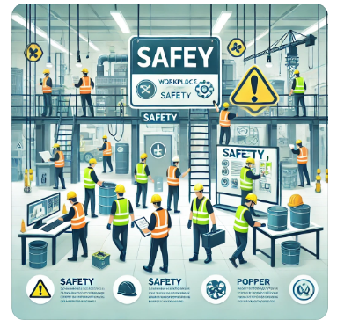
A. Wearing safety gear
B. Using damaged tools
C. Keeping the workplace clean
D. Following safety guidelines
- Which of the following is an example of an online threat?
A. Firewall protection
B. Phishing scams
C. Data backup
D. Using strong passwords
- What is the function of a VGA cable when connecting a projector?
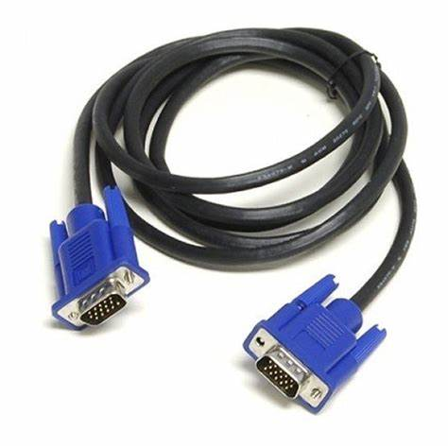
A. Transmitting power
B. Transmitting video signals
C. Providing internet connection
D. Transmitting audio signals
- Which of the following is NOT a type of artistic drawing?
A. Graffiti
B. illustrations
C. mechanical
D. Portrait
- The best measuring tool for checking the diameter of a pipe is:
A. Tape measure
B. Vernier caliper
C. Protractor
D. Ruler
- One function of money is:
A. To be used as decoration
B. To be a medium of exchange
C. To increase inflation
D. To control economic resources
- Which of the following is an example of a non-metallic material?
A. Aluminum
B. Copper
C. Rubber
D. Iron
- Which fire extinguisher is used for electrical fires?
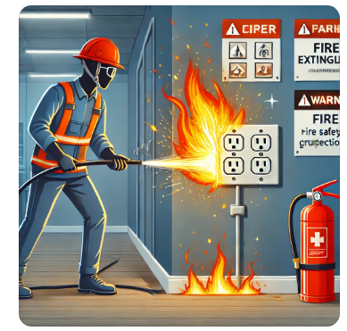

A. Water
B. Foam
C. Carbon dioxide (CO2)
D. Sand
- Which of the following is NOT a function of an input device?
A. Entering data into a computer
B. Processing data
C. Scanning documents
D. Typing text
- Which of the following is an example of a storage device?
A. Printer B. USB flash drive
C. Monitor D. Keyboard
- What is the function of a CPU in a computer?

A. Input data
B. Process information
C. Store permanent files
D. Display images
- Which of the following is a cause of fire in the workplace?
A. Proper storage of chemicals
B. Overloading electrical sockets
C. Using fire extinguishers
D. Regular fire drills
- The two main categories of economic resources are:
A. Natural and human resources
B. Expensive and cheap resources
C. Renewable and unlimited resources
D. Solid and liquid resources
- Which of the following is NOT a measuring tool?
A. Ruler B. Tape measure
C. Vernier caliper D. Hammer

- Which type of business transaction involves exchanging goods for money?
A. Barter trade
B. Credit purchase
C. Cash transaction
D. Lease agreement
- What is the main use of a protractor in technical drawing?
A. Measuring angles
B. Drawing straight lines
C. Measuring length
D. Sharpening pencils
- Which of the following is an ethical practice in communication?
A. Spreading false information
B. Respecting confidentiality
C. Ignoring customer feedback
D. Using abusive language
- What is the main purpose of budgeting?
A. To overspend money
B. To plan income and expenses
C. To increase borrowing
D. To reduce income
- Which factor should be considered when choosing a business location?

A. Popularity of the owner
B. Distance from competitors
C. Availability of customers
D. The type of clothing worn by workers
- What is a composite material?
A. A natural material like wood
B. A material made by combining two or more different materials
C. A soft metallic material
D. A type of raw clay
- Which of the following is a non-metallic material?
A. Gold B. Silver
C. Plastic D. Copper
- Which of the following is NOT an investment method?
A. Buying shares
B. Saving in a bank
C. Spending all your income
D. Purchasing real estate
- What is the purpose of book-keeping in a business?
A. To record financial transactions
B. To make business losses
C. To increase employee salaries
D. To buy more stock
- Which of the following is a function of money?
A. It is used for decoration
B. It is a store of value
C. It increases inflation
D. It reduces trade
- What is the importance of marketing goods and services?
A. To increase business profits
B. To reduce competition
C. To avoid selling products
D. To close down the business
- Which of the following is a method of saving?
A. Gambling
B. Investing in land
C. Opening a savings account
D. Spending all income
- Which of the following is a factor of production?
A. Fashion
B. Capital
C. Weather
D. Music
- What is the best communication channel for urgent business information?
A. Letter
B. Telephone
C. Newspaper
D. Billboard
- Which of the following is an output device?
A. Scanner
B. Keyboard
C. Printer
D. Mouse
- What is the main role of an investor?
A. To keep money at home
B. To make profits by investing in businesses
C. To buy luxurious items
D. To reduce production

SECTION B: (50 Marks)
- (2 Marks) Define online threats and give one example.
____________________________________________________________________________________________________________________________________________________________________________________________________________________________________________________________________________________________________________________________
- (3 Marks) Explain three safety measures in the work environment.
  - _______________________________________________________________________
  - _______________________________________________________________________
  - _______________________________________________________________________
- (3 Marks) State three functions of money in an economy.
  - ________________________________________________________________________
  - ________________________________________________________________________
  - ________________________________________________________________________
- (2 Marks) Mention two ways of preventing fire outbreaks in a workplace.
  - _______________________________________________________________________
  - _______________________________________________________________________
- (2 Marks) Differentiate between metallic and non-metallic materials.
____________________________________________________________________________________________________________________________________________________________________________________________________________________________________________________________________________________________________________________
- (2 Marks) Identify two factors to consider when selecting a communication channel.
  - _______________________________________________________________________
  - _______________________________________________________________________
- (3 Marks) Explain three characteristics of a good entrepreneur.
  - _______________________________________________________________________
  - _______________________________________________________________________
  - _______________________________________________________________________
- (2 Marks) Give two ethical practices in business communication.
  - ______________________________________________________________________
  - ______________________________________________________________________
- (3 Marks) Explain three reasons why saving money is important.
  - ______________________________________________________________________
  - ______________________________________________________________________
  - ______________________________________________________________________
- (2 Marks) Define bookkeeping and state one of its functions.
_______________________________________________________________________________________________________________________________________________________________________________________________________________________________________
- (3 Marks) Mention three types of drawing lines used in technical studies.
  - ______________________________________________________________________
  - ______________________________________________________________________
  - ______________________________________________________________________
- (2 Marks) What is plane geometry, and give one example of its application?
_______________________________________________________________________________________________________________________________________________________________________________________________________________________________________
- (3 Marks) State three roles of visual programming in ICT.
  - _______________________________________________________________________
  - _______________________________________________________________________
  - _______________________________________________________________________
- (2 Marks) Name two cutting tools used in pre-technical studies.
  - _______________________________________________________________________
  - _______________________________________________________________________
- (3 Marks) List three functions of Kenyan money.
  - ______________________________________________________________________
  - ______________________________________________________________________
  - ______________________________________________________________________
- (2 Marks) Differentiate between input and output devices in a computer.
________________________________________________________________________________________________________________________________________________________________________________________________________________________
- (3 Marks) Identify three sources of income for individuals.
  - ________________________________________________________________________
  - ________________________________________________________________________
  - ________________________________________________________________________
- (2 Marks) Mention two methods of investment.
  - ________________________________________________________________________
  - ________________________________________________________________________
- (3 Marks) Describe three types of business transactions in Kenya.
  - ________________________________________________________________________
  - ________________________________________________________________________
  - ________________________________________________________________________
- (2 Marks) Explain the importance of marketing in a business.
  - _______________________________________________________________________
  - _______________________________________________________________________
  - _______________________________________________________________________

THIS IS THE LAST PRINTED PAGE

ANSWERS
- B - Using damaged tools
- B - Phishing scams
- B - Transmitting video signals
- C – Mechanical
- B - Vernier caliper
- B - To be a medium of exchange
- C - Rubber
- C - Carbon dioxide (CO₂)
- B - Processing data
- B - USB flash drive
- B - Process information
- B - Overloading electrical sockets
- A - Natural and human resources
- D - Hammer
- C - Cash transaction
- A - Measuring angles
- B - Respecting confidentiality
- B - To plan income and expenses
- C - Availability of customers
- B - A material made by combining two or more different materials
- C - Plastic
- C - Spending all your income
- A - To record financial transactions
- B - It is a store of value
- A - To increase business profits
- C - Opening a savings account
- B - Capital
- B - Telephone
- C - Printer
- B - To make profits by investing in businesses
- Online threats are risks associated with using the internet, such as cyber-attacks.
Example: Phishing, where hackers trick users into revealing personal information.
- Three safety measures in a work environment:
- Always wear protective gear (gloves, goggles, and helmets).
- Keep the workplace clean and organized.
- Follow fire safety procedures, such as having fire extinguishers.
- Three functions of money:
- Medium of exchange – used to buy and sell goods and services.
- Store of value – retains value over time.
- Measure of value – used to compare the worth of goods/services.
- Two ways to prevent fire outbreaks in the workplace:
- Proper storage of flammable materials.
- Regular maintenance of electrical equipment.
- Difference between metallic and non-metallic materials:
- Metallic materials are strong, good conductors of heat and electricity (e.g., iron).
- Non-metallic materials are poor conductors and lightweight (e.g., rubber).
- Two factors to consider when selecting a communication channel:
- Urgency of the message.
- Cost of the communication method.
- Three characteristics of a good entrepreneur:
- Innovative – comes up with new ideas.
- Risk-taker – willing to take business risks.
- Hardworking – puts in effort to achieve business goals.
- Two ethical practices in business communication:
- Honesty in delivering messages.
- Respecting confidentiality of clients.
- Three reasons why saving money is important:
- Helps in financial emergencies.
- Allows investment opportunities.
- Helps achieve long-term financial goals.
- Definition of bookkeeping and its function:
- Bookkeeping is the recording of financial transactions in a business.
- Function: Helps track income and expenses.
- Three types of drawing lines in technical studies:
- Continuous thick line – used for visible outlines.
- Dashed line – used for hidden details.
- Centerline – used to show symmetry.
- Plane geometry and an example of its application:
- Plane geometry deals with two-dimensional shapes like circles and rectangles.
- Example: Drawing floor plans for buildings.
- Three roles of visual programming in ICT:
- Allows users to create applications without coding.
- Helps in game and web development.
- Simplifies complex programming concepts.
- Two cutting tools used in Pre-Technical Studies:
- Hacksaw
- Chisel
- Three functions of Kenyan money:
- Used for buying and selling goods.
- Used for saving and investment.
- Used to measure the value of goods.
- Difference between input and output devices:
- Input devices allow users to enter data (e.g., keyboard).
- Output devices display processed information (e.g., printer).
- Three sources of income for individuals:
- Salaries and wages.
- Business profits.
- Rental income.
- Two methods of investment:
- Buying shares in a company.
- Purchasing real estate.
- Three types of business transactions in Kenya:
- Cash transaction – paying for goods immediately with cash.
- Credit transaction – buying goods and paying later.
- Barter trade – exchanging goods for goods.
- Importance of marketing in a business:
- Increases sales and profits.
- Helps attract new customers.
- Creates brand awareness.

