COMPETENCE BASED CURRICULUM

ΑSSESSMENT ONE 2024 ENVIRONMENTΑL ΑCTIVITIES GRΑDE TWO
CBC
01

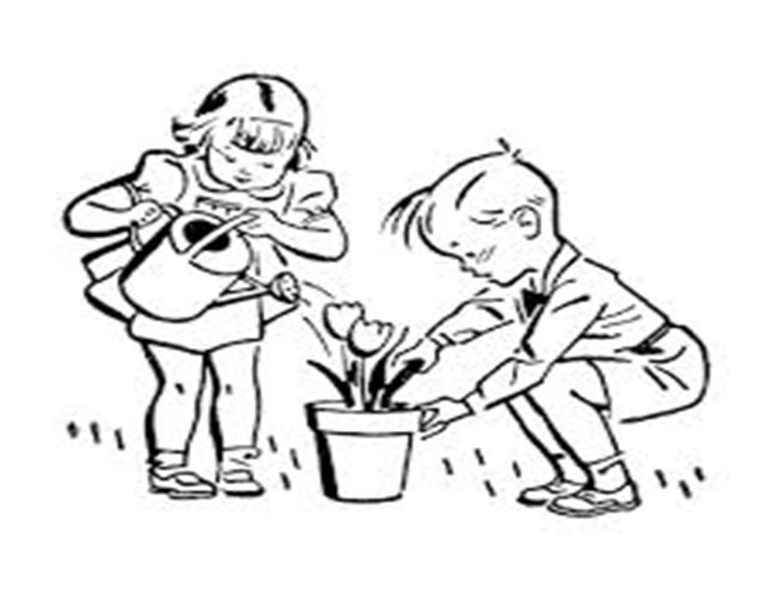


Name:
School:
Grade:
Date: .

Strands: Weather, Water
Different weather conditions.

- The day to day changes in the atmosphere is called
. ( /1mark)
- Draw and name three weather conditions. ( /6marks)

- Mother is carrying an umbrella. The weather is
_. ( /1mark)
- Clothes dry fast when the weather is and
. ( /2marks)
- Name two different clothes we can wear during this weather.
( /2marks)
.
.

- Tick the clothes worn during cold weather. ( /5marks)

kikoi | socks | trousers | sweater
jacket | dress | scarf | vest
- When we wear heavy clothes on a hot day, we . (sweat, don’t sweat) ( /1mark)

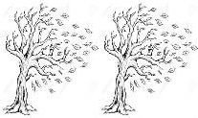Recording weather.
- Pictures used to record weather are called weather
. (sins, symbols) ( /1mark)

Study the pictures below and answer the questions.
Day | Morning | Afternoon
Monday | 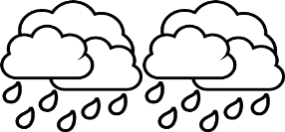 | 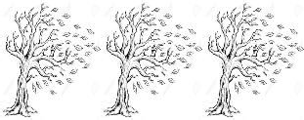
Tuesday
Wednesday
Thursday | 
Friday |  | 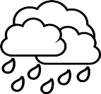
  - We record weather on a weather ( /1mark)
  - Mother washed clothes and they dried very fast. Which day was it? _. ( /1mark)
  - On Thursday the weather was _ and
. ( /2marks)
  - The best days for winnowing grains were the afternoons of
. ( /1mark)
  - When did the pupils wear gumboots on their way to school in the morning? _. ( /1mark)
  - Pupils enjoyed swimming on ( /1mark)
  - It was cloudy and rainy on ( /1mark)
- During the windy days. ( /3marks)
  - We can fly .
  - We can sail .
  - Avoid wearing clothes. (light, heavy)

- When the winds are very strong, we say the weather is
. ( /1mark)
- Write True or False. ( /5marks)
  - Weather keeps changing _.
  - We wear heavy clothes on a sunny day. .
  - Rain is important to us. _.
  - Dark clouds bring rain. _.
  - We should play in the rain. _.
- Name the following bad weather condition. ( /1mark)

.

Storing water.

a. | Name | three uses of water. | ( /3marks)
 | 1. | _.
 | 2. | _.
 | 3. | _.
b. Draw, name and colour three containers of storing water at home.

Αssessment Rubric:
( /9marks)

Exceeds Expectαtion | Meets Expectαtion | Αpproαching Expectαtion | Below Expectαtion
98-100 | 80-97 | 50-79 | 0-49

