COMPETENCE BASED CURRICULUM

ΑSSESSMENT ONE 2024
CBC
01

LΑNGUΑGE ΑCTIVITIES GRΑDE TWO




Name:
School:
Grade:
Date: .

Assessement area: School and home activities
Sub-strand: Vocabulary, formation of words, continuous form of verbs, use of was/were.

- Why should we listen attentively when other people are talking? ( /6marks)
1. .
2. .
3. .

Write the name of the pictures by filling in the missing letters.
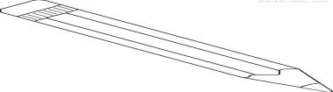( /4marks)
a.
P nc l

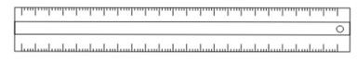
a.
R__l__r

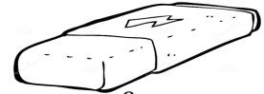
a.
Er s r

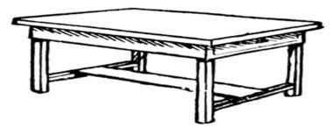
a.
T bl
- Name 5 things we do at home. ( /5marks)
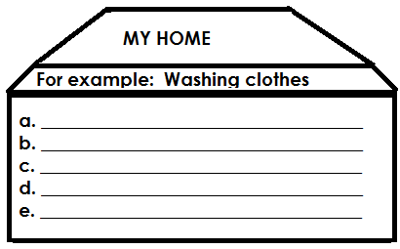
- Make words using sound “pr” ( /5marks)


prize
“pr”

- Use was or were to complete the sentences. ( /5marks)
  - The teacher marking our books.
  - The pupils listening to the teacher.
  - Halima writing in her workbook.
  - The children skipping.
  - Otieno in class sweeping.

6. Draw, name and colour 5 things we find in a school.
( /5marks)

Arrange the words properly. ( /5marks)
  - bkucet- .
  - rofwle- .
  - ndwowi- .
  - eetr- .
  - oobrm- .

Colour the names of the things we find at home. ( /5marks)
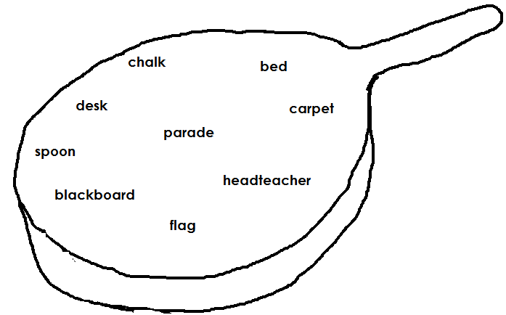

- Read the short passage below and answer the questions.
My name is Lisa, I go to Lisala primary school, I like going to school daily. My school is located at Panda village. It is a very nice place away from all the crowd and noise of the city.
My school has a headteacher called Mrs. Linda. It has a big garden where we have gron colourful flowers and fruits.
There are about five hundred pupils in our school.
My teacher Mrs. Lisala teaches us very well and makes us learn subjects in very creative and attractive way.

Questions.
- What is the name of the write? (1mark)
- Where is the school located? (1mark)
- What is the name of their headteacher? (1mark)
- What is grown in their garden? (1mark)
- How many pupils are in the school? (1mark)

Αssessment Rubric:

Exceeds Expectαtion | Meets Expectαtion | Αpproαching Expectαtion | Below Expectαtion
48 - 50 | 40-47 | 30-39 | 0-29

