`Name……………………………………….. Index No….......Class............... Sign............
441/ 1
HOME SCIENCE
(THEORY)
Paper 1
July, 2024
2 ½ Hours
MOKASA II JOINT EXAMINATIONS
Kenya Certificate of Secondary Education
441/ 1
HOME SCIENCE
Instructions to candidates
- Write your name and index number in the spaces provided above.
- This paper consists of three sections A, B and C.
- Answer all questions in Section A and B and any TWO questions from section C
- Answers to all questions must be written in this booklet
- This paper consists of 10 printed pages.
- Candidates should answer the questions in English.

FOR EXAMINER’S USE ONLY
SECTION | QUESTION | MAXIMUM SCORE | CANDIDATE’S SCORE
A | 1 – 40 | 40
B | 41a, b | 20
C | 42 | 20
 | 43 | 20
 | 44 | 20
 | TOTAL | 100
SECTION A (40 MARKS)
Attempt ALL questions in this section. Write answers in the spaces provided
- Give two grooming requirements of persons handling food (1mark)
................................................................................................................................................................................................................................................................................................................................................................................................................................................
- Indicate the most suitable method of cooking for the following groups of people; (1mark)
- Convalescents............................................................................................................

- Adolescents ...............................................................................................................

- Name two childhood nutritional disorders that are caused by lack of vitamin B1(thiamin) and vitamin D respectively (1mark)
- Vitamin B1 -..............................................................................................................

- Vitamin D-................................................................................................................

- Give two benefits of prior planning of a meal to the host (1mark)
................................................................................................................................................................................................................................................................................................................................................................................................................................................
- Describe any two aspects of variety in a meal (1mark)
................................................................................................................................................................................................................................................................................................................................................................................................................................................
- Give two reasons why breakfast is considered as the most important meal of the day (1mark)
................................................................................................................................................................................................................................................................................................................................................................................................................................................
- Differentiate the two types of vegetarians (1mark)
................................................................................................................................................................................................................................................................................................................................................................................................................................................

- Give two reasons for including citrus fruits to the diets of patients recuperating at home
(1mark)
................................................................................................................................................................................................................................................................................................................................................................................................................................................
- Name two examples of shortenings used in baking (1mark)
................................................................................................................................................................................................................................................................................................................................................................................................................................................
- Mention the two uses of batter mixture (1mark)
................................................................................................................................................................................................................................................................................................................................................................................................................................................
- List two ways of neutralizing an acidic poison at home (1 mark)
................................................................................................................................................................................................................................................................................................................................................................................................................................................
- Write down two reasons why non-stick cooking pans are becoming popular in today’s kitchens (1mark)
................................................................................................................................................................................................................................................................................................................................................................................................................................................
- List down two functions of whiteners on white canvas shoes (1mark)
................................................................................................................................................................................................................................................................................................................................................................................................................................................
- Your soccer coach has rented a flat near the stadium prior to the national games. Give two disadvantages of this type of housing (1mark)
................................................................................................................................................................................................................................................................................................................................................................................................................................................
- Give reasons for the following practices done during weekly cleaning of a pit latrine
- High dusting –.............................................................................................

- Smoking – .................................................................................................. (1mark)
- State two applications of chemistry knowledge at home (1mark)
................................................................................................................................................................................................................................................................................................................................................................................................................................................

- State two benefits of “drip drying’’ on a garment (1mark)
................................................................................................................................................................................................................................................................................................................................................................................................................................................

- Mention two ways of disposing refuse that are beneficial to farming (1mark)
................................................................................................................................................................................................................................................................................................................................................................................................................................................

- Identify two functions of a stool in an invalid’s sick room (1mark)
................................................................................................................................................................................................................................................................................................................................................................................................................................................

- Mention two basic functions of kitchen chimneys (1mark)
................................................................................................................................................................................................................................................................................................................................................................................................................................................

- Suggest two factors to bear in mind when choosing fuel for home consumption (1mark)
................................................................................................................................................................................................................................................................................................................................................................................................................................................

- State two factors to consider when selecting lighting for a specific room (1mark)
................................................................................................................................................................................................................................................................................................................................................................................................................................................

- Identify two types of twins in pregnancy (1mark)
................................................................................................................................................................................................................................................................................................................................................................................................................................................
- Give two reasons why baby napkins are slowly fading away (1mark)
................................................................................................................................................................................................................................................................................................................................................................................................................................................
- Define the term immunization (1mark)
................................................................................................................................................................................................................................................................................................................................................................................................................................................
- Apart from cereal and protein, name the four components of a multi-mix (1mark)
................................................................................................................................................................................................................................................................................................................................................................................................................................................
- Identify two characteristics shared by cotton and viscose when exposed to a flame
(1mark)
................................................................................................................................................................................................................................................................................................................................................................................................................................................
- Give two reasons as to why a running stitch is referred to as a versatile stitch (1mark)
................................................................................................................................................................................................................................................................................................................................................................................................................................................
- Mention two functions of the stitch length regulator (1mark)
................................................................................................................................................................................................................................................................................................................................................................................................................................................
- Mention two instances where binding is the most suitable method of finishing seams
(1mark)
................................................................................................................................................................................................................................................................................................................................................................................................................................................

- Suggest two inconspicuous methods of controlling fullness at the crown of set in sleeves
(1mark)
................................................................................................................................................................................................................................................................................................................................................................................................................................................
- Name two types of facings (1mark)
................................................................................................................................................................................................................................................................................................................................................................................................................................................
- State two advantages of making your own clothes (1mark)
................................................................................................................................................................................................................................................................................................................................................................................................................................................
- Identify two reasons for introducing a thread shank on a flat button (1mark)
................................................................................................................................................................................................................................................................................................................................................................................................................................................
- Describe any two design features in clothing that can give an illusion of enlargement of one’s figure (1mark)
................................................................................................................................................................................................................................................................................................................................................................................................................................................
- Using one food example explain the meaning of complementary goods (1mark)
................................................................................................................................................................................................................................................................................................................................................................................................................................................
- Discuss two disadvantages of buying goods using hard cash (1mark)
................................................................................................................................................................................................................................................................................................................................................................................................................................................

- Name two acts of government tasked with protection of consumers (1mark)
................................................................................................................................................................................................................................................................................................................................................................................................................................................

- State two disadvantages of hoarding food (1mark)
................................................................................................................................................................................................................................................................................................................................................................................................................................................
- List down 2 basic needs to a young family (1mark)
................................................................................................................................................................................................................................................................................................................................................................................................................................................

SECTION B(20 MARKS)
Compulsory- Answer question 41 in the spaces provided
42. You have taken off some time of your half-term break to do the following tasks for your mother.
- Thoroughly launder her woolen shawl (8marks)
- Clean the cemented kitchen counter top where you earlier worked on (7marks)
- Thoroughly clean the stainless steel balloon whisk you used to make pancake batter (5marks)

............................................................................................................................................................................................................................................................................................................................................................................................................................................................................................................................................................................................................................................................................................................................................................................................................................................................................................................................................................................................................................................................................................................................................................................................................................................................................................................................................................................................................................................................................................................................................................................................................................................................................................................................................................................................................................................................................................................................................................................................................................................................................................................................................................................................................................................................................................................................................................................................................................................................................................................................................................................................................................................................................................................................................................................................................................................................................................................................................................................................................................................................................................................................................................................................................................................................................................................................................................................................................................................................................................................................................................................................................................................................................................................................................................................................................................................................................................................................................................................................................................................................................................................................................................................................................................................................................................................................................................................................................................................................................................................................................................................................................................................................................................................................................................................................................................................................................................................................................................................................................................................................................................................................................................................................................................................................................................................................................................................................................................................................................................................................................................................................................................................................................................................................................................................................................................................................................................................................................................................................................................................................................................................................................................................................................................................................................................................................................................................................................................................................................................................................................................................................................................................................................................................................................................................................................................................................................................................................................................................................................................................................................................................................................................................................................................................................................................................................................................................................................................................................................................................................................................................................................................................................................................................................................................................................................................................................................................................................................................................................................................................................................................................................................................................................................................................................................................................................................................................................................................................................................................................................................................................................................................................................................................................................................................................................................................................................................. ................................................................................................................................................................................................................................................................................................................................................................................................................................................................................................................................................................................................................................................................................................................................................................................................................................................................................................................................................................................................................................................................................................................................................................................................................................................................................................................................................................................................................................................................................................................................................................................................................................................................................................................................................................................................................................................................................................................................................................................................................................................................................................................................................................................................................................................................................................................................................................................................................................................................................................................................................................................................................................................................................................................................................................................................................................................................................................................................................................................................................................................................................................................................................................................................................................................................................................................................................................................................................................................................................................................................................................................................................................................................................................................................................................................................................................................................................................................................................................................................................................................................................................................................................................................................................................................................................................................................................................................................................................................................................................................................................................................................................................................................................................................................................................................................................................................................................................................................................................................................................................................................................................................................................................................................................................................................................................................................................................................................................................................................................................................................................................................................................................................. .................................................................................................................................................................................................................................................................................................................................................................................................................................................................................................................................................................................................................................................................................................................................................................................................................................................................................................................................................................................................................................................................................................................................................................................................................................................................................................................................................................................................................................................................................................................................................................................................................................................................................................................................................................................................................................................................................................................................... .................................................................................................................................................................................................................................................................................................................................................................................................................................................................................
SECTION C (40 MARKS)
Answer any TWO questions from this section in the spaces provided at the end.
42. A) Describe any four dishes that can be made from left over boiled eggs (4mark)
(B)) Loose covers have made a comeback in the soft furnishing markets. Give four reasons to explain this move (4mark)
(C) Explain four points to consider when buying baby’s clothes (4marks)
(D) You have decided to patch your five-year-old sister’s light cotton overall instead of darning. Give four explanations to your decision (4marks)
(E) Give four reasons for making a shopping list before visiting a supermarket (4marks)
43. (A) State four functions of retinol as a nutritional necessity for children (4marks)
(B) Explain any four advantages of breast milk compared to cow’s milk in child care (4marks
(C) Describe four ways of ensuring safety in storage of firewood (4marks)
(D) A sample of a girl’s dress top is shown below. Study and name parts A-H (4marks)
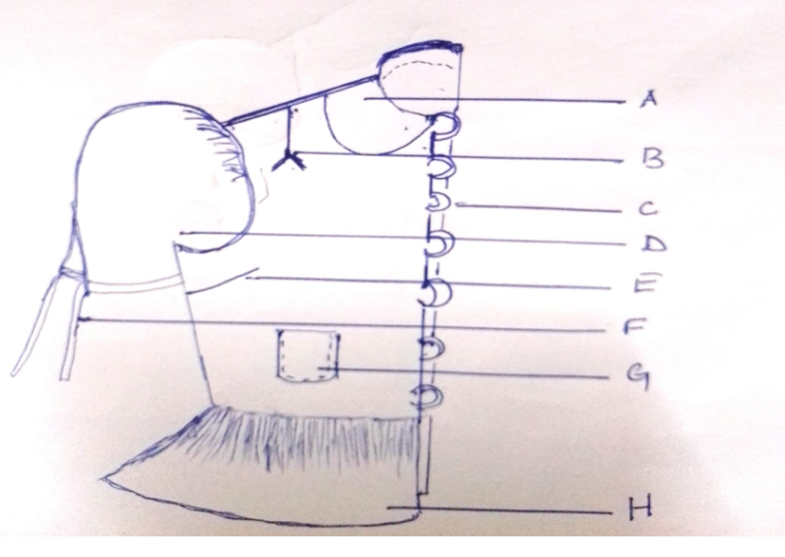
(E) State and explain four scarcity based problems of a consumer in buying (4marks)
44. (A) A house wife has chosen to buy readymade cakes for the family. State and explain four disadvantages of readymade food products (4marks)
(B) As a MOKASA beauty pageant 2024, outline four ways you would use to enhance your looks for the competition (4marks)
(C) Explain four roles of the family in a child’s play (4marks)
(D) Outline the preparation of the cut in one waistband in readiness for attaching (4marks)
(E) Give four duties of an advertising company (4marks)

.....................................................................................................................................................................................................................................................................................................................................................................................................................................................................................................................................................................................................................................................................................................................................................................................................................................................................................................................................................................................................................................................................................................................................................................................................................................................................................................................................................................................................................................................................................................................................................................................................................................................................................................................................................................................................................................................................................................................................................................................................................................................................................................................................................................................................................................................................................................................................................................................................................................................................................................................................................................................................................................................................................................................................................................................................................................................................................................................................................................................................................................................................................................................................................................................................................................................................................................................................................................................................................................................................................................................................................................................................................................................................................................................................................................................................................................................................................................................................................................................................................................................................................................................................................................................................................................................................................................................................................................................................................................................................................................................................................................................................................................................................................................................................................................................................................................................................................................................................................................................................................................................................................................................................................................................................................................................................................................................................................................................................................................................................................................................................................................................................................................................................................................................................................................................................................................................................................................................................................................................................................................................................................................................................................................................................................................................................................................................................................................................................................................................................................................................................................................................................................................................................................................................................................................................................................................................................................................................................................................................................................................................................................................................................................................................................................................................................................................................................................................................................................................................................................................................................................................................................................................................................................................................................................................................................................................................................................................................................................................................................................................................................................................................................................................................................................................................................................................................................................................................................................................................................................................................................................................................................................................................................................................................................................................................................................................................................................................................................................................................................................................................................................................................................................................................................................................................................................................................................................................................................................................................................................................................................................................................................................................................................................................................................................................................................................................................................................................................................................................................................................................................................................................................................................................................................................................................................................................................................................................................................................................................................................................................................................................................................................................................................................................................................................................................................................................................................................................................................................................................................................................................................................................................................................................................................................................................................................................................................................................................................................................................................................................................................................................................................................................................................................................................................................................................................................................................................................................................................................................................................................................................................................................................................................................................................................................................................................................................................................................................................................................................................................................................................................................................................................................................................................................................................................................................................................................................................................................................................................................................................................................................................................................................................................................................................................................................................................................................................................................................................................................................................................................................................................................................................................................................................................................................................................................................................................................................................................................................................................................................................................................................................................................................................................................................................................................................................................................................................................................................................................................................................................................................................................................................................................................................................................................................................................................................................................................................................................................................................................................................................................................................................................................................................................................................................................................................................................................................................................................................................................................................................................................................................................................................................................................................................................................................................................................................................................................................................................................................................................................................................................................................................................................................................................................................................................................................................................................................................................................................................................................................................................................................................................................................................................................................................................................................................................................................................................................................................................................................................................................................................................................................................................................................................................................................................................................................................................................................................................................................................................................................................................................................................................................................................................................................................................................................................................................................................................................................................................................................................................................................................................................................................................................................................................................................................................................................................................................................................................................................................................................................................................................................................................................................................................................................................................................................................................................................................................................................................................................................................................................................................................................................................................................................................................................................................................................................................................................................................................................................................................................................................................................................................................................................................................................................................................................................................................................................................................................................................................................................................................................................................................................................................................................................................................................................................................................................................................................................................................................................................................................................................................................

