PAVEMENT FORM 4 TRIAL 1 EXAMINATION 2022
Kenya certificate of secondary education (K.C.S.E)
MARKING SCHEME
HOME SCIENCE 441/1
- Two ways in which home science is beneficial to the family. (2 Marks)
- An individual with home science knowledge and skills in a family helps in
- Planning, preparing and serving nutritious meals to meet individual needs of the family.
- He/she practices safety precautions in home in case of an accident.
- Imparts skills that can be used to generate income to support the family. 2X1=2 Marks
- Improvised laundry storage facilities. (2 Marks)
- Cartons
- a large basket
- Strings to hang clothes.
- Piece of wood with nails fixed across the wall. 2x1 = 2 Marks.
- Three objectives of first aid. (3 Marks)
- To save life.
- To relieve pain
- To prevent further injury. 3x 1= 3Marks.
- Reasons for doing each of the following during cleaning. (3 Marks)
- Overlapping sections of the floor when scrubbing.
- To ensure that all parts are cleaned. 1x1 =1 Mark
- Smoking a pit latrine during weekly cleaning.
- To kill flies and maggots. 1x1 = 1 Mark
- Leaving floor for a while after polishing.
- For the polish to set/dry. 1x1 = 1 Mark.
- State two advantages of melamine. (2 Marks)
- Can withstand high temperatures.
- Resistant to household cleaning solvents.
- Has a hard surface resistant to scratching.
- Resistant to oil and grease. 2x1 = 2Marks
- Causes of hypertension. (3 Marks)
- Alcoholism
- heavy smoking
- obesity
- Excessive salt/sodium intake.
- diabetes
- Hereditary factors. 3x1 = 3 Marks
- List four sources of consumer information. (2 Marks)
- mass media -Other consumers
- manufacturers -Government bodies
- Private organisations /bodies 4 x ½ = 2 Marks.
- Reasons why babies cry. (2 marks)
- Babies cry because they :
- Are hungry - are lonely - want to be held.
- are wet /wet diaper or napkin -are sick -need to burp
- are afraid -are sleepy -too hot/too cold 4x½= 2Marks
- Reasons why smocking is used in garment construction. (2 Marks)
- To decorate the garment.
- To shape the garment.
- To give the garment a good fit. 2 x 1 = 2 Marks.
- Two measures which may prevent the occurrence of head lice. (2 Marks)
- Avoid sharing combs and hair brushes.
- Wash hair regularly.
- Clean and disinfect hair brushes and combs regularly. 2x1 = 2 Marks.
- Two disadvantages of using hot water for cleaning wooden surfaces. (2 Marks)
- Hot water:
- discolors wood
- Causes wood to warp.
- Softens wood due to absorption of moisture by wood cells. 2x1=2 Marks.
- Limitations of linen. (2 Marks)
- Linen creases badly.
- It frays badly.
- It shrinks.
- Is expensive. 2x1 = 2 Marks.
- Advantages and disadvantages of buying goods using credit cards. (2 Marks)
Advantages.
- In case of emergency, a consumer can access goods and services.
- It can be used at any time, day or night.
- Some credit cards give cash credit. 1x1= 1 Mark
Disadvantages.
- May lead to overspending.
- May lead to impulse buying
- A consumer does not follow a prepared monthly budget.
- Some goods and services cannot be obtained using a credit card esp .those sold in local markets. E.g. vegetables.
- There is high interest charged when one is unable to settle the credit bill. 1x1= 1 Mark
- Two common skin problems that may affect babies. (1 Mark)
- Nappy rash.
- Prickly heat -seborrhea/cradle cap
- Interring (rash found in a baby’s skin folds) 2x ½= 1 Mark.

- Identify two causes of hard and tough pastry. (2 Marks)
- Too little fat.
- Mixing in a warm area.
- too much water
- slow cooking
- Over kneading or heavy rolling.
- Fat melted during rubbing in. 2x1=2 Marks.
- Highlight two differences in the diet of lactating and non-lactating mothers. (2 Marks)
The diet of a lactating mother has more:
- Fluids since breast milk is mainly composed of water.
- Calcium for bone and teeth development of the baby.
- iron.
- Three precautions which can prevent diarrhea in babies. (3 Marks)
- Clean feeding equipment thoroughly and sterilizing it to kill bacteria.
- Prepare weaning dishes in hygienic conditions to prevent contamination with disease causing organisms.
- Cleaning and sterilizing baby toys regularly.
- Measure milk accurately when preparing milk formula to prevent stomach upsets.
- Spandex is an example of elastomeric or elastofibres. (1 Mark)

- Outline the four basic ingredients of a multi-mix as used in weaning. (2 Marks)
- a cereal/carbohydrate
- A protein supplement from plant or animal food.
- Vegetable and/or a fruit to provide vitamins and minerals.
- an energy supplement e.g. oil, fat or sugar

SECTION B (20 marks)
- a) Giving reasons outline the procedure you would use to launder a pair of woolen socks.
(14Marks)
- Shake (½) socks to remove loose dirt. (½)
- Take measurements (½) and record (½) to help check for stretching or shrinkage after washing.
- wash in warm (½) detergent (½) water to emulsify grease/dirt.(½)
- wash using kneading (½) and squeezing (½) to prevent stretching and damage since wool is weak when wet (½)
- Rinse in warm (½) water thoroughly (½) to remove traces of soap (½) and dirt.
- Final rinse in warm(½) water not cold as wool is sensitive to changes in temperature. (½)
- Squeeze (½) socks out of washing and rinsing water to preserve /prevent stretching (½)of wool as it is weak when wet.
- Roll in a towel (½) to remove excess water. (½)
- Spread/dry flat (½) on a clean towel to prevent stretching (½) and under the shade (½) to avoid felting. (½)
- Take measurements and compare with previous record (½)to check for shrinkage and stretching.
- Press(½) on the wrong side using a warm iron. (½)
- Air (½) Fold and store. (½) 28 x½= 14 marks.

b) Describe the correct procedure of thorough cleaning a plastic comb. (6 marks)
- Remove all hair (½) from the comb using a hair brush /soft brush or a thin thread (½) wrap hair in a paper and dispose appropriately. (½)
- Beat (½) the comb up and down (½) into warm(½) soapy(½) water until all dirt is removed.
- Rinse in warm (½) water thoroughly. (½)
- Final rinse in cold (½) water to freshen it.
- Flick/shake off(½) as much water as possible.
- Dry by lying it on the side/hang (½) to allow water to drain. (12 x ½ = 6 marks.

SECTION C (40 marks)
- a) An outbreak of bilharzia has been reported in one of the swampy areas in the country.
(i) Outline four signs and symptoms of the disease. (4 marks)
- Itching at the point of entry.
- Fever due to the presence of bilharzia worms in the bloodstream.
- Presence of the blood in the of blood loss.
- Rashes on the skin.
- Abdominal discomfort.
(ii) State four measures that should be taken to prevent the disease. (4 marks)
- Proper disposal of faeces and urine.
- All drinking water should be treated to kill eggs.
- People should not bathe or swim in infested water.
- People working in rice fields should wear protective clothing such as gumboots.

b) Explain the abbreviation RICE as used in the management of sprains. (4 marks)
- R- Rest- Place the casualty in the most comfortable position.
- I-Ice -Apply a cold compress or an ice pack over the bandage for 15 minutes.
- C-Compression – Apply a firm bandage on the affected area.
- E-Elevation- Elevate the injured part.
- Explain four ways through which fibre content determines laundry processes. (4 marks)
- Fibre content determines:
- Method of washing to be used. Fibres that are weak when wet should be washed using kneading and squeezing while those that are strong when wet are washed using friction or gentle friction.
- Temperature of washing and rinsing water
- Method of drying.
- Method of finishing: cool/warm iron for heat sensitive fibres such as synthetics.
- Temperature of iron when finishing clothes/items.
- a) State four reasons why buffet type of meal service is suitable for a large number of guests. (4 marks)
- It is a fast method of food service.
- Requires less staff to render the service needed.
- Offers a variety of options thus caters for all guests.
- Accommodates more guests than a dining room table can seat.
- It is more informal and relaxed.
b) Discuss four ways of conserving nutrients when cooking vegetables. (8 marks)
- Cook immediately after cutting as long exposure leads to more loss of nutrients through oxidation.
- Cook in the shortest time possible as prolonged cooking leads to destruction of nutrients.
- When necessary use as little water as possible to avoid loss of water soluble nutrients to the cooking water which may be thrown away.
- Use a fitting lid when cooking as evaporation leads to loss of nutrients through oxidation.
- Avoid using bicarbonate of soda as it destroys vitamin B and C.
- Use high temperatures for cooking to ensure fast cooking as low temperature leads to prolonged cooking hence loss of nutrients.
c) State four differences between kwashiorkor and marasmus. (4 marks)
KWASHIORKOR | MARASMUS
Caused by protein deficiency | Caused by inadequate intake of all nutrients
Affects children up to 5 years old | Can affect persons at any age.
Victim is dull and inactive | Victim is alert.
Hair is scanty, thin , brownish and silky. | Hair is normal.
Swelling of the stomach, face, hands and feet due to excessive retention of body fluids. | The skin is loose and wrinkled due to loss of subcutaneous fat
The child loses appetite. | Victim has a good appetite.
4x1 =4 marks.
23. a) Discuss five points to consider when choosing fastenings. (5 marks)
- Type of fabric. E.g. use loops and buttons for fraying fabrics, buttons and buttonholes for non-fraying fabrics.
- The type of opening e.g. buttons and buttonholes where edges overlap and loops and buttons in openings whose edges meet.
- Type of garment and its use. E.g. zip fasteners in skirts, buttons and buttonholes in pyjamas.
- Colour of fastener. Colour of fastener should match the colour of the garment or be smart contrast if decorative.
- The age of the wearer. Children’s clothes require fasteners that are safe or comfortable on their bodies. e.g ties/ribbons, loops and small buttons. The type of fastener used on an adult’s garment depends on one’s preference and the type of garment.
- The size of fastenings should be suitable for the wrap and length of the opening .e.g openings with narrow wraps require smaller fastenings. 5x1=5 marks.
b) (i) State three advantages of a hand sewing machine. (3 marks)
- It is cheap.
- It is easy to operate.
- 1t is portable.
- It occupies little space. 3x1=3 marks
(ii) Explain three preparations on a sewing machine in readiness for stitching. (3 marks)
- Dusting the machine to avoid making the work dirty.
- Winding the bobbin. The thread used should match the upper thread in fibre content, color and texture.
- Threading the machine. This should be done correctly to avoid thread breaking.
- Testing the tension and stitch length on scrap of fabric that is the same as the garment to be stitched.
3x1 =3 marks.
c) With the aid of two well labeled diagrams, describe the procedure of making a plain seam. (9 marks)
- Place together the two pieces to be joined with the RS facing. Match the fitting lines, balance marks and raw edges. (1 mark)
- Pin (1/2) and tack (1/2) along the fitting line.

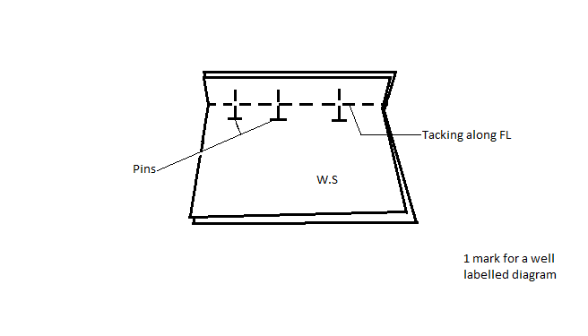

- Remove pins (1/2) and machine (1/2) along the fitting line.(1/2)
- Remove tacking (1/2) and press (1/2) the seam opens on the WS and flat on the RS.
- Trim the seam turnings to 6mm (1/2) and neaten (1/2) the two edges together using loop /buttonhole stitches/binding /machine zigzag. (1/2)
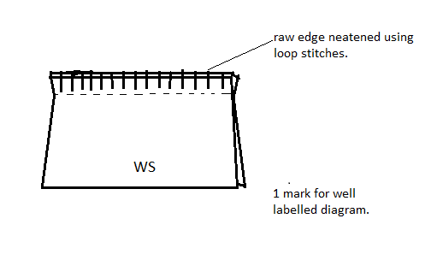
TOTAL= 9marks

