441/2
HOME SCIENCE (CLOTHING CONSTRUCTION)
TIME: 2 ½ Hours

PAVEMENT FORM 4 TRIAL 1 EXAMINATION 2022
Kenya certificate of secondary education (K.C.S.E)

A pattern of a girl’s skirt is provided. You are advised to study the sketches and layout carefully before you begin the test.
MATERIALS PROVIDED
- Pattern pieces.
A-Skirt
B-Skirt yoke
C-Skirt back
D- Waistband
E-Pocket
- Plain cotton fabric 90cm by 40cm
- Sewing thread.
- A piece of iron- on interfacing 40cm by 5cm.

THE TEST
Using the materials provided, cut out and make the right half of the girl’s skirt to show the following:
- The making of the back dart.
- Preparing and attaching the pocket.
- Making the inverted pleat on skirt front.
- Attaching skirt yoke to skirt using an overlaid seam. Neaten 10cm of the seam using loop stitches.
- Attaching pocket sections to garment sections.
- Complete the side seam above and below the pocket sections using a neatened open seam.
- Making the pocket bag. Do not neaten.
- Preparing interfaced waistband.(use provided interfacing)
- Attaching of waistband and hemming it down.
At the end of the examination, firmly sew onto your work, on a single fabric, a label bearing your Name and Admission Number. Remove the needles and pins from your work, then fold your work carefully and place it in the envelope. Do not put scraps of material in the envelope.

SKETCHES
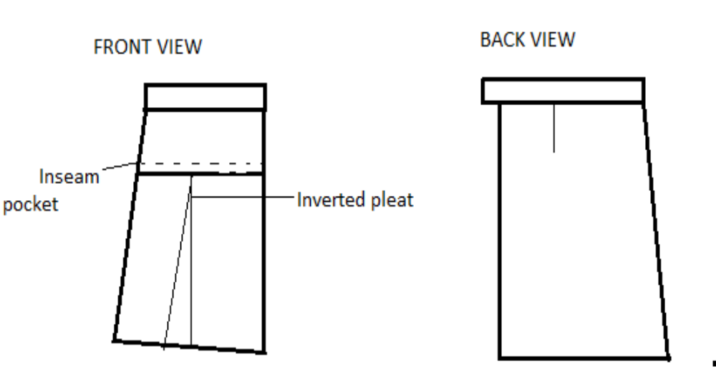LAYOUT (NOT DRAWN TO SCALE)
90 CM
`
D
E
A
B
c
FOLD
40 cm
SELVEDGE
SELVEDGE

