COMPETENCE BASED CURRICULUM
7
2024
JUNIOR SCHOOL
INTEGRATED SCIENCE
MARKING SCHEME

Please Note:
Facilitators are advised to go through the marking scheme as answers given could not be exhaustive.
      - Name two laboratory apparatus used for measuring mass of substances.( 2 mks)
- Electric balance
- Double beam balance
- Triple beam balance
- What is the meaning of the following sign?( 3 mks)
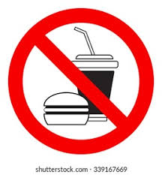
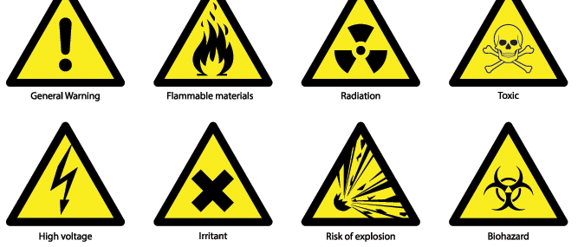

Food not allowed

- Name two careers related to integrated science.(2mks)
- Doctors,
- Science /Technology Teachers,
- Engineers,
- Architects,
- Nurses, Etc
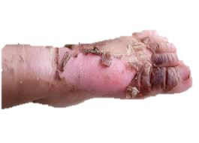
- Identify the common lab injury below. ( 1mk)
Scald

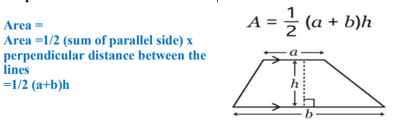
- Calculate the area of the following object.( 3 mks)
15cm

10cm

12cm
=$\frac{1}{2}$*10cm*(15cm+12cm)
=135cm²

Mention two rules you must observe when in the laboratory. (2 mks)
- Work carefully as carelessness can cause accidents as well as inaccurate results.
- Wear gloves, laboratory aprons and safety glasses.
- Never eat or drink in the laboratory.
- Tie back loose hair, roll back and secure open sleeves and neckties and make sure you wear shoes that fully cover your feet.
- Do not carry out laboratory experiments at home or in the dormitories unless directed to do so by your class teacher.
- Carefully read chemical labels and understand the hazard symbol on them.
- Listen carefully to your teacher’s instructions on when and how to use safety equipment such as glasses, protective aprons, fire extinguishers and fire blankets.
- Make sure you know where the nearest fire alarm is in your school laboratory.
- Do not begin an experiment until the teacher instructs you to do so.
- Do not touch substances unless the teacher instructs you to do so. What looks harmless may be dangerous.
- Wash your hands with soap and running water after handling chemical substances. Some chemical substances are poisonous.
- Heat materials in suitable containers only, such as Pyrex glass container that can resist breakage.
- Always keep the open end of the test tube pointed away from the learners and yourself when heating chemicals because the fumes produced may be harmful.
- Pick up hot objects carefully using tongs or insulated materials.
- Make sure that you turn off the heat source when not in use to conserve energy.
- Always unplug electric cords by pulling out the plug and not the cord.
- Check that there are no flammable substances near the burner. Flammable substances will cause fire if exposed to a flame.
- After each experiment, tidy up your working area, clean all equipment and put them in their respective storage areas.
- Report any accidents, broken equipment and damaged facilities to your teacher. In this way, you will be taking responsibility for your safety and for those who use the laboratory after you.
- If a chemical gets into your eyes, wash it out with running water for about 12 minutes and then visit a health centre or hospital for further medical attention.
- If you inhale poisonous gases or vapour, move outside the laboratory for fresh air. Immediately seek medical assistance.
- In case of electric shock immediately cut off the electric power source using an insulated object.
- In case of a fire outbreak, use sand, fire blankets and fire extinguishers to put out the fire.

- Name two heat instruments used in the lab for heating purposes.(2 mks)
- Portable burner
- Bunsen burner
- Candle
- Spirit lamp
- State two ways of reducing frictional force between two surfaces.( 2mks)
- Greasing movable parts.
- Streamlining bodies.
- Making a surface smoother.
- Use of rollers.
- Use of ball bearings.
- Use of wheels.
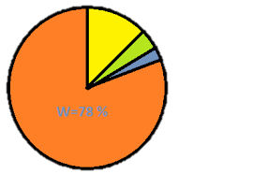
- The chart drawn below shows the composition of air in the atmosphere. Use it to answer quiz (a) and (b)
- Identify the gases labeled(4 mks)
W Nitrogen W X Y Z
X Oxygen
Y Inert gases
Z carbon-dioxide
b. Write two uses of gas X. (2 mks)
- Used in deep sea diving.
- Used in breathing
- Used in welding.
- Used in photosynthesis.

- State the functions of the following parts of a Bunsen burner.( 5mks)

Part | Function
Collar | Regulates amount of air entering the Bunsen burner through the air hole.
Air hole | Allows air to enter the chimney. (air mixes with the gas making flame hotter and  blue.
Base | Supports the Bunsen burner and prevent it from toppling.
Gas hose | The flexible hose pipe connects the Bunsen burner and the gas tap.
Gas inlet | Controls the flow of gas to the Bunsen burner.
- Name two types of blood groups. ( 2mks)
- Blood group A Blood group AB
- Blood group B Blood group O
- Identify the following parts of the human skeleton. (4 mks)
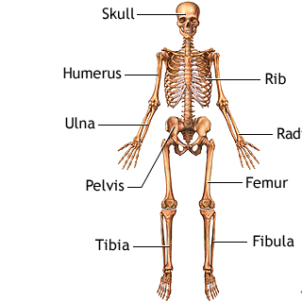
Tibia
Radius
Skull
Pelvis
Rib
Femur
Humerus

- Identify the following parts of a Bunsen burner. (3 mks)
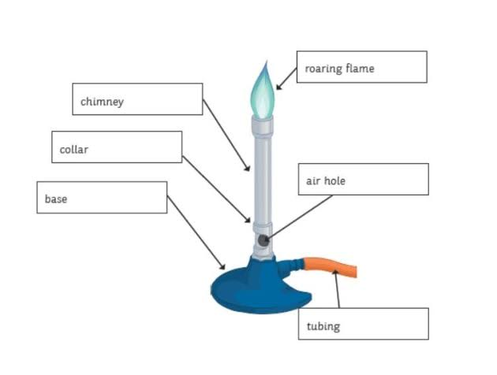

- To identify whether a substance is either acidic or basic, we use
Litmus paper. ( 1mk)

State two ways of handling a light microscope. ( 2mks)
- Always use both hands when carrying a light microscope.
- Do not place a light microscope on the edge of a bench or table as it may fall.
- Do not place specimens directly on the stage of a light microscope. Always place them on a microscope slide and cover them with a cover slip.
- Always use a lens tissue to clean the lenses. Hard materials are likely to scratch the lenses.
- Ensure that the low power lens is in position before storing the microscope.
- Always dust the microscope using a soft cloth, for example linen.
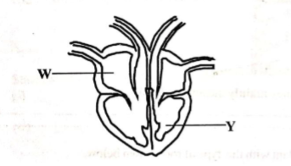
- The diagram below shows the human heart. Name the parts(2 mks)

W right auricle
Y left ventricle

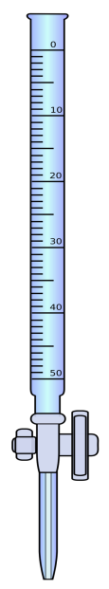
- Identify the following lab apparatus. (3 mks)
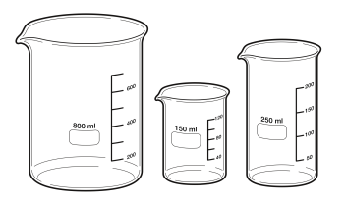
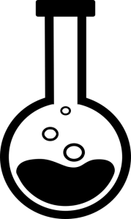
Round-bottomed flask

Beaker

Burette

Name two components of a first aid kit ( 2 mks)
  - An instruction manual giving general guidance.
  - Individually wrapped sterile adhesive dressings in a variety of sizes.
  - Sterile eye pads with bandages for attachment.
  - Triangular bandages.
  - Safety pins.
  - A bottle that contains eye drops.
  - A First Aid manual.
  - Scissors.
  - Gloves.
  - Antiseptic.
- The volume of 2355g of glass was found to be 50cm³.Calculate the density of mercury ( 2 mks)
Density =$\frac{mass}{volume}$
D=$\frac{2355g}{50cm3}$
D=47.1g/cm³

- Draw in the meniscus the following readings.(1 mk)
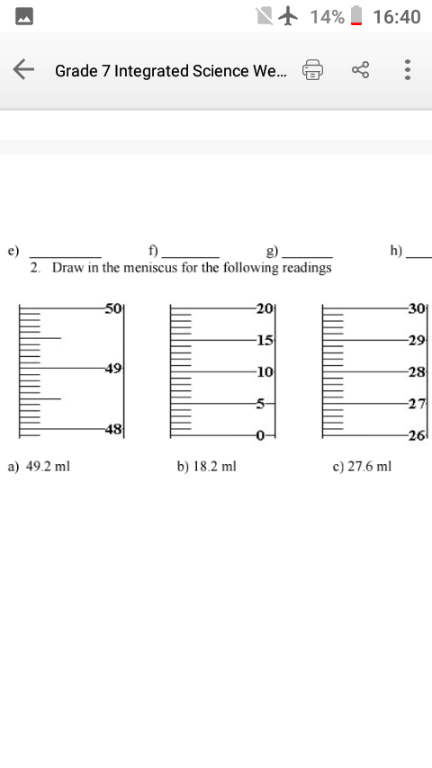
8cm³

THIS IS THE LAST PRINTED PAGE
……………….Every learner counts …………

