121/1 - MATHS - Paper 1


JULY 2022

Kenya Certificate of Secondary Education (K.C.S.E)
MATIMATHICS PAPER 1
2 HRS 30 MINS

Name ……………………………………………… Index Number ………………………... Class…………………………………... Candidates Signature…………………………….
Date ……………………………………

2022 TRIAL 2 JULY INTERNAL EXAMINATION
(Kenya Certificate of Secondary Education)

Kenya Certificate of Secondary Education (K.C.S.E)

INSTRUCTIONS TO CANDIDATES
- Write your name and Admission number in the spaces provided at the top of this page.
- This paper consists of two sections: Section I and Section II.
- Answer ALL questions in section 1 and ONLY FIVE questions from section II
- All answers and workings must be written on the question paper in the spaces provided below each question.
- Show all the steps in your calculation, giving your answer at each stage in the spaces below each question.
- Non – Programmable silent electronic calculators and KNEC mathematical tables may be used, except where stated otherwise.

FOR EXAMINERS USE ONLY
SECTION I
1 | 2 | 3 | 4 | 5 | 6 | 7 | 8 | 9 | 10 | 11 | 12 | 13 | 14 | 15 | 16 | TOTAL
SECTION II GRAND TOTAL

17 | 18 | 19 | 20 | 21 | 22 | 23 | 24 | TOTAL

This paper consists of 15 printed pages. Candidates should check the question paper to ascertain that all pages are printed as indicated and that no pages are missing.

SECTION I (50 marks)
Answer all the questions in this section in the spaces provided.
- Without using mathematical tables or calculators, evaluate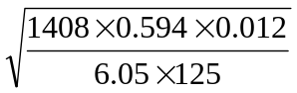 leaving your answer as a simplified fraction
(3mks)

2. Two similar solids have surface areas 48cm² and 108cm²respectively. Find the volume of the smaller solid if the bigger one has a volume of 162cm³. (3mks)

3. A triangle flower garden has an area of 28m². Two of its edges are 14 metres and 8 metres. Find the angle between the two edges. (2mks)

4. A watch which looses a half a minute every hour.It was set read the correct time at 0445hr on Monday. Determine in twelve hour system the time the watch will show on Friday at 1845hr the same week. (3mks)

5. Find the least whole number by which $2^{5 }×5^{4 }×7^{3}$ must be multiplied with to get a perfect cube. What is the cube root of the resulting number? (3mks )

6. A woman went on a journey by walking, bus and matatu. She went by bus $\frac{4}{5}$of the distance, then by matatu for $\frac{2}{3}$ of the rest of the distance. The distance by bus was 55km more than the distance walked. Find the total distance. (3mks).

7. Simplify the expression: $\frac{9t^{2}- 25a^{2}}{6t^{2}+ 19at+15a^{2}}$ (3mks).

8. Solve the simultaneous equations
X y = 4 and x + y = 5 (4mks)

9. The size of an interior angle of regular polygon is 3xº. While its exterior angle is
(x – 20) º. Find the number of sides of the polygon. (3mks)

10. A Kenya company received US Dollars M. The money was converted into Kenya Shillings in a bank which buys and sells foreign currencies.
Buying (in Ksh) Selling (in (Ksh)
1 Sterling Pound 125.78 126.64
1 Us Dollar 75.66 75.86
(a) If the company received Ksh.15, 132,000, calculate the amount, M received in US Dollar. (2mks)

- The company exchanged the above Kenya shillings into Sterling pounds to buy a car in Britain. Calculate the cost of the car to the nearest Sterling pound. (2mks)

11. A plot in a shape of rectangle measurers 608m by 264m. Equidistance fencing posts are
Placed along its length and breadth as far apart as possible. Determine
a) The maximum distance between the posts. (1mk)

b) The number of posts used. (2mks)

12. Given that sin (x – 30)⁰ - Cos (4x) ⁰. Find the tan (2x+30)⁰ (3mks)

13. A trader sold a dress for Ksh 7200 allowing a discount of 10% on the marked price. If the discount had not been allowed the trader would have made a profit of 25% on the sale of the suit. Calculate the price at which the trader bought the dress. (3mks)

14. In august, Joyce donated 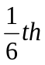 of her salary to a children’s home while Chui donated 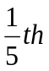 of his salary to the same children’s home. Their total donation for August was Kshs 14820. In September, Joyce donated 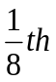 of her salary to the children’s home while Chui donated 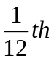 of his salary to the children’s home. The total donation for September was Kshs 8675. Calculate Chui’s monthly salary. (4mks)

15.Simplify completely 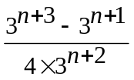 (3mks)

16.In what ratio should grade A tea costing Sh. 180 per kg be mixed with grade B tea costing Sh. 300 per kg to produce Nganomu Tea which when sold at Kshs 270 a profit of 20% is realized? (3mks)

SECTION II (50 MARKS)
Answer any five questions from this section in the spaces provided
. 17. Atambo poured spirit into a test tube which has hemispherical bottom of inner radius 1.5cm. He noted that the spirit is 8cm high.
(a) What is the area of surface in contact with spirit? (4mks)

(b) Calculate volume of spirit in the test tube. (4mks)

(c) If Atembo obtained the mass of the spirit as 10g. Calculate the density of the spirit. (2mks).

18.A bus left Nairobi at 7.00 am and traveled towards Eldoret at an average speed of 80Km/hr. At 7.45am a car left Eldoret towards Nairobi at an average speed of 120Km/hr. The distance between Nairobi and Eldoret is 300 km. Calculate:
(a) The time the bus arrived at Eldoret. (2mks)

(b) The time of the day the two met. (4mks)

(c) The distance of the bus from Eldoret when the car arrived in Nairobi. (2mks)

(d) The distance from Nairobi when the two met. (2mks)

19. The figure below C is a point on AB such that AC: CB=3:1 and D is the mid –point of OA. OC and BD intersect at X.
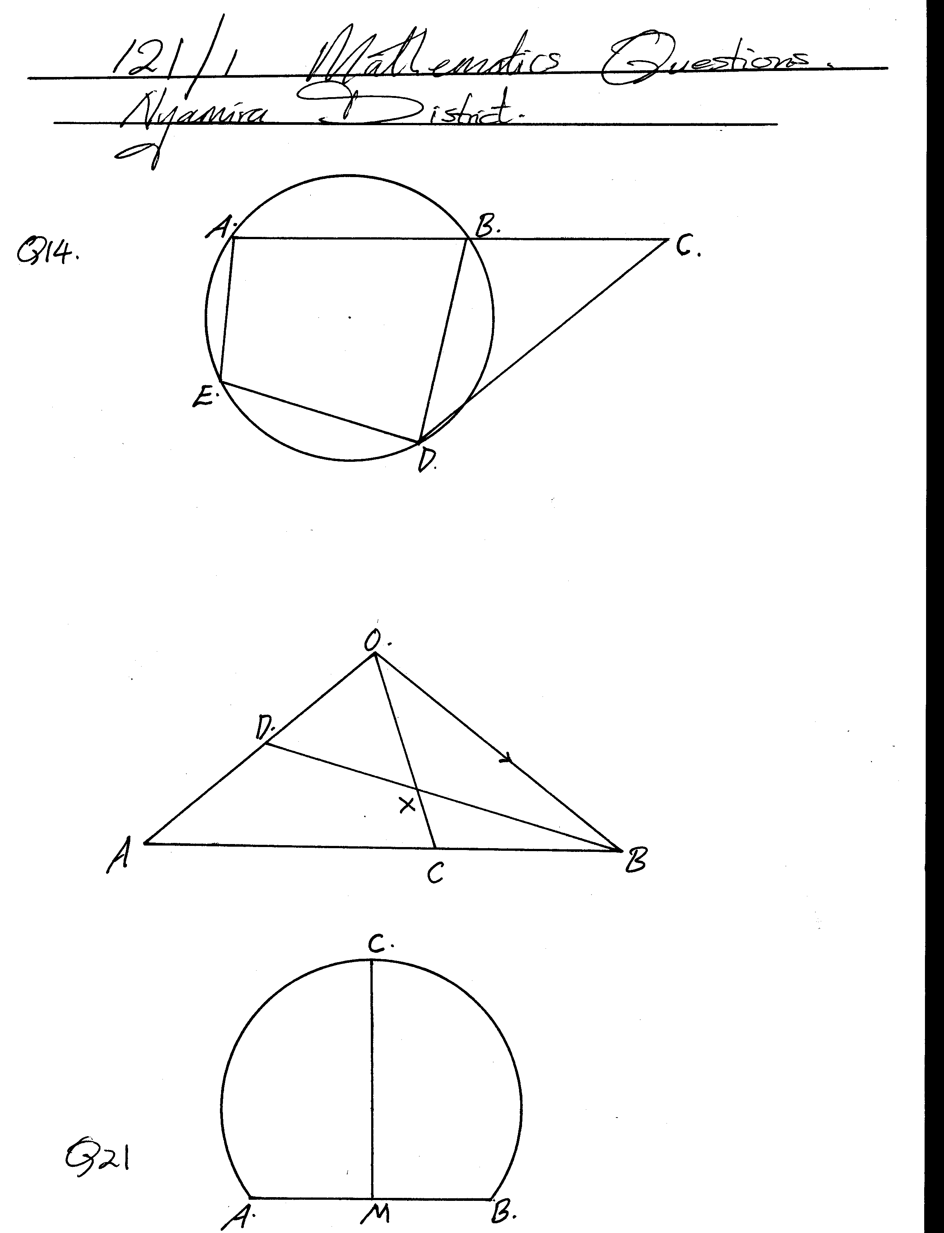
Given that OA = a and OB = b
- Write the vectors below in terms of a andb.
(i) AB (1mk)

(ii) OC (2mks)

(iii) BD (1mk)

(b) If BX = h BD, express OX in terms of a, b, and h. (1mk)

(c) If OX = KOL, find h and k. (4mks)

(d) Hence express OX in terms of a andb only. (1mk).
20. (a) Using a ruler and a pair of compasses only, draw a triangle ABC such that AB = 5cm,BC = 8cm and <ABC = 60º. Measure AC and <CAB. (4mks)

(b) Find a point O in Δ ABC such that OA = OB = OC. (2mks).

(c) Construct a perpendicular from A to BC to meet BC at D. Measure AD. Hence calculate the area of the Δ ABC (4mks)

21. A boy started walking due East from a dormitory 100m South of a bore-hole. He walked to the school library from which the bearing of the bore-hole is 315º. He then walked on a bearing of 030º to the water tank. From the water tank he went west to the bore-hole.
(a) Using a scale of 1cm to represent 20m, construct a diagram to show the positions of the tank, borehole, dormitory and library. (5mks).

(b) Find the distance and bearing of the bore-hole from the water tank. (3mks)

(c) Calculate the total distance covered by the boy. (2mks).

22. The table below shows the amount in shillings of pocket money given to students in a particular school.
Pocket Money (Ksh) | 210 – 219 | 220-229 | 230-239 | 240-249 | 250-259 | 260-269 | 270-279 | 280-289 | 290-299
No. of Students | 5 | 13 | 23 | 32 | 26 | 20 | 15 | 12 | 4

(a) State the modal class. (1mk)

- Calculate the mean amount of pocket money given to these students to the nearest shilling. (4mks).

(c) Use the same axes to draw a histogram and a frequency polygon on the grid provided
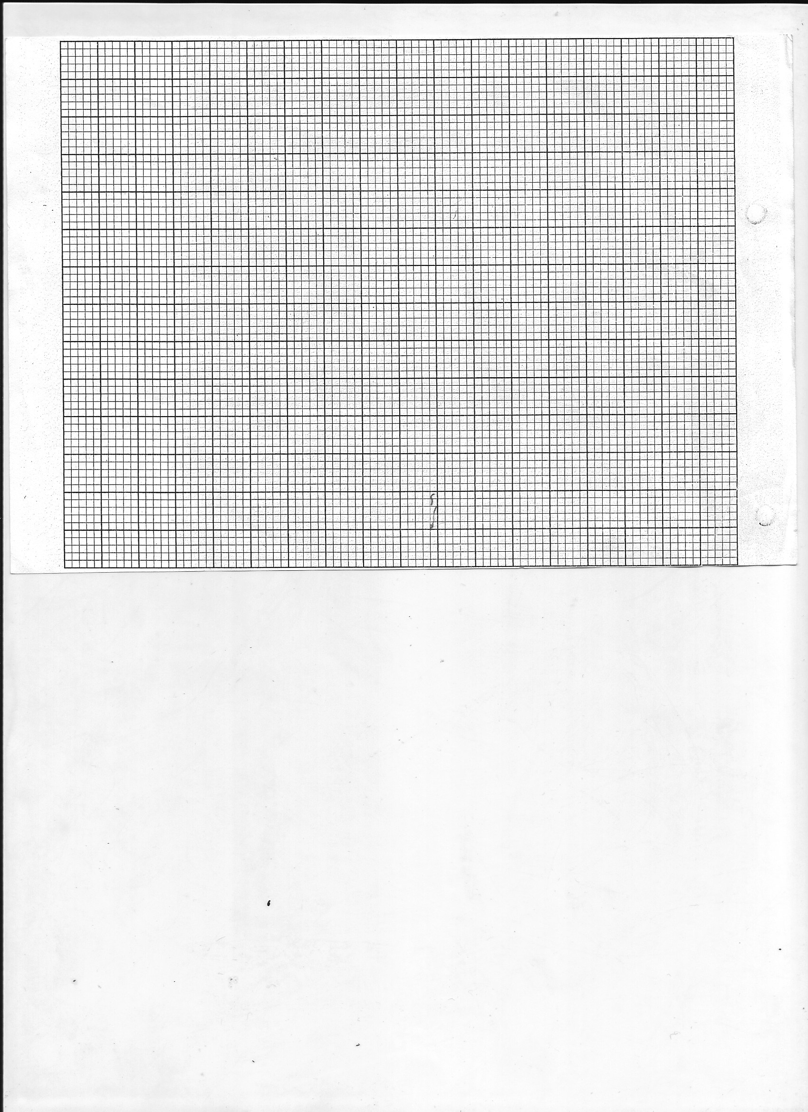
(5mks)

23. (a)Given that y = 7 + 3χ - χ², complete the table below. (2mks)
χ | -3 | -2 | -1 | 0 | 1 | 2 | 3 | 4 | 5 | 6
y | -11 |  |  | 7 |  |  |  |  |  | -11

(b)On the grid provided and using a suitable scale draw the graph of y = 7 + 3χ - χ².(3mks)
(b)On the same grid draw the straight line and use your graph to solve the equation
χ² - 4χ – 3 = 0. (3mks)
(c)Determine the coordinates of the turning point of the curve. (2mks)

24. A straight line L₁ has a gradient ˉ½ and passes through point P (-1, 3). Another line L₂ passes through the points Q (1, -3) and R (4, 5). Find.
(a) The equation of L₁. (2mks)

(b) The gradient of L₂. (1mk)

(c) The equation of L₂. (2mks)

(d) The equation of a line passing through a point S (0, 5) and is perpendicular to L₂. (3mks)

(e) The equation of a line through R parallel to L₁. (2mks)

