121/2 - MATHS - Paper 2


JULY
2022

Kenya Certificate of Secondary Education (K.C.S.E)
MATIMATHICS PAPER 2
2 HRS 30 MINS

Name ……………………………………………… Index Number ………………………... Class…………………………………... Candidates Signature…………………………….
Date ……………………………………

2022 TRIAL 2 JULY INTERNAL EXAMINATION
(Kenya Certificate of Secondary Education)

Kenya Certificate of Secondary Education (K.C.S.E)

INSTRUCTIONS TO CANDIDATES

- Write your name and Admission number in the spaces provided at the top of this page.
- This paper consists of two sections: Section I and Section II.
- Answer ALL questions in section I and ONLY FIVE questions from Section II.
- All answers and workings must be written on the question paper in the spaces provided below each question.
- Show all the steps in your calculation, giving your answer at each stage in the spaces below each question.
- Non – Programmable silent electronic calculators and KNEC mathematical tables may e used, except where stated otherwise.

FOR EXAMINERS USE ONLY

SECTION I

1 | 2 | 3 | 4 | 5 | 6 | 7 | 8 | 9 | 10 | 11 | 12 | 13 | 14 | 15 | 16 | TOTAL
GRAND TOTAL
SECTION II

17 | 18 | 19 | 20 | 21 | 22 | 23 | 24

SECTION I
1. If a = 2.7ºC, b = 3.4ºC. c = 9.8ºC and d = 3.0ºC, find the percentage error in bc-ad. (4 mks)

2. Find the value of x in the equation log₁₀ (2x-1) + log₁₀ 3 = log₁₀ (8x-1). (2 mks)

3. Find the compound interest on sh. 200,000 for 2 years at 14% pa. Compounded semi-
annually. (3 mks)

4. Simplify by rationalising the denominator
√ 2 + √3 (3 mks)
√6 - √3

5. Express 30 – 30 = ½ in the form ax² + bx + c = 0 hence solve the equation using the
x-2 x
completing square method. (4 mks)

6. The ratio of 12th to 10th term in a geometric series is 9:1. Find the common ratio. (2 mks)

7. i) Expand (2 – ¼ x)⁵ (1 mk)

ii) Use your expansion to find the value of (1.96)⁵ correct to 3 decimal places. (2 mks)

8. Chord WX and YZ intersect externally at Q. The secant WQ = 11cm and QX = 6cm while
ZQ = 4cm.
W
X
6cm
Y
Z
4cm
Q
S
- Calculate the length of chord YZ. (2 marks)

- Using the answer in (a) above, find the length of the tangent SQ. (2 marks)

9. Given that y – 1 y + 1 is a singular matrix, find the possible values of y. (3mks)
3y y

10. Given that S = a (1- r^{n}) , make n the subject of the formula. (3 marks)
1 - r

11. It would take 18 men 12 days to dig a piece of land, if they work for 8 hours a day. How
long will it take 24 men if they work 12 hours a day to cultivate three quarters of the
same land. (3 marks)

12. Use logarithms to evaluate. (4 marks)
4
0.8465 x 12.14
214.5 ÷ 9.067

13. The masses to the nearest kg of 50 adults were recorded as follows:

Mass (kg) Frequency (f)
45 – 50 2
51 – 56 10
57 – 62 11
63 – 68 20
69 – 74 6
75 – 80 1

Calculate the quartile deviation. (3 marks)

14. P varies as the cube of Q and inversely as the square root of R. If Q is increased by 20%
and R decreased by 36%, find the percentage change in P. (3 marks)

15. Solve 8 cos² x – 2 cos x – 1 = 0 (3 marks)

16. A(0,3), B(1,5) and C(4,11) are three points. Show that they are collinear. (3 marks)

SECTION II

17. In the figure below, OABC is a trapezium. AB is parallel to OC and OC = 5AB. D is a
point on OC such that OD: DC = 3:2
A
B

X

C
D
O

- Given that OA = p and AB = Q, express in terms of p and q.
- OB (1 mk)

- AD (2 mks)

- CB (2 mks)

- Lines OB and AD intersect at point X such that AX = kAD and OX = rOB where
k and r are scalars. Determine the values of k and r. (5 marks)

18. The diagram below shows a lampshade in the shape of an open frustrum of an open
square based right pyramid. The base PQRS is a square of side 25cm. The top TUVW is
a square of side 10cm and each of the slanting edges of the frustrum is 15cm.
W
V
10cm
10cm
15cm
U
T

S
R

25cm
P
Q
25cm

Calculate to one decimal place.
- The height of the frustrum. (3 marks)

- The angle between
- Line VR and the base. (2 marks)

- Plane UQRV and the base. (2 marks)

- The volume of the frustrum. (3 marks)

19. The table below shows the rates of taxation in a certain year.

Income in K£ pa Rate in Ksh per K£
1 – 3900 2
3901 – 7800 3
7801 – 11700 4
11701 – 15600 5
15601 – 19500 7
Above 19500 9

In that period, Juma was earning a basic salary of sh. 21,000 per month. In addition, he
was entitled to a house allowance of sh. 9000 p.m. and a personal relief of ksh.105 p.m
He also has an insurance scheme for which he pays a monthly premium of sh. 2000. He
is entitled to a relief on premium at 15% of the premium paid.

- Calculate how much income tax Juma paid per month. (7 marks)

- Juma’s other deductions per month were cooperative society contributions of sh. 2000 and a loan repayment of sh. 2500. Calculate his net salary per month. (3 mks)

20. Wainaina has two dairy farm A and B. Farm A produces milk with 3 ½ percent fat and
farm B produces milk with 4 ¾ percent fat. Determine;

- The total mass of milk fat in 50kg of milk from farm A and 30kg from farm B. (3 marks)

- The percentage of fat in a mixture of 50kg of milk from A and 30kg of milk from farm B. (2 marks)

- Determine the range of values of mass of milk from farm B that must be used in a 50kg mixture so that the mixture may have at least 4 percent fat. (5 marks)

21. A cupboard has 7 white cups and 5 brown ones all identical in size and shape. There was
a blackout in the town and Mrs. Kamau had to select three cups, one after the other
without replacing the previous one.

- Draw a tree diagram for the information. (2 marks)

- Calculate the probability that she chooses.
- Two white cups and one brown cup. (2 marks)

- Two brown cups and one white cup. (2 marks)

- At least one white cup. (2 marks)

- Three cups of the same colour. (2 marks)

22. A triangle ABC has vertices A(-5,-2), B(-3,-2) and C(-5,-5). The triangle is rotated
through a positive quarter turn about the origin to obtain the image A¹B¹C¹.

- Draw triangle ABC and its image A¹B¹C¹ on the grid. (2 marks)

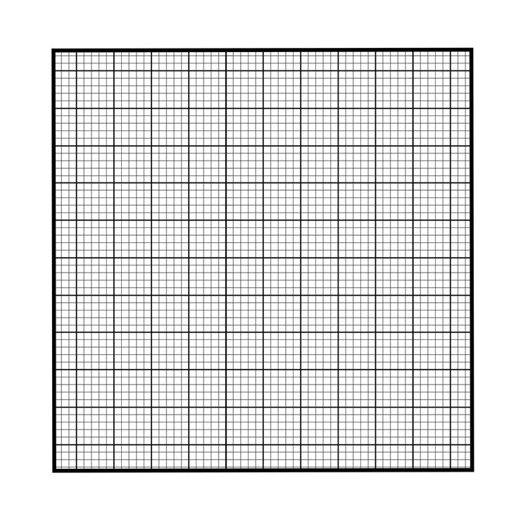
- A¹B¹C¹ is then reflected on the line y + x = 0 to get A¹¹B¹¹C¹¹ on the same grid.
(2 marks)

- Find a single matrix of transformation that maps ABC onto A¹¹B¹¹C¹¹.
(3mks)

- Describe the transformation in (c) above. (2 marks)

- Find the coordinates on the image of ABC under a shear factor 2 parallel to x-axis.
(2 marks)

23. a) Complete the table below, giving the values correct to 1 decimal place. (2 marks)

x | 0 | 40 | 80 | 120 | 160 | 200 | 240
2sin(x+20º) | 0.7 |  | 2.0 |  | 0.0 |  | -2.0
√3 cos x | 1.7 | 1.3 |  | -0.9 |  | -1.6

b) On the grid provided, draw the graphs of y = 2sin(x+20)⁰ and y = √3 cos x for
0 < x < 240⁰ (5 marks)

- Use the graphs drawn in (b) above to determine:
- The values of x for which 2 sin (x+20)⁰ = √3 cos x. (2 marks)

- The difference in amplitude of y = 2 sin (x+20)⁰ and y = √3 cos x. (1 marks)

24. An aircraft leaves town P (30⁰S, 14⁰W) and moves directly east of town Q at a speed of
270 knots for 12 hours. Determine:
a) i) the distance covered in nautical miles. (2 marks)

ii) the distance covered in km. (2 marks)

b) the position of town Q. (3 marks)

c) the local time at Q if the local time at P is 9.13p.m. Give your answer to the nearest
minutes. (3 marks)

