NAME……………………………………………………………ADM.NO………….CLASS………..
Date …………………

.
END OF TERM 2 EXAM

FORM 3 MATHEMATICS
Paper 1
.
2 ½ Hours

Instructions to candidates

- Write your name, admission number and class in the spaces provided above.
- Sign and write the date of examination in the spaces provided above.
- The paper contains two sections: Section I and Section II.
- Answer All the questions in section I and strictly any five questions from Section II.
- All answers and working must be written on the question paper in the spaces provided below each question.
- Show all the steps in your calculations, giving your answers at each stage in the spaces below each question.
- Marks may be given for correct working even if the answer is wrong.
- Non-programmable silent electronic calculators and KNEC mathematical tables may be used, unless stated otherwise.

For Examiner’s use only.
Section I
1 | 2 | 3 | 4 | 5 | 6 | 7 | 8 | 9 | 10 | 11 | 12 | 13 | 14 | 15 | 16 | Total

Section II
17 | 18 | 19 | 20 | 21 | 22 | 23 | 24 | Total

Grand Total

This paper consists of 14 printed pages .Candidates should check the question paper to
Ensure that all the pages are printed as indicated and no question(s) are missing

SECTION A ( 50 MARKS )
Answer all the questions in this section
- Without using mathematical tables or calculator, evaluate. 3 mks
$$\frac{\left(\sqrt[3]{13824) } -4 \right)}{3+4 ÷2-5×7}$$

- A watch which looses a half a minute every hour was set read the correct time at 0445hr on Monday. Determine in twelve hour system the time the watch will show on Friday at 1845hr the same week. 3mks

- Find the least whole number by which $2^{5 }× 5^{4 }× 7^{3}$ must be multiplied with to get a perfect cube. What is the cube root of the resulting number. 3mks

- A woman went on a journey by walking, bus and matatu. She went by bus $\frac{4}{5}$ of the distance , then by matatu for $\frac{2}{3}$ of the rest of the distance. The distance by bus was 55km more than the distance walked. Find the total distance. 3mks.

- Equity bank buys and sells foreign currencies as shown:

Currency | Buying (ksh) | Selling (ksh)
1 US Dollar | 77.43 | 78.10
1 S.A Rand | 9.03 | 9.51

A tourist arrived in Kenya with 5 600 US Dollars and changed the whole amount to Kenya shillings. While in Kenya he spent Sh. 201 376 and changed the balance to S.A Rand before leaving to South Africa. Calculate in SA Rand he received. 3 mks

- The size of an interior angle of regular polygon is 3xº . While its exterior angle is
(x – 20)º. Find the number of sides of the polygon. 3mks

- Use reciprocal, cosine and square tables only to evaluate to 4.s.f the expression.
$\frac{1}{15.79} - {(coscos 73.61) }^{2}$ 4mks

- Given that $\left(x+ {20}^{o}\right) = coscos \left(2x+25\right)$ find the value of $x$ and hence find the value of $tantan x$. 3mks

- A rectangular room is 4m longer than it is wide. If its area is 12 m² ,find its dimensions. 3mks.

- The masses of two similar building blocks are 2.7 kg and 800grams respectively. Find the surface area of the larger block if the surface area of the smaller block is 120 cm².
3 mks

- By completing the square solve the following quadratic equation 4mks
$$x^{2}+8x+9=0$$

- Without using a calculator , evaluate: $\frac{\frac{3}{4}+ 1\frac{2}{7} ÷\frac{3}{7} of 2\frac{1}{3} }{\frac{2}{3} (1\frac{2}{7} - \frac{3}{8})}$ 3 mks

- Simplify the expression: $\frac{9t^{2}- 25a^{2}}{6t^{2}+ 19at+15a^{2}}$ 3mks.

- A business bought 300 kg of tomatoes at Ksh. 30 per kg. He lost 20% due to waste. If he has to make a profit 20%, at how much per kilogram should he sell the tomatoes.
3mks.

- Find the equation of the line through the point (2,3) and parallel to the line x – 8y -2=0. Leave the equation in the form y = mx + c. 3 mks

- A rectangular field measures 308m by 228m. Fence posts are placed along its sides at equal distance apart. If the posts are as far as possible, what is the distance between them.
3mks

SECTION II (50mks)
Answer only five questions in this section in the spaces provided.
- Three points P, Q and R are on a level ground. Q is 240 m from P on a bearing of 230º, R is 120m to the East of P.
- Using a scale of 1cm to represent 40m, draw a diagram to show the positions of P, Q and R in the space provided below. 4mks

- Determine:
- The distance of R from Q. 1mk

- The bearing of R from Q. 1mk

- A vertical post stands at P and another one at Q. A bird takes 18 seconds to fly directly from the top of the post at Q to the top of the post at P. Given that the angle of depression of the top of the post at P from the top of the post at Q is 9º, calculate.
- The distance to the nearest metre the bird covers. 2mks

- The speed of the bird in Km/h. 2mks

- A and B are two towns. Tom left town A at 8:00 am travelling towards town B at an average speed of 90km/h. At 8:21 am on the same day, John left town A for town B travelling along the same road at an average speed of 97km/h. Determine;

- The time John caught up with Tom. 5mks

- The distance from town A to the point where John overtook Tom. 2mks

- On the same day, Paul left town B for A at 8:40am travelling at an average speed of 80km/h. He met Tom after 2hours 30 minutes. Determine the distance between A and B. 3 mks

- A surveyor recorded the following information in his field book after taking measurement in metres of a plot.

 | To E
720 to F  240 to G | 1000  880  640  480  400  200 | 320 to D  600 to C  400 to B
 | From A
- Sketch the layout of the plot. 4mks.

- Calculate the area of the plot in hectares. 6mks

- Complete the table for the function y = 1 – 2x - 3x² in the range -3 ≤ x ≤ 3 (2mks)
X | -3 | -2 | -1 | 0 | 1 | 2 | 3
-3x² | -27 |  | -3 | 0 |  | -12
-2x |  | 4 |  | 0 |  |  | -6
1 | 1 | 1 | 1 | 1 | 1 | 1 | 1
Y | -20 |  |  | 1 |  | -15
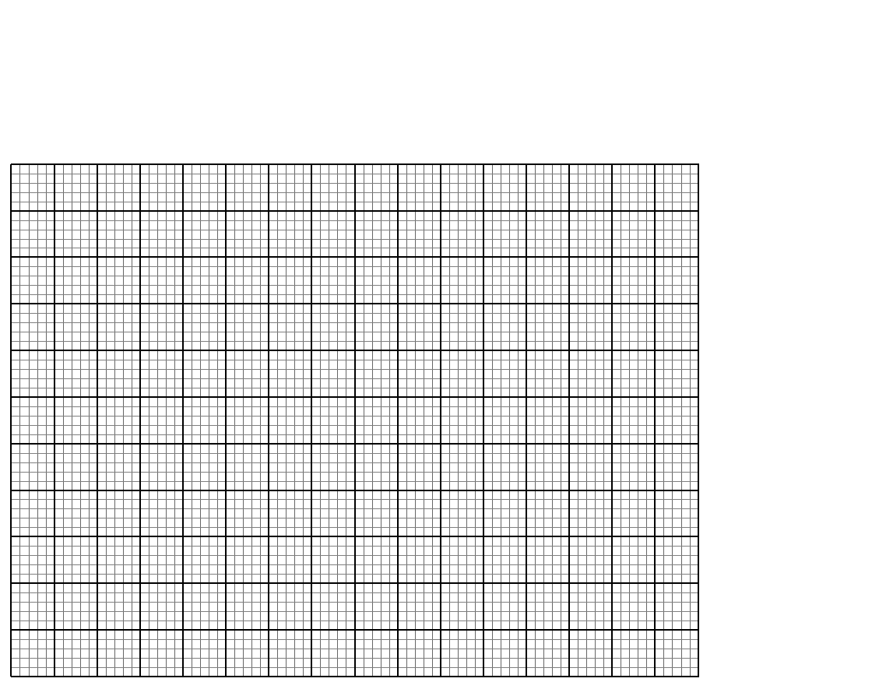
- Using the table above and the graph paper provided, draw the graph of
y = 1 – 2x –3x² (4mks)

- Use the graph in (b) above to solve
- 1 – 2x – 3x² = 0 (2mks)

- 2 – 5x – 3x² = 0 (2mks)

- The diagram below shows two circles, centre A and B which intersect at points P and Q.
Angle PAQ = 70⁰, angle PBQ = 40⁰ and PA = AQ = 8cm.

A

P

70⁰
40⁰
B

Q

Calculate
- PQ to correct to 2 decimal places 2 Mks

- PB to correct to 2 decimal places 2 Mks

- Area of the minor segment of the circle whose centre is A 2 Mks

- Area of shaded region 4 Mks

- The region marked R below is enclosed by three inequalities as shown.
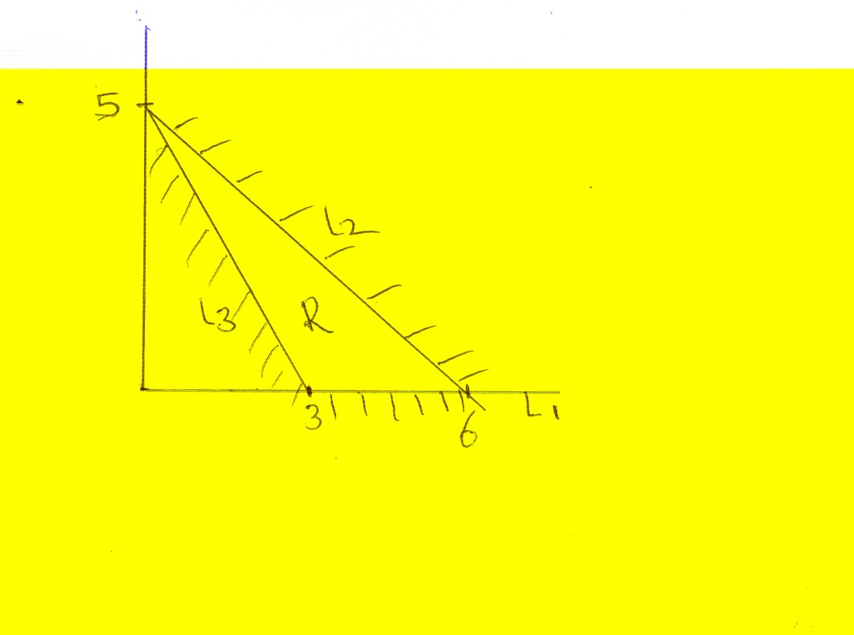
- Determine the area of region R (2mks)

(b) determine the inequalities that enclose the region
(i) L₁ (2mks)

(ii) L₂ (3mks)

(iii) L₃ (3mks)

- Three business partners, Bela ,Joan and Trinity contributed Kshs 112,000, Ksh,128,000 and ksh,210,000 respectively to start a business. They agreed to share their profit as follows:
30% to be shared equally
30% to be shared in the ratio of their contributions
40% to be retained for running the business.

If at the end of the year, the business realized a profit of ksh 1.35 Million. Calculate:

- The amount of money retained for the running of the business at the end of the year. (1mk)

- The difference between the amounts received by Trinity and Bela (6mks)

- Express Joan’s share as a percentage of the total amount of money shared between the three partners. (3mks)

- In the figure below POR is a diameter. PQT is a straight line, and ∠QRT = 30⁰ and RPS=∠35⁰. O is the centre of the circle.
V
P

S
O
35⁰

R
Q
30⁰

T

Calculate
- Angle PRQ (2 Marks)

- Angle RPQ ( 2 Marks)

- Acute angle SOR (2 Marks )

- Angle RTQ (2 Marks)

- Angle PVS (2 Marks)

