COMPETENCE BASED CURRICULUM
7
2024
JUNIOR SCHOOL
MATHEMATICS MARKING SCHEME

- The interior angles of a triangle are as shown below.
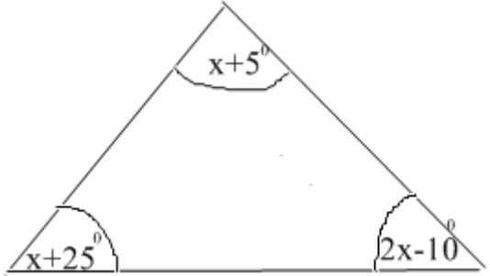
Find the value of x. (2mk)

Solution
Angles in a triangle adds up to 360⁰
(x+5)⁰ +(x+25) º+ (2x-10)⁰=360⁰
$$(x+5) +(x+25) + (2x-10)=360$$
Open brackets and collect like terms
$$X + x+ 2 x +25+5 -10=3600$$
Crossing the whole numbers over the other side of the equal sign and changing their signs
$X + x+ 2x=360-25-5 +10$
4x=160
Dividing both sides by 4
$$\frac{4x}{4}=\frac{160}{4}$$
X=40⁰

- Find the area of the circle drawn (take = 𝜋 =22/7 (2mk)
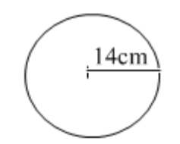
Solution
Area of a circle is given by AREA=Πr²
Area= 22/7*14cm*14cm
Area= 616cm²
- A cube has a volume of 3.6m3. What is the volume of the cube in cubic centimetres? (1mk)

1m=100cm
1m²=100cm*100cm
1m³=100cm*100cm*100cm
1m³=1000000cm³

If 1m³=1000000cm³

3.6m³ =? cm³
= 3,600,000cm³

- Convert 72000m2 into hectares. (2mk)
1ha=10,000m²

?ha=72,000m²

=72ha
- Express 80 as a product of its prime factors using a factor tree.(2 marks)
Ans 2X2X2X2X5
- What is the sum of the GCD and the LCM of 6, 12 and 18? (3 marks) Ans 42

- A trader stored milk in three containers of 24 litres, 30 litres and 60 litres. The milk in each container was then repacked into smaller containers. The amount of milk in each of the small container was the same. What was the capacity of the largest container used to repack the milk? (3 marks) Ans 6 L

- Maria bought$6\frac{2}{3}$ metres of white cloth material and $2 ¾$ metres of yellow cloth material to be used in a home science project. How many metres of material did she buy altogether? (3 marks)
Ans$9\frac{5}{12}$
- Work out the following .
  - $33\frac{7}{12}+40\frac{2}{3}$(2 marks)
Ans$74\frac{1}{4}$
  - $14\frac{5}{8}-2\frac{2}{5}-4 ½$ (3 marks)
Ans$7\frac{29}{40}$

- Work out the following.
$5\frac{5}{8}×24$(2 marks)
Ans 135
- Find the area of the figure below. (2 marks)
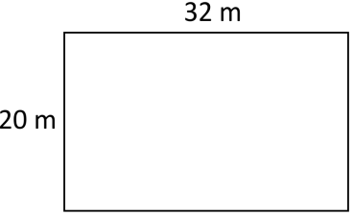 Ans 640CM²
- Name the angle shown below. (1 mark)
Ans obtuse ANGLE

- What is 25% written as a fraction in its simplest form? (1 mark)
Ans ¼
- What is the volume of the cuboid below? (2 marks)
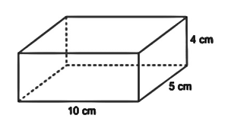 Ans 200CM³
- How many days are there in total in the months of November, December and January? (1 mark)
Ans 92 DAYS
- Simplify the following expression. ( 2 mks)
(5(x+4) + 4(2x+5)
Ans 13x+40

- The perimeter of the figure below is 100cm. what is the length of the longest side?( 2mks)
(3x+10) cm

(2x-5) cm

Ans 42cm

- The diagonal of a square measures 44cm.Calculate the perimeter of the square. (3mrks)

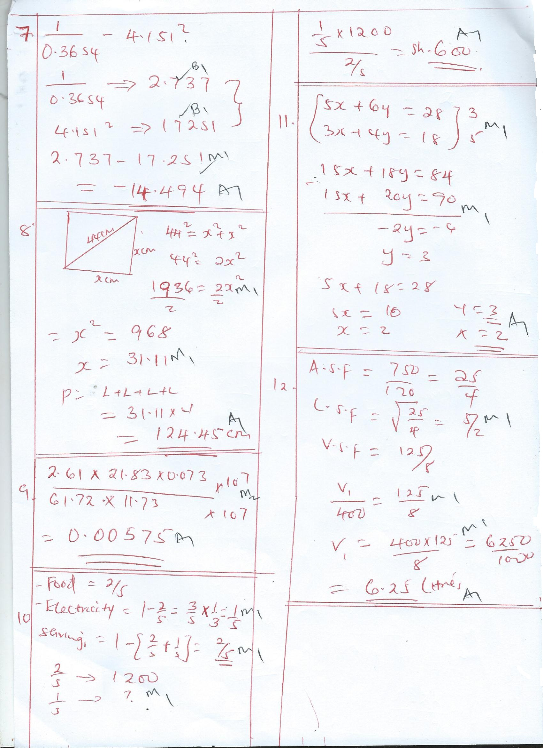

- Calculate; (3 mks)
2.61 x 21.83 x 0.073
61.72 x 11.73

- Patrick spent 2/5 of his salary on food, 1/3 of the remainder on electricity and saved the rest.

(a). What fraction of his salary did he save? (2mrks).

(b). If he spent Sh. 1,200 on food, how much did he spend on electricity? (2Mks)

- A farmer has three containers of capacity 12L, 15L and 21L, calculate the capacity of:
- The smallest container which can be filled by each one of them an exact number of times (2 Mrks).

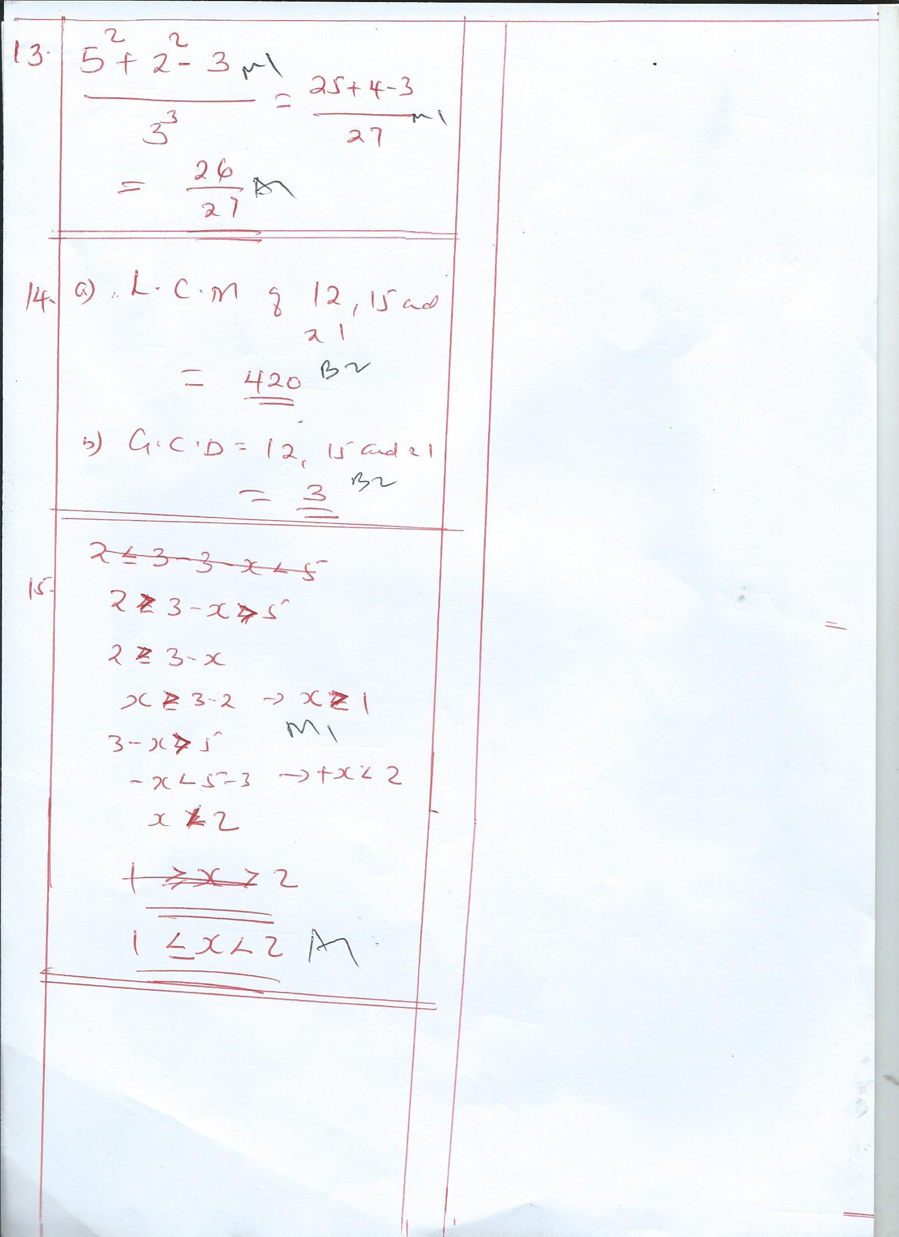

- (b). The largest container which can fill each one of them an exact number of time.(2 Mks)

THIS IS THE LAST PRINTED PAGE
……………….Every learner counts …………

