1 | N  −(−1)²+(−1)(2)(−3)  =−1+6  =5 $\frac{N}{D}=\frac{5}{5}=1$  D  (−1)²(2)—3  =2+3  =5 | M1  M1  A1  3Marks
2 | N  −8+80+112 Combined: 184÷29=$6\frac{10}{29}$  =184  D  −3+4×8  =29 | M1  M1  A1  3marks
 | −5y=3x+10  y = $(-3)/5x+-2$  _{M1=M2=}$\frac{-3}{5}$  _{(x,y) ,(−2,8) m=}${-3}/5$  $\frac{y-8}{x+2}=\frac{-3}{5}$  _{5y−40=−3x−6}  _{3x+5y−46} | M1  M1  A1  3marks
4 | - T=$\left({6 \atop -2}\right)-\left({4 \atop 1}\right)=\left({2 \atop -3}\right)$  - P¹$=\left({4 \atop 2}\right)+\left({2 \atop -3}\right)=\left({6 \atop -1}\right),$P¹$\left(6,-1\right)$  Q¹$=\left({3 \atop 5}\right)+\left({2 \atop -3}\right)=\left({5 \atop 2}\right)$ ^{, =} $(5,2)$ | M1  A1  B1  B1  4marks
5 | $a^{2}$ $+\frac{3}{2}a+\left(\frac{1}{2}\right)=0$  $a^{2}+\frac{3}{2}a+{\left(\frac{3}{4}\right)}^{2}$ $=\frac{-8+9}{16}$  ${\left(a+\frac{3}{4}\right)}^{2}$ $=\frac{1}{16}$  $\left(a+\frac{3}{4}\right)=±\frac{1}{4}$  a$=±\frac{1}{4}-\frac{3}{4}$  a$=\frac{-1}{2} or a=-1$ | M1  M1  A1  3marks
6 | Water  Mass=0.5$×1000×1=500g$  volume$=500{cm}^{2}$  Alcohol  Mass$=1200×0.8=960g$  V$=1200{cm}^{2}$  D$=\frac{500+960}{1200+500}=0.8588{g/cm}^{2}$ | M1  M1  A1  3marks
7 | Total distance$=\frac{1}{2}+20×8+\frac{1}{2}×6×20=140m$  A.V$=\frac{140}{14}=10m/s$ | M1  M1, A1  3marks
8 | 48 = $2^{4}$x 3  72 = $2^{3}$x $3^{2}$  Prime number 1008 = 7  $${24x3}^{2}$$  Other number = 7 x 3 = 21 | M1  M1  A1  3marks
9 | 3P + 4e = 87 ………. (i)  2P + 5e = 93 ………. (ii)  2(2P + 4e = 87)  3 (2P + 5e = 93)  6P + 8e = 174 (iii)  6P + 15e = 279 (iv)  7e = 105  e = 15  Substitute in (ii)  2P + 75 = 93  2P = 18  P = 9  Cost of exercise book Sh. 15  Cost of a pen Sh. 9 | M1  M1  M1  A1  3marks
10 | 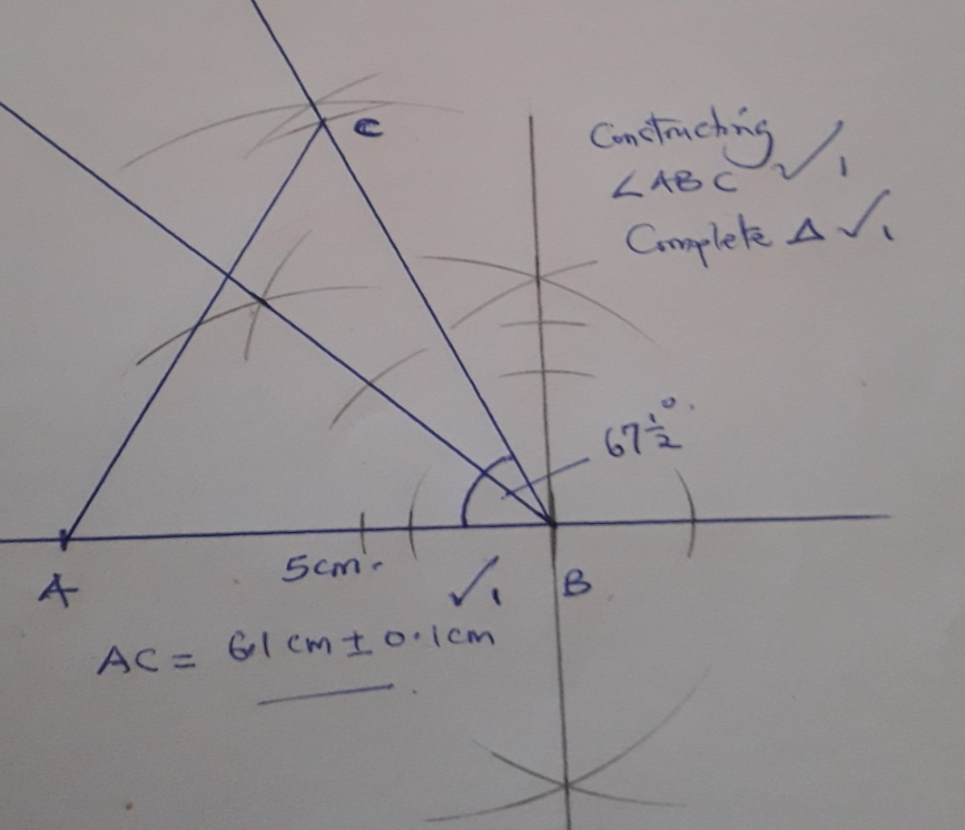 | 3 marks
11 | 5 x $\frac{1}{8.29 x{10}^{-2}}$ - 14 x $\frac{1}{5.81 x {10}^{-1}}$  5 x 0.126 x ${10}^{2}$ - 14 x 0.1721 x 10  = 60.3 – 24.094  = 36.206 | M1  M1  A1  3marks
12 | 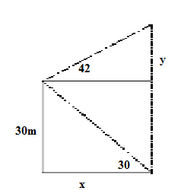  Viewing tower  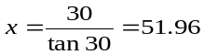  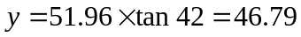  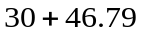  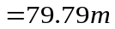 | B1  M1  A1  3  marks
13 | Numerator (3x + 1) (3x – 1)  Denominator (3x – 1) (x + 1)  $\frac{\left(3x-1\right)(3x+1)}{\left(3x-1\right)\left(x+1\right)}$ = $\frac{3x+1}{x+1}$ | M1  M1  A1  3 marks
14 | $$\frac{x}{y}=\frac{2}{3} ⇒x=\frac{2}{3}y$$  $$\left(\frac{5x\left(2\right)}{3}y-2y\right):\left(\frac{2}{3}y+y\right)≡\left(\frac{10}{3}y-2y\right):(\frac{2}{3}y+y)$$  $$\frac{4}{3}y:\frac{5}{3}y=4:5$$  Alternative  $$\frac{x}{y}=\frac{2}{3} ⇒x=2 ,y=3$$  $$\left[5\left(2\right)-2\left(3\right)\right]:\left(2+3\right)=4:5$$ | M1  M1  A1  M1  M1A1  3 marks
15 | 5000 x 84.15  = 420,750  420 750  289 850  130 900  $\frac{130900}{80.43}$ = 1627.50  ≈ 1628 | M1  M1  A1  3marks
16 | - 7532  - 500 | B1  B1  2 marks

SECTION II

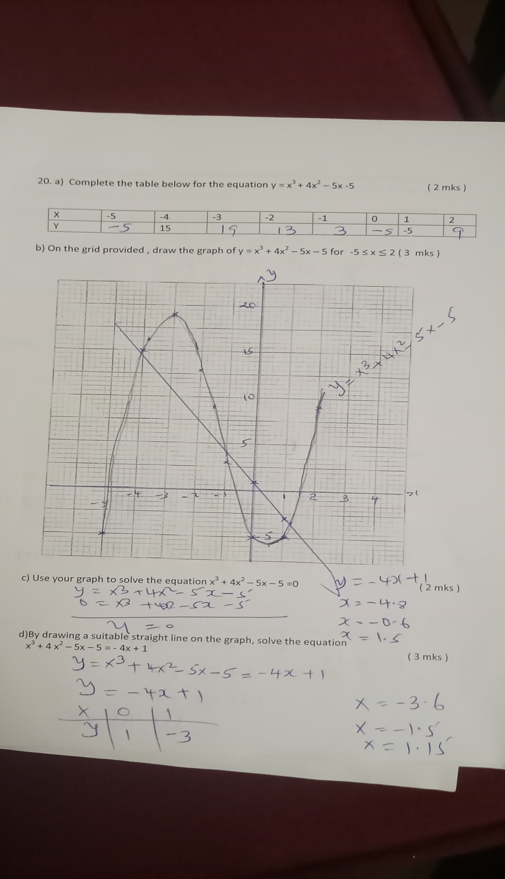
17.

8. | a) $\frac{180}{360}$ x 2 x $\frac{22}{7}$ 6370 cos 40  = 15, 336. 2098 km  ii) $\frac{100}{360}$ x 2 x $\frac{22}{7}$ x 6370  = 11, 122.22 km  b) P = 400 Knots  Q = 600 Knots  Distance AB by Q = 180 x 60 x cos 40  = 8273.28 nm.  Time taken by Q = $\frac{8273.28}{600}$ = 13.79 hrs  = 13 hrs 47 min Distance covered by P= 100 x 60 = 6000nm  Time taken by P = $\frac{6000}{400}$ = 15 hrs  Q arrived earlier by 1hr. 13 minutes | M1  A1  M1M1  A1  M1  A1  M1  A1  B1  10 Mks
19. a) i  ii)  iii) | $π$rl + $2πr^{2}$  (3.142 x 8 x10 ) + ( 2 x 3.142 x 8² )  = 653. 7143 cm²  $\frac{1}{2}x 4/3π$r³ + $1/3πr^{2}$h  ( 2/3 x 22/7 x 8³ ) + ( 1/3 x 22/7 x 8³ x 6 )  = 1072.7619 + 402. 2857  = 1475. 0476 cm³  M = $\frac{1.5 x 1475.0476}{1000}$ = 2.2126 kg | M1 M1  A1  M1 M1  M1  A1  M1 M1A1  10 Mk

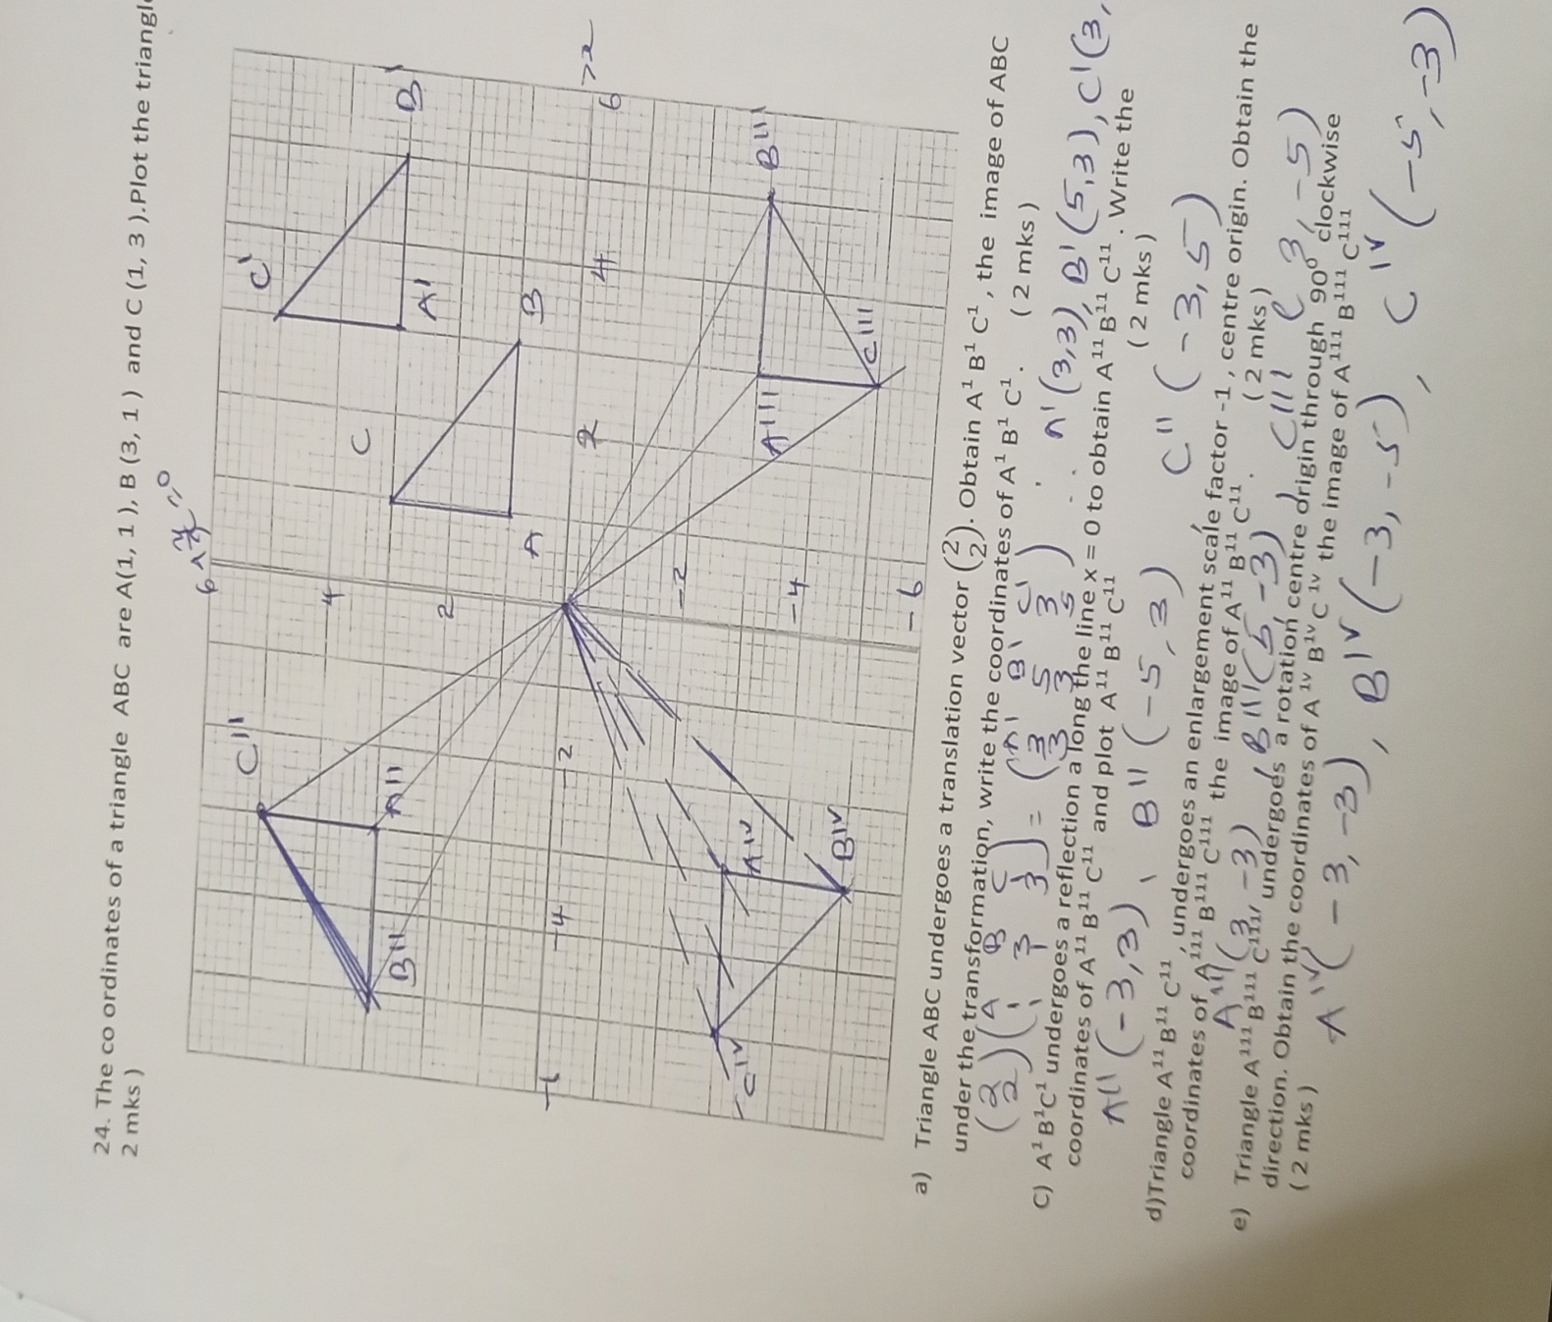
20.

b)A¹(3, 3 ), B¹ ( 5, 3 ) , C¹ ( 3, 5 )
- A¹¹ ( - 3, 3 ) , B¹¹ ( -5, 3 ) , C¹¹ ( - 3 , 5 )
- A¹¹¹ ( 3,-3 ) ,B¹¹¹ ( 5 , - 3 ) , C¹¹¹ ( 3 , - 5 ) e) A^{IV} ( -3 , -3 ) , B^{IV} ( - 3, - 5 ) C^{IV} ( - 5 , - 3 )
21. | $\frac{y+1}{x+2}$ = $\frac{- 2}{3}$  3y + 3 = - 2x – 4  Y = - $\frac{2}{3 }$x – 2 $\frac{1}{3}$  b) $\frac{- 2}{3}$ x M = - 1  M = $\frac{3}{2}$  $\frac{Y+1}{X+2}$ = $\frac{3}{2}$  2y + 2 = 3x + 6  $\frac{- 3 x}{4}$ + $\frac{y}{2}$ = 1  c) Grad N = $\frac{3}{2}$  $\frac{y-2}{x+1}$ = $\frac{3}{2}$  - 3x + 2y = 7  - $\frac{3 }{7} x$+ $\frac{2}{7}y$ = 1 | M1  M1  A1  B1  M1  M1  A1  M1  M1  A1  10 Mks
22. |  | (a) 40⁰ – Angle subtended by the same  arc: MN  (b) 25⁰ – Diameter of a circle subtends  90⁰ at the circumference of a circle.  (c) 65⁰ – Alternate segment theorem  (∠LNP is alternate to ∠LKN)  (d) 10⁰ – Sum of angles in a triangle  add up to 180  (e) 50⁰ – Alternate segment theorem or  sum of angles in a straight line add  up to 180⁰. |  | B1 Angle  B1 Reason  B1 Angle  B1 Reason  B1 Angle  B1 Reason  B1 Angle  B1 Reason  B1 Angle  B1 Reason  10 Mks
23. | OS = $\frac{1}{3}$OP QT = $\frac{3}{4}$OSOR = $\frac{1}{3}$OQ  (i) SR = SO + OR = $\frac{1}{3}$P + $\frac{1}{3}$Q  = $\frac{1}{3}$(Q – P)  (ii) QS = QO + OS= Q + $\frac{1}{3}$P  = $\frac{1}{3}$P – Q  (iii) PT = PS + ST  = -$\frac{2}{3}$P + $\frac{1}{4}$(-QS)= -$\frac{2}{3}$p + $\frac{1}{4}$ (Q - $\frac{1}{3}$P)  =-$\frac{2}{3}$p + $\frac{1}{4}$q - $\frac{1}{12}$p  =-$\frac{9}{12}$p + $\frac{1}{4}$q = $\frac{1}{4}$q - $\frac{3}{4}$p  (iv) TR = TQ + QR  = $-\frac{3}{4}$ QR - $\frac{2}{3}$Q  = -$\frac{3}{4}$($\frac{1}{3}$p – q) - $\frac{2}{3}$Q  = -$\frac{1}{4}$p + $\frac{3}{4}$q - $\frac{2}{3}$q= - $\frac{1}{4}$P + $\frac{1}{12}$Q  = $\frac{1}{12}$Q - $\frac{1}{4}$P  PT = $\frac{1}{4}$Q - $\frac{3}{4}$P  TR = $\frac{1}{12}$Q - $\frac{1}{4}$P  ∴ PT = 3TR or $\frac{1}{3}$PT = RT  Common point T  PT is a multiple of TR  PT = 3TR  Hence PTR are collinear |  | B1  M1  A1  M1  A1  M1  A1  M1 (both seen)  M1 (both seen)  A1 conclusion |  | 24. | (a) 250 x 14 x 2 x 2 = 14000  Net profit = 14000 – 6000  = KSh. 8000  (b) 8000 x 25 = 200,000  = 190,000  (c) Saving: $\frac{40}{100}$ x 190,000  = 76000  Remaining profit = $\frac{36}{100}$ x 190,000  = 68,400  Muthoka’s share  $\frac{45,600}{3}$ + $\frac{2}{9}$ x 68,400  = 30,400  (d) 475,000 x 3 x 100  95  = 1,500,000 |  | M1 Profit  A1  B1 Profit  M1 Equation for equal share  A1  M1 Expression of M uthoka’s share  A1  M1  M1  A1

