NAME........................................................ Index number..................................ADM NO............
Candidate’s signature.................................................. Date..................................
121/1
MATHEMATICS
PAPER 1 (THEORY)
2¹/₂ HOURS
CHUGU BOYS SECONDARY SCHOOL
Kenya certificate of secondary education (K.C.S.E)
PAPER 1 (THEORY)
2¹/₂ HOURS
Instructions to candidates
- Write your name and index number in the spaces provided above.
- Sign and write the date of examination in the spaces provided above.
- This paper consists of two sections I, II.
- Answer all the questions in section 1 and any five questions from section II.
- All working and answers must be written on the question paper in the spaces provided below each question.
- Show all steps in your calculations, giving answers at each stage in the spaces provided below each question.
- Marks may be given for correct working even if the answer is wrong.
- Non-programmable silent electronic calculators and KNEC mathematical tables may be used.
SECTION I
Questions | 1 | 2 | 3 | 4 | 5 | 6 | 7 | 8 | 9 | 10 | 11 | 12 | 13 | 14 | 15 | 16 | Total
marks
SECTION II

TOTAL

Questions | 17 | 18 | 19 | 20 | 21 | 22 | 23 | 24 | Total
Marks 17

- If X = -1, Y = 2 and Z = -3
Evaluate (3Marks)
-Z²$+$ XYZ
X²y – Z

- Evaluate (3Marks)

$$\frac{-8+\left(-\right)10×\left(-\right)8-(-112)}{-3-\left(-\right)8÷2×8}$$

- A line passing through point P(-2,8) is parallel to line -3$x$-5y=10, find its equation leaving your answer in form ax+by+c=0 (3Marks)

- The vertices of a triangle ore P (a,2), Q(3,5) and R (4,2). Co-ordinates of R¹ image the image of R under a translation vector T are (6,-2).
- Determine the translation vector T (2Marks)

- Find the co-ordinates of P¹ and Q¹ under the same translation. (2Marks)

- Solve by completing square method. (3Marks)

4a²+6a+2=0

- 1.2 litres of alcohol whose density is 0.8 g/cm³ is mixed with 0.5l of water whose density is 1g/cm³. Find the density of the mixture. (4Marks)

- The graph below shows the velocity of a particle after time in seconds. Find the average velocity of the particle. (3Marks)
20m/s

O 8 14

Time (seconds)

- The GCD and LCM of three numbers are 3 and 1008 respectively. If two of the numbers are 48 and 72, find the least possible value of the third number. (3 Marks)

- Three pens and four exercise books cost Sh. 87. Two pens and five exercise books cost Sh. 93. Find the cost of one pen and one exercise book. (4 Marks)

- Use a ruler and a pair of compasses only in this question.
(a) Construct triangle ABC with AB = 5cm, BC = 6cm and ABC=67$\frac{1}{2}$⁰ (2 Marks)

(b) Measure AC (1 Mark)

- Use tables of reciprocals only to find the value of
$\frac{5}{0.0829}$ - $\frac{14}{0.581}$ (3 Marks)

- From a viewing tower 30 metres above the ground, the angle of depression of an object on the ground is 30⁰ and the angle of elevation of an aircraft vertically above the object is 42⁰. Calculate the height of the aircraft above the ground. (3 Marks)

- Simplify: $\frac{9x^{2}- 1}{3x^{2}+2x-1}$ (3 Marks)

- Given that the ratio x: y = 2:3, find the ratio (5x-2y) : (x+y) (3 Marks)

- A Kenyan bank buys and sells foreign currency as shown below.
Buying Selling
Kenya shillings Kenya shillings
1 Euro 84.15 84.26
1 US Dollar 80.12 80.43
A tourist travelling from Britain arrives in Kenya with 5000 Euros. He converts all the Euros to Kenya shillings at the bank. While in Kenya he spends a total of KSh. 289,850 and then converts the remaining Kenya shillings to US dollars at the bank. Calculate (to nearest dollar) the amount he receives? (3 Marks)

- All prime numbers less than ten are arranged in descending order to form a number.
(a) Write down the number formed ( 1 Mark)

(b) State the total value of the second digit in the number formed in (a) above (1 Mark)

SECTION II (50MKS)
ANSWER ANY FIVE QUESTIONS IN THIS SECTION

- (a) Complete the table below for the equation $y = x^{3}+ 4x^{2} – 5x -5$for $-5 ≤ x ≤ 2$(2 Marks)

$$x$$ | $$-5$$ | $$-4$$ | $$-3$$ | $$-2$$ | $$-1$$ | $$0$$ | $$1$$ | $$2$$
$$y$$ |  | $$15$$ |  |  |  |  | $$-5$$

(b) On the grid provided, draw the graph of $y = x^{3}+ 4x^{2} – 5x -5$for $-5 ≤ x ≤ 2$ (3 Marks)
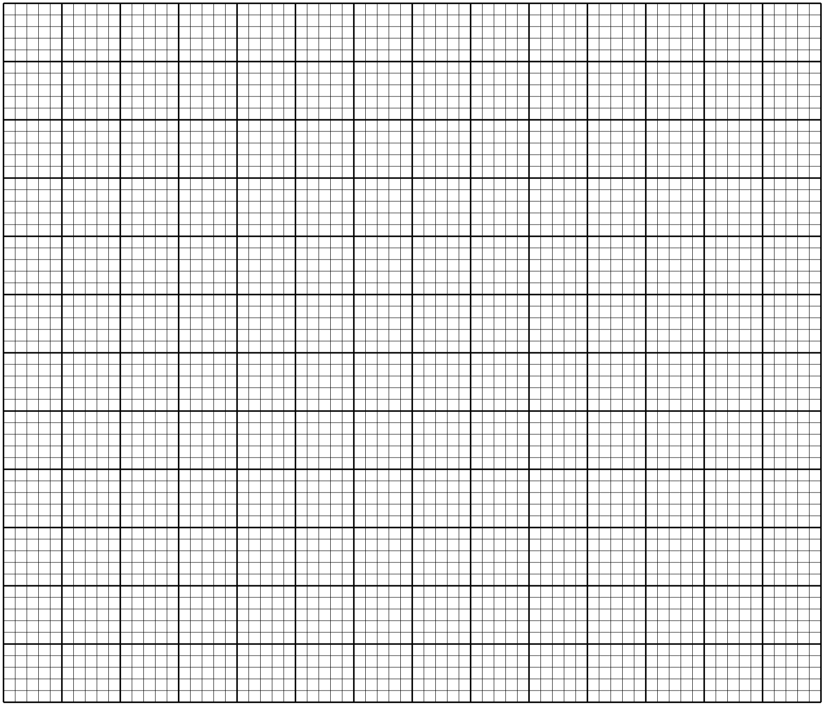

(c)Use your graph to solve the equation x³ + 4x² – 5x – 5 =0 (2 Marks)

(d). By drawing a suitable straight line on the graph, solve the equation $x^{3}+4x^{2}-5x-5=-4x+1$
(3 Marks)

18. A bus left Bondo at 8:00 a. m. and travelled towards Kisumu at an average speed of 80 km/hr. At 8:30 a.m. a car left Kisumu for Bondo at an average speed of 120 km/hr. Given that the distance between Bondo and Kisumu is 400 km. Calculate:

- The time the car arrived in Bondo (2 Marks)

- The time the two vehicles met. (4 Marks)

- The distance from Bondo to the meeting point (2 Marks)

- The distance of the bus from Kisumu when the car arrived in Bondo. (2 Marks)

- A solid consists of a cone and hemisphere. The common diameter of the cone and hemisphere is 16 cm and the height of the cone is 6 cm. Using π=3.142
Calculate correct to two decimal places:
- The surface area of the solid (3 Marks)

- The volume of the solid (4 Marks)

- If the density of the material used to make the solid is 1.5 g/cm³ , calculate its mass in kilograms
(3 Marks)

20. The coordinates of a triangle ABC are$A(1, 1)$, $B(3, 1)$ and$C(1, 3)$.
- Plot the triangle ABC on the grid provided. (1 Mark)

- Triangle ABC undergoes a translation vector $\left(\begin{aligned}2 \\ 2\end{aligned}\right).$ Obtain$A'B'C'$, the image of ABC under the transformation, write the coordinates of$A'B'C'$. (3 Marks)

- $A'B'C'$Undergoes a reflection along the line $x=0$ to obtain$A''B''C''$.On the same pair of axes, plot $A''B''C''$andstate its coordinates. (2 Marks)

- $A''B''C''$undergoes an enlargement scale factor $-1$, centre (0, 0) to obtain $A'''B'''C'''$. Draw triangle $A'''B'''C'''$ (2 Marks)

- Describe fully, the transformation that maps triangle $A^{IV}B^{IV}C^{IV}$with coordinates$A^{IV}(-3, -3)$, $B^{IV}(-3, -5)$ and $C^{IV}(-5, -3)$onto triangle. (2 Marks)

21. A straight line L passes through P $(- 2, - 1)$ and $Q (x, y).$ It has a gradient of - $\frac{2}{3}$ .
- Find the equation of the line L in the form $ax+by=c$, where $a$, $b$ and $c$ are integers. (3 Marks)

- The line L is perpendicular to another line M. If the two lines meet at point P, find the equation of the line M in the form $\frac{x}{a}$ + $\frac{y}{b}$ = 1. (4 Marks )

c) If the line M is parallel to line N which passes through point$R(- 1, 2)$, find the equation of the line N. (3 Marks)

22. In the figure below, K,L,M and N are points on the circumference of the circle centre O. The points K,
O, M and P are on a straight line. PN is tangent to the circle at N. ∠KOL = 130⁰ and ∠MKN = 40⁰.
130⁰
40⁰
P
L
N
Q
O
M
K

Stating the reason in each case, find the values of the following angles,
- MLN (2 Marks)

- OLN (2 Marks)

- LNP ( 2 Marks)

- MPN ( 2 Marks)

- KNQ (2 Marks)

23. The figure below shows triangle OPQ in which OS = $\frac{1}{ 3}$ OP and OR = $\frac{1}{3}$ OQ. T is a point on QS such that QT = $\frac{3}{4}$ QS
P
S
O
Q
R
T

- Given that OP = p and OQ = q, express the following vectors in terms of p and q.
̃
̃
(i) SR (1 Mark)
̃

(ii) QS (2 Marks)
̃

(iii) PT (2 Marks)
̃

(iv) TR (2 Marks)
̃

- Hence or otherwise show that the points P, T and R are collinear. (3 Marks)

24. Three partners Mutua, Muthoka and Mwikali contributed Sh. 600,000, Sh. 400,000 and Sh. 800,000 respectively to start a business of a matatu plying Mbumbuni – Machakos route. The matatu carries 14passengers with each paying Sh. 250. The matatu makes two round trips each day and ever full. Each day Sh. 6000 is used to cover running costs and wages.
- Calculate their net profit per day. (2 Marks)

- The matatu works for 25 days per month and is serviced every month at a cost of KSh.10, 000. Calculate their monthly profit in June. (1 Mark)

- The three partners agreed to save 40% of the profit, 24% to be shared in the ratio of their contribution. Calculate Muthoka’s share in the month of July (4 Marks)

- The matatu developed mechanical problems and they decided to sell it through an agent who charged a commission of 5% on selling price. Each partner received KSh. 475,000 from the agent after he had taken his commission. Determine the price at which the agent sold the matatu. ( 3 Marks)

