511/3 MUSIC, MOKASA 2 2024
Paper 1
Sight Reading Exercises
July 2024
(15 minutes per candidate)

- Flute

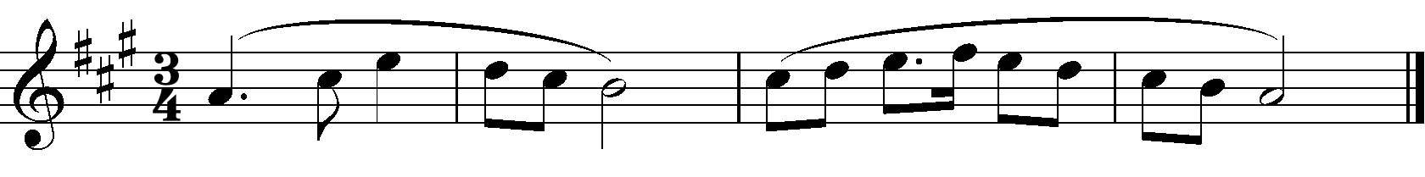

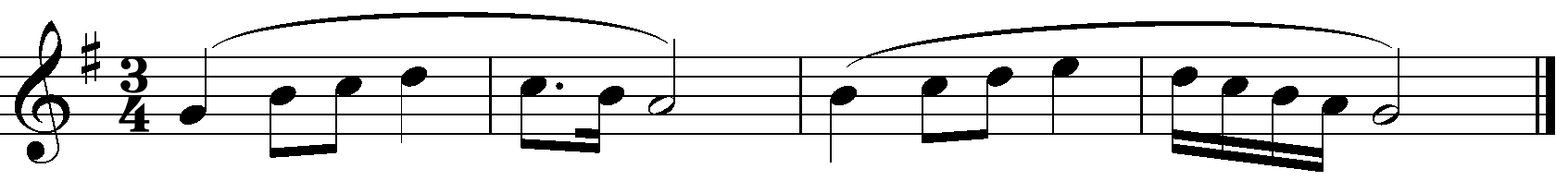

- Horn in F

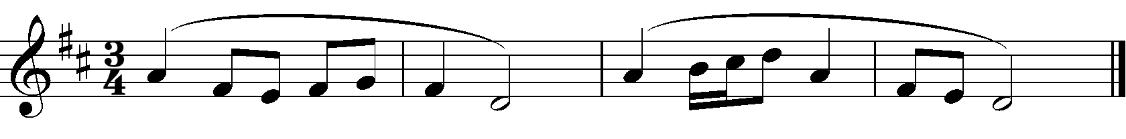

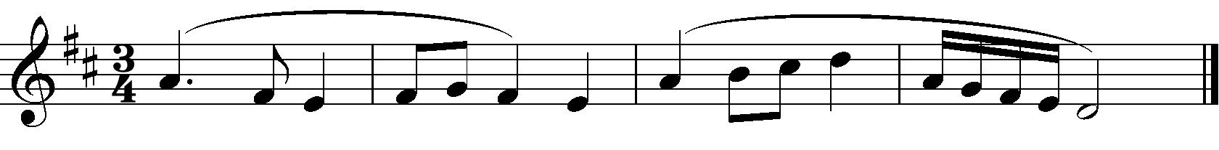

- Viola

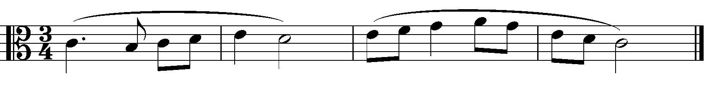

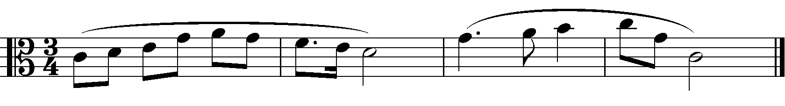

- Violin

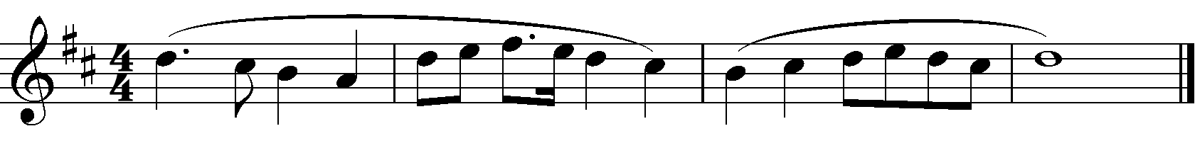

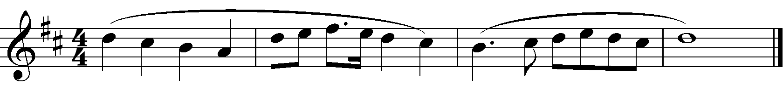

- Recorder

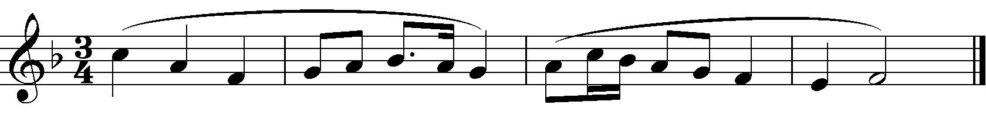

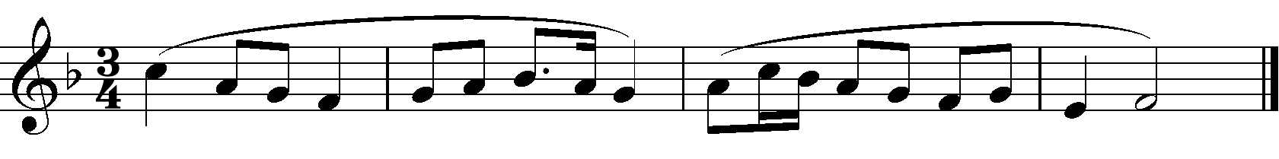

- Piano

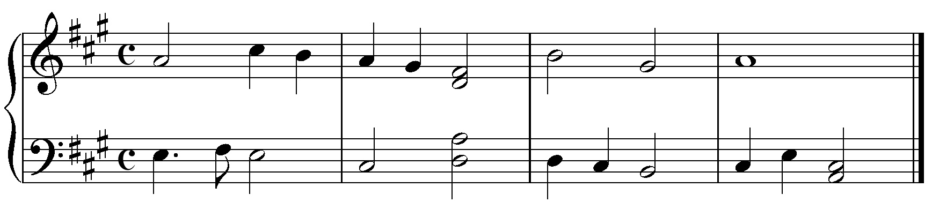
- Guitar

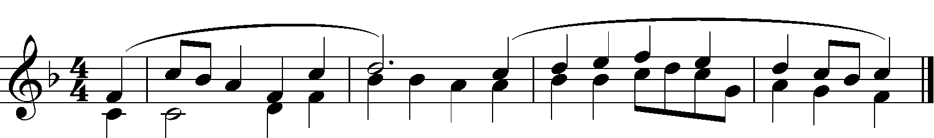

- Trombone

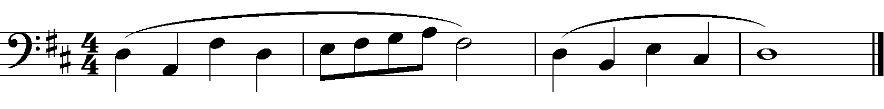

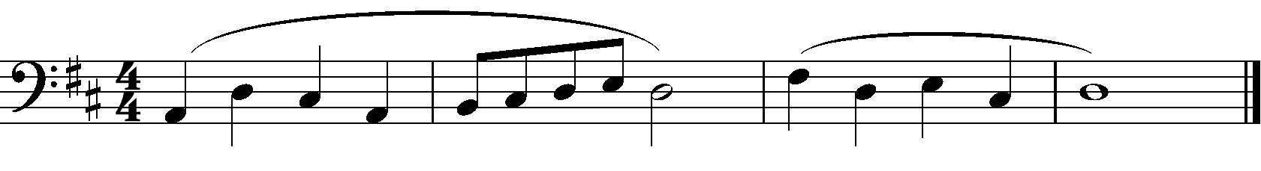

- Saxophone/Clarinet/ Trumpet

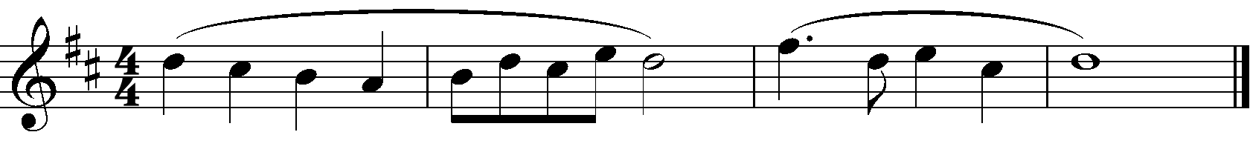

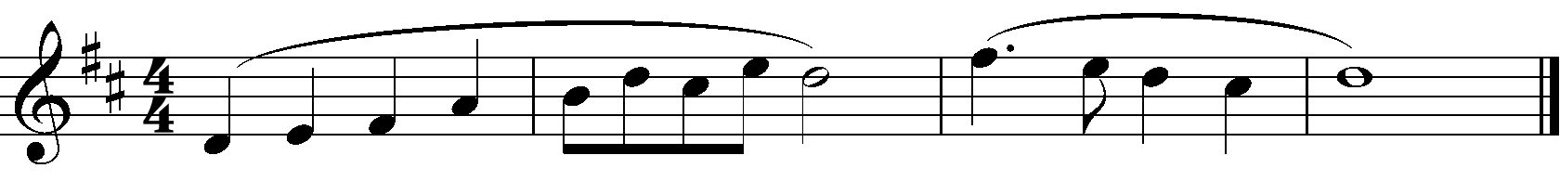

- Voice

