Name: ……………………………………………………Adm. No: ………………Class:……………..

232/1
PHYSICS
Paper 1
(THEORY)
.
Time: 2 Hours

FORM 3
TERM 2
Kenya Certificate of Secondary Education (K.C.S.E)

PHYSICS
Paper 1
Time: 2 Hours

INSTRUCTIONS TO CANDIDATES:-
- Write your name, index number and class in the spaces provided above.
- This paper consists of two sections; A and B
- Answer all the questions in section A and B in the spaces provided
- All working must be clearly shown.
- Mathematical tables and electronic calculators may be used
- This paper consists of 11 printed pages. Candidates should check to ascertain that all pages are
printed as indicated and that no questions are missing.
- Candidates should answer the questions in English.
- Take g = 10N/kg

For Examiner’s Use Only:

Section | Question | Maximum  Score | Candidate’s  Score
A | 1 – 13 | 25
 | 14 | 11
 | 15 | 9
B | 16 | 11
 | 17 | 11
 | 18 | 13
Total Score |  | 80

SECTION A: 25mks (Answer all the questions)
- State one assumption made when determining the size of a molecule in an oil drop experiment
(1 Mark)

- The drop is perfectly spherical any one = ✔1 Mark
- The layers/ patch is one molecule thick.
- Air is blown into the horizontal tube as shown below.

- Indicate the levels of water in tubes A and B when air passes through the horizontal tube at a high velocity . (1 Mark)
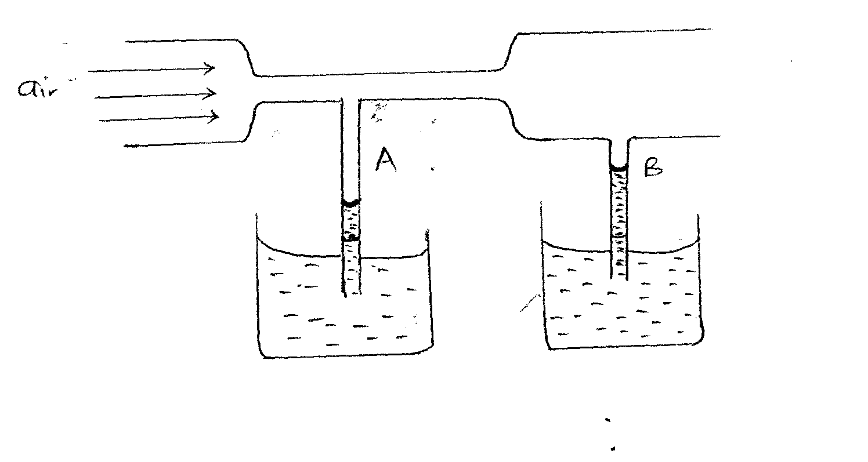
- Explain your observation in (a) above (1 Mark)
- In tube A, velocity of air above it is higher ✔than velocity of air above tube B
- Therefore in table A, pressure is lower than tube B
- Sketch a velocity – time graph of a body moving with uniform velocity. (1 Mark)
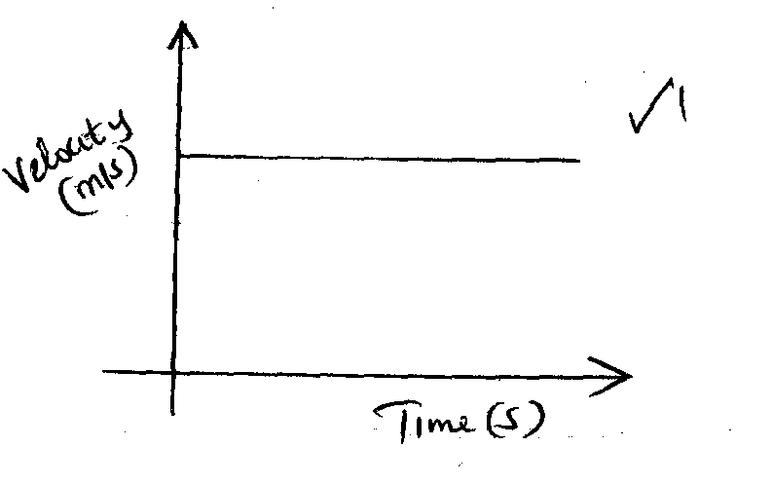

- The figure below shows an empty wire glass.
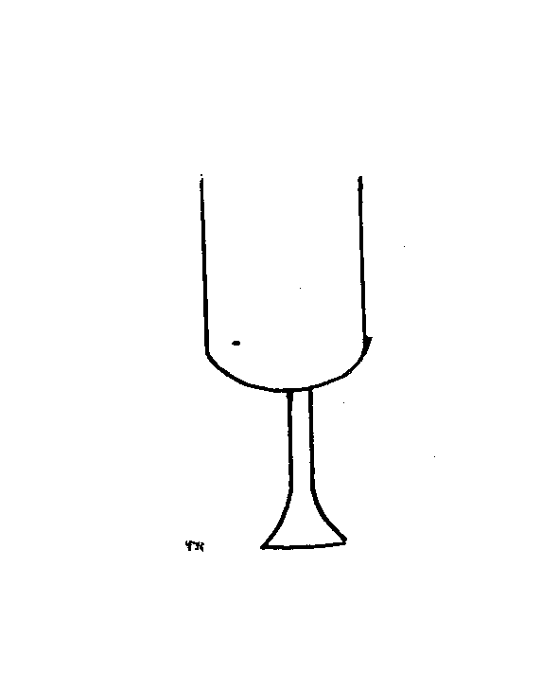
- How is its stability affected when filled with wine? (1 Mark)
- Stability is reduced ✔
- Explain the observation in (a) above (1 Mark)
- The position of the centre of gravity is raised ✔¹ when more weight is added on the upper side, reducing stability
- State one factor that affects heat transfer in solids. (1 Mark)
- Length of the conductor

- Cross sectional area any one=✔1
- Temperature difference of the source
- Nature of the material making the conductor.
- The figure below shows a uniform bar of length 1 metre. Calculate the weight of the beam. (3 Marks)
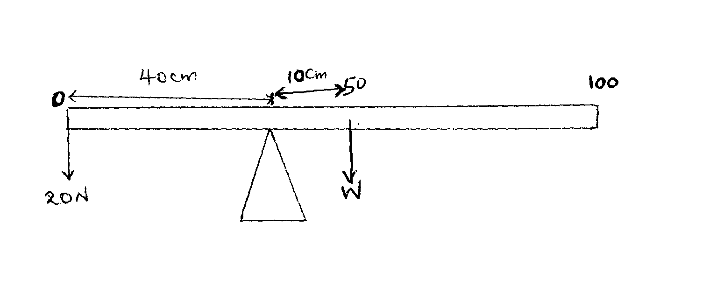
- Clockwise moments = Anti clockwise moments
$0.1×W=0.4m×20N$ ✔ $W=\frac{0.4×20}{0.1}$✔
$W=80N$ ✔

- The figure below shows a u-tube containing the liquids X and Y. Given that the density of liquid X is 1.8g/cm³, calculate the density of liquid Y in g/cm³. (3 Marks)
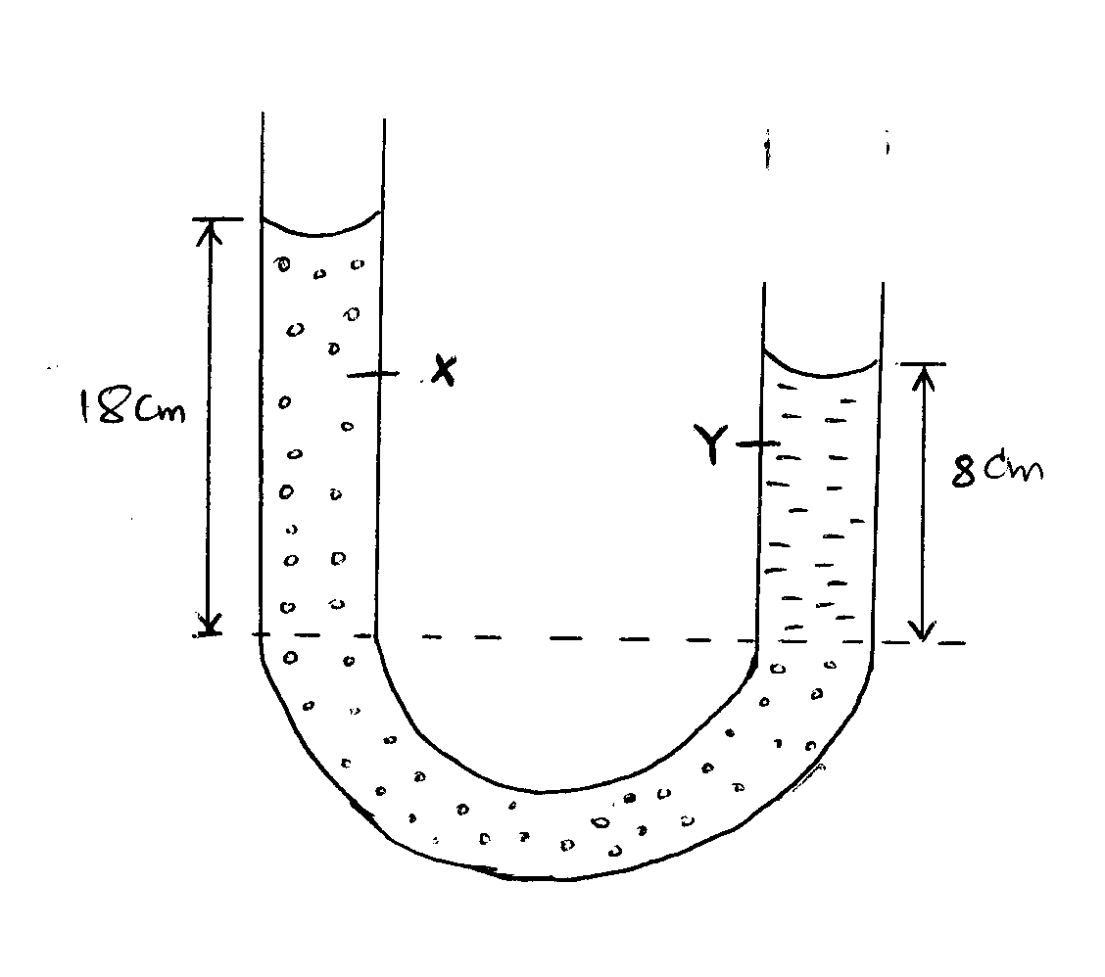

$ρ_{x}h_{x}g=ρ_{x}h_{x}g$ ✔
$ρ_{x}h_{x}$ =$ρ_{x}h_{x}$
$1.8g/cm^{3} ×18cm=ρ_{y}×8cm$ ✔
$$ρ_{y}=\frac{1.8×18}{8}$$
$ρ_{y}=4.05g/cm^{3 }$✔
- Name one factor that affects surface tension. (1 Mark)
- Temperature
- Impurities
Any= ✔1
- When a liquid is heated in a glass flask, its level first falls and then starts rising. Explain this observation.
(2 Marks)
- The level first dropped due to expansion of glass ✔1
- The level then started rising when the heat reaches the water. ✔1
- The figure below shows two identical springs with negligible weight. The extension produced on the system is 10cm
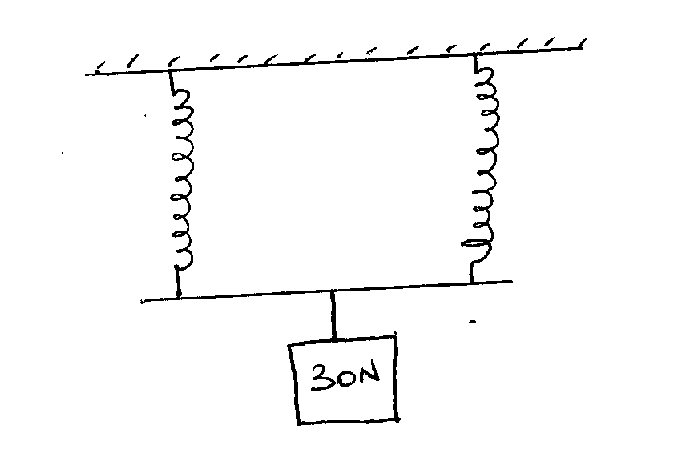

Determine the spring constant of each spring. (3 Marks)
$combined spring constant =k_{1}+k_{2}$
$for identical spring, k_{e}=2k$
$f=2ke$✔
$30N=2k×0.1m$✔
$2k=\frac{30N}{0.1m}$
$2k=300N/m$
$k=150N/m$ ✔
- A body A of mass 2kg moving with a velocity of 5m/s collides with a body B of mass 30kg travelling at 2m/s in the opposite direction. If the collision is perfectly inelastic, find their common velocity after collision. (3 Marks)
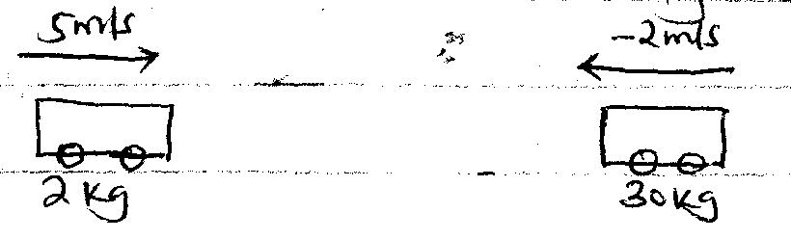
$m_{1}u_{1}+ m_{2}u_{2}= {(m}_{1}+m_{2})$V✔
$(2kg×5m/s )+(30kg×-2m/s )=(30kg+2kg)V$ ✔
$10kgm/s -60kgm/s=32kgV$
$V=-1.56m/s$
$moves in the direction of 30kg body$
- The figure below shows a velocity time graph for a trolley
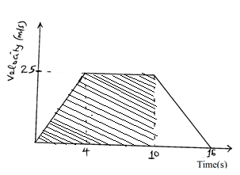
From the graph, calculate the distance covered by the trolley in the first 10 seconds (2 Marks)
Distance = Area under the graph from 0-10seconds
$Area=\left(\frac{6+10}{2}\right)×25$✔
$8×25=200m$
Distance = 200m ✔
- State the reason why gases are easier to compress than solids. (1 Mark)
- Gas particles have larger intermolecular distances than solids ✔

SECTION B: 55mks
- a. State Hook’s law (1 Mark)
For a helical spring or any other elastic material, the extension is directly proportional to the stretching force, provided that elastic limit is not exceeded. ✔
b. The table below shows the extension produced in a spring by various forces.
Extension (cm) | 0 | 0.3 | 0.7 | 1.10 | 1.5 | 1.9 | 2.4
Force (N) | 0 | 1.0 | 1.9 | 3.0 | 4.1 | 5.0 | 8.0

- Plot a graph of force against extension. (5 Marks)
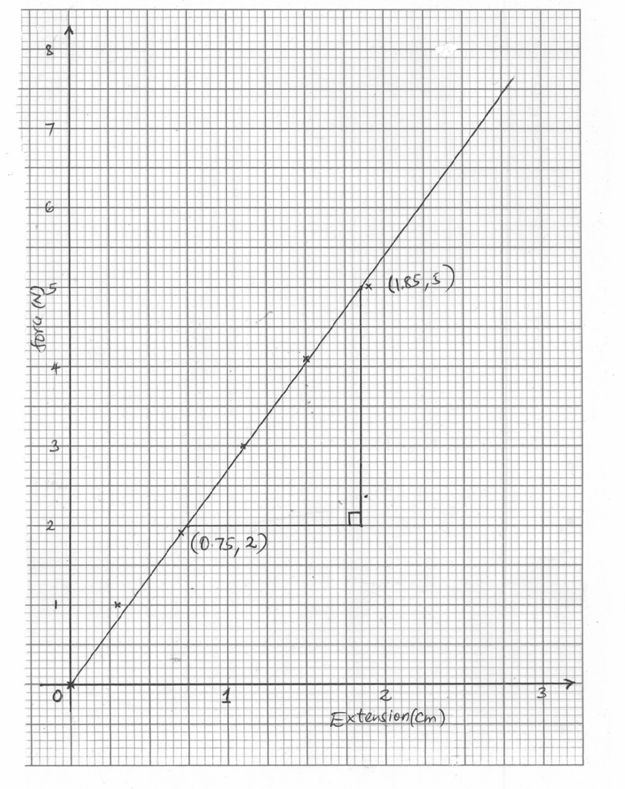
- From the graph, determine the spring constant. (3 Marks)
Gradient = Spring constant
$K=\frac{5-2}{1.85-0.75}$ ✔
$K=\frac{3}{1.1}$ ✔
$K=2.73 N/cm$ ✔
- What force would cause an extension of 1.2cm on the spring? (2 Marks)
Force = Ke
F = 2.73N/cm X 1.2cm✔
F = 3.276 N✔
- The figure below shows a block tackle system
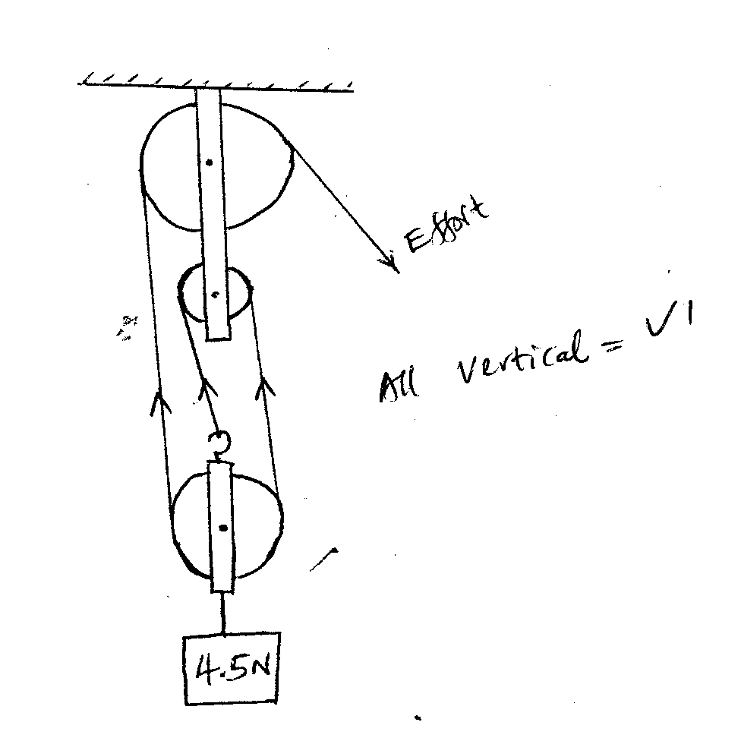
- State the velocity ratio of the system (1 Mark)
3 ✔
- Mark the direction of tension in the springs (1 Mark)
All vertical tensions✔1
- If an effort of 2N is applied, calculate the mechanical advantage of the system. (3 Marks)
$MA=\frac{Load}{Effort}$ ✔
$MA=\frac{4.5N}{2N}$ ✔
$MA=2.25$ ✔

- Calculate the efficiency of the system. (3 Marks)
$Efficiency=\frac{MA}{VR}×100\%$ ✔
$\frac{2.25}{3}×100\%$ ✔
$Eff=75\%$ ✔
- Explain why the efficiency of the system is less than 100%. (1 Mark)
- Weight of the pulley blocks/ dead weight ✔1
- Friction
- A body of mass 2kg is thrown vertically upwards with a velocity of 14m/s. Determine;
- The maximum height reached by the body (3 Marks)
$V^{2}=U^{2}-2gh$✔
$V=0$
$U^{2} 2gh$
${14}^{2}=2×10×h$✔
$h=\frac{196}{20}$
$h=9.8m$ ✔
- Its velocity after 0.5 seconds. (3 Marks)
$V=u-gt$✔
$V=14m/s-(10×0.55)$✔
$$V=14-5$$
$V=9m/s$ ✔
- The time taken to reach maximum height. (3 Marks)
$V=u-gt$✔
$O=14m/s-10t$
$10t=14$✔
$T=\frac{14}{10}=1.4 seconds$✔
- Calculate the net force acting on the ball as it moves upwards if it experiences an air resistance of 8N. (2 Marks)
$Net force =mg-Air resistance$
$= (2kg×10N/kg)-8 N$✔
$=20N-8N$
$=12N$✔
- a. State the Newton’s 2nd law of motion (1 Mark)
The rate of change of momentum of a body is directly proportional to the force applied and take place in the direction of the force ✔
b. A lady of mass 90kg is standing on the floor of a lift. Determine the reading on the weighing machine when
- Lift is at rest (2 Marks)
$At rest Reaction =mg$
$=90Kg ×\frac{10N}{kg}$ ✔
$= 900N$✔
- Lift is moving upwards with an acceleration of 3m/s² (2 Marks)
$R=mg+ma$
$=\left(90×10\right)+(90×3)$✔
$= 900N+270N$
$=1170N$✔
c. Two masses of 4kg and 2kg are connected by a light string passing over a frictionless pulley as shown below.
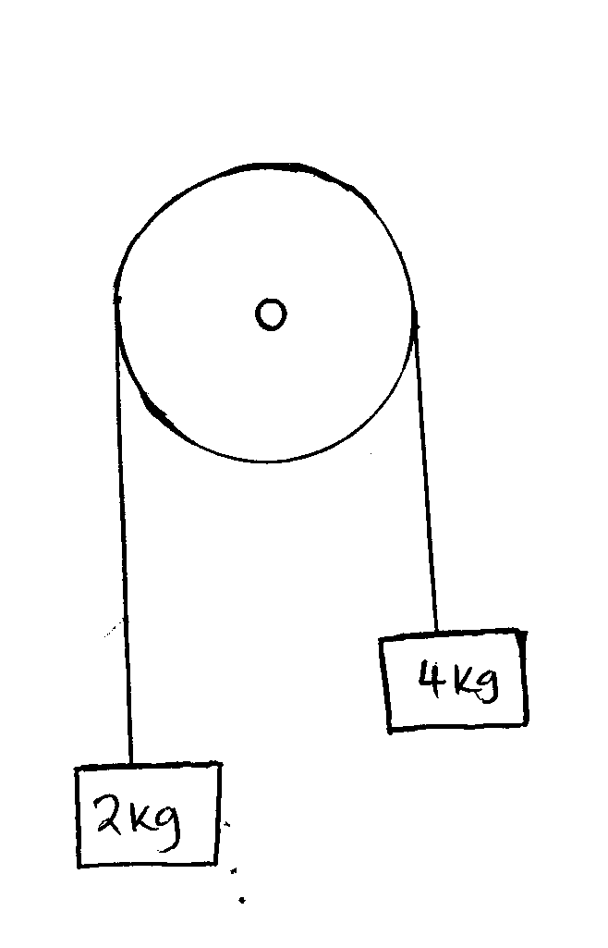
Calculate the acceleration of the masses when left to move freely. (3 Marks)
$Net force=40N-20N=20N$ ✔
$Force=Mass×acceleration$
$20N=6kg×a$ ✔
$a=\frac{20N}{6kg}=3.33{m/s}^{2 }$✔

d. A block of mass 35kg is pushed along a horizontal surface whose frictional force is 20N. If the force moving the block is 100N, calculate the co-efficient of friction between the block and the surface.
(3 Marks)

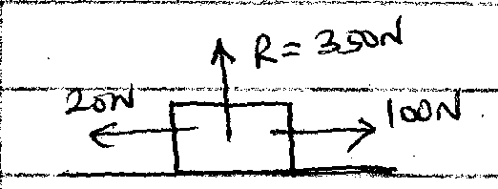
$μ=\frac{F}{R}$ ✔
$μ=\frac{20N}{350N}$ ✔

$μ=0.06$ ✔

- The figure below shows a hydraulic brake system.
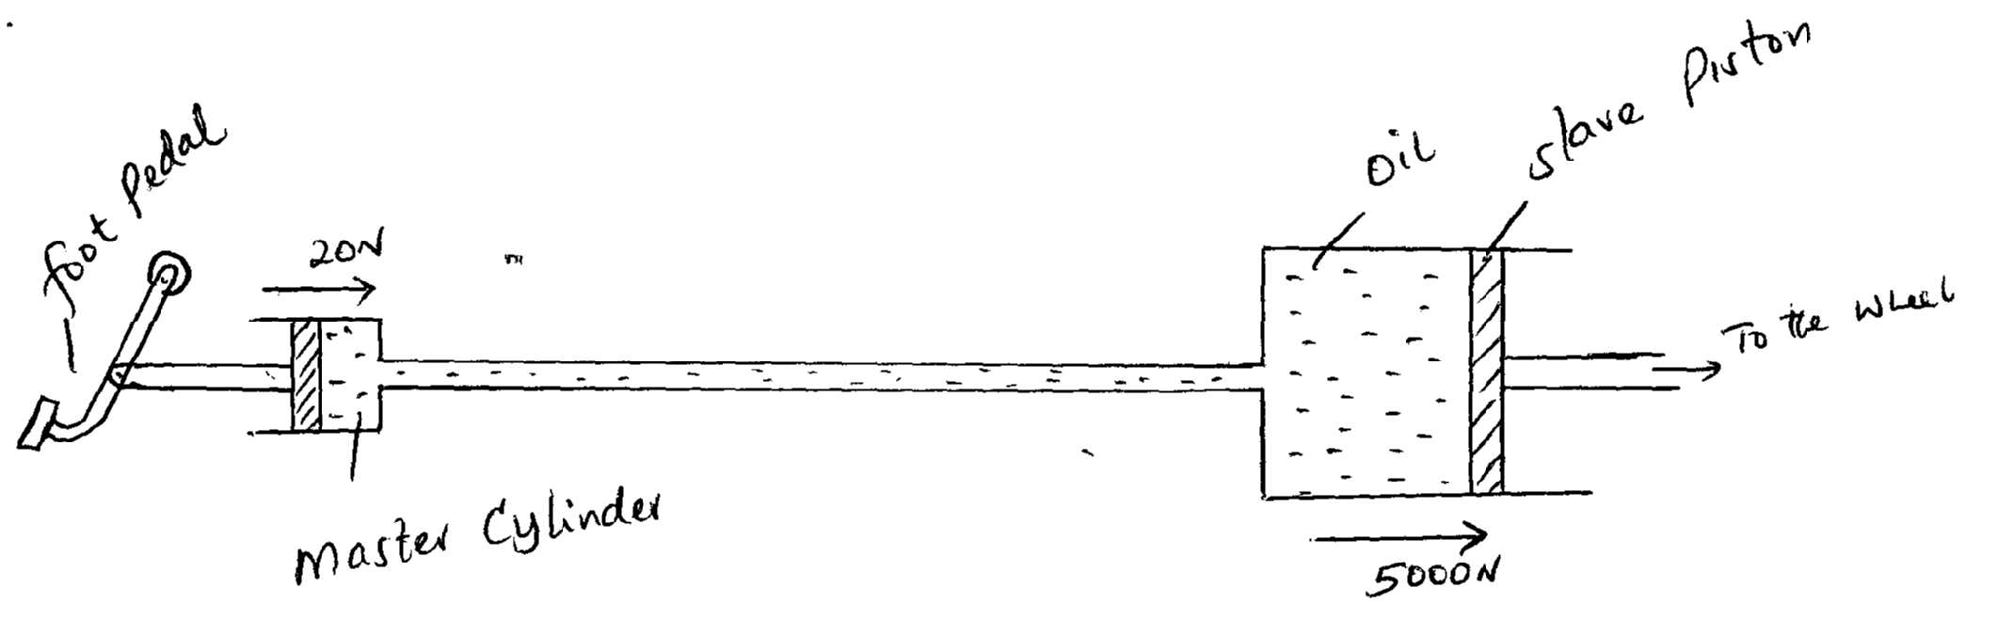
A force of 20 N is applied on the foot pedal connected to a master piston of area 0.05m². This causes a stopping force of 500N on one wheel. Calculate.
- Pressure in the master cylinder (3 Marks)
$Pressure=\frac{force}{area}$✔
$=\frac{20N}{0.05m^{2 }}$✔
$Pressure=400N/m^{2 }$✔
- Area of the slave piston. (3 Marks)
$Pressure is transmitted equally$
$\frac{400N}{m^{2 }}=\frac{5000N}{Area}$✔
$Area=\frac{5000}{400}$✔
$Area=12.5m^{2}$✔
- Velocity ratio of the system. (3 Marks)
$V.R=\frac{Area of the load piston}{Area of effort piston}$✔
$V=R=\frac{12.5}{0.05}$ ✔
$=250$ ✔
- Give two reasons why oil is used in the hydraulic brake system. (2 Marks)
- Incompressible ✔1
- Does not corrode the system ✔1
- State two factors affecting pressure in liquids. (2 Marks)
- Density

- Depth of the liquid Each = ✔1

